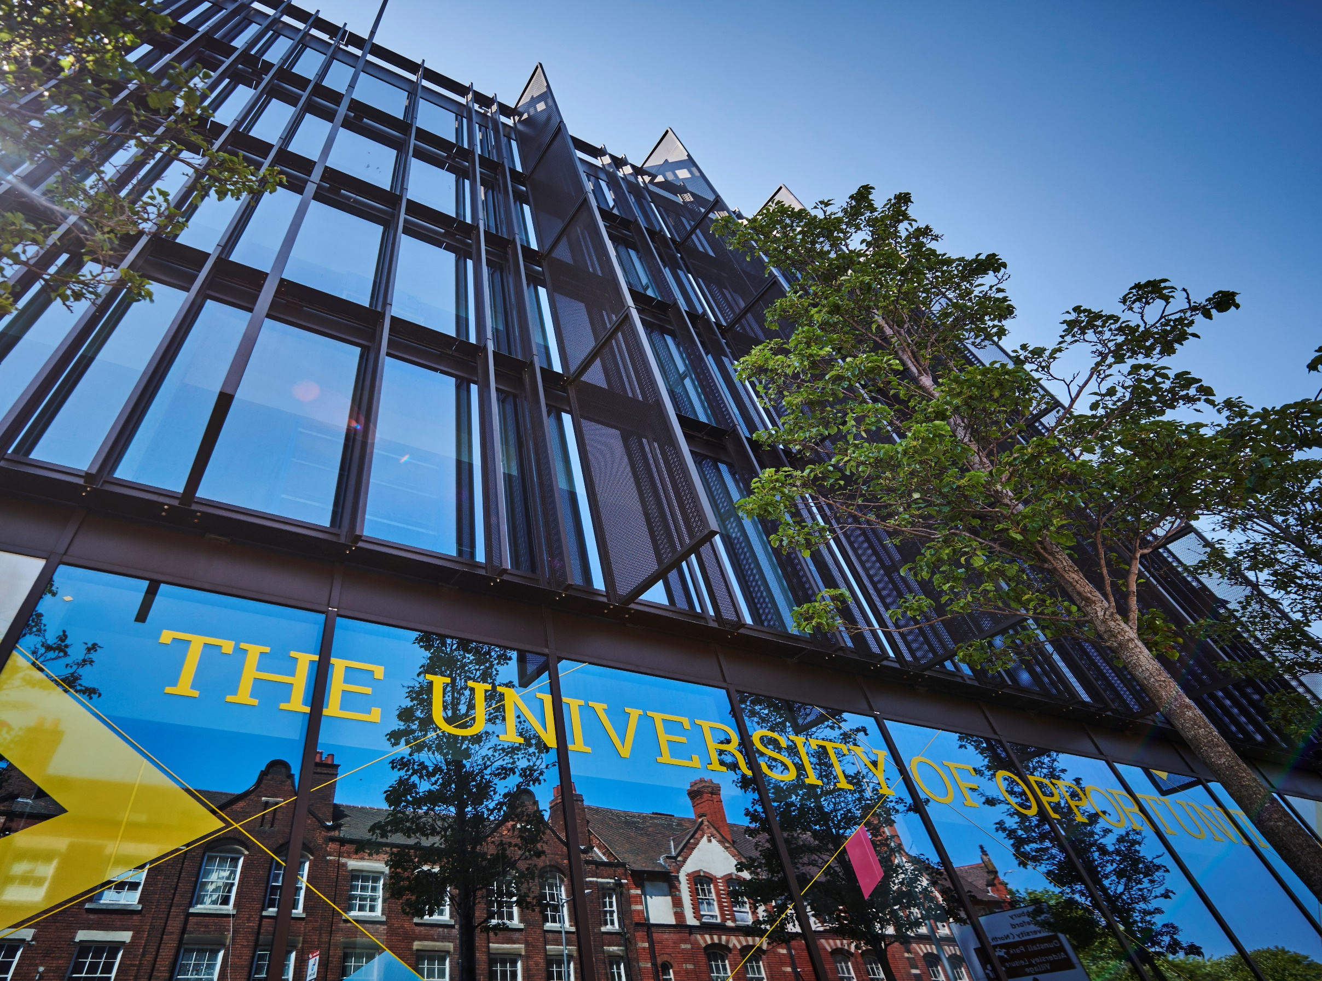

**Visa Refusal Policy**

**and Procedure**



1. **Introduction**
2. **Purpose**
3. **Principles**
4. **Scope**

**5. Details of Policy**

* 1. CAS Request Process

5.2 VISA Application Outcomes

5.3Unsuccessful Decisions

1. **Data Protection Requirements**
2. **Training**
3. **Exceptions**
4. **Amendments**
5. **Information and Resources**
6. **Contact**

# POLICY

1. **Introduction**

The University of Wolverhampton is committed to developing and maintaining constructive relations with its employees. This Policy has been approved by the University’s Academic Board. It sets out the University’s requirements to maintain our UKVI sponsor status and track record of compliance with respect to VISA refusals. This policy is designed to address any issues that result in an applicant’s visa application being refused and to protect our UK Visas and Immigration (UKVI) sponsor status by not issuing Confirmation of Acceptance for Studies (CAS) to applicants who are likely to receive a further visa refusal.

1. **Purpose**

This policy has been reviewed for the 2024/2025 academic year and beyond and ensures that the policy remains fit for purpose; for both the University and its applicants/students.

1. **Principles**

The objectives of this policy are to ensure that the approach to issuing CAS statements, where a VISA request is refused is fair, transparent, and reasonable.

The implementation of this policy is in accordance with the University’s core values which are to be:

* **Inclusive;** we are welcoming, respectful, collegiate and supportive.
* **Ambitious;** we are imaginative, confident, innovative and deliver excellence.
* **Accountable;** we take pride in what we do and how we do it, take responsibility for our actions and operate with transparency and integrity.
* **Resilient;** we have a positive outlook; we are adaptable and recover from setbacks.

1. **Scope**

The VISA Refusal Policy and Procedure applies to all overseas domiciled applicants to the University. The responsibilities and organisational arrangements for the VISA Refusal Policy are owned by Registry Services with dependencies on a variety of university departments/services – including Global Opportunities, Admissions, Finance Income Section, and Faculties.

1. **Policy Details**

**5.1** **CAS Request Process**

Confirmation of Acceptance for Studies (CAS) statements will only be issued to applicants upon completion of the CAS Request task in e:Vision, either directly by the applicant or their agent on their behalf.

The CAS Request task asks the applicant to confirm the details that will be included on the CAS statement and also asks them to confirm that they have the necessary funding and documents in place to ensure they will gain the 10 points awarded for meeting visa application maintenance requirements.

* 1. **VISA Application Outcomes**

The University must be informed of all visa application decisions. The applicant (or agent on their behalf) can inform the university of the visa decision by completing a task in e:Vision prior to enrolment, or alternatively by providing their documentation by email to [RTS@wlv.ac.uk](mailto:RTS@wlv.ac.uk).

* 1. **Unsuccessful Decisions**

If an applicant is unsuccessful in gaining a visa, the student or agent should provide full visa refusal documentation to Admissions, and this will be uploaded to the applicant’s record through e:Vision.

If a refusal is considered incorrect by the Student Visa Compliance and Advice team, a second CAS will not be considered until the student has requested an administrative review.

Applicants will not be allowed to request a further CAS, defer or reapply if their second visa application is refused. Presuming it is a first visa refusal, the university will consider the grounds for refusal before considering whether to issue a second CAS. The table below should guide when a second CAS is likely to be issued, but each case will be considered separately:

|  |  |
| --- | --- |
| **Refusal Reason** | **Consideration** |
| **Immigration history** | If the refusal was on the grounds of the applicant’s immigration history and either the refusal document states that this decision will remain for any future visa applications, or it is clear that the applicant has misled the university, the applicant will not be allowed to defer or apply again to the University. |
| **Unverifiable or unverified qualifications** | If the refusal was on the grounds of the applicant’s qualifications not being verified by the Home Office or accepted as a true document, the applicant will not be allowed to defer or apply again to the University unless they provide alternative equivalent qualifications to be reconsidered. If the applicant has provided demonstrably fraudulent documents, the applicant will not be allowed to defer or apply again to the University. |
| **Maintenance requirements** | All documentation used with the failed visa application is to be provided to admissions. If the admissions team feel this new documentation is likely to result in a visa being issued, a second CAS may be issued. |
| **Credibility interviews** | We will not issue a further CAS where a student has been found to be non-genuine. Where a student has previously been unable to satisfy the UKVI of their intentions it is highly unlikely that they will be able to do so in the future. |
| **CAS statement errors** | These must be reviewed by the Admissions Unit to ensure the data held on SITS is corrected. |
| **English language** | It is highly unlikely that we will issue a further CAS if the student was unable to satisfy an ECO of their language level at interview. If there is an issue with the document submitted (i.e. the refusal was not based on interview) this must be considered by the Admissions Office. |

If a second CAS or deferral is not possible, applicants may apply for a refund of their deposit. Please see the refunds policy for confirmation.

As a responsible sponsor, the University of Wolverhampton reserves the right to refuse to issue a CAS in all instances in which we feel a student is likely to receive a visa refusal.

1. **Data Protection Requirements**

When personal data is expected to be used under this policy, staff must adhere to applicable data protection laws. These are outlined in the University's Data Protection Policy and related policies (<https://www.wlv.ac.uk/about-us/corporate-information/wlv-policies/>). Any use of personal data should be detailed in the relevant privacy notice and processed in accordance with all data protection principles.

For processing activities that may carry high risk; completion of a Data Protection Impact Assessment (DPIA) may be required. This is determined by answering a series of screening questions included in the DPIA template. The Data Protection Team is available to provide assistance and guidance with any part of this process, please contact them via email: [dataprotection@wlv.ac.uk](mailto:dataprotection@wlv.ac.uk).

Please note that whilst the Data Protection Act does not cover aggregate data, it must be ensured that small numbers held within aggregate data sets do not inadvertently identify individuals.

1. **Training**

This policy will be linked to the application process and staff directly involved in the application and admissions process of the university, will be supported with any appropriate training.

1. **Exceptions**

There are no exceptions to this policy.

1. **Amendments**

This Policy was approved by the University’s Academic Board on 27 August 2024. The University may change this Policy at any time, and where appropriate. Where a policy is not due for review, but is found to require updating, it will remain published, unless the reasons for review render it obsolete.

1. **Information and Resources**

This policy should be read in conjunction with the Admissions Policy and Procedure: <https://www.wlv.ac.uk/about-us/corporate-information/wlv-policies/academic-policies/>

1. **Contact**

For general queries, please contact the University VISA Advice team by email.   
Email: [visa-enquiries@wlv.ac.uk](mailto:visa-enquiries@wlv.ac.uk)

For general queries, please contact the Corporate Compliance Team via email: [compliance@wlv.ac.uk](mailto:compliance@wlv.ac.uk).

|  |  |  |  |
| --- | --- | --- | --- |
| **VERSION** | 1.0 | **AUTHOR/OWNER** | Registry |
| **Approved Date** | 27 August 2024 | **Approved By** | University Executive Board |
| **Review Date** | 27 August 2027 |  |  |