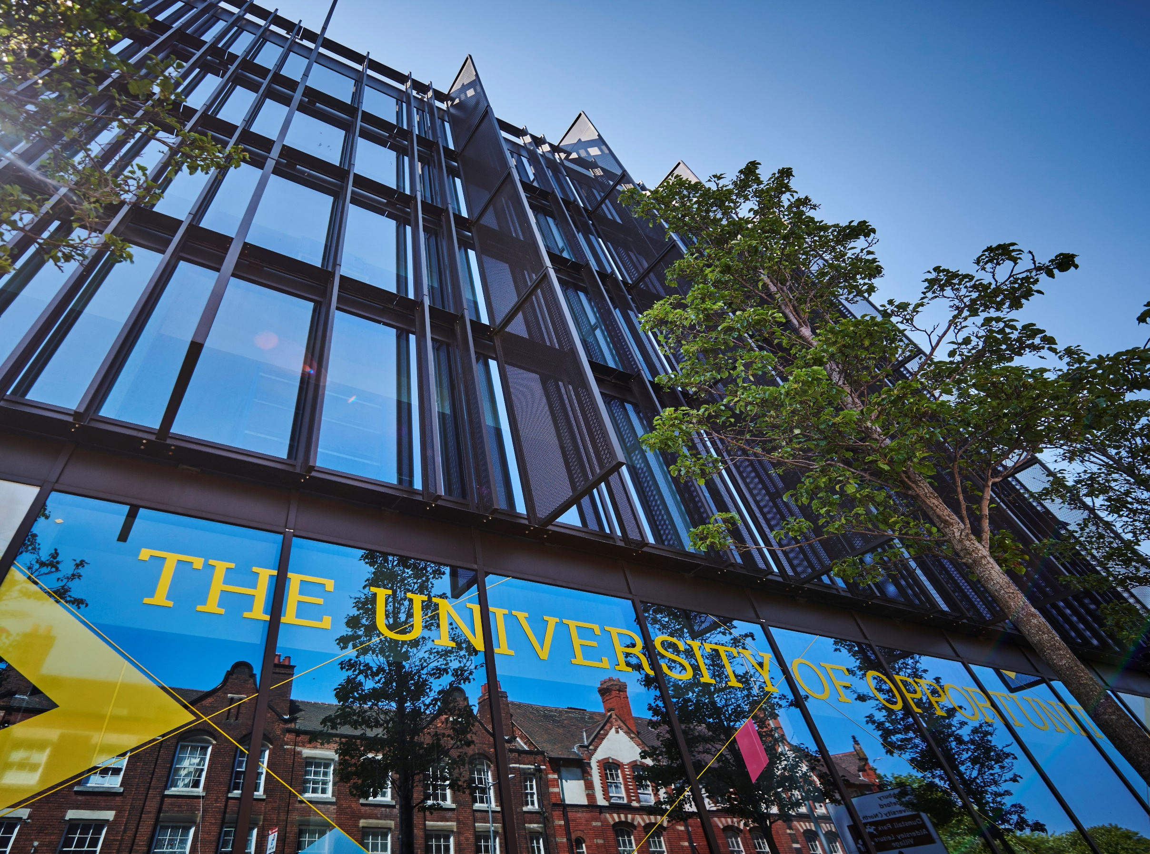

**Recognition of Prior Learning**

**Policy and Procedure**



1. **Introduction**

**2. Details of Policy**

1. **Our University Responsibilities in Relation To This Policy**
2. **Your Responsibilities as a Student in Relation To This Policy**

**5. What To Do If You Need Support With This Policy**

# POLICY/PROCEDURE

1. **Introduction to Policy**

The University of Wolverhampton is committed to create opportunity and transform lives. It also recognises that the student journey starts before the student arrives, and that our application processes will be transparent and timely. This should apply in the same way where a student’s record of prior learning (RPL) is considered as part of their application to study with the university.

This policy sets out the scope, principles and processes for RPL. This policy has been created for prospective and current applicants to the university and key stakeholders including our collaborative partners. It is reviewed annually by the university admissions department and is subject to approval by the university’s academic board. This policy is informed by the [Quality Assurance Agency’s UK code for Higher Education](https://www.qaa.ac.uk/the-quality-code).

This Policy has been approved by the University’s Academic Board.

1. **Details of Policy**

This policy has been reviewed in light of the annual review of contextual admissions criteria and policy both internally and externally for UK and international applications across modes and levels of study.

The objectives of this policy are to ensure:

1. The scope, eligibility, principles and processes for RPL are clear for prospective students, their advisors and our partners.
2. Use of RPL admissions information forms part of the University’s ongoing commitment to providing a transparent, high-quality application experience that is inclusive and fair.

The implementation of this policy is in accordance with the University’s core values which are to be:

* **Inclusive;** we are welcoming, respectful, collegiate and supportive.
* **Ambitious;** we are imaginative, confident, innovative and deliver excellence.
* **Accountable;** we take pride in what we do and how we do it, take responsibility for our actions and operate with transparency and integrity.
* **Resilient;** we have a positive outlook; we are adaptable and recover from setbacks.

The RPL Policy applies to eligible prospective students of the University. The responsibilities and organisational arrangements for the RPL Policy lie principally with the University Admissions Service, with liaison with other departments (where appropriate) as follows:

1. Faculties, including recruitment leads, heads of school and course teams,
2. Student Support and Wellbeing services,
3. Registry Services,
4. Quality and Standards.
5. **Our University Responsibilities in Relation to This Policy**

* The ultimate authority to offer a place based upon RPL on a University of Wolverhampton programme lies with the institution. All applications and enrolments with validation partners are approved by The University of Wolverhampton in collaboration with academic partners.
* The criteria, process and implementation of RPL are clear for prospective students, their advisors and external partners.
* The University of Wolverhampton sets all entry requirements in consultation with the relevant academic team on an annual basis.
* The University of Wolverhampton Admissions Services is responsible for ensuring that all RPL applicants are treated fairly and consistently, regardless of the course or level to which they have applied.
* The responsibility for ensuring the accuracy and relevance of this RPL Policy document lies with the Head of UK & International Admissions.
* This policy document has also been reviewed and approved by senior management at the University of Wolverhampton who drive our commitment to the ethical and fair acceptance of students at The University of Wolverhampton.

1. **Your Responsibilities as a Student in Relation to This Policy**

* Applicants, their advisors and partners understand our admissions policy and process and how it impacts them.
* All applicants are expected to provide full and honest information as part of their application, documentation, and any subsequent enquiries. Applicants who do not respond to enquiries or provide the specific information requested may have their application rejected or withdrawn.
* Applicants provide accurate information when applying to the university along with the appropriate evidence needed.
* Applicants, their advisors and partners understand processes around extenuating circumstances, appeals and complaints in relation to the policy.

1. **What To Do If You Need Support with This Policy**

Further student guidance and University Policies can be located here:

<https://www.wlv.ac.uk/about-us/corporate-information/wlv-policies/>

[Regulations, Codes of Conduct and Bye Laws - University of Wolverhampton](https://www.wlv.ac.uk/about-us/governance/legal-information/regulations-codes-of-conduct-and-bye-laws/)

If you need to talk to someone with regards to this policy please contact the admissions team at admissions@wlv.ac.uk.

|  |  |  |  |
| --- | --- | --- | --- |
| **VERSION** | 1.0 | **AUTHOR/OWNER** | Louise Psaras/Jack Clare |
| **Approved Date** | 06 January 2025 | **Approved By** | Academic Board |
| **Review Date** | 06 January 2028 |  |  |