AIMS AND ACTIONS | REVIEW AND UPDATE
Recruitment and selection – recognition and value  AIM - Review the implementation of the University Fixed Term Contracts Policy in relation to research staff  ACTIONS -  - Continue to analyse on an annual basis (co-terminus with the Academic Year), the numbers of research staff on each contract type (using a baseline of data as at 31st July 2016) – with a further 10% reduction in the number of Fixed Term Contracts (FTC’s) being used by the date of policy review.  - Review relevant funding streams, life-cycles & timescales.  - Reconsider the ‘business model’ by which the University determines its researcher staffing needs and employs/deploys its staff, ensuring that the approach is appropriate to Concordat standards | ACTIONS a.) AND b.)  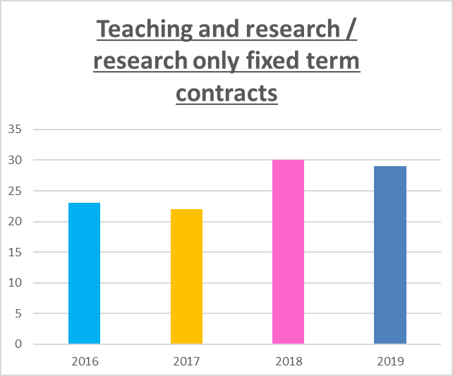  Key activities have focused on the use of Fixed Term Contracts (FTCs) and the way in which staffing needs for researchers are determined.  The number of FTCs for research staff (including Research Assistants) has been monitored for the past four years – Table 1. This shows a growth since 2019.  Table 1  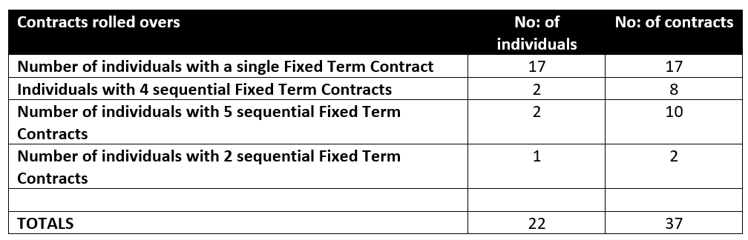  For this reason, we looked into the situation using a specific snapshot to see what the situation was in terms of contracts rolling over and Table 2 was taken to the Research Concordat Committee for discussion on 28th January 2019.  Table 2  The Research Concordat Committee noted that there had been considerable progress in HR procedures for staff to become permanent on completion of their fourth year of continuous employment. They also noted that relatively few FTCs exist within research staff and that few extended over a longer period. The Research Institute in Information and Language Processing (RILLP) was identified as the chief employer of researchers on FTCs and they support these staff with the same development / conference attendance opportunities as permanent staff.  It was also noted that although there has been an increase, this is due mainly to the Marie Sklodowska-Curie Fellowship funding and the set-up of the Institute for Community and Research Development. There were 6 Sklodowska-Curie fellowships between 2016/17 and 2018/19  ACTION c.)  In the academic year 2016 a workforce development plan was introduced to enable Deans and Directors to review the way in which they determined the staffing needs of all staff (including researchers). All Deans and Directors went through process, with the support of their HRBP and the Head of Organisational Development, which enabled them to ensure that researcher staffing needs were met. The final point of this process was the completion of the Table 3 below:  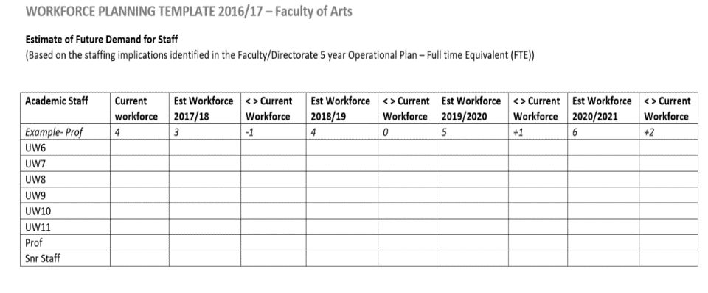  Table 3  We have now reviewed and improved this process again and in this academic year (2019/20) we have a new five step workforce development process based on ‘the five rights’.  The five rights The five step process  Right size – getting the right amount of staff to reach our strategic goals effectively and efficiently. Right skills – identifying gaps in the skills of our staff. Right shape – getting our structures and operating models right to enable and motivate our workforce. Right spend – invest the right amounts and spend less on the wrong things. Right site – as we continue to grow, ensure we have the right people in the right places. - Define the scope of the operational plan - Assess demand - Assess supply - Plan actions - Implement and review  This has been built into our strategic planning cycle shown Figure 1 below:  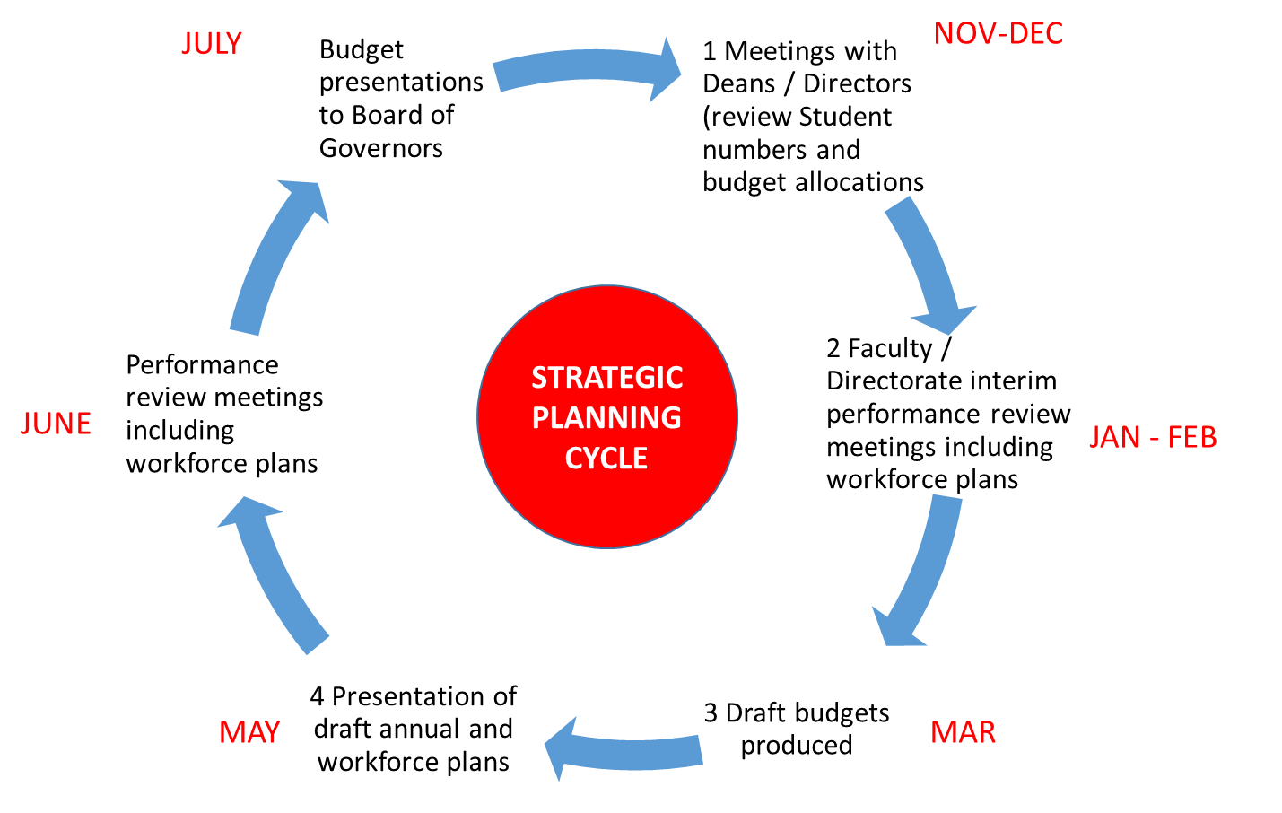  Figure 1
Recruitment and selection – recognition and value  (cont…)  AIM - Having established an online presence for the University-wide research community, review and monitor its effectiveness.  ACTIONS –  - Enhancement of the research-focussed website and virtual University-wide researcher community including (in line with the University ‘Digital Campus’ project), resulting in a 20% increase in ‘web hits’ from a baseline established as at the 31st July 2016  - Roll out and subsequently monitor the new process (June 2016) by which staff can update their own ‘home pages’. 90% of all research staff to utilise this facility within the next 2 years; achievement of this target to be monitored through the annual appraisal process and captured on the relevant document.  - Identification and delivery of targeted ‘digital capabilities’ training for research staff to assist them to participate, communicate, share ideas & good practices and be part of supportive, professional internal and external virtual networks. 90% of all research staff to have received the training identified in their JISC ‘Building Digital Capability – Diagnostic’ by their next appraisal – as captured on their appraisal document. | ACTION a).  Following the improvements which have been made to the research-focussed website. The number of page views on the research web pages has risen steadily since the academic year 2016 (Table 4). This represents a 32% increase on page views.  Table 4  ACTION b).  “Elements” was implemented for Research Staff in April 2019. This system allows researchers to showcase and share their research activity within the community. In addition, researchers can now create their research profiles, add publications, grants, professional and teaching  activity directly.  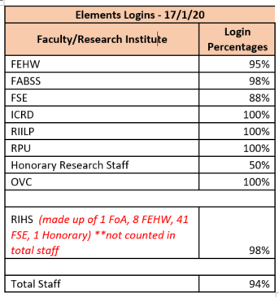  Table 5  A lot of activity has been put in place to support and train research staff to be able to use Elements with confidence. This includes Profile Building workshops, Researcher Manager training and Assessment Module workshops.  The Benefits of Elements are:  - Updated researcher profiles  - Automated data capture  - Linkage between research activities (eg linking grants with outputs and/or impact)  - Compliance with HEFCE Open Access Policy  - Integration with other University systems (eg – WIRE, Agresso, SITS)  Following this work, Table 5 shows the current number of research staff actively using Elements – an average of 94% across the University. The final stage of this project will link the staff member’s Elements profile to their staff profile on the university website which will substantially raise the number of profiles. We currently have 245 profiles currently. This will raise it to 353 as it stands with further activity currently happening to engage the final 6%.
ACTION c.)
A JISC digital skills survey was promoted within the University and the results of the pilot of the JISC Discovery Tool show that the University is broadly in line with the rest of the sector in terms of digital skills. However, It did, the results may be skewed by both the sample size (only 180 staff responded).
On the back of this, a second survey was designed by the Organisational Development Department and was launched in the academic year 2016/17. The purpose of this survey was to investigate digital skills further and to try to increase the response rate. The responses from the first survey were trebled and 590 members of staff completed the survey.
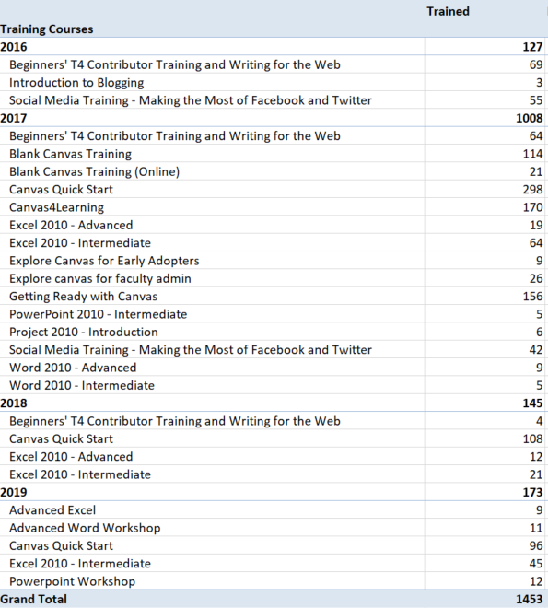
Table 6
This survey was then used to inform procurement of digital training for staff which was completed in the academic year 2017/18. This resulted in training courses being advertised to all staff and delivered as shown to the left.

In addition, since 2015, a Digital Campus Transformation Programme has been working to create a ‘digital campus’ that is every bit as important as our physical campuses; bringing people, processes and systems together. This resulted in a number of workshops (both face to face and online) being delivered to researchers.

Ultimately, 1453 delegates attended these courses over the four years (Table 6). Looking at the period from 2018 onwards, following the introduction of the Wolverhampton Academic framework, we established that in these two years only four researchers attended this face to face option.

For this reason, we are now piloting an online option – a YouTube channel with training on micro-soft applications to provide ‘just in time’ solutions.

In addition, The Doctoral College provided face to face training on the use of social media for researchers. This training covered how to use social media to enhance the impact and reach of research outputs using academic.edu, Twitter and blogs. 44 delegates attended this training.

AIM – Increase effectiveness of, and participation in, staff appraisal for both research staff and managers (P.I.’s)  ACTIONS  - Establish a process for collating the baseline data as at the 31st July 2016, review and enhance the process and usage levels of the University’s staff appraisal scheme () as a key strategic priority. This will enhance the linkage between staff and organisational priorities.  - This includes the introduction of a new on line appraisal completion recording system to allow monitoring of appraisal take up. A minimum of 90% of all eligible research staff to have had an appraisal recorded on the ‘Agresso’ system in the appraisal year. | ACTION a.) and b.)  Table 7  FABSS  2017/18 data gathered through employee engagement survey  2018/19 data gathered through online process  There is now a process in place for collecting data regarding appraisal completions. Overall, the University Completion rate is 90.4% and currently only one of our Faculties is exceeding this average – there is a recognition therefore that there is still some progress to be made (Table 7). However, the improvement from 2017/18 figures is marked in all Faculties and Deans are working to drive these rates still higher.  In addition, a full employee engagement survey was published in December 2018 for all staff to comment on the value of appraisals. We achieved a completion rate of 54% (up 9% on the previous survey) and from the feedback received, a new appraisal policy and process “MyDPD” – My Development and Performance Discussion – was introduced in April 2019. This new process includes a new section for research staff and is designed to help managers who do not have significant research responsibilities. Either, the line manager and member of staff will agree a list of 2 – 3 people whom it would be useful to approach and ask for feedback using a bespoke form which gives an opportunity for feedback on strengths / achievements, areas for development, publications to target within objectives and suggestions for long term objectives. Alternatively, the line manager and member of staff might like to ask one of the above to join part of the “MyDPD”.
AIM – Increase uptake of CROS and PIRLS surveys  ACTIONS  - Achieve a minimum of an 80% return rate from the CROS and PIRLS surveys in 2017 (and beyond if applicable)  - Analyse the survey outcomes and design ; designing a plan of action for dissemination to Faculty Research Leaders  - Monitor effectiveness of the plan of action, revising actions as necessary | 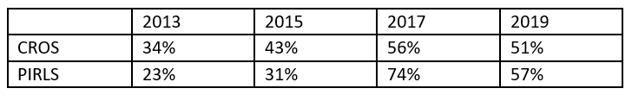  We recognise that staff at the University of Wolverhampton tend to be ‘over-surveyed’. We also recognise that there were times in the past when staff did not always receive full feedback on surveys before the next survey was live.  Table 8  The response rate for CROS and PIRLS surveys did increase over the time (Table 8). However, CROS and PIRLS 2019 coincided with an intensive phase of REF preparation, in particular the Code of Practice consultation, which involved an online survey and face to face feedback meetings. This, alongside the relaunch of Employee Engagement surveys affected the response rates especially to PIRLS.  However, our new approach to Employee Engagement surveys involved having Employee Engagement Champions who meet monthly to express the views of all staff (academic and professional services staff). This group meets monthly and feeds into an Engagement Steering Committee chaired by the University Registrar.  The most recent surveys very much tie in with the principles of the Research Concordat and do overlap the content of the CROS and PIRLS surveys as shown below.  Table 9  - Employee Engagement Survey – December 2018 – UCEA Benchmarking questions and appraisals  - Employee Engagement Survey – November 2019 – Internal communications  Completion rates for these surveys have grown.
AIM – Encourage researchers to engage pro-actively with career planning and raise their awareness of careers services available to them  - Further enhance careers webpages for researchers.  - Establish a process for collating the baseline data as at the 31st July 2016 and increase by 50% the participation in 'Personal and Career Development' programme run jointly by Careers & Counselling Units. Undertake further monitoring of event attendance & provide data to research management  - Having run an inaugural “Residential Researchers Week” in 2016; increase by 60% the participation of PGR’s in subsequent years” | A substantial investment has been made at the University of Wolverhampton in the upgrading, redesign and enhancement of our website – which has included the careers webpages. The researchers’ pages include specific information and signposting around researcher career pathways from Research Assistant to Professor.  In addition, a number of new initiatives have been designed and implemented as shown below:  - A refreshed ‘Readership and Associate Professorship Conferment process’ has been designed alongside a ‘Professorial conferment policy and procedure’.  - A framework, “Professorial Criteria for Academic Promotion”, ensures that there is full transparency regarding what is expected of Professors, Readers and Associate Professors.  These initiatives have very much encouraged researchers in managing their careers proactively. Applications have grown from 14 applications in 2019 (28.5% of which were from females) to 31 applications in 2020 (45% of which were from females)  Finally, there are two further key ways we encourage researchers in developing their careers:  1 - The provision of staff scholarship funding. Looking at the data, over half of the members of staff funded through this scheme are studying towards a PhD or Professional Doctorate  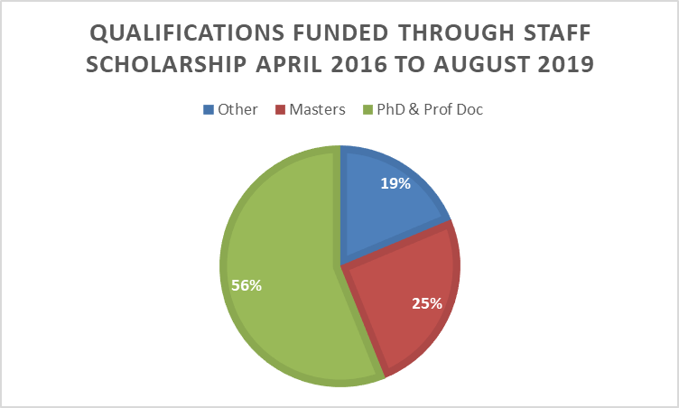  2 – Mentoring or seeking a mentor via our new, online Staff Mentoring Network (SMN). As of November 2019, almost a third of mentors registered on the SMN were research staff.

