**HR Excellence in Research:**

**Update on Researcher Development Concordat actions at the University of Wolverhampton.**

**Context**

Since the compilation of the Researcher Development Concordat Action Plan 2016 (RCAP), the University of Wolverhampton (the University) has worked to deliver its agreed action plan through its Researcher Development Concordat Committee (RCC). The RCC reports into the University Research Committee (URC).

Contextual factors of note (both macro and micro):

* Micro – Many key institutional representatives previously involved from both Research and HR involved have left the University. New representatives are in place. It has therefore been agreed that the University will supply “6 year” documentation reviewing the “4 year plan” from 2016.
* Macro – The Higher Education landscape has changed substantially since 2016 (Brexit, introduction of the Office for Students and UKRI, revised concordat etc.). The impact of Covid19 more recently has been substantial.

Our review takes into account these changes and highlights additional priorities and actions.

**Review methodology**

The Associate Director of HR (AD of HR) and the Dean of Research met monthly from October 2019 to May 2020 to produce this review. Three principles were key.

|  |  |  |
| --- | --- | --- |
| PRINCIPLE | DEMONSTRATED THROUGH | OUTCOME |
| Diversity | The Terms of Reference of the RCC were reviewed prior to commencing to check the diversity within this committee. | Higher creativity and diversity of thought in setting out future actions. |
| Engagement | Members of the RCC received information in advance to enable them to engage widely with colleagues ahead of formal discussions. | Larger range of smarter actions. Higher levels of engagement from the research community. |
| Planning | The AD of HR and Dean of Research devised a gantt chart in October 2019 to outline activities required for this review. | Space to think, to consult and time to evolve / refine future plans. |

Key activities:

* January 2020 - Draft review of action plan produced by the AD of HR and the Dean of Research.
* January 2020 - RCC Meeting discussed draft review and the actions for next 2 year strategy.
* February 2020 – Draft submission taken to the URC meeting.
* April 2020 – HE EiR – Researcher Development Concordat webinar attended.
* May 2020 – Revised submission (new template) taken to RCC.
* May 2020 – Revised submission (new template) taken to URC.

**Key elements of progress (as reviewed against the 7 Principles of the Concordat 2008)**

**Principle 1 – Recruiting, selecting and retaining researchers with the highest potential.**

*Key activities have focused on the use of Fixed Term Contracts (FTCs); the way in which staffing needs for researchers are determined and the online presence of the University research community.*

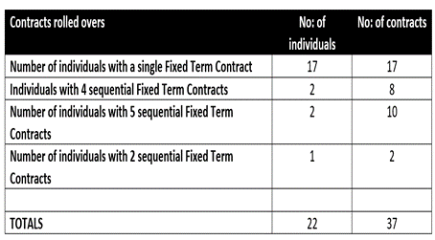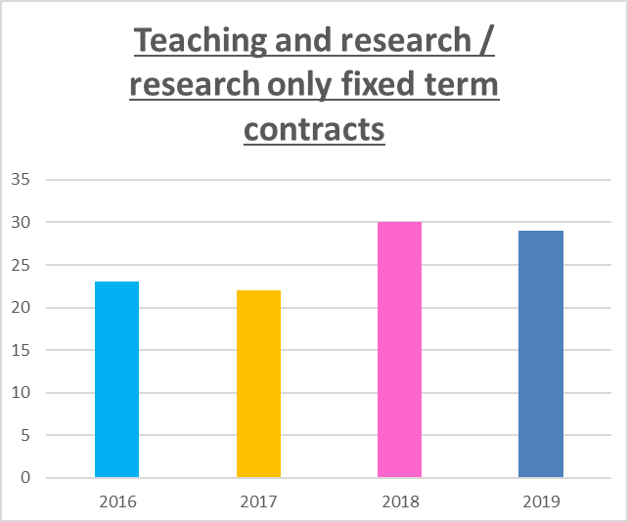The number of FTCs for research staff (including Research Assistants) have been monitored over the past four years (table 1 – left) as has the number of FTCs rolled over (table 2 – below – a point in time report for Jan 2019).

Table 2

Table 1

There has been considerable progress in HR procedures for staff to become permanent on completion of their fourth year of continuous employment. Although there has been an increase in FTC since 2016 this is due mainly to the new Marie Sklodowska-Curie Fellowship funding and the set-up of the Institute for Community and Research Development. There were 6 Sklodowska-Curie fellowships between 2016/17 and 2018/19.

A Workforce Development plan was introduced in the academic year 2016 to explore how all staffing needs are determined. This has now been reviewed and in the academic year 2019/20 a new version is being introduced based on the ‘five rights’ (right size, right skills, right shape, right spend, right site). This has been built into the strategic planning process.

**Principle 2 – Researchers are recognised and valued to develop and deliver world class research.**

*Increasing effectiveness of, and participation in, staff appraisal for both research staff and managers (P.I.s)*

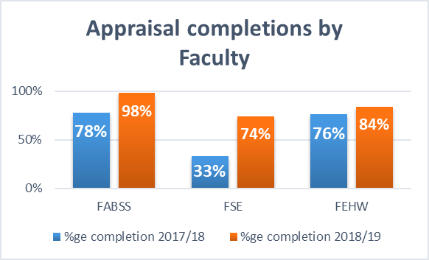A process is now in place for collecting appraisal completion data. Improvement in completion rates has been marked in all faculties. A full review of the appraisal process and policy has been undertaken (which included a full staff survey, focus group interviews with researchers and other consultation meetings). The ‘MyDPD’ (My Development and Performance Discussion) was introduced in April 2019. This includes a new section for research staff. If their line manager does not have significant responsibility for research, researchers can either agree a list of 2-3 people whom it would be useful to approach and request feedback from or they can invite an identified researcher to join part of the ‘MyDPD’ discussion.

Table 3

*2017/18 data gathered through employee engagement survey*

*2018/19 data gathered through new online process*

**Principle 3 – Researchers are equipped and supported to be adaptable in a diverse, mobile and global research environment**

*Establish an online presence for University-wide research community, review and monitor its effectiveness*

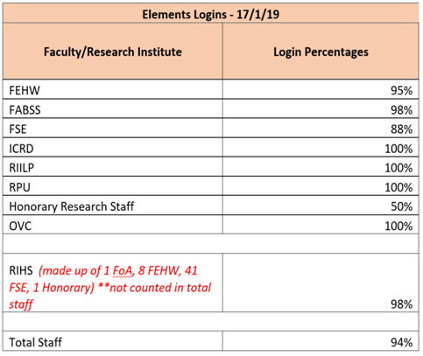The number of page views on the research web pages has risen steadily (Table 4) – a 32% increase on page views. A new online system, Elements, allows researchers to showcase and share their research activity. Researchers can create their research profiles, add publications, grants or professional / teaching activity directly.

Table 5

An average of 94% of research staff across the University are actively using Elements and activity is currently happening to engage the final 6%.

Much activity has been put into developing the digital capabilities of researchers and is defined further in the action plan review.

**Principle 4 and 5 – Recognising the importance of researchers’ personal and career development. Individual researchers proactively engage with this.**

A number of new initiatives have been implemented:

* 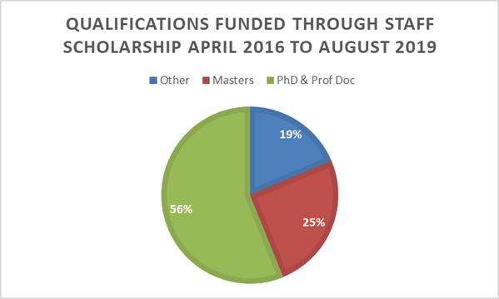A refreshed ‘Readership and Associate Professorship Conferment process’ has been designed alongside a ‘Professorial conferment policy and procedure’.
* A framework, “Professorial Criteria for Academic Promotion”, ensures that there is full transparency regarding what is expected of Professors, Readers and Associate Professors.
* A new “Return to work guidelines for line managers supporting Researchers” is being implemented.

Table 6

11 Professors, 5 Associate Professors and 11 Readers have been conferred since 2016.

These initiatives have very much encouraged researchers in managing their careers proactively and have also supported their line managers in this respect too.

In addition, over half of members of staff funded through the Staff Scholarship scheme (table 6) are studying for a PhD or Professional Doctorate. Finally, we have continued to annually deliver “Researchers’ Week” which provides wide ranging opportunities for all research staff. In the academic year 2019 the focus for the different days was as show below:

The Researcher’s Week 2019 took place week commencing 17th June. The focus for each day is shown below:

* Day 1 & 2 – Addressing societal challenges (primary focus for the Researcher’s Week)
* Day 3 – Careers and promoting yourself as a successful researcher
* Day 4 – Support to engage in funded research projects
* Day 5 – Symposium on the completion of doctoral studies

The events were moved online in 2020 due to the Covid19 pandemic ([programme](https://www.wlv.ac.uk/media/departments/research/documents/Researcher's-Week-2020-Programme.pdf)).

**Principle 6 – Promotion of diversity and equality in all aspects of recruitment and career management of researchers**

The University achieved Bronze Athena Swan Award in April 2019 and feedback cited

“The university’s efforts to improve the gender balance of their REF submissions is also considered very good, including the creation of a Research Investment Fund (and making the fund conditional on units having a gender equality action plan) and moving to a shared leadership model for units of assessment.”

Five departmental award submissions are recorded as part of our current Athena Swan action plan for 2020-21.

**Review conclusions**

The review of the 2016 action plan has led to a number of reflections and conclusions:

* The University is in the position of completing a 4 year review on this occasion. This is too long. Some of the actions within the 2016 action plan are long since completed and we have moved on to other activities or they are now less of a priority given the macro changes within the HE landscape. The University is setting in place a process to ensure that 2 year reviews can take place even when there is a change of University representatives.
* The process of this review has been helpful to identify areas of strength (progress made with our appraisal process, enhancements to our research focused website, the introduction of ‘Elements’ and such like). In addition, there is greater clarity about those areas which do still require further development (engaging researchers in career planning, identifying researchers’ feedback more clearly within our Employee Engagement surveys).