Acoustic performance of interference based customisable cavities for targeted noise reduction

Dr Arun Arjunan

ERAS Fellow 2015-16

Contents

Contents 2
Tables 2
Figures 3
1. Introduction 4
2. Background 4
3. Aims and objectives 5
4. Methods 5
4.1. Theoretical concept to geometry based DI 5
4.3. Rapid prototyping 7
5. Results and Discussion 10
5.1. Validation 10
5.2. Interference Cavities 10
5.3. Assumptions and Limitations 12
6. Conclusions 12

Tables

Table 1 Specimen design parameters
(6)
Table 2 Material properties of Nylon 12 sintering powder
(8)
Table 3 Experimental test measurement uncertainty
(10)

Figures
Fig. 1. Acoustic interference
(3)
Fig. 2. Proposed concept to create PDI based on existing theoretical literature
(5)
Fig. 3. Designs of the test specimen considered
(6)
Fig. 4. Sintered Nylon 12 geometries
(7)
Fig. 5. Experimental setup to measure the sound reduction indices
(8)
Fig. 6. Comparison of reference and measured R values for validation of the test set-up
(9)
Fig. 7. Sound reduction indices measured for 3BU
(10)
Fig. 8. Sound reduction indices for geometrical cavities with interference length of 17.15 cm
(10

Introduction

The environmental impact of noise associated with airports, roads and railways is a major problem worldwide. In Britain alone, more than half a million people move home every year to escape noise pollution. Consequently, this ERAS project investigates the possibility of using geometrical cavities to create Acoustic Interference (AI) to reduce airborne noise. Emerging field of digital design and manufacturing techniques are used to develop customisable geometrical cavities to recreate interference from a common acoustic source. These cavities are then studied for their acoustic behaviour to quantify the influence of cavity size and length.
The primary objective of the project was to validate the concept of geometrical AI through experimental testing of laboratory prototypes. Consequently, complex geometrical cavities to exploit the theory of AI were digitally conceived and prototyped using the Selective Laser Sintering (SLS) process in a Nylon 12 material. A modified impedance tube method was then used for the measurement of the frequency dependent Sound Reduction Index (R) values to characterise the PDI behaviour of the acoustic cavities.
The study established proof-of-concept showing that interference cavities can be exploited to develop high efficiency frequency dependent noise abatement devices. In particular encouraging results at the low frequency range means that the proposed theory has significant advantages over conventional methods in terms of light weighting. Measured R values for the test specimen presented peaks values of 48.17, 72.47 and 71.57 dB around 500, 900 and 1500 Hz critically confirming the potential of the presented technology. However, further studies combining multichannel interference cavities into a single structure is necessary to develop further design guidelines to cover a broad frequency spectrum.
The results of this study are promising and establish a new technology for custom noise reduction. The research has a profound environmental, economic and social impact through reducing noise pollution, supporting transport expansion and improving public health. Furthermore, the impacts of the research extend beyond REF2020 and are expected to inspire further research participation at the University of Wolverhampton (UoW).

Background
The research investigated the potential to develop a high-efficiency noise abatement structure by applying the principle of acoustic interference. The phenomenon of acoustic interference is shown in Fig. 1 where two waves A1 and A2 superimpose to form a resultant wave B of higher (constructive interference) or lower amplitude (destructive interference).
Acoustic Wave A1
Acoustic Wave A2
A
A1+A2=B
Constructive interference
Constructive interference
Destructive interference
Direction of propagation
Fig. 1. Acoustic interference.
Acoustic interference is well known and is used for noise cancelling applications using Active Destructive Interference (ADI) also known as Active Noise Cancellation. One common application of ADI is found in noise cancelling headphones [1]. Here, ADI employs a microphone that picks up ambient noise and uses an electronic circuit to create a similar wave with a 180° phase difference to cancel/reduce the ambient noise. However, the proposed project is concerned with changing the phase of an acoustic wave using passive measures (no active components).

Aims and objectives

The research is an investigation into the feasibility of developing an innovative sound barrier that can be customised, based on the sound source frequency, through optimising geometrical parameters in order to create Destructive Interference (DI). Accurate geometry descriptors based on the principle of DI is used to create noise abatement thus making the performance material independent. This approach will be conceived through taking advantage of emerging digital technologies in design, analysis and manufacture.
The primary objective of the study was to establish a proof-of-concept and laboratory prototypes to validate the adoption of geometrical DI to develop an innovative noise abatement structure. The sound reduction performance that can be expected, as a function of the incident frequency based on simulated acoustic pressure and frequency in a laboratory environment was investigated. In order to achieve this, numerous complex geometries to exploit the concept of PDI was prototyped using the SLS process in a Nylon 12 material suitable for laboratory testing. The analysis of the test data was then used to inform the current knowledge gap in order to validate numerical models to conduct further parametric analysis.

Methods

Theoretical concept to geometry based DI
The theoretical principle behind the proposed concept to create DI is shown in Fig. 2. When the sound wave from a common source enters the geometrical cavity of a different but connected length, the sound waves meet with a phase difference to create destructive interference at a specific point. The amount of phase shift between the two waves depends on the relative length of the cavity and the wavelength of the incident acoustic wave. When the difference in wavelength is half the incident wavelength, the phase difference will be $180°$ and can be used to cancel the noise.
Considering a case shown in Fig. 2; sound waves simultaneously enter through both sides of a cavity of total length $l$ under constant sonic velocity$c$. The frequency can be roughly related in a single dimension using Eqn. (1): [2]

$$f=\frac{(2n-1)c}{2δl}$$ | (1)

Where, $n$ is a positive integer and $δl$ is the transmission length difference or interference length (referring to the location where interference will occur). Consequently, the length of the short path ($l_{1}$) and long path ($l_{2}$) can be related as:
$$δl=l_{2}-l_{1}$$ | (2)
According to published literature [2] for a one-dimensional linear system based on a Herschel-Quincke theory, interference boundary can be expected to between 1/4th and the total length of the air cavity.

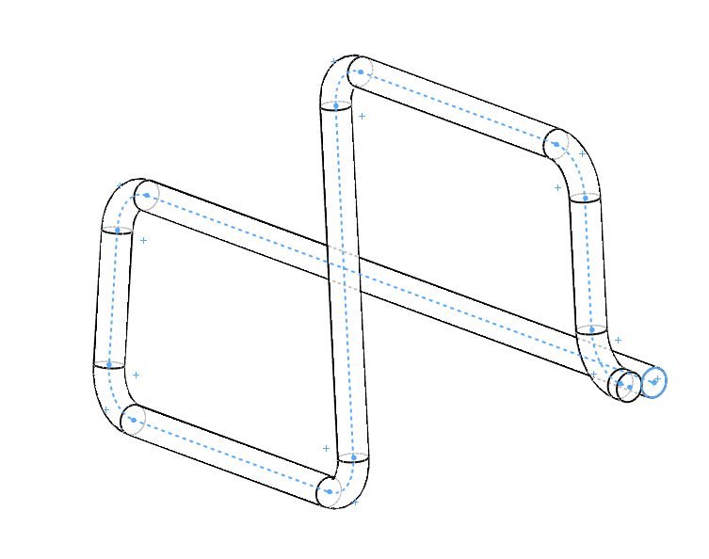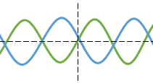
Incident sound wave
Possible areas of destructive interference
$$l_{1}$$
Short path
Long path
$$l_{1}/2$$
$$l_{1}/4$$
$$l_{1}/2$$
Fig. 2. Proposed concept to create PDI based on existing theoretical literature
Even though, the theory seems to have the potential for noise reduction, research is necessary in order to deliver such a device with predictable acoustic behaviour. Consequently, extensive laboratory testing was carried out to understand the behaviour to establish design guidelines related to the cavity length and diameter. SLS was employed to develop precise geometrically controlled structures with enclosed cavities for experimental testing.
  - Design generation
The design of the interference cavity started with calculations following Eqn. (1). Using a sonic velocity of 343 m/s and assuming that ratio of total length ($l$) to interference length ($δl$) is 1 as shown in Eqn. (3):
$$\frac{l}{δl}=1$$ | (3)

Table 1 Specimen design parameters
Shape | $$δl$$  (cm) | $$d1$$  (cm) | $$d2$$  (cm) | $$d3$$  (cm) | $$d4$$  (cm) | $$t$$  (cm) | $$h$$  (cm) | D  (cm)
U | 17.5 | 3  (3BU) | 2.5  (2.5BU) | 2  (2BU) | 1.5  (1.5BU) | 1 | 10 | 10

Using the above assumption, destructive interference can be expected to occur at the mouth of the cavities. Using this relation $δl$was predicted to be 17.15 cm for a frequency of 1000 Hz. A minimum wall thickness (t) of 1cm was considered to minimise vibro-acoustic transmission through the cavity boundary. However, it is acknowledged that studying the effectiveness of wall thickness for further characterization was outside of the scope of this study.
A total of four designs featuring cavity diameters (d) of 1.5, 2, 2.5 and 3 cm were conceived with further parameters presented in Table 1. The global diameter (D) and height (h) were prescribed by the dimensions of the impedance tube required to conduct the analysis at a frequency range of 250 to 1600 Hz. In order to effectively consider a $δl$ value of 17.15 cm within a global diameter and height of 10 cm, various cavity shapes were consulted. Finally, a U shape as shown in Fig. 3 was used because of its scalable simplicity.

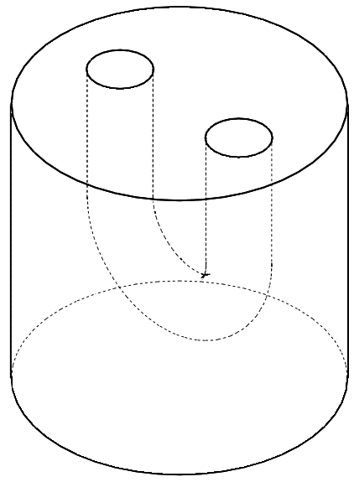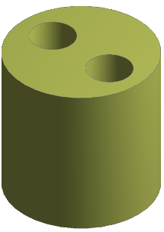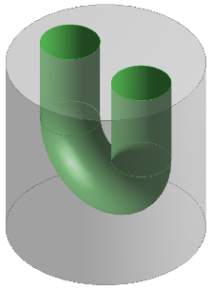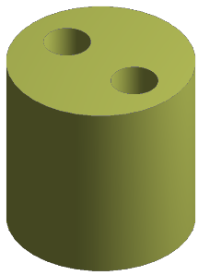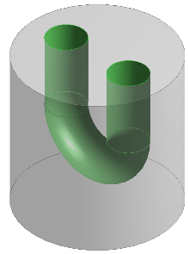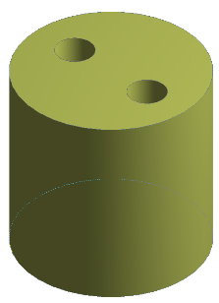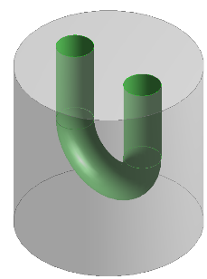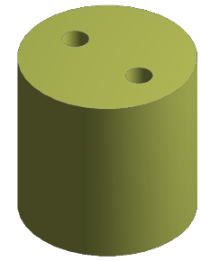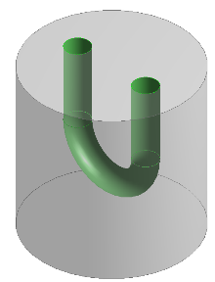
Cavity
Nylon 12
3BU
2.5BU
2BU
1.5BU
h
D
d
Dimension reference
Fig. 3. Designs of the test specimen considered
The U shape also assisted in easy powder removal from the cavities after the SLS process used for Rapid Prototyping (RP) [3]. The conceptual designs were then digitally produced using the SolidWorks 2015 Computer Aided Design (CAD) package. SolidWorks is an industry standard, general purpose computer CAD software developed by Dassault Systèmes.

Rapid prototyping
Using the CAD files generated, rapid prototyping of the test specimens were carried out using the SLS process categorised under the Additive Layer Manufacturing (ALM) technique. ALM is an emerging technique that provides an alternative solution to traditional, subtractive manufacturing in many situations where fast and ‘cost-efficient’ fabrications are required [4]. SLS is a popular technique which enables fast, flexible and cost-effective fabrication of highly complex polymer parts. The quick set-up and build time enable the fastest route from design generation to prototyping.
Before the sintering process, the CAD files were sent to a proprietary software called ‘Magics’ to generate layer-by-layer data for the SLS process. Magics is a data preparation software for the ALM process, it is also used to orient and assemble the parts on the SLS build platform. The self-supporting capabilities of the technique allowed the fabrication of geometrically complex interference cavities with relative ease compared to traditional and other ALM techniques.
The SLS machine brand named ‘Sinterstation 2500’ developed by 3D Systems owned by the University of Wolverhampton, School of Engineering at Telford Innovation Campus was used for manufacture of the test parts. Powdered Nylon 12 was the material used with properties listed in Table 2.

Table 2 Material properties of Nylon 12 sintering powder [5]
Density of Laser Sintered Part | 0.9 to 0.95 g/cm³
Tensile Modulus | 1700 ± 150 MPa
Tensile Strength | 45 ± 3 MPa
Elongation at Break | 20 ± 5%
Flexural Modulus | 1240 ± 130 MPa
Melting Point | 172 to 180°C
Coefficient of Thermal Expansion | 1.09 $×$ 10⁻⁴ K⁻¹

The manufacturing process began with the conversion of 3D CAD files into a sliced STL file format using the Magics software. The STL file is then sent to the SLS machine for processing. On receiving the process command, the machine warms up with the material heated to just below melting point prior to the feed bed rise and the levelling roller pushes fresh powder across the build platform.

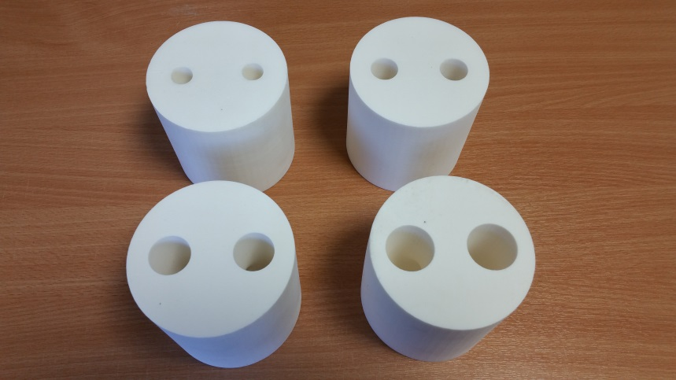
Fig. 4. Sintered Nylon 12 geometries
The first layer is then traced out by a CO2 laser which melts and fuses the material upon contact. After the completion of the first layer the build platform drops by a set amount, and a new layer of powdered material is added. The next layer is then traced out and the process repeats layer by layer until the model part is fully developed. Once the sintering process is complete, the model is allowed to cool and then it is removed from the build platform. The un-sintered powder in the interference cavity is removed using compressed air. The finished prototypes of the test parts each having a unique interference cavity is shown in Fig. 4.

  - Acoustic testing
The measurement of the sound reduction indices were carried out using an impedance tube measurement setup using the transfer function method. This method can accurately measure sound absorption coefficients and impedance in accordance with ISO10534 [6]. The method separates the incident and reflected energy from the measured transfer function, and then estimates the acoustic properties of the tested sample installed in the tube.
The schematic of the test setup is shown in Fig. 5. Four MPA416 1/4’’ Class 1 microphones, with a frequency response 20 ~ 12.5k (Hz) designed for impedance applications were used. The sound source is an in-tube loudspeaker connected to a PA50 power amplifier. The microphones and the power amplifier were directly connected to a 4-channel MC3242 data acquisition hardware. The MC3242 was then connected to a PC running the VA-Lab software.
Using the four microphone setup the R values were measured for a frequency range of 250 Hz to 1600 Hz. A tube diameter of 10 cm was used to allow a snug fit for the test specimens. Before commencing the measurement all microphones were calibrated taking into consideration the background noise. The calibrated microphones were then placed in the microphone cavity and sealed to avoid any leakage.

SC
RC
S1
S2
L1
L2
h
D
Sound source
M1
M2
M3
M4
Microphone

Test specimen
Power
Amplifier
Data acquisition card
Computer
Open/close terminal
SC – Source Chamber
RC – Receiving Chamber
Fig. 5. Experimental setup to measure the sound reduction indices

Before testing the prototypes, a validation study was carried out using a foam specimen of known R values and the measured results compared. During the measurements, the temperature and relative humidity in the test lab was measured to be $21℃$ and 64% respectively.
After the validation study, the test specimens were fitted snugly into the specimen holder, with care taken to avoid undue compression. Any gaps around the edges of the samples were sealed with Vaseline after making sure that the front surface of the specimens was normal to the tube axis. The microphone spacing S1 and S2 were measured to be 8 cm and the distance from the sample to the nearest microphone L1 was measured to be 4.8 cm, the furthest distance L2 was measured to be 15 cm. Finally, the specimen height h and diameter D was measured to be 10 cm.
A total of four specimens were analysed and the R values measured. For each specimen, a total of six measurements were taken at 1/12 octave band range, three measurements with the receiving chamber open and three with the receiving chamber closed. The measurements were then averaged to obtain the final R value representing the frequency dependent sound reduction indices for the prototypes.

Results and Discussion

Validation

Before commencing the test on the interference cavities, a validation study was conducted using a Polyurethane foam of density of 6 Kg/m³ to evaluate the effectiveness of the modified impedance tube test set-up used for the study. The thickness and diameter of the foam sample used were 2.5 cm and 10 cm respectively.

Fig. 6. Comparison of reference and measured R values for validation of the test set-up

Comparison of the measured values with respect to existing reference data is presented in Fig. 6. Analysing the results, a highest difference of 0.39 dB was observed at a frequency of 500 Hz. This is well below the ISO specified measurement uncertainty of $±$1.2 dB at the same frequency. The difference in results with respect to ISO10140 [7] measurement uncertainty is listed in Table 3. It can be seen that a good agreement is obtained as all experimental data is well within the standard measurement uncertainty expected.
Table 3 Experimental test measurement uncertainty
Frequency, Hz | Measurement Uncertainty
 | Standard (dB) | Experimental (dB)
$$250$$ | $$±1.5$$ | $$- 0.19$$
$$315$$ | $$±1.5$$ | $$- 0.02$$
$$400$$ | $$±1.2$$ | $$+ 0.01$$
$$500$$ | $$±1.2$$ | $$- 0.39$$
$$630$$ | $$±1.2$$ | $$+ 0.04$$
$$800$$ | $$±1.0$$ | $$+ 0.13$$
$$1000$$ | $$±1.0$$ | $$+ 0.35$$
$$1250$$ | $$±1.0$$ | $$- 0.11$$
$$1600$$ | $$±1.0$$ | $$+ 0.31$$

Interference Cavities
Based on the validated test method, the acoustic performances of the interference cavities were analysed. The first step was to evaluate whether the geometries based on the proposed theory were able to recreate destructive interference to cancel/reduce the sound that is transmitted through the structure.
Since $δl/l=1$ and the cavity length is 17.15 cm; theoretically destructive interference can be expected to occur around a frequency of 1000 Hz. Looking at the results presented in Fig. 7, destructive interference can be clearly observed around 900 Hz validating the interference can be created as a function of geometry. The peak sound reduction of 72.47 dB during interference is substantially higher than the linear value clearly making a case for high performance noise abatement devices.
Even though, the results validated the creation of destructive interference, a variation in the frequency from the predicted 1000 Hz to 900 Hz can be observed. Consequently, continued parametric studies are required to improve the theoretical accuracy. The ratio of cavity length to diameter may have an influence in the frequency deviation, further strengthening the requirement of a multi-dimensional approach going forward.

Destructive interference peak at 72.47 dB (900 Hz)

Fig. 7. Sound reduction indices measured for 3BU

In order to study this further, the four diameters considered were 1.5 cm, 2 cm, 2.5 cm and 3 cm named 1.5BU, 2BU, 2.5BU and 3BU respectively. The results for these geometries are presented in Fig. 8. Consistent with previous performances, all geometries featuring the same interference length recreated peak destructive interference at the same frequency of 900 Hz. However, the peak interference noise reduction values seems to vary according to the diameter cavity diameter.

Fig. 8. Sound reduction indices for geometrical cavities with interference length of 17.15 cm

Peak sound reduction values were observed to be 55.22 dB, 42.73 dB, 50.47 dB and 72.42 dB for diameters of 1.5 cm, 2 cm, 2.5 cm and 3 cm respectively. The highest R values under this series of geometries with a $δl$of 17.15 was observed for a diameter of 3 cm (3BU).
The analysis showed that there is a shift of within $±20\%$ of the predicted frequencies using for a $δl$ of 17.5 cm between the proposed theory and experimental values. In order to incorporate this diversity into a design guideline, the targeted frequency for peak interference is proposed as $0.8f<f<1.2f$ in conjunction with Eqn. (1). This added boundary represents the frequency where peak interference can be expected to occur. However, it is acknowledged that this study was limited to interference cavities with a ratio$δl/l=1$, and more studies featuring designs where $δl/l≠1$ is required to further elaborate the suggested theoretical boundary.
Overall, the results are encouraging and establish the proof of concept that interference cavities can be used to develop high efficiency noise abatement devices. The study also helped relate the performance of interference cavities with respect to length and diameter. Additionally, comparative R values that can be expected through employing interference cavities as a function of frequency is also introduced.

Assumptions and Limitations
The study did not characterise the surface finish of the Nylon 12 geometries created using the SLS process. Consequently, it was assumed that the surface finishes of all the geometries are constant. It is also assumed that the SLS process has generated a homogenous structure for all the 13 prototypes with equivalent material properties.
The study is primarily limited to low frequencies between 250 Hz and 1600 Hz. In addition, only a single inference length is exploited in the samples tested. Consequently, for the research to be applied to potentially reduce broadband noise, further samples consisting of multiple cavities for a range of frequencies need to be designed and analysed.
Finally, the study only looked at interference cavities where the ratio of the interference length to the total cavity length is equal to one ($δl/l=1$). This need to be expanded and cavities with ratios not equal to one need to be explored to create multiple destructive interference hitting more frequencies under a single$δl$.

Conclusions
This project validated and established the proof of concept regarding the potential of utilising acoustic interference to create noise insulation. Accordingly, strategies to implement inference cavities through design and manufacture of complex geometries combining digital design and SLS are presented. The principle of destructive interference was investigated and validated experimentally through measuring the Sound Reduction Index (R) for a frequency range of 250 to 1600 Hz at 1/12 octaves. It was found that sound reduction of up to 72.47 dB can be expected at 900 Hz. Further analysis found that samples with a diameter of 3 cm resulted in higher sound reduction in comparison with smaller diameters featuring a constant cavity length. A shift in the frequencies where interference peaks occur between theoretical and experimental frequency were observed during the study. In order to represent this as a design guideline the targeted frequency for peak interference theoretically is proposed as $0.8f<f<1.2f$ in conjunction with Eqn. (1). The study establishes a new view point for the potentials of customizable structures for noise reduction. However, further studies in this area are required for parametric characterisation and to accurately identify the material dependence of the measured R values.
References
- Benoit, B.; Camastra, C.; Kenny, M.; Li, K.; Romanowski, R. and Kevin, S. (2012) Engineering Silence: Active Noise Cancellation. Published by the North Carolina State University.

- James, M. J. (2005) Fundamental studies of the Herschel-Quincke tube concept with mode measurements. Blacksburg: Virginia Tech; 2005.

- Yongnian Y, Shengjie L, Renji Z, Feng L, Rendong W, Qingping L, et al. Rapid Prototyping and Manufacturing Technology: Principle, Representative Technics, Applications, and Development Trends. Tsinghua Science & Technology 2009.
- Guan G, Hirsch M, Lu ZH, Childs DTD, Matcher SJ, Goodridge R, et al. Evaluation of selective laser sintering processes by optical coherence tomography. Mater Des 2015 12/25; 88:837-846.
- Material Specification Nylon 12. 2016; MD_NY12_01 Iss2.
- BSEN ISO 10534-2: 2001. Determination of sound absorption coefficient and impedance in impedance tubes, Part 2: Transfer-function method. 2001.
- BS EN ISO 10140-1: Acoustics. Laboratory Measurement of Sound Insulation of Building Elements. Application Rules for Specific Products. 2014.

