Your University at your side
Mental Health and Wellbeing at the University of
Wolverhampton:
- provide free and confidential individual counselling
- offer non-judgemental support and understanding
- are professionally trained
- are experienced in dealing with a wide range of problems
Counselling can:
What are sexuality and gender identity?
Some helpful information

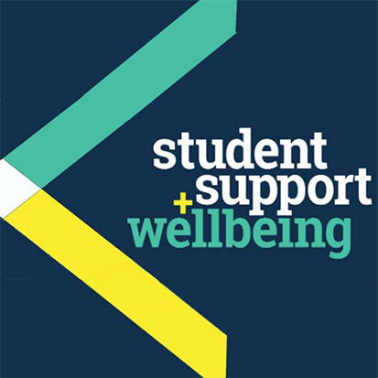
- help you to develop your strengths
What are sexuality and gender identity?
- offer you the chance to focus on and understand your difficulties
- enable you to make positive decisions and changes
- help you to develop the skills and resources to cope
- help prevent small problems from becoming bigge.r

Get in touch
You can make an appointment to see a counsellor by filling out the Contact Us form at www.wlv.ac.uk/SSW, alternatively, you can come along to one of our drop-in services. For more information go to the web address above and click on the Mental Health and Wellbeing option. From here you will find a wealth of useful information and self-help tools as well as our Drop-ins and Group activities.

University Mental Health & Wellbeing

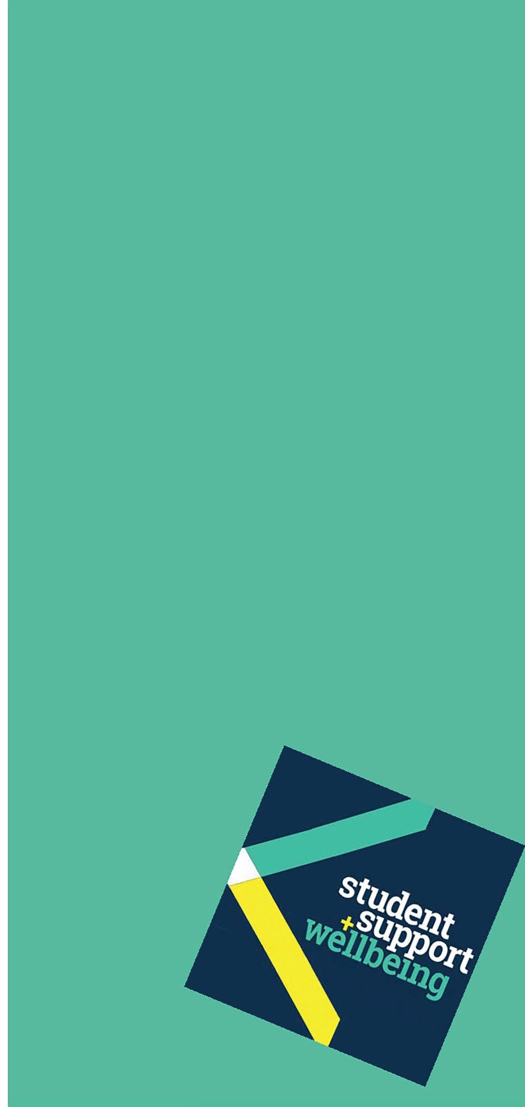What are sexuality and gender identity? Sexuality and gender identity are both vitally important aspects of who we are and how we relate to others.
Our gender identity is how we view ourselves in terms of our gender – masculine/feminine. Our sexuality or sexual orientation describes to whom we are attracted.

Sexuality Genes
Like many human characteristics, sexuality is a chance result of our individual make up (nature), which our enviornment (nuture) can
also influence. Although this line is not without its critics, research suggests that people are born heterosexual (attracted to the opposite sex); homosexual (attracted to the same sex - gay/ lesbian) or bisexual (attracted to both sexes).

Homophobia
Because our society is predominantly a heterosexual one, it is sometimes hard for someone to admit to either themselves or others that they may be different from the ‘norm’.
They may fear discrimination or rejection from those who find homosexuality hard to accept. Or they themselves may have absorbed society’s subtle undercurrent of prejudice, and they may feel there is something wrong with being gay. A person may face a time of confusion, denial and even sometimes self- hatred upon discovering their sexuality. For some, an upbringing in a culture or religion that views homosexuality as sinful or unnatural can make acceptance of themselves even more difficult.
Some may discover that they are gay early on in their lives or perhaps in their teens, while others may only recognise this later in life, even after years of marriage.

‘Coming out’ to others
There are both risks and rewards in ‘coming out’ (revealing your sexuality) to others:
- don’t blame yourself for anyone’s negative
reaction. You don’t need to apologise for who you are
- is it important for everyone to know your sexuality or just those with whom you are close?
- coming out first to those you are sure will accept you will give you confidence
- don’t be put off if friends or relatives are shocked. Shock over the unexpected can soon turn into acceptance
- having come out, if you experience discrimination in your professional relationships, you have rights under the Equality Act 2010.

Gender identity
We all have a sense of our gender identity (whether we ‘feel’ male or female), which in most cases matches our biological sex. Some feel the opposite of what their bodies are, which can cause difficulty in terms of self-acceptance and acceptance by society. There are several different groups under this umbrella:
Transvestite: Those who regularly dress as the opposite sex. They do not want to change their biological sex, but enjoy exploring their opposite gender.
Transgendered and Transsexual: Those who are born one sex, but feel much more comfortable in their gender identities as the other sex. They may choose to have hormone therapy. Also transsexuals may choose to have surgical reassignment, so they can live fully as the opposite sex.
Talking through your sexuality or gender identity with a non-judgemental professional can help you work through difficult feelings.

You might like to look at:
Stonewall works to achieve equality and justice for lesbians, gay men and bisexual people - visit: www.stonewall.org.uk
The Lesbian Gay Bisexual Transgender Network has links to both West Midlands’ and also national groups and activities - visit: www.lgbtwolverhampton.org.uk
Families and Friends of Lesbians and Gays (FFLAG), provides information and help lines - visit: www.fflag.org.uk
The Gender Trust provides national information and support for trans-individuals and their families - visit: www.gendertrust.org.uk
Gender Matters is a Wolverhampton charity offering information and support for trans-individuals and their families - visit: www.gender-matters.org.uk

People you might want to contact:
‘x2y’ group for young (under 25 year-old) gay, lesbian, bisexual and transgendered – tel: 0800 073 0233 or visit: www.x2y.org.uk
Terrence Higgins Trust provides counselling for those affected by HIV and gay men concerned about their sexual health – tel: 0808 802 1221 or visit:
www.tht.org.uk

Other useful websites:
The Royal College of Psychiatrists
www.rcpsych.ac.uk/healthadvice/atozindex.aspx
Advice from Mind:
www.mind.org.uk/information-support/mental-health-a-z/
Useful leaflets:
www.ntw.nhs.uk/pic/selfhelp/
Health A-Z at:
www.nhs.uk
Free meditation exercises: http://franticworld.com/free-meditations- from-mindfulness/

