Your University at your side

Counsellors at the University of Wolverhampton:
- provide free and confidential individual counselling
- offer non-judgemental support and understanding
- are professionally trained
- are experienced in dealing with a wide range of problems

Counselling can:
- help you to develop your strengths
- offer you the chance to focus on and understand your difficulties
- enable you to make positive decisions and changes
- help you to develop the skills and resources to cope
- help prevent small problems from becoming bigger.

Get in touch

You can make an appointment to see a counsellor by filling out the Contact Us form at www.wlv.ac.uk/SSW, alternatively, you can come along to one of our drop-in services. For more information go to the web address above and click on the Mental Health and Wellbeing option. From here you will find a wealth of useful information and self-help tools as well as our
Becoming Assertive
Drop-ins and Group activities.
Becoming Assertive
Tips on how to become more assertive.

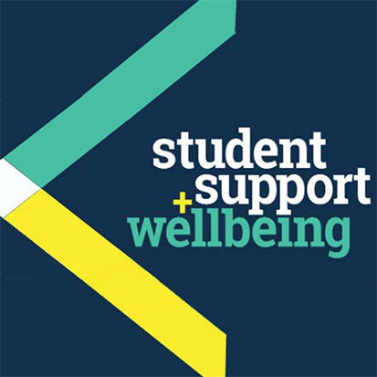

University Counselling Service

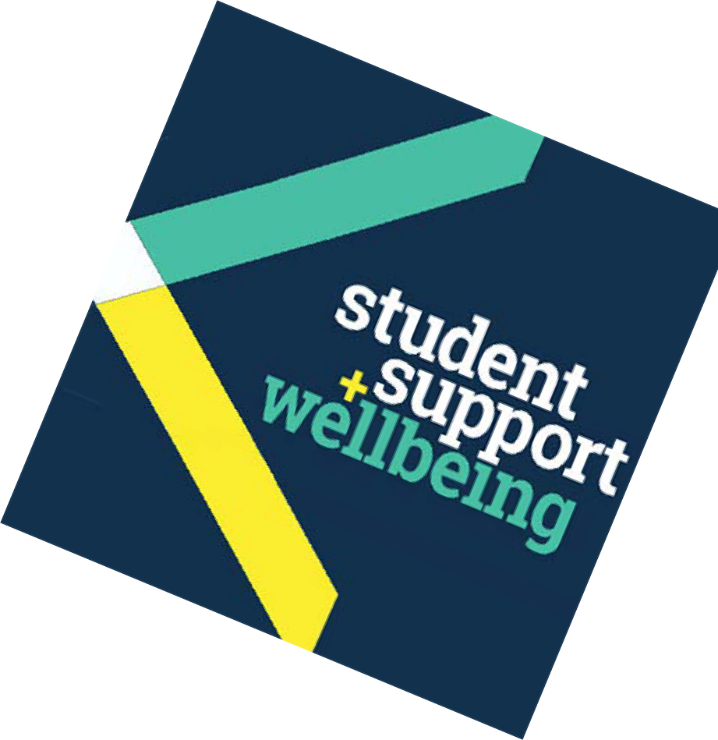What is assertiveness?

When being assertive, we not only retain the ability to respect and value ourselves (our needs, desires, and feelings), but also respect and value the needs, desires and feelings of others.

The result of assertive communication is that both we and those we are interacting with are more likely to:
- feel heard
- be understood
- have our, or their needs met.

Why might we not be assertive?
We may not be assertive because of negative messages we have taken in or internalised about ourselves due to past criticisms. These may have undermined our self- esteem.

As a result, when we’re challenged by others in life, we either avoid confrontation by caving in – believing that we don’t deserve to have our own needs met – or we give in to demands because we’re desperate to please people.

On the other hand, we may go on the attack too readily, not believing that we can get our needs met by any means other than aggressive ones.

Examples of assertiveness
Assertiveness is often best illustrated when contrasted with other styles of relating, eg. passivity (which may sometimes involve subtle manipulation), or aggression. Here are some examples.

- Someone you work with is trying to persuade you to do something that you consider unreasonable eg. to do extra work at short notice, when you’ve already made plans.

Passive response:
“Hmmmmm… (feeling guilty) OK… I don’t mind (not being honest). If it will help you out of a jam, and if you really need me, I’ll do it. I’ll have to cancel on my friend, (feeling resentful, and wanting to send signals in order to make other person feel bad), but I’ll do it…”

Aggressive response:
“There’s no way I’m doing that! You can .........! I’m not helping someone who doesn’t treat me with respect!” (feeling hurt and victimised, and hence, wanting to lash out).

Assertive response:
“I can see that you’re desperate for my help, but I can’t work any more now, as I’ve already made other plans. I’m sorry I can’t help you this time, but I’d be happy to work another night if you give me a bit of prior warning.” (Whilst having shown understanding, you feel justified in refusing the request, because you value yourself and your plans).

- Your friend comes in and has a go at you because she’s had a bad day. There are similarly a number of ways in which you could respond.

Passive response:
“I’m really sorry if I’ve upset you. I’ve put my foot in it again, haven’t I? I‘m like that, I’m afraid: always saying the wrong thing. Perhaps it would be best if I go out and leave you in peace.”

Aggressive response:
“I can’t believe you’re talking to me like that. You always fly off the handle at the smallest thing. Well, I’m not standing for it! Why don’t you p*** off, and not bother coming back!”

Assertive response:
“I’m sorry to hear you’ve had a bad day, but I’m feeling attacked, right now. It feels like you’re taking your anger out
on me. Why don’t we leave this aside for the moment, and talk about it later when we’ve both had a chance to calm down?”

How can we be assertive?
It can be hard to be assertive, especially in confrontational situations. We may feel attacked to such an extent that we feel an instant need to defend ourselves, and subsequently, go on the counter-attack ourselves.

On the other hand, we may back down because we don’t want to risk ‘rocking the boat’, worrying that we might alienate the other person or lose their friendship.

The key to responding in an assertive way is to develop greater self-esteem and self-confidence, which allows us to value ourselves, and believe that our needs are just as important as those of others. We don’t need to feel selfish when we ask for something for ourselves, nor to feel mean or bad if we have to refuse a request (see above examples).

It takes practice but it is worth developing assertiveness skills
– in the end you feel better, as do those around you. An assertive person will not let him/herself be taken advantage of but instead is able to communicate what he/she really wants in a clear, respectful, honest and appropriate manner.

You might find it helpful to:
- attend one of our workshops on this and related subjects. Visit our website for details.
- read some of our other leaflets: Dealing with anxiety and panic attacks; Overcoming the fear of failure; Managing your stress; Developing confidence and self-esteem; Combating anger; Mindfulness.
- read: Lindenfield, G. (2001) Assert Yourself: Simple steps to getting what you want. London: Thorsons

Other people you might want to contact
- Your doctor
- NHS 111, calls are free from landlines and mobiles, tel:

111
- The Samaritans for 24-hour confidential support – tel: 01902 426 422 or 08457 90 90 90 or visit: samaritans.org.uk

Other useful websites
MIND: the mental health charity

mind.org.uk/information
The Royal College of Psychiatrists

rcpsych.ac.uk/mentalhealthinformation.aspx

Some of the things students have said about the University Counselling Service:
“Counselling made issues more manageable.”
“Counselling has helped me to put my life into perspective and sort out my problems.”

