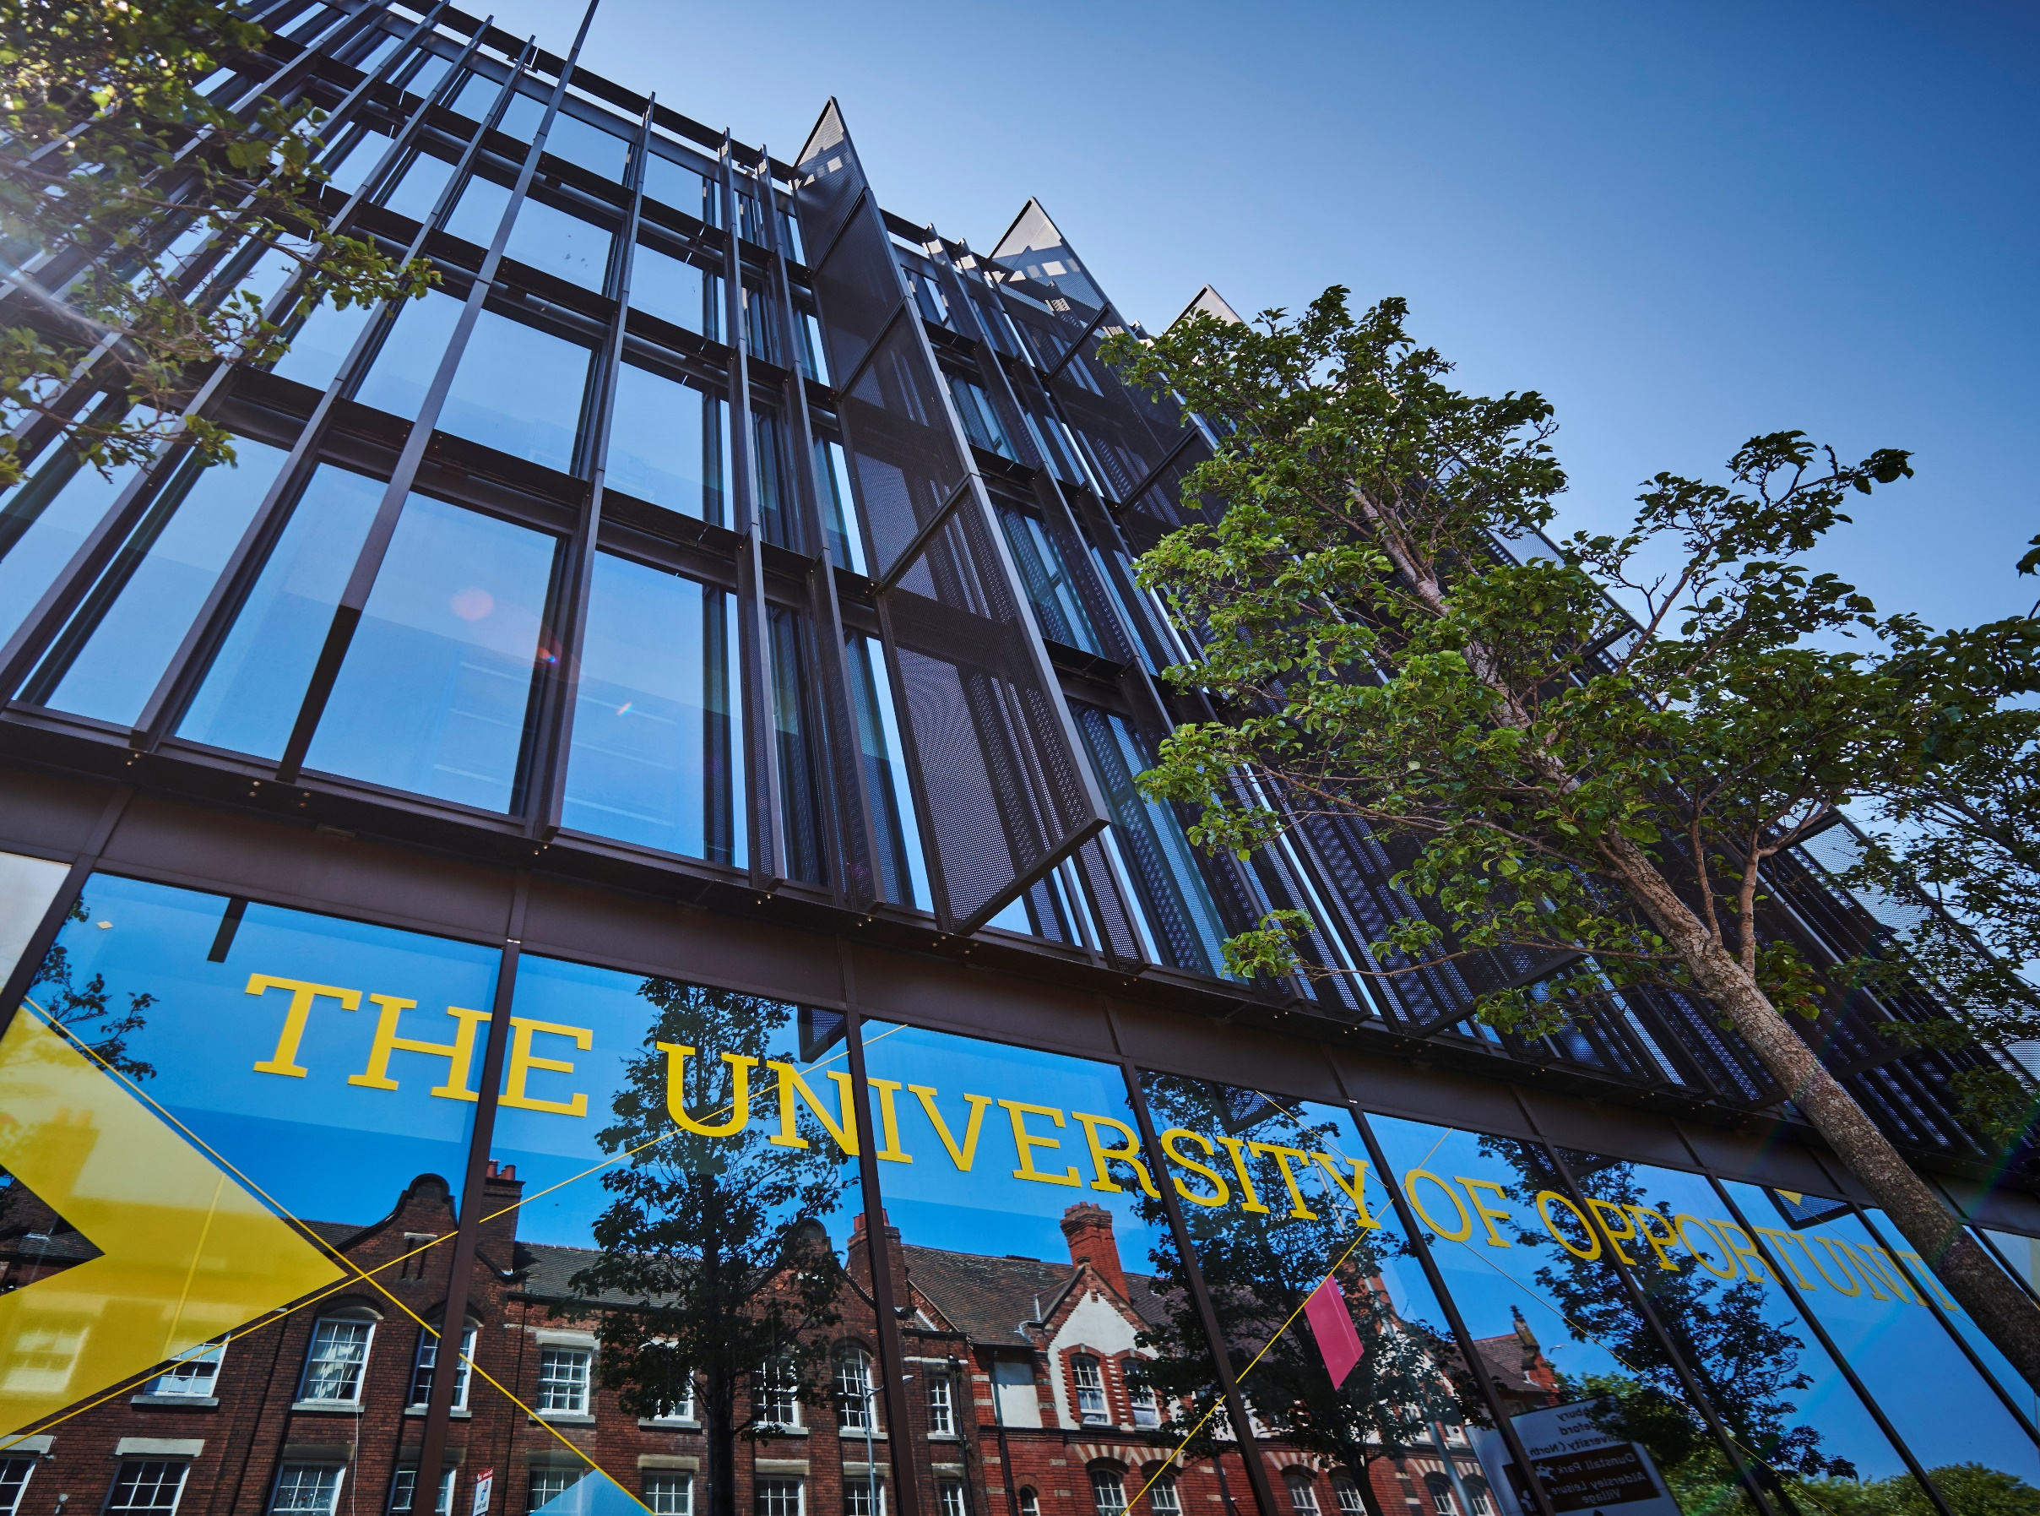

**Academic Integrity Policy**





POLICY 1

1. Introduction to Policy 1

2. Developing Academic Integrity 2

3. Enhancing Academic Integrity through Assessment Activities 3

4. Breaches of Academic Integrity 4

5. References 4

Appendix 1: Academic Misconduct 5

A1. Categories of Academic Misconduct 5

A1.1 Cheating 5

A1.1.1 Essay Mills 5

A1.2 Collusion 6

A1.3 Plagiarism 6

A1.3.1 Use of Generative Artificial Intelligence 6

A1.4 Fabrication 7

A1.5 Falsification 7

A1.6 Misrepresentation 7

A2 Other Considerations 7

A2.1 Proofreading 7

A2.2 Translation software or services 8

# POLICY

## Introduction to Policy

1.1 The University of Wolverhampton is committed to academic integrity. Academic integrity is a fundamental principle that applies to all members of the University community (i.e., members of staff, researchers, and students). Academic integrity ensures that anyone wishing to access and use work produced by members of the University can be confident in using and trusting the information and data that have been provided. This work can include material that has been submitted for academic assessment purposes (such as documents, data and artefacts) as well as outputs from research and scholarship.

1.2 Academic integrity is aligned with the development of good academic practice, which is expected of all members of the academic community.

1.3 The following key values underpin academic integrity:

* Acting ethically  
  (e.g., acting in a way which ensures that all the values described below are adhered to, and that respect for others is maintained)
* Honesty  
  (e.g., honesty in the production, preparation, publication and presentation of material, including the extent to which ideas have been derived and developed from others)
* Fairness  
  (e.g., not misusing information or material that may have been developed by others or taking advantage of other people such as colleagues, students and members of the academic community)
* Responsibility  
  (e.g., taking personal responsibility for determining the validity and credibility of the source information and data that are used, and for applying appropriate ethical procedures in the way in which the information is used and presented)
* Care and respect  
  (e.g., showing care and respect for the views and opinions expressed by others, as well as for any participants involved in the development of a piece of work)
* Accuracy  
  (e.g., ensuring that the work and data are as accurate as possible so that the information can be used by others with confidence)
* Rigour  
  (e.g., applying rigour in ensuring that appropriate protocols, standards, and frameworks are adhered to, and that the interpretation, presentation and communication of information is undertaken with care and consideration)
* Transparency  
  (e.g., transparency in communicating the approach adopted for the collection and interpretation of results, and for highlighting any conflicts of interest where appropriate)

(Academic integrity values derived from: International Center for Academic Integrity, 2021; Universities UK, 2019; Research Councils UK, 2013.)

## Developing Academic Integrity

2.1 It is assumed that all members of the academic community wish to demonstrate academic integrity, and that it is only through certain circumstances that some members may exhibit academic misconduct (e.g., poor time management; lack of awareness of academic integrity issues), which is discussed further in Section 4 and Appendix 1.

2.2 Activities to support and develop academic integrity include:

* providing pre-enrolment information and guidance on academic integrity, and to emphasise this as part of the transition process into higher education and between levels of study
* providing information about the development of good academic practice and embedding and applying this information within the curriculum at each level of study
* recognising and supporting the needs of members of the academic community who may be studying off campus
* developing expertise amongst members of staff
* using different approaches to assessment design
* providing support materials for students who may have been taught in a non-UK context (e.g., some international and TNE students), and who may have developed approaches to academic writing and the use of source material that may not always align with UK custom and practice
* ensuring that instances where academic integrity is not maintained are not ignored, and that appropriate support or action is taken as a result (see Section 4).

2.3 Poor time management can often result in academic misconduct, particularly if completion of a piece of work is left until a point that is close to the submission deadline. This can sometimes also be a result of procrastination through not understanding what is required of the work (see Section 3). The use of formative submissions and feedback on early drafts can help to support the time management and submission process. Working on drafts and amending these as a result of the feedback received is more likely to result in submissions that demonstrate academic integrity and good academic practice. Opportunities for formative feedback will therefore be made available to develop these key academic skills. In the case of text-based work, this includes an opportunity to submit the work formatively through text-matching software and specific sites within the virtual learning environment have been made available for this purpose. For non-text-based work (e.g., artefacts, music, etc.) there will be opportunities within the course for formative feedback.

2.4 Members of the academic community will be provided with information about academic integrity and the development of good academic practice through the University webpages (for example, Skills for Learning - <https://www.wlv.ac.uk/lib/skills-for-learning/>), virtual learning environment and at relevant points throughout an academic course (e.g., induction, prior to assessment deadlines).

2.5 Members of staff and researchers should refer to the information provided in the *University of Wolverhampton Research Integrity Statement of Commitment*, which is available at <https://www.wlv.ac.uk/research/research-policies-procedures--guidelines/research-integrity/>.

2.6 Students for whom English is an additional language can access support from the Academic English team (<https://www.wlv.ac.uk/lib/skills-for-learning/academic-english-language/>).

## Enhancing Academic Integrity through Assessment Activities

3.1 To enhance academic integrity, consideration will be given to the nature of assessment activities to reduce the likelihood of academic misconduct (see Section 4). Members of the academic community will be supported in the development of appropriate assessment activities by the Learning Enhancement and Academic Development (LEAD) team and the Conduct & Appeals Unit.

3.2 Examples of the ways in which assessment activities can be designed to support academic integrity may include:

* development of inclusive assessment activities that allow all students to demonstrate that they have achieved the relevant learning outcomes
* using assessment tasks (e.g., essay questions) that differ from previous years
* providing assessment tasks that require students to provide information on something specific and unique (e.g., reflection using a particular model or structure; the use of a specified theory in relation to a case study – possibly local / regional)
* asking students to provide evidence of personal experiences or perspectives (e.g., the effectiveness of a group work activity, or a critical and analytical narrative that compares and contrasts different viewpoints), rather than providing text that is purely descriptive
* using authentic (i.e., real-world or simulated) teaching, learning and assessment activities, particularly if it is clear that these experiences are developing skills and knowledge that will be useful to support lifelong learning and employability
* embedding viva tasks (formative and/or summative) to determine students’ knowledge and level of achievement, rather than relying solely on written outputs that could have been generated by artificial intelligence or authored by a third party.

3.3 All members of the academic community will be provided with clear guidance on work that is to be assessed. Uncertainty as to what was required in an assessment task is often cited as one of the reasons for academic misconduct (see Section 4). Clear and concise information (e.g., assessment briefs), and offering the chance for student-led ‘What’s my assignment?’ sessions, can help to explain and clarify the purpose and requirements of an assessment activity. (See the Assessment Handbook on the *Regulations, Codes of Conduct and Bye Laws* webpage - <http://www.wlv.ac.uk/polsregs> - for further details.)

## Breaches of Academic Integrity

4.1 The term *academic misconduct* is used to describe breaches of academic integrity. Examples of academic misconduct are described in Appendix 1.

4.2 All members of the academic community need to be aware of the consequences of not maintaining academic integrity. These consequences are detailed in the University’s *Regulations & Procedure for the Investigation of Academic Misconduct*, which can be accessed at <http://www.wlv.ac.uk/polsregs>.

## References

International Center for Academic Integrity (2021) *The Fundamental Values of Academic Integrity*, 3rd edition. Delaware: ICAI. Available at: <https://academicintegrity.org/images/pdfs/20019_ICAI-Fundamental-Values_R12.pdf> [Accessed August 2024].

Research Councils UK (2013) *UKRI Policy and Guidelines on Governance of Good Research Conduct (2013)*. Available at: <https://docplayer.net/286441-Rcuk-policy-and-code-of-conduct-on-the-governance-of-good-research-conduct-integrity-clarity-and-good-management.html> [Accessed August 2024].

Skills and Post-16 Education Act (2022) Available at: [https://www.legislation.gov.uk/ukpga/  
2022/21](https://www.legislation.gov.uk/ukpga/2022/21).

Universities UK (2019) *The Concordat to Support Research Integrity*. London: Universities UK. Available at: <https://www.universitiesuk.ac.uk/topics/research-and-innovation/concordat-support-research-integrity> [Accessed August 2024].

## Appendix 1: Academic Misconduct[1]

The term ‘academic misconduct’ is used for situations when academic integrity has not been maintained. It is recognised that instances of academic misconduct may be unintentional, and support will be provided to raise awareness of academic integrity and to highlight good academic practice.

### A1. Categories of Academic Misconduct

Categories of academic misconduct include:

1. Cheating
   * Essay Mills
2. Collusion
3. Plagiarism
   * Use of Generative Artificial Intelligence (GenAI)
4. Fabrication
5. Falsification
6. Misrepresentation

#### A1.1 Cheating

Cheating is defined as any attempt to gain unfair advantage in an assessment by dishonest means and includes, for example: cheating in an examination; stealing someone else’s work; commissioning of work from a third party, including the use of ‘essay mills’; and the impersonation of someone else.

This is not an exhaustive list and other common examples of cheating include:

* breach of examination regulations
* copying from the work of someone else
* prohibited communication during an examination
* unauthorised use of electronic devices during examination or assessment activities
* submitting work that has been downloaded from the Internet.

##### A1.1.1 Essay Mills

Essay Mills are online sites that provide bespoke pieces of work for students (i.e., contract cheating). Since the Skills and Post-16 Education Act came into force in 2022, Essay Mills are illegal and it is an offence “for a person to provide, or arrange for another person to provide, in commercial circumstances, a relevant service for a student in relation to a relevant assignment” (Skills and Post-16 Education Bill, 2022). These sites may, however, disguise themselves in different ways in order to appeal to students (e.g., proofreading or academic support services). Although it is not illegal to use the services of an Essay Mill, students should be aware that submitting work from an Essay Mill will count as an act of academic misconduct. In addition, students should be aware that there are reports of Essay Mills targeting users for blackmail (e.g., threatening to contact a university to expose the use of the Essay Mill) and / or identity theft.

#### A1.2 Collusion

Collusion is when two or more people combine to produce a piece of work for assessment that is passed off as the work of one person alone. The work may be so alike in content, wording and structure that the similarity goes beyond what might have been coincidence. For example, where one person has copied the work of another, or where a joint effort has taken place in producing what should have been an individual effort, including preparation for a seen examination.

Collusion should not be confused with the situation in which people learn from one another, sharing ideas and group work to complete assignments (where this is specifically authorised).

#### A1.3 Plagiarism

Plagiarism is the act of taking someone else’s work and passing it off as your own. This includes incorporating either unattributed direct quotation(s) or substantial paraphrasing from the work of another/others/or yourself.

It is important to cite all sources whose work has been drawn on and to reference them fully in accordance with the referencing standard used in each subject area.

The most common forms of plagiarism are:

* materials copied and pasted from websites
* copying the work of another student (past or present), including essays available through ‘essay bank’ websites
* copying material from a textbook or journal
* directly copying material created by a GenAI tool
* inappropriate paraphrasing of someone else’s work
* self-plagiarism (i.e., re-use of an entire piece of work, or parts of a piece of work, that was previously submitted for assessment or review – for example, for academic credit or peer review – and which is then submitted as part of another work without providing proper acknowledgement of this fact).

##### A1.3.1 Use of Generative Artificial Intelligence

Owing to the rapid development and capability of GenAI tools, it will be necessary to update the guidance continuously on the ethical use of these tools by staff and students. Information will be provided to staff in the [Staff Help & Guidance](https://canvas.wlv.ac.uk/courses/10325) Canvas site and to students through the [Canvas Help & Guidance to Students](https://canvas.wlv.ac.uk/courses/9339/) course.

GenAI tools can support productivity, and it is recognised that such tools are being incorporated into standard software products used by the University. The University therefore supports the appropriate use of GenAI in the development of University work, including assignment submissions; however, such tools should be used intelligently and users should be aware of the limitations of GenAI and should adopt a critical approach to the information provided. For example, GenAI tools may provide a biased perspective on a particular topic, based upon information and viewpoints that have been harvested from online sources.

All use of specific GenAI tools should be attributed, in the same way that any other source material would be referenced within a piece of academic work. The use of GenAI tools should be referenced in accordance with the [Cite Them Right](https://www.citethemrightonline.com/) guidelines.

It is important to remember that all work submitted for assessment or review must be the product of the person who is making the submission. Anyone who submits a piece of work for assessment will be making a declaration as to the authenticity and originality of the submitted piece of work and should be aware that the University may utilise electronic tools to detect instances of academic misconduct. This may include the submission of work that has been created by GenAI tools. This means that incorporating material created by GenAI without appropriate attribution will count as academic misconduct.

It should be noted that there may be some assignments where the use of GenAI is not permissible. You will be notified as part of the assignment brief and by your Module Leader if the use of GenAI is not allowed in the development of an assignment.

#### A1.4 Fabrication

Fabrication involves the creation of false data or other outputs (e.g., false citations, documentation, consent of participants, artefacts) and presenting these as though they are real. Such outputs can also be the result of materials created by GenAI tools.

#### A1.5 Falsification

Falsification involves the inappropriate use, manipulation and/or selection of data or other forms of information (including images).

#### A1.6 Misrepresentation

Misrepresentation involves the presentation of data or information that is known by the author to be incorrect, incomplete or flawed. This could include, for example:

* suppression of relevant data
* presenting flawed interpretations of data
* failure to be clear about the origin of information or data (i.e., where they have been collected or derived)
* failure to declare conflicts of interest or other areas of material interest
* false claims relating to experience or qualifications
* inappropriate claims, or implied claims, to authorship and data collection
* denying authorship to a co-worker who has made a significant contribution.

### A2 Other Considerations

#### A2.1 Proofreading

The University defines proofreading as the careful reading of a document to detect any errors in spelling, punctuation, or grammar. Staff and students are expected to proofread their own work; however, it is recognised that it may be desirable for someone else to look at a piece of work to provide a different perspective or opinion on the different elements of academic writing. A proofreader is a person who reads work to check it before it is submitted for assessment and can be, for example, a member of the University, a family member, friend or colleague. It may also be helpful to use machine-based tools (e.g., MS Editor, Grammarly, MS Copilot or Google Gemini).

Staff and students should be able to demonstrate their knowledge/skills and develop their own authorial voice. It is therefore not appropriate to ask another person or machine-based tool to re/write content or make corrections. Staff and students should, at all times, retain ownership of their content/ideas and the way in which they are expressed.

It is therefore recommended that, when using the services of another person or machine-based tool to **proofread** work, they are asked to:

* highlight any mistakes or areas for improvement
* explain why a word or phrase is problematic and how it could be improved.

Staff and students can then decide whether or not to accept the suggestion. Another person or machine-based tool **should not** be asked to ‘correct all my mistakes’. The person may not understand what a member of staff or student is trying to say (a machine-based tool cannot ‘understand’ it) and the suggestions may not be appropriate. Also, asking another person or machine-based tool to correct all mistakes will not help staff and students to develop their own authorial voice.

When asking another person or machine-based tool to check work, please bear in mind that if a member of staff or student’s level of expression is very different from what can be achieved without assistance (e.g., in an oral assessment or handwritten exam), the assessor may think that academic misconduct has taken place. It is therefore always a good idea to keep notes and drafts of work to demonstrate (if required) sole authorship of the text.

When using a machine-based tool, please read the Terms and Conditions and Privacy policy very carefully before uploading work. What use will the tool make of the data? Will it share the work with other users or publish it on another platform? In particular, if the assignment contains sensitive information it MUST NOT be uploaded to an external tool. It is recommended that you only use software licensed by the University for this purpose (e.g., Turnitin, MS Copilot), as the data will be protected.

The University offers training and support in developing an authorial voice. This includes module-based teaching and feedback from lecturers, and workshops/one-to-one meetings with Skills for Learning and Academic English staff. You can also find resources to help with proofreading on the [Skills for Learning](https://www.wlv.ac.uk/lib/skills-for-learning/) webpages and [Academic English Language Skills](https://canvas.wlv.ac.uk/enroll/6AHT8E) Canvas site.

As with the use of GenAI in the development of assignment tasks (see A1.3.1), the use of GenAI tools for correcting or amending grammar in an assignment should be recognised and attributed using the Cite Them right guidelines for citing software.

#### A2.2 Translation software or services

The availability of digital translation tools has increased rapidly, particularly with the development of GenAI. The use of translation tools is similar to the use of proofreading and GenAI tools for the development of pieces of work. These tools can be used as a way of helping to understand content during the development process (e.g., to help clarify understanding about a particular theory or idea); however, it would not be appropriate to write a piece of work in another language, and then use translation software or services to translate this work and then submit it.

As with proofreading and the use of GenAI in assignments, where translation software has been used to translate a portion of text (e.g., to incorporate a quote from a source in a different language), the software used (as well as the original author/s) should be referenced in accordance with the Cite Them Right guidelines for citing software.

|  |  |  |  |
| --- | --- | --- | --- |
| VERSION | 2.5 | AUTHOR/ OWNER | Dean of Students and Education |
| Approved Date | September 2024 | Approved By | Academic Board |
| Review Date | July 2025 |  |  |

1. Information in Appendix 1 has been derived from: the *University of Wolverhampton Policy on Maintaining Academic Integrity* (June 2015-2018); Universities UK (2019); Research Councils UK (2013).