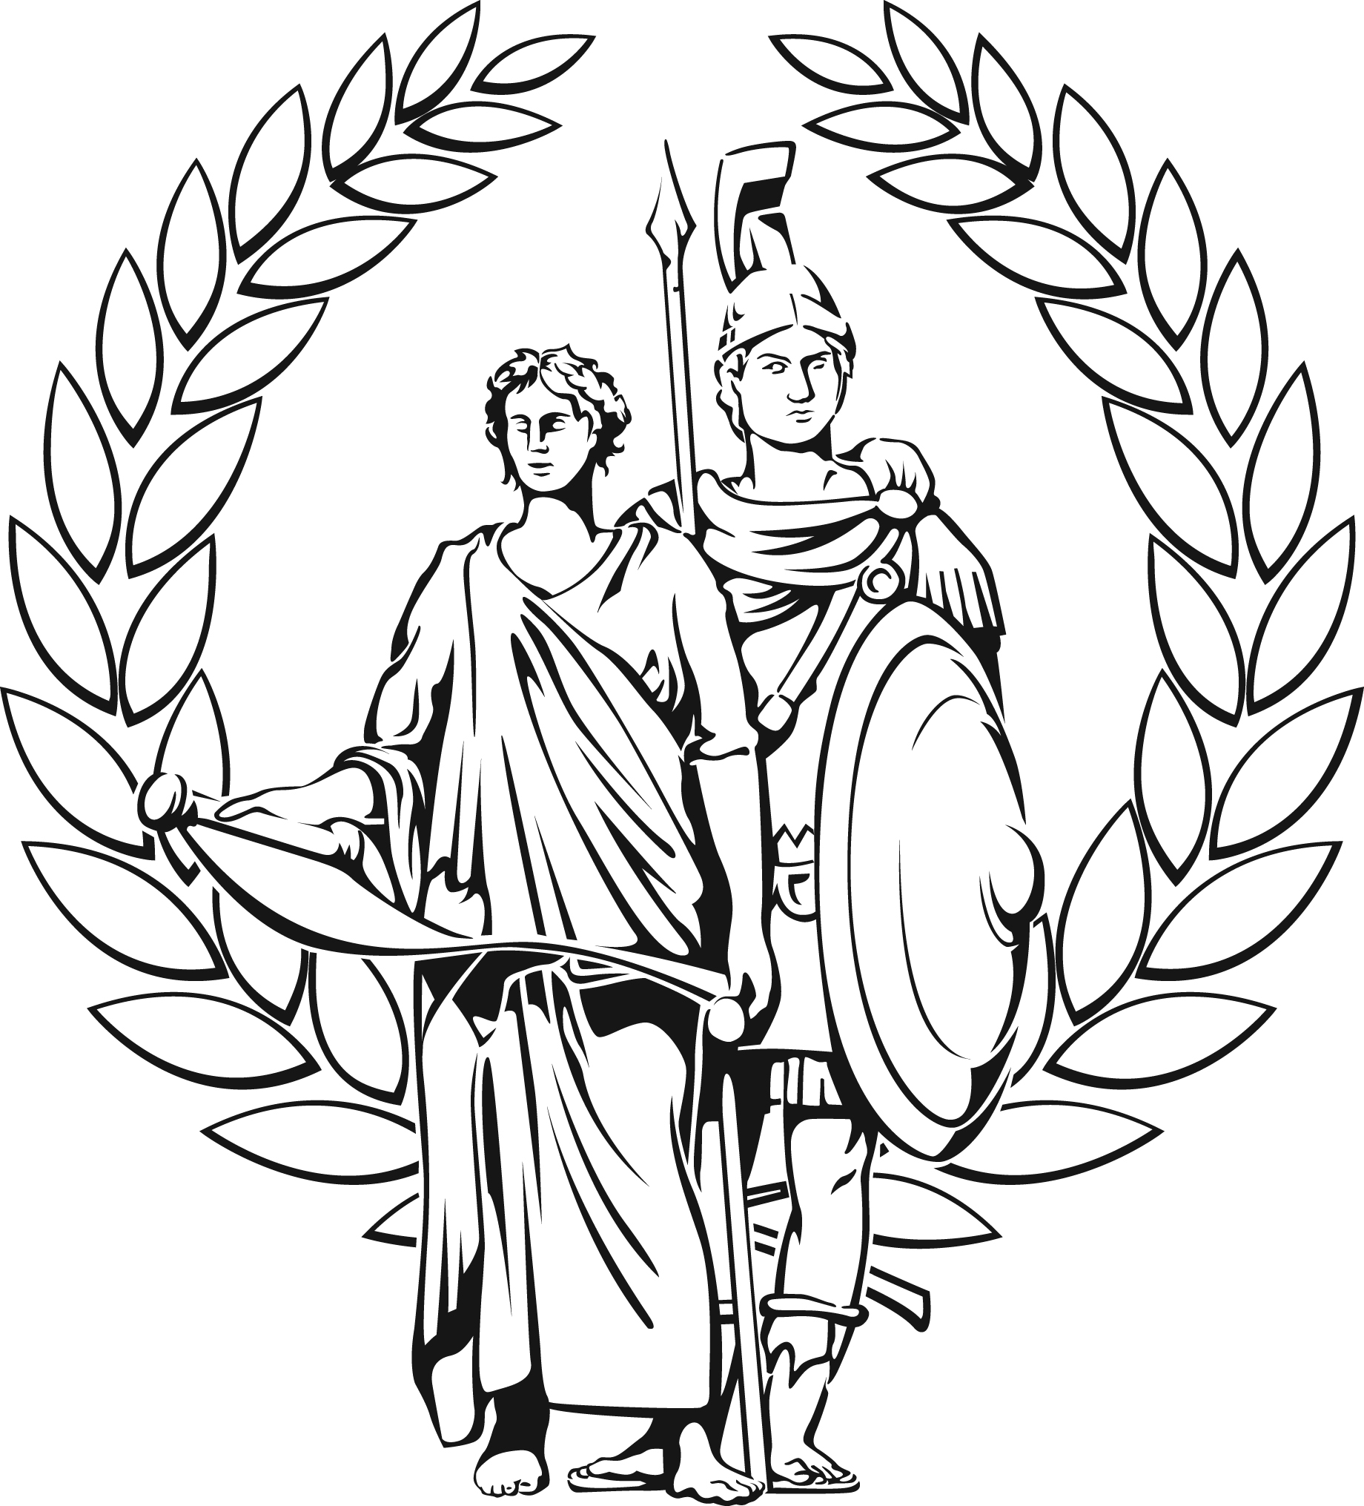 PROGRAMME

BRITISH COMMISSION FOR MILITARY HISTORY
5TH ANNUAL CONFERENCE ON

NEW RESEARCH IN MILITARY HISTORY:
A CONFERENCE FOR POSTGRADUATE AND EARLY CAREER RESEARCHERS

UNIVERSITY OF WOLVERHAMPTON
DEPARTMENT OF HISTORY, POLITICS AND WAR STUDIES

SATURDAY 22ND NOVEMBER 2014

The conference is held in the Millennium City (MC) Building, City Campus South. Entrance is through the MD Building in Wulfruna Street.

09:30-10.30 Registration and tea/coffee

10.30-11.00 Introduction by Professor Stephen Badsey (Wolverhampton) and Major General Mungo Melvin, President of the British Commission for Military History

11.00-12.00 FIRST PARALLEL SESSION

PANEL A: THE WESTERN FRONT IN THE FIRST WORLD WAR (1)
Room MC001– chaired by John Spencer (Wolverhampton University)
Kate James (Oxford University) ‘Enlisted Boy Soldiers During the First World War’
Tom Thorpe (University of Kent) ‘The six-week myth: an infantryman’s life expectancy on the Western Front in the Great War’

PANEL B: THE ROYAL AIR FORCE 1919-45
Room MC201 – chaired by Dr Peter Preston-Hough (Wolverhampton University)
Matthew Powell (Birmingham University) ‘Army Co-operation Command and Tactical Airpower Development in Britain 1940-43’
Trevor Nash (Birmingham University) ‘How did what was being taught and thought at the RAF Staff College affect the development of operational training in the RAF 1922-39?’

PANEL C: ITALY IN THE FIRST WORD WAR
Room MC228 – chaired by Major General Mungo Melvin (BCMH)
Meighan McCrae (Oxford University) ‘Allied notions of victory and the role of the Italian Theatre in winning the First World War in 1919’
Stefano Marcuzzi (Oxford University) ‘Anglo-Italian Naval Co-Operation in the First World War’

12.00-1.00 SECOND PARALLEL SESSION

PANEL D: THE WESTERN FRONT IN THE FIRST WORLD WAR (2)
Room MC001 – chaired by Professor William Philpott (Kings College London / BCMH)
Christopher Philips (Leeds University) ‘Civil-Military co-operation before Geddes: logistics management on the Western Front 1914-16’
Lt Col Jeff Schakenberg (Birmingham University) ‘Intelligence of a Striking Kind: British Intelligence and Chemical Warfare during World War I’

PANEL E: BRITISH AIRBORNE FORCES IN THE SECOND WORLD WAR
Room MC201 – chaired by Philip McCarty (Wolverhampton University)
Dr Linda Parker (Independent Scholar) ‘Nearer My God to Thee: the genesis and development of the role of airborne chaplains in the Second World War’
Andrew Wheale (Buckingham University) ‘Major General F.A.M. Browning and the British Airborne project 1941-3’

1.00-2.30 LUNCH (allowing 10 minutes to/from The Grain Store)

2.30-4.00 THIRD PARALLEL SESSION

PANEL F: MILITARY HISTORY AND MEMORY
Room MC001 – chaired by Dr Eamonn O’Kane (Wolverhampton University)
Dr Christopher Brice (Independent Scholar) ‘The Art of Military Biography’
Imogen Peck (Bristol University) ‘The English Civil Wars in popular memory 1647-1660’
Dr Brett Holman (University of New England) ‘Folk Strategy, Mauberge Platforms and Zeppelin Bases in Britain, Autumn 1914’

PANEL G: LESSONS OF THE SECOND WORLD WAR
Room MC201 – chaired by Dr Matthew Ford (Sussex University / BCMH)
Dr Richard Hammond (Portsmouth University/RAF Cranwell) ‘Out of Africa: Forgotten Aspects of the Allied Anti-Shipping Campaign in the Mediterranean 1940-44’
Philip McCarty (Wolverhampton University) ‘Change is Constant; Change Is Inevitable – Even When Wrong – The British Army’s Reaction to Defeat in France 1940’
Panagiotis Papadopoulos (Athens University) ‘A Surprise in West Macedonia: Wehrmacht’s XXXX Motorised Corps’ heavy fighting during the invasion of Greece in 1941’

PANEL H: WAR AND EMPIRE
Room MC228 – chaired by Andrew Duncan (Birmingham University)
Martin Green (Birmingham University) ‘Counterinsurgency Japanese Style: Population-Centric COIN in Manchuria’
Jerome Devitt (Trinity College Dublin) ‘The British Army and “Infrastructural” power in Ireland in the 1860s: from Deterrence to Flying Columns’
Adam Prime (Leicester University) ‘Fond of Shooting? The Background and Social Ties of the Indian Army’s British officer corps 1871-1914’

4.00-4.30 Tea/coffee

4.30-5.30 KEYNOTE ADDRESS
Professor John Buckley (Wolverhampton) ‘Monty’s Men – the Road to Luneburg Heath’ – chaired by Professor Stephen Badsey

5.30-6.00 Concluding remarks and departure

