The University of Wolverhampton in partnership with Wolverhampton Wanderers Football Club

PhD Studentship- Parent Engagement in Elite Academy Football

Applicant Pack
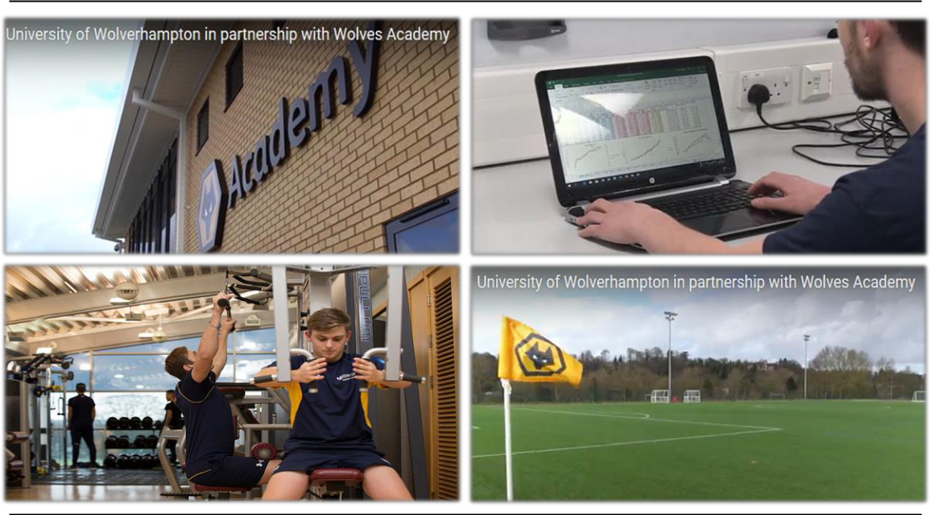

University of Wolverhampton

PhD Studentship

We are offering a fully funded bursary opportunity (£15,009 + fee waiver) in conjunction with Wolverhampton Wanderers FC for applicants interested in studying a PhD at the University of Wolverhampton.

Closing Date: 31.1.2020

Interview Date: Week commencing 17.2.2020

Bursary Role Descriptor
Funding is available to support a full time fully funded (£15,009 + fee waiver) PhD, over a three-year period from September 2019 (or as soon afterwards as possible). This PhD studentship will form part of the Club’s EPPP (Category 1) academy provision and will focus on supporting academy players and coaches in the areas of delivering and monitoring psychological support services to youth players at the Club.

Wolverhampton Wanderers Football Club is one of only 22 clubs to be awarded the Category 1 rating for its Academy. Recently the Club has invested over £6.5 million into a new Academy building and full-size indoor arena, which will be based at the Club’s main training ground in Compton. The investment further signals the Club’s intention to develop home-grown players for the senior team. The PhD Studentship will primarily focus on the youth team and their parents providing an exciting opportunity for a post graduate student with an applied background.

The PhD student will usually be located at the Wolverhampton Wanderers FC Compton training venue studying alongside Academy staff, but will also be expected to attend the University (usually Walsall campus for at least one day per week for 30 weeks across the year) and, during specific times of scholarship, may be based there. This time will be provided for associated tuition, general research training and mandatory attendance at the Annual Progress Review. Whilst the successful applicant may undertake duties at the football club academy that are complementary to the PhD research (agreed in advance with the supervisory team), the focus and primary aim shall remain the successful completion of the PhD in the allotted timeframe.

Project: Parent Engagement in Elite Academy Football

Parents play a critical role in the lives of players attending football academies including areas such as influencing standard of involvement as well as the psycho-social development of players (Babkes & Weiss, 1999). There is evidence for a range of positive and negative effects that parents may have on young athletes (Ross, Mallett, & Parkes, 2015; Teques, Calmeiro, Rosado, Silva, & Serpa, 2019; Teques, Serpa, Rosado, Silva, & Calmeiro, 2016). In order to enhance parental involvement in youth sport research must not simply seek to manage parents, but rather seek to understand why parents get involved in their children’s sport, what type of behaviours they display, and how this influences young athletes.
This PhD programme aims to develop evidence-based interventions that foster positive parental influence and enhance the player-coach-parent triad. Specifically, the PhD aims to:

- Understand why parents get involved in their children’s academy football, and the behaviours displayed during involvement;
- Understand how parent behaviours influence academy football players;
- Examine 1 and 2 from player, parents and coaches’ perspectives;
- Develop evidence-based interventions that foster positive parental influence and enhance the player-coach-parent triad.
It is anticipated this research will draw on a range of methodologies within sport psychology and other spheres of high-performance development. The precise research question(s) and methodologies adopted will be negotiated with the successful applicant.

Bursary

The studentship is for three years and is intended to start in March 2020. The studentship provides a tax-free stipend of £15,009 per year plus the tuition fees at the UK/EU rate. Due to funding restrictions, this studentship is only open to UK/EU applicants.

2

Person Specification

 | ATTRIBUTE | ESSENTIAL |  | DESIRABLE
1. | Academic  Qualifications | 1.1 An Undergraduate degree (2:1 or above with honours) in Sport & Exercise Science, Sport and Exercise Psychology, Psychology or related area (cv)
 |  | 1.2 A masters-level qualification in Sport & Exercise Science, Sport and Exercise Psychology, Psychology or related area (cv)
2. | Professional  Qualifications |  |  | Accreditation or desire to work towards accreditation from relevant professional body e.g., BASES, BPS (cv)
 |  |  |  | A current first aid or basic support qualifications from a recognised organisation (cv)
3. | General Skills/  Experience | 3.1 | Good IT skills, including data analysis skills (cv)
 |  | 3.2 | Good communication and interpersonal skills, written and oral (cv and interview) | 3.3 | Personal initiative, reliability, attention to detail (cv and interview)
4. | Specific Skills/  Experience | 4.1 | Experience delivering sport psychology sessions to different populations of sports people (cv, interview) | 4.6 | Evidence of managing research projects (cv, interview)
 |  | 4.2 | A minimum of 2 years’ experience of working in an environment supporting athletes in a sport psychology capacity (cv, interview) | 4.7 | Knowledge of the FA and Premier League rules and regulations with regard to Academies (Interview)
 |  | 4.3 | Good understanding of qualitative and quantitative research methods and designs (cv, interview)
 |  | 4.4 | Understanding of the psychological preparation of young athletes (cv, interview) | 4.8 | Knowledge of monitoring performance and wellbeing using various methods.  (cv)
6. | Specific Qualities  related to particular  position | 6.1 | Experience of analysing qualitative and quantitative data (cv and interview) | 6.4 | Able to handle multiple simultaneous demands and activities (cv)
 |  | 6.2 | Ability to work as part of a multi-disciplinary team (cv)
 |  | 6.3 | Ability to work independently and set realistic but attainable goals (cv, interview)
7. | Other | 7.1 Commitment to the University’s policy framework on diversity and the University’s and Club’s policies on health and safety  (cv, interview)
 |  | 7.2 The studentship will involve times to suit the football schedule which will include some evenings, weekends and bank holidays (interview)

This bursary involves training, supervising, working with and/or being in sole charge of children and young people. The successful applicant will therefore be required to apply for a disclosure from the Disclosure and Barring Service (DBS). A disclosure is an impartial and confidential document that details an individual’s criminal record and where appropriate gives details of those who are banned from working with children. Having a criminal record will not necessarily be a bar to obtaining a position.

How do I Apply?

For an informal discussion about this opportunity please email Professor Tracey Devonport T.Devonport@wlv.ac.uk or David Morrison (Head of Academy Sports Science) davidmorrison@wolves.co.uk
Applicants should email a CV and covering letter detailing their suitability for the project and contact details of two referees to FEHWAcademicSupportW&B@wlv.ac.uk. Please clearly indicate the reference “PhD WWFC Sports Science” in the title of the email and on your cover letter.

5

