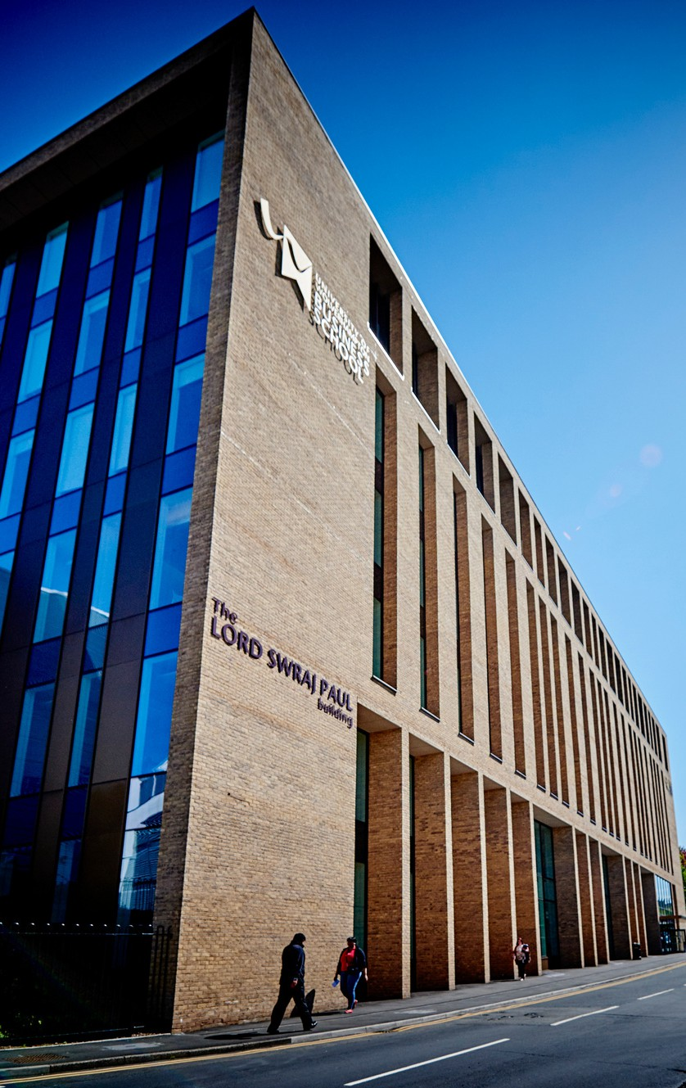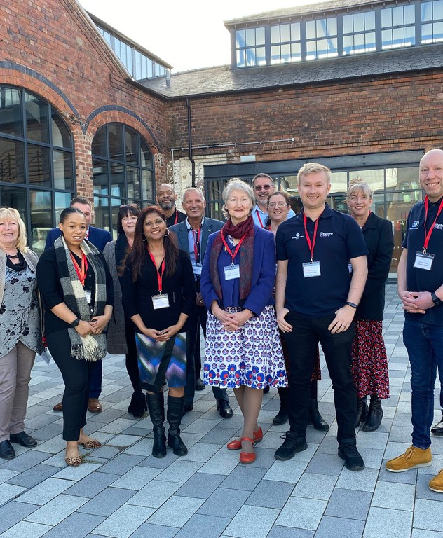

University of Wolverhampton Diversity pay gaps 2023



PAY GAP REPORT 2023

1

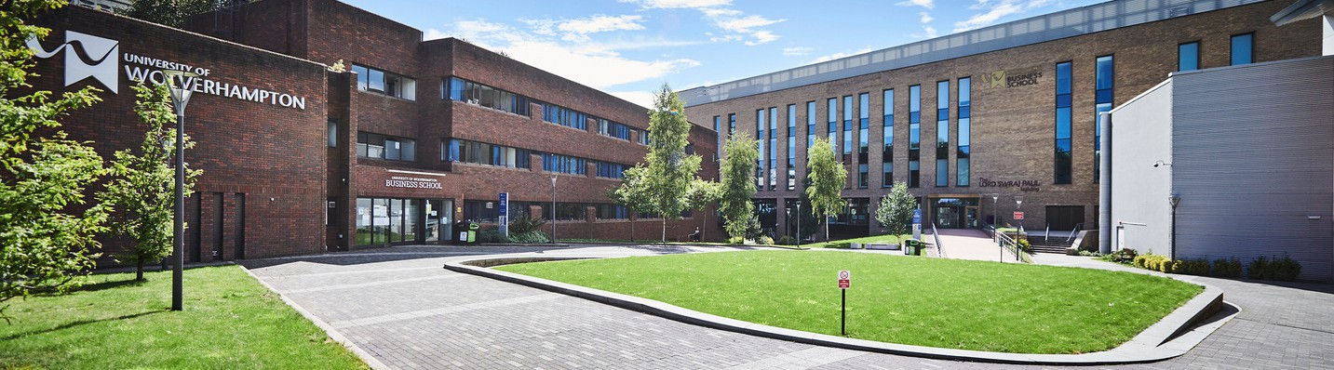

## Executive Summary of University of Wolverhampton Disability, Global Majority and Gender pay gaps 2023.

### INTRODUCTION

The University has a statutory duty under the Equality Act 2010 (Gender Pay Gap Information) Regulations 2017, to publish the gender pay gap on an annual basis, by 31st March each year. As a university, we have also used an intersectionality approach looking at gender and race.



PAY GAP REPORT 2023

2

METHODOLOGY

For our report, the staff data used is as of 31st March 2023. The total number of establishment staff used for the calculations was 2217. This number excludes half pay, no pay, starters, leavers and other pay deductions. The data is then utilised to create an overall hourly paid rate per job an individual undertakes.

We have used the gender pay gap to illustrate the formula used to calculate the mean and median pay gaps below. For the ethnicity and disability pay gap calculations, the formula is the same, but the variables change.

**Mean:**

A - B x100 A

A= Mean hourly pay of male employees B= Mean hourly pay of female employees

**Median:**

C - D x100 C

C= Median hourly pay of male employees D= Median hourly pay of female employees

Quartile Figures:

The hourly pay is divided into four quartiles (divided as evenly as possible). The four quartiles are: lower, lower middle, upper middle and upper. With the upper quartile having the highest hourly pay rates. The proportion of staff for each quartile is then calculated, so for gender its male and female, for ethnicity its global majority and white staff and for disability its staff with disabilities and those with none.

**A full draft report with all data sets is attached as an appendix 1 to this paper**





GENDER PAY GAP

3

The mean gender pay gap at 12.8% has slightly decreased by 0.1% compared to last year. However there has been an increase in the median pay gap (13.7%), by 2.1%.

Comparing the pay quartiles to 2022, for the first time we have more female staff in the upper quartile (51%) than male staff by 2%. There has also been an increase by 2% at the lower middle quartile for female staff.

At first glance the pay gap maybe due to the larger percentage of female staff (73%) compared to male staff (27%) in the lower pay quartile. However, this year we decided to investigate this further by calculating the pay gaps within each quartile.

The largest pay gap for both mean and median is at the upper quartile at 6.3% and 5.7% respectively. Next was the lower quartile. Within the upper middle and lower middle quartiles, the pay gaps are negative, meaning female staff earn more than male staff in these quartiles.

Since there are more female staff in upper quartile, the pay mean and median gaps could be explained by there being a higher number of male staff within the higher pay scales and salary points, thus higher hourly pay rates than female staff. This was confirmed when the data was cross referenced with data being used for the Athena Swan renewal submission.



ETHNICITY PAY GAP

4

This is the pay gap between global majority staff and white staff. The mean pay gap at 6.4% has reduced by 2.6% from the previous year, whilst the median pay gap at 2.9% has reduced by 5.6%. This demonstrates that we are travelling in the right direction to eliminate any gaps at all.

This could be explained by the increase in global majority staff of 2% in the upper quartile and a 1% decrease in the lower quartile compared to last year. However, in general there is proportionally over representation of global majority staff within the lower quartiles at 29% and underrepresentation in the upper quartile at 20.0% compared to the overall percentage of global majority staff of 26%.

The global majority community are not homogenous and there maybe disparities within this group. The data has therefore been disaggregated further. The benchmark used is the white ethnic group compared to the other ethnic groups. The Asian group still has the largest mean gap at 10.4% compared to 3.8% for the black group and 1.6% for the mixed group. Excluding the other and unknown groups there has been a reduction in the mean gap of 3% for both black and mixed ethnic groups and 2% for the Asian ethnic group.

The median gap for the Asian group has increased, however there have been reductions for all the other groups, especially the other ethnic groups by a large amount that could be the reason for the larger reduction in the overall median gap.

With regards to pay quartiles there is proportionality a higher percentage of Asian staff in the lower quartile, 19% compared 14.0% at the University and lower percentage within the upper quartile at 9.9%. For Black staff there is proportionately an under- representation in the upper quartile by 1%.

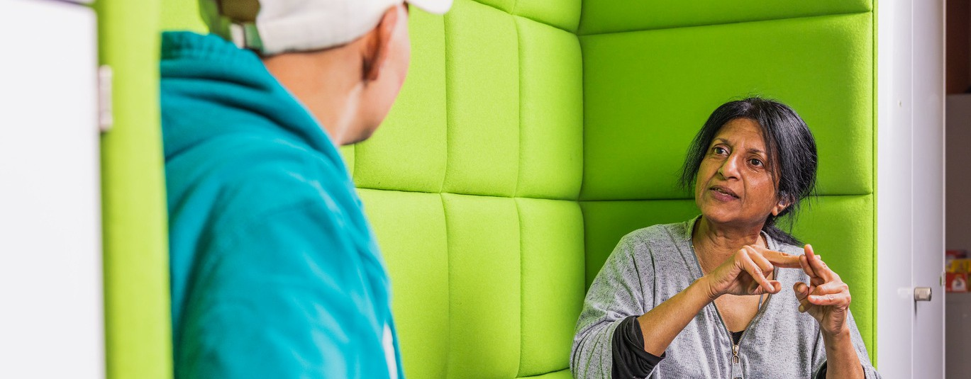



DISABILITY PAY GAP

*5*

Overall, there has been an increase in both the mean and median pay gaps for staff with disabilities. Last year where the mean pay gap was negative in favour of staff with disabilities, this year there is a mean gap of 2.0% for staff with disabilities. The median pay gap was negative last year and for this year it is zero, meaning the median pay is the same for both disabled and non- disabled staff.

This could be as a result of a decrease in staff with disabilities of 1.1% in the upper quartile (5.6%) and an increase in the lower and lower middle quartiles by 1% and 1.9% respectively compared to last year.



INTERSECTIONALITY

6

#### Gender and Race:

The mean pay gap for Global Majority female staff was 19.1%, a decrease by 2.6% from last year. This was in comparison to a gap of 10.8% for White female’s, a smaller decrease by 1.6%. For Global majority male staff, the mean pay gap was 0.3%, a decrease by 7.7%.

Median pay gap for Global Majority female staff was 18.7%, a decrease by 5.7%. In comparison to 5.8% for White female’s, a decrease by 3.7%. For Global majority male staff, the mean pay gap was 0%, a decrease by 6.8%. Meaning for the first time Global majority male staff were paid on average the same as White male staff.

With regards to pay quartiles compared to the overall percentage of global majority female’s (15%), there was proportionally a lower percentage in the upper quartile (7.9%) and a higher percentage in the lower quartile (23.6%).

Disaggregating the data by ethnicity, the highest mean and median pay gaps were for Asian female staff at 24.2 and 25.5% compared to white females at 10.8% and 5.8% respectively. Next were black females at 14% and 5.9%.

#### Gender and Disability:

Female staff with disabilities have a lower mean (11.5% increase from last year 10.5%) and median (-0.5%) pay gaps compared to female staff with no disabilities at 13.5% and 1.9% respectively. However, they have a higher mean and median pay gap when compared to male staff with disabilities.



BENCHMARKING 2023

7

**12.8%**

|  |  |  |  |  |
| --- | --- | --- | --- | --- |
|  | **MEAN** | **MEDIAN** | **UPPER QUARTILE F** | **LOWER QUARTILE F** |
| **Statutory reporting, all UK sectors** | **11.8%** | **9.0%** |  |  |
| **Statutory reporting, higher education** | **11.9%** | **10.1%** |  |  |
| **UOW** |  | **13.7%** | **51%** | **73%** |
| **Post 92 Universities** |  |  |  |  |
| **Anglia Ruskin University** | **9%** | **5.6%** | **52.7%** | **66.1%** |
| **Birmingham City University** | **7.9%** | **8%** | **49%** | **64%** |
| **Coventry University** | **13%** | **8.3%** | **45.1%** | **70.8%** |
| **Buckinghamshire New University** | **11.8%** | **10.8%** | **46.9%** | **68.6%** |
| **University of Buckingham** | **26%** | **29%** | **42%** | **68%** |
| **Leeds Trinity University** | **11.9%** | **8.3%** | **51.5%** | **72.3%** |
| **Newman University** | **13.4%** | **23.8%** | **51%** | **73%** |
| **Leeds Beckett University** | **9%** | **13.4%** | **47.6%** | **63.8%** |

### The University had a larger mean and median pay gap than the average for the HE sector.

ANALYSIS AND RECOMMENDED ACTIONS TO REDUCE GENDER PAY GAP

8

Although we have a reduction in both the mean and median pay gaps for both Global majority and White female staff, it would seem the increase in the overall median pay gap is due to the larger decrease and hence larger amount of global majority male staff being in the higher pay grades and scales.

To reduce the pay gaps further we will be taking actions under the following themes (further details in appendix 1):

**·We will be using charter marks/action plans both Athena Swan and Race Equality Charter.**

**·Using positive action.**

**·Reviewing recruitment process and cycle.**

**·Staff development.**

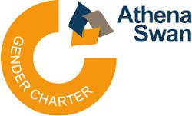**·Culture**

**·Family-friendly initiatives and policies.**

**·Reasonable adjustments.**

**·EDI data dashboards**



PAY GAP REPORT 2023

Appendix 1

9

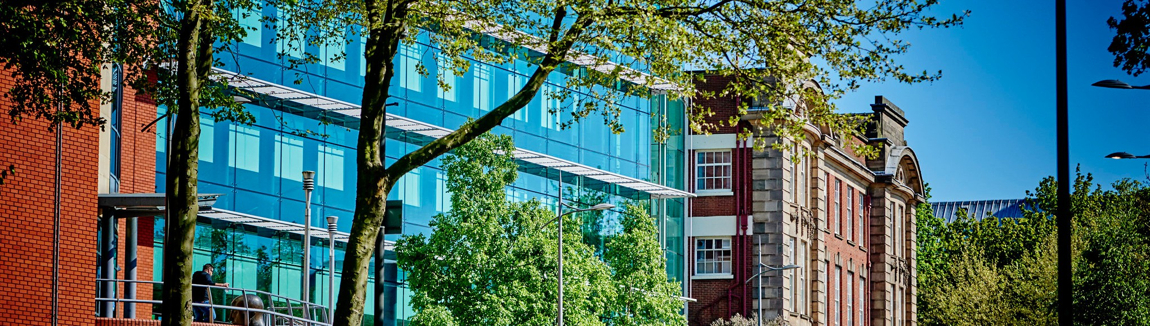

## University of Wolverhampton Diversity - Disability, Global Majority and Gender pay gaps Report 2023.

### INTRODUCTION

The University has a statutory duty under the Equality Act 2010 (Gender Pay Gap Information) Regulations 2017, to publish the gender pay gap on an annual basis, by 31st March each year. As a university we have also used an intersectionality approach looking at gender and race.



PAY GAP REPORT 2023

10

METHODOLOGY

For our report, the staff data used is as of 31st March 2023. The total number of establishment staff used for the calculations was 2217. This number excludes half pay, no pay, starters, leavers and other pay deductions. The data is then utilised to create an overall hourly paid rate per job an individual undertakes.

We have used the gender pay gap to illustrate the formula used to calculate the mean and median pay gaps below. For the ethnicity and disability pay gap calculations, the formula is the same, but the variables change.

**Mean:**

A - B x100 A

A= Mean hourly pay of male employees B= Mean hourly pay of female employees

**Median:**

C - D x100 C

C= Median hourly pay of male employees D= Median hourly pay of female employees

Quartile Figures:

The hourly pay is divided into four quartiles (divided as evenly as possible). The four quartiles are: lower, lower middle, upper middle and upper. With the upper quartile having the highest hourly pay rates. The proportion of staff for each quartile is then calculated, so for gender its male and female, for ethnicity its global majority and white staff and for disability its staff with disabilities and those with none.



GENDER SPLIT BY QUARTILES

11

|  |  |  |  |  |  |
| --- | --- | --- | --- | --- | --- |
| **March 2023** | **Male** | **Female** | **Female pay as % of Male pay** | **GAP 2023** | **GAP 2022** |
| **Count** | 885 | 1332 |  |  |  |
| **% Workforce** | 39.9% | 60.1% |  |  |  |
| **Median** |  | £18.71 | 87.21% | 12.79% | 12.85% |
| **Mean** | £18.56 | £16.27 | 86.27% | 13.73% | 11.61% |

The mean gender pay gap at 12.8% has slightly decreased by 0.1% compared to last year. However there has been an increase in the median pay gap (13.7%), by 2.1%.

£18.66

£21.47

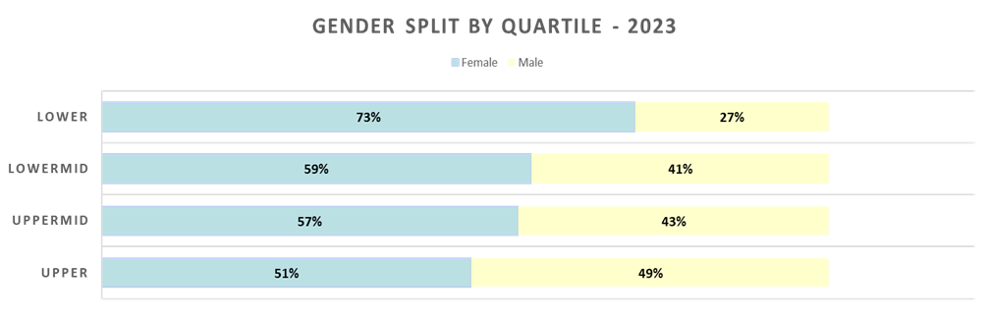

Comparing the pay quartiles to 2022, for the first time we have more female staff in the upper quartile (51%) than male staff by 2%. There has also been an increase by 2% at the lower middle quartile for female staff.

At first glance the pay gap maybe due to the larger percentage of female staff (73%) compared to male staff (27%) in the lower pay quartile. However, this year we decided to investigate this further by calculating the pay gaps within each quartile.



GENDER SPLIT BY QUARTILES

12

**Upper Quartile**

£18.66

|  |  |  |  |  |  |
| --- | --- | --- | --- | --- | --- |
| **March 2023** | **Male** | **Female** | **Total** | **Female pay as % of Male pay** | **GAP 2023** |
| **Count** | **273** | **282** | **555** |  |  |
| **Workforce %** | **49.19%** | **50.18%** |  |  |  |
| **Median** | **£28.46** | **£26.83** |  | **94.28%** | **5.72%** |
| **Mean** | **£32.07** | **£30.07** |  | **93.74%** | **6.26%** |

**Upper Mid Quartile**

£18.66

|  |  |  |  |  |  |
| --- | --- | --- | --- | --- | --- |
| **March 2023** | **Male** | **Female** | **Total** | **Female pay as % of Male pay** | **GAP 2023** |
| **Count** | **236** | **317** | **553** | **100.70%** | **-0.70%** |
| **Workforce %** | **42.68%** | **57.32%** |  | **119.26%** | **-19.26%** |
| **Median** | **£22.50** | **£26.83** |  |  |  |
| **Mean** | **£21.56** | **£21.71** |  |  |  |



GENDER SPLIT BY QUARTILES

13

##### Lower Mid Quartile

£18.66

|  |  |  |  |  |  |
| --- | --- | --- | --- | --- | --- |
| **March 2023** | **Male** | **Female** | **Total** | **Female pay as % of Male pay** | **GAP 2023** |
| **Count** | **228** | **327** | **555** |  |  |
| **Workforce %** | **41.08%** | **58.92%** |  |  |  |
| **Median** | **£14.75** | **£15.34** |  | **100.26%** |  |
| **Mean** | **£15.22** | **£15.26** |  | **104.02%** | **-4.02** |

**Upper Mid Quartile**

£18.66

**-0.26%**

|  |  |  |  |  |  |
| --- | --- | --- | --- | --- | --- |
| **March 2023** | **Male** | **Female** | **Total** | **Female pay as % of Male pay** | **GAP 2023** |
| **Count** | **148** | **406** | **554** |  |  |
| **Workforce %** | **26.71%** | **73.29%** |  |  |  |
| **Median** | **£11.13** | **£10.97** |  |  | **1.48%** |
| **Mean** | **£11.31** | **£11.27** |  | **99.58%** | **0.42%** |

The largest pay gap for both mean and median is at the upper quartile at 6.3% and 5.7% respectively. Next was the lower quartile. Within the upper middle and lower middle quartiles, the pay gaps are negative, meaning female staff earn more than male staff in these quartiles.

**98.52%**

Since there are more female staff in upper quartile, the pay mean and median gaps could be explained by there being a higher number of male staff within the higher pay scales and salary points, thus higher hourly pay rates than female staff. This was confirmed when the data was cross referenced with data being used for the Athena Swan renewal submission.



GENDER PAY GAP BENCHMARKING

14

**12.8%**

|  |  |  |  |  |
| --- | --- | --- | --- | --- |
|  | **MEAN** | **MEDIAN** | **UPPER QUARTILE F** | **LOWER QUARTILE F** |
| **Statutory reporting, all UK sectors** | **11.8%** | **9.0%** |  |  |
| **Statutory reporting, higher education** | **11.9%** | **10.1%** |  |  |
| **The Higher Education Policy Institute (HEPI) report (Mean across 114 HEIs)** | **13.2%** | **11.9%** |  |  |
| **UOW** |  | **13.7%** | **51%** | **73%** |
| **Post 92 Universities** |  |  |  |  |
| **Anglia Ruskin University** | **9%** | **5.6%** | **52.7%** | **66.1%** |
| **Birmingham City University** | **7.9%** | **8%** | **49%** | **64%** |
| **Coventry University** | **13%** | **8.3%** | **45.1%** | **70.8%** |
| **Buckinghamshire New University** | **11.8%** | **10.8%** | **46.9%** | **68.6%** |
| **University of Buckingham** | **26%** | **29%** | **42%** | **68%** |
| **Leeds Trinity University** | **11.9%** | **8.3%** | **51.5%** | **72.3%** |
| **Newman University** | **13.4%** | **23.8%** | **51%** | **73%** |
| **Leeds Beckett University** | **9%** | **13.4%** | **47.6%** | **63.8%** |

The University had a larger mean and median pay gap than the average for the HE sector.



ETHNICITY PAY GAP

15

|  |  |  |  |  |  |  |
| --- | --- | --- | --- | --- | --- | --- |
|  | **Global Majority** | **White** | **Not Known** | **Total** | **GAP 2023** | **GAP 2022** |
| **Count** | **574**  **(26%)** | **1594**  **(7%)** | **49**  **(2%)** | **2217** |  |  |
| **Mean** | **£18.76** | **£20.03** | **£24.76** |  | **6.4%** | **9.0%** |
| **Median** | **£16.75** | **£18.56** | **£17.25** |  | **2.9%** | **8.5%** |

This is the pay gap between global majority staff and white staff. The mean pay gap at 6.4% has reduced by 2.6% from the previous year, whilst the median pay gap at 2.9% has reduced by 5.6%. This demonstrates that we are travelling in the right direction to eliminate any gaps at all.

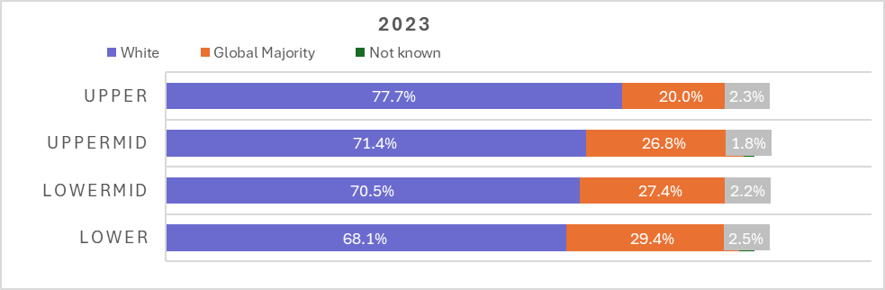



ETHNICITY PAY GAPS

16

The decrease in the pay gaps could be explained by the increase in global majority staff of 2% in the upper quartile and a 1% decrease in the lower quartile compared to last year. However, in general there is proportionally over representation of global majority staff within the lower quartiles at 29% and underrepresentation in the upper quartile at 20.0% compared to the overall percentage of global majority staff of 26%.

The global majority community are not homogenous and there maybe disparities within this group. The data has therefore been disaggregated further. The benchmark used is the white ethnic group compared to the other ethnic groups. The Asian group still has the largest Mean gap at 10.4% compared to 3.8% for the black group and 1.6% for the mixed group. Excluding the other and unknown groups there has been a reduction in the mean gap of 3% for both black and mixed ethnic groups and 2% for the Asian ethnic group.

The median gap for the Asian group has increased, however there have been reductions for all the other groups, especially the other ethnic groups by a large amount that could be the reason for the larger reduction in the overall median gap.

This could be explained by the fact that proportionally the Asian group are overrepresented by a larger percentage in the lower and lower middle quartiles as below:

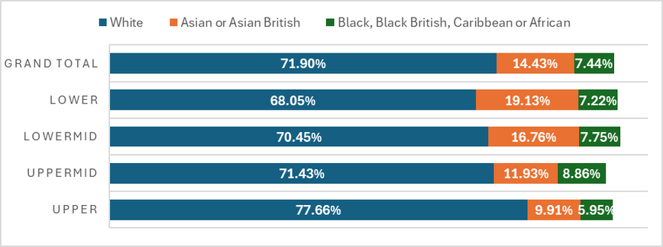

There is proportionally a higher percentage of Asian staff in the lower quartile, 19% compared to 14.0% across the University and lower percentage within the upper quartile at 9.9%. For Black staff there is proportionately an under-representation in the upper quartile by 1%.



DISABILITY PAY GAPS

17

|  |  |  |  |
| --- | --- | --- | --- |
|  | **No** | **Yes** | **Unknown** |
| **Count** | **1902**  **(85.8%)** | **160**  **(7.2%)** | **155**  **(7.0%)** |
| **Mean** | **£19.66** | **£19.26** | **£22.20** |
| **Mean Gap** | **0.0** | **2.04%**  **(0.5%)** | **12.93%**  **(-7.3%)** |
| **Median** | **£18.30** | **£18.30** | **£20.95** |
| **Median Gap** | **0.0** | **0.0%**  **-1.7%** | **14.46%**  **-1.7%** |

Overall, there has been an increase in both the mean and median pay gaps for staff with disabilities. Last year where the mean pay gap was negative in favour of staff with disabilities, this year there is a mean gap of 2.0% for staff with disabilities. The median pay gap was negative last year and for this year it is zero, meaning the median pay is the same for both disabled and non-disabled staff.

This could be because of a decrease in staff with disabilities of 1.1% in the upper quartile (5.6%) and an increase in the lower and lower middle quartiles by 1% and 1.9% respectively compared to last year.

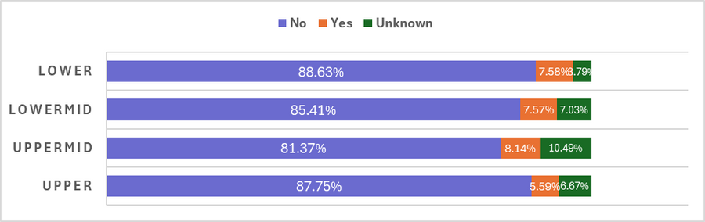



INTERSECTIONALITY - GENDER & ETHNICITY

18

This is the pay gap, where white male staff are used as the benchmark.

|  |  |  |  |  |
| --- | --- | --- | --- | --- |
|  | FEMALE | | MALE | |
|  | Count | Percentage | Count | Percentage |
| Global Majority | 334 | 15.1% | 240 | 10.8%. |
| White | 971 | 43.8% | 623 | 28.1% |
| Unknown | 27 | 1.2% | 22 | 1.0% |

In table below the figures highlighted in RED are last year’s figures:

|  |  |  |  |  |  |
| --- | --- | --- | --- | --- | --- |
| Average of Hourly pay GPG | Female | Male |  | Female | Male |
| White | £19.13 | £21.45 | White | £17.77 | £20.22 |
| Mean Gap | 10.8%  12.4% | 0.0% | Median Gap | 5.77%  9.51% | 0% |
| Global Majority | £17.36 | £20.71 | Global Majority | £15.34 | 18.86% |
| Mean Gap | 19.06%  21.7% | 0.3%  8.0% | Median Gap | 18.65%  24.41% | 0.0%  6.75% |

The mean pay gap for Global Majority female staff was 19.1%, a decrease by 2.6% from last year. This was in comparison to a gap of 10.8% for White female’s, a smaller decrease by 1.6%. For Global majority male staff, the mean pay gap was 0.3%, with the largest decrease by 7.7%.

Median pay gap for Global Majority female staff was 18.7%, a decrease by 5.7%. In comparison to 5.8% for White female’s, a decrease by 3.7%. For Global majority male staff, the mean pay gap was 0%, a decrease by 6.8%. Meaning for the first time Global majority male staff were paid on average the same as White male staff.

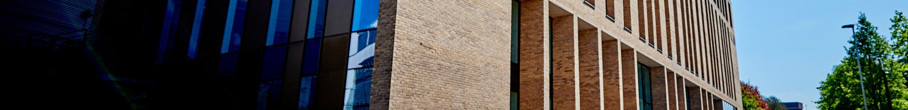

GENDER AND ETHNICITY SPLIT BY QUARTILES:

19

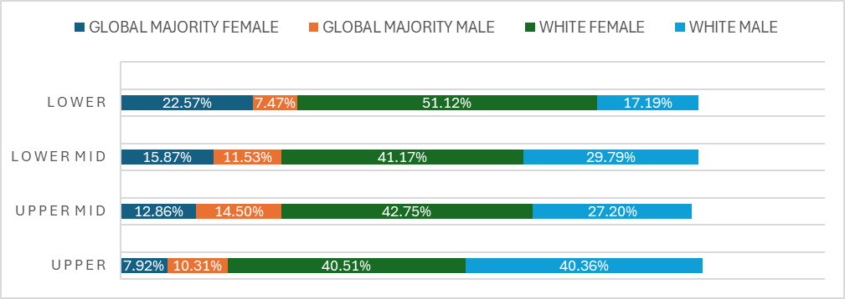

Compared to the overall percentage of global majority female’s (15%), there was proportionally a lower percentage in the upper quartile (7.9%) and a higher percentage in the lower quartile (23.6%). Overall, there is an over-representation of white male staff in the upper quartile and under-representation in the lower quartile compared to the overall percentage within the University. This would explain the higher pay gaps for global majority female staff.



INTERSECTIONALITY PAY GAP GENDER & ETHNICIT% Y

20

In the table below is the data disaggregated into the various ethnic groups by gender.

%

The highest mean and median pay gaps were for Asian female staff at 24.2 and 25.5% compared to White females at 10.8% and 5.8% respectively.

Next were Black females at 14% and 5.9%.

|  |  |  |  |  |  |
| --- | --- | --- | --- | --- | --- |
|  | FEMALE | | | | |
| ETHNIC GROUP  ASIAN OR ASIAN BRITISH  BLACK/ BLACK BRITISH/ AFRICAN/ CARIBBEAN  MIXED OR MULTIPLE ETHNIC GROUPS NOT KNOWN  OTHER ETHNIC GROUPS  WHITE | COUNT % | MEAN | MEDIAN | MEDIAN GAP | MEDIAN GAP |
| **9.4%** | **£16.26.** | **£14.05** | **24.2%** | **25.5%** |
| **3.7%** | **£18.45** | **£17.77** | **14.0%** | **5.8%** |
| **1.5%** | **£20.37** | **£20.22** | **5.0%** | **-7.2%** |
| **1.2%** | **£20.54** | **£15.35** | **4.2%** | **18.6%.** |
| **0.4%** | **£21.98** | **£20.23** | **-2.5%** | **-7.3%.** |
| **43.8%** | **£19.13** | **£17.77** | **10.8%** | **5.8%** |

|  |  |  |  |  |  |
| --- | --- | --- | --- | --- | --- |
|  | MALE | | | | |
| ETHNIC GROUP  ASIAN OR ASIAN BRITISH  BLACK/ BLACK BRITISH/ AFRICAN/ CARIBBEAN  MIXED OR MULTIPLE ETHNIC GROUPS NOT KNOWN  OTHER ETHNIC GROUPS  WHITE | COUNT % | MEAN | MEDIAN | MEDIAN GAP | MEDIAN GAP |
| **5.0%** | **21.13%** | **19.52%** | **1.5%** | **-3.5%** |
| **3.7%** | **20.10%** | **18.85%** | **6.3%** | **0.0%** |
| **1.3%** | **18.91%** | **15.12%** | **11.18%** | **19.8%** |
| **1.0%** | **29.95%** | **19.19%** | **-39.7%** | **-1.8%** |
| **0.9%** | **23.53%** | **23.58%** | **-9.7%** | **-26.5%** |
| **28.1%** | **21.45%** | **18.86%** | **0.0%** | **0.0%** |

When looking at male staff it is mixed ethnic group that have the highest gaps followed by the Black ethnic group males.

For Asian males the median is in the negative, which shows they are doing better than White males.

%



DISABILITY PAY GAP

21

Last year’s figures in RED for comparison.

|  |  |  |  |  |  |  |  |  |  |  |
| --- | --- | --- | --- | --- | --- | --- | --- | --- | --- | --- |
|  | FEMALE | | | | | MALE | | | | |
|  | COUNT | MEAN | MEDIAN | MEAN GAP | MEDIAN GAP | COUNT | MEAN | MEDIAN | MEAN GAP | MEDIAN GAP |
| YES | 4.3% | £18.95 | £16.96 | 11.45%  10.53% | -0.48%  4.86% | 2.9% | £19.72 | £18.85 | 7.82%  2.34% | -4.59%  1.7% |
| NO | 51.5% | £18.50 | £16.27 | 13.53%  13.51% | 1.89%  16.66% | 34.3% | £21.40 | £18.86 | 0.0% | 0.0% |
| UNKNOWN | 4.3% | £21.02 | £20.95 | 1.76% | -11.47% | 2.7% | £24.07 | £19.87 | -12.50% | -27.64% |

Female staff with disabilities have a lower mean (11.5%) and median (-0.5%) pay gaps compared to female staff with no disabilities at 13.5% and 1.9% respectively. However, they have a higher mean and median pay gap when compared to male staff with disabilities.

# Analysis and recommended actions to reduce gender pay gap

There has been a reduction in the mean and median ethnicity pay gaps, which demonstrates we are moving in the right direction to reducing the gaps completely. For Global majority male staff, the mean pay gap was 0%, a decrease by 6.8%. Meaning for the first time Global majority male staff were paid on average the same as White male staff. Although we have a reduction in both the mean and median pay gaps for both Global majority and White female staff, it would seem the increase in the overall median pay gap is due to the larger decrease and hence larger amount of global majority male staff being in the higher pay grades and scales.

To reduce the pay gaps further we will be taking actions under the following themes

##### We will be using charter marks/action plans to be tackling the pay gaps:

The Athena Swan Self-Assessment Team (SAT) is working on analysing data on staff representation, experience, reward and recognition and career progression across the institution.

Through Athena Swan work, there is a commitment to increasing the number of women in senior positions, increasing gender diversity in decision-making committees, and supporting career development.

Ongoing data analysis linked to work on Athena Swan and the Race Equality Charter will enable a more granular understanding of our gender pay gap to inform future localised actions.

Introducing of University-level and unit-level dashboards tailored to Athena Swan and Race Equality Charter data requirements. Year-on-year improvements in the gender pay gap, in part, achieved through a comprehensive and targeted action plan, drawn up in partnership with the staff networks and trade unions.

##### Other recommended Actions, to be included in the Athena Swan action plan: Positive action:

Promote the positive action guidance to all line managers. Implementation and monitoring of positive action initiatives.

# Analysis and recommended actions to reduce gender pay gap

##### Recruitment:

Continuation of the roll out of inclusive recruitment methods and how to promote ‘Conscious Inclusive thinking and behaviours’ to all key staff.

An Inclusive approach to the attraction and recruitment of staff to all roles, ensuring that the University is gender neutral in its requirements.

An end-to-end review of the recruitment process as part of a long-term culture and process change that will create a more inclusive recruitment process.

##### Staff development:

Continue to champion the implementation of the Aurora women’s personal and professional development programme. Encourage all female staff to apply and join the Women in Wolves (WoW) development programme.

Encourage staff to join the annual reverse mentoring programme.

##### Culture/Work environment:

Continuing to embed the People Strategy’s new approach to inclusion, such as the implementation of the equality targets. Ensuring the menopause policy/ guidance is developed and promoted across the University.

Monitor uptake and evaluation of the policies and practices in place that support part-time and flexible working.

##### Family-friendly initiatives:

Reviewing paternity and shared parental leave policies following implementation of improved maternity and adoption policies. The review will explore how the University can ensure parity in support for both male and female colleagues to help reduce the gender pay gap.

Initiatives to support staff with their caring responsibilities by looking at sector-leading, progressive family-friendly policies.

# Analysis and recommended actions to reduce gender pay gap

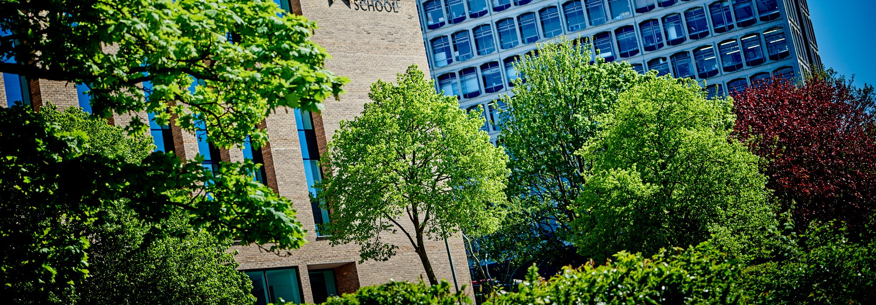

##### Data analysis:

Continue submitting pay gap data to UCEA to enable us to benchmark equality pay gap data across the higher education sector. Analysis of the current pay gaps by faculty and department will be conducted and work undertaken with the senior leadership within faculties and departments to identify issues and implement appropriate actions to improve their specific pay gaps.

Introduction of University-level and unit-level dashboards tailored to Athena Swan and Race Equality Charter data requirements.



