Do you s
Do you have any dietary requirements (vegetarian, allergies etc.) ?

Age Band:
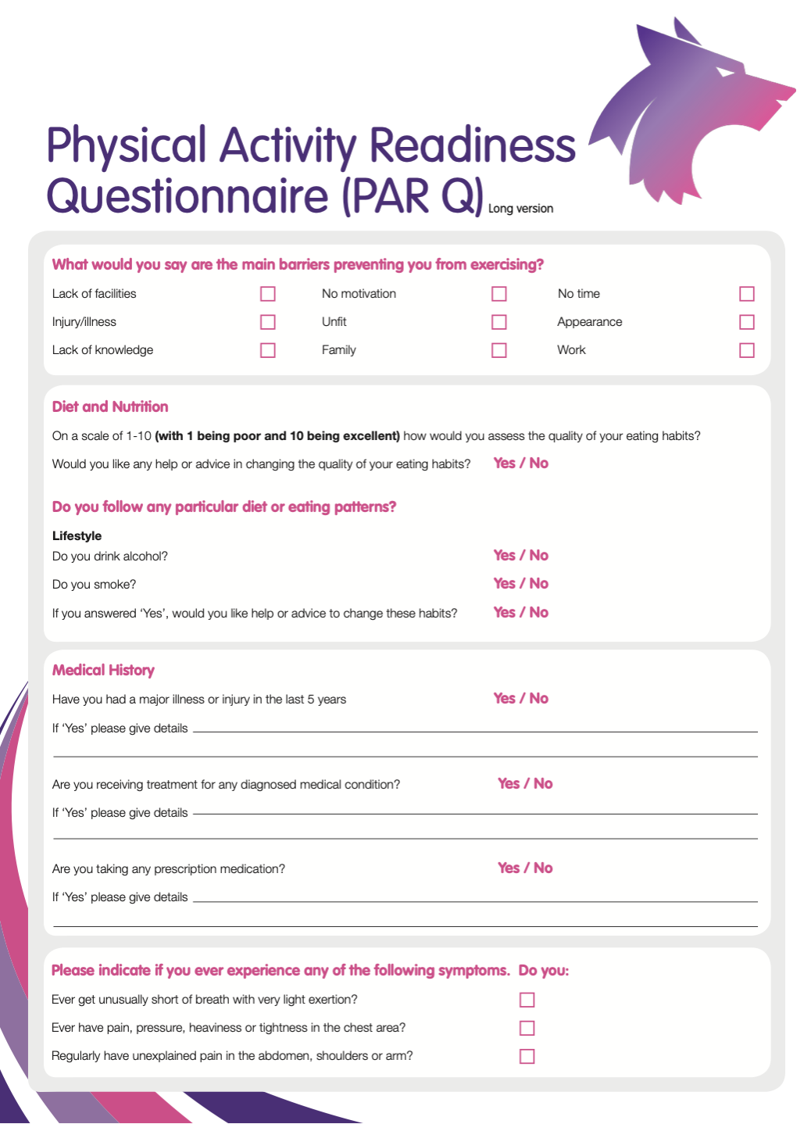
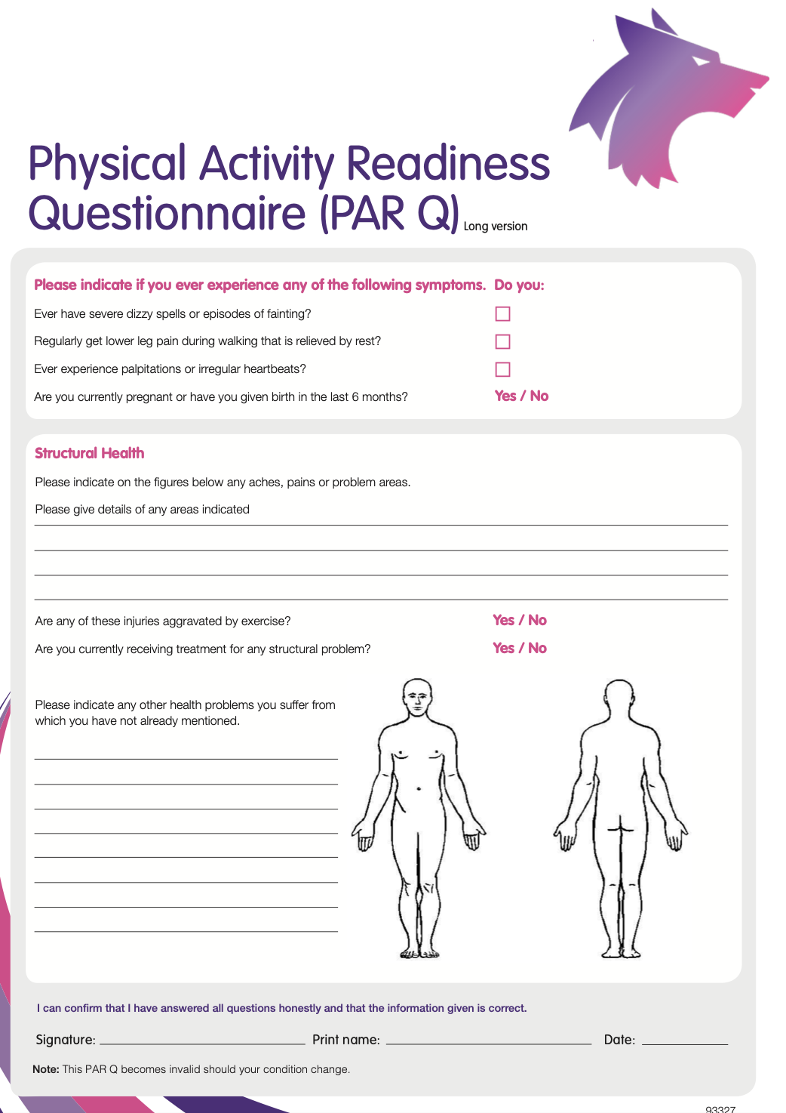
Monthly Health Assessment Consent Form

Name _________________________________________
Address _________________________________________
_________________________________________

Postcode _________________________________________
Telephone _________________________________________

The university of Wolverhampton is providing a Monthly health assessment to provide staff and students at the university with the following information about their health, blood pressure, BMI, weight, height, bone mass density, skeletal muscle mass and body fat percentage. To provide them with lifestyle advice if needed and monitor them over the year to help them achieve their goals.
How will my information be used?
The information that you provide about yourself will be used to give you nutritional, training and lifestyle advice, along with keeping a record of your health throughout the year.
Information that you provide to me will be recorded and stored securely. Both you and I will retain an electronic copy of this. With my copy stored on a locked and encrypted drive only I have access to. We understand that some information may be sensitive, and I will keep your information confidential and use it only for purposes of the health assessment. The only exception to this is if you tell me anything indicating that someone might be in danger; then we have a responsibility to act on that information, but we would not do this without telling you and including you in the process. We are not medical professionals and therefore we can advise you to see the GP by providing you with an advocacy letter to the GP if any of your results are abnormal.
Anonymised health data may be published about yourself, with all identifiers removed, within a research paper or project report. This may be published online and that published material from this may be used and distributed for training and service design and development.

Consent
I have read the information above and have had an opportunity to ask questions about the monthly health assessment and how my information will be used. I understand the purpose of this is for my own benefit and what my participation involves.
I agree to take part in the health assessment and for the information I provide to be shared between me and Olivia Simpson (who carries out the health assessment.)
I know that my participation is voluntary and that I can choose to withdraw from the health assessment program at any point.
I understand that muscle mass, bone mass and body fat percentage are estimates based on my height and weight.

Name: _________________________________________ (print)

Signed: _________________________________________

Witness name: _________________________________________ (print)

Signed: _________________________________________

Date: ___________________

Physical Measurements

Name: Age: Height: Weight:
Body Composition Parameters | 1st | 2nd | 3rd | 4th | 5th | 6th
Body Mass Index (%)
-A measure of weight and height
Muscle mass (KG)
-Total weight of all muscles in the body; including skeletal, cardiac and smooth muscle
Body Fat (%)
- refers to the amount of body fat mass in regard to the total bodyweight
Bone mass (KG)
-Mass of bone comprising of bone minerals (calcium and phosphorus etc) and bone matrix (collagen and inorganic salts etc)
Blood pressure (mmHg)
-The force at which blood is pumped through your arteries.
Resting Metabolism (Kcal)
-Indicates how many calories you need in order to provide enough energy for your body to function.

