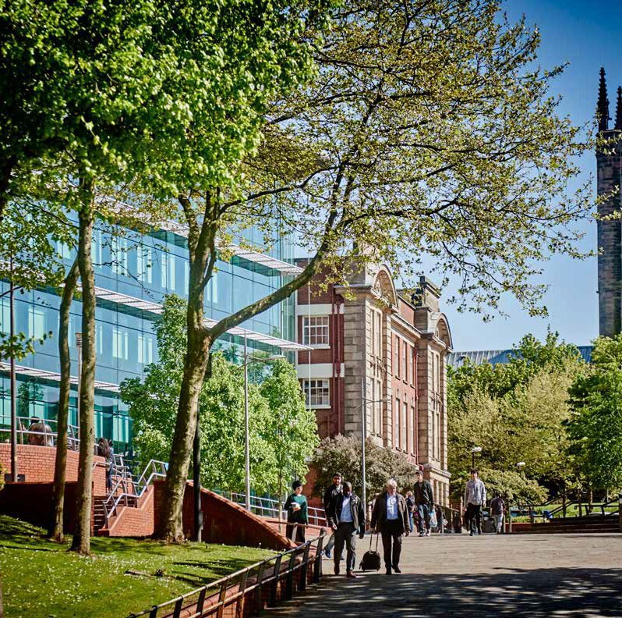

**Confidential Waste Disposal**

**Procedure**

1

2



1. **Introduction**
2. **Principles**

**3. Scope**

**4. Roles and Responsibilities**

**5. One-Off or additional collections**

**6. Exceptions**

**7. Amendments**

**8. Information and Resources**

**9. Contacts**

**PROCEDURE**

**Introduction**

The University has contracted Restore PLC the approved suppliers for the disposal

of paper and confidential waste. This procedure gives instructions to university staff

on the process for the disposal of confidential waste.

**Principles**

The implementation of this procedure is in accordance with the University’s core values which are to be:

Ethical

Respectful

Transparent

Inclusive and fair

Challenging

Confident

Collaborative

Professional

**Scope**

Each School/Service Area identifies a contact who will link with their local Campus Facilities Information Hubs for Confidential waste disposal.

[City Campus](mailto:Sarah.Martin@wlv.ac.uk?subject=WEEE%20Collection%20Request)

[Walsall Campus](mailto:N.Lloyd2@wlv.ac.uk?subject=WEEE%20Collection%20Request)

[Telford Campus](mailto:M.Porter2@wlv.ac.uk?subject=WEEE%20Collection%20Request)

[UWSPfacilitieshub@wlv.ac.uk](mailto:UWSPfacilitieshub@wlv.ac.uk)

**Roles and Responsibilities**

The representative identifies the departmental locations for bins. Containers will only be made available to those offices that are accessible by lift or are based on the ground floor. The container must be clearly marked on the top of the bin with the relevant Work Order.

Confidential waste bags can be provided for remote areas or for larger clear outs of

an individual’s office or storeroom. All bags used must have a work order number clearly written on them; otherwise, they will not be accepted. In most cases, there is an expectation that staff will take their confidential waste directly to their school/dept confidential waste disposal bin.

If a School, or department opts to have waste bags instead of containers, Schools

and departments need to ensure that they have sufficient space to store full bags

securely until collection by the company. Under no circumstances is confidential

waste to be left in unsecured areas such as corridors. This could make the University

legally vulnerable under the Data Protection Act for failing to exercise duty of care.

The contract charges for waste disposal are priced on a per kilo basis. The company

will attend site and remove and shred the documents either on the premises or at the depot. For each and every bag or container, a weight will be recorded. Any costs

incurred will be automatically directly coded to your work order and charged via

management accounts.

On each campus, the Facilities Information Hubs will be the point of contact. They

will send the relevant paperwork over to Business Support to make contact with the

waste disposal company. The company will attend site about every 6 weeks to

remove waste from containers. Further requests for the collection of full containers or large one-off collections are to be directed to the Facilities Information Hub and they will arrange disposal when the volume of waste makes it economic to do so.

All communication with the company needs to go through the Facilities Information

Hub and the Business Support Team. The volume of waste for a viable uplift is in the

region of 200kgs. This is the equivalent of two full wheelie bins or 18 full confidential waste sacks.

**For one- off or additional collections**

The Facilities Information Hubs will raise a schedule of collection based on

- the location points

- the work order to be recharged

- the number of containers/sacks

Additional services are available for Magnetic Waste i.e. CDs, DVDs, USBs etc.

Uniform, these most be stored/bagged separately to the paper waste and annotated on the waste collection sheet.

The schedule is emailed to the Estates and Facilities commercial team (e.f.commercial@wlv.ac.uk) who will liaise with the

contractor who will confirm the service date and access needs.

A certificate of destruction will be provided at the end of each destruction service.

This is signed by a member of Facilities staff. The certificate is retained on file for a

two-year period, with a copy forwarded to the Estates and Facilities commercial team,

Housman Building, City Campus.

When the invoice is received, the costs of service will be cross checked against the

certificate details and recharged directly through account management to

participating cost centres.

Please note that lever arch files and plastic sleeves need to be removed from

any confidential waste prior to disposal; otherwise, it will contaminate the load

and prevent it from being recycled.

**Exceptions**

There are no exceptions to this policy.

**Amendments**

This Procedure was approved by assistant Commercial Manager on 8/6/ 2023. The University may change this Procedure at any time, and where appropriate. Where a procedure is not due for review, but is found to require updating, it will remain published, unless the reasons for review render it obsolete.

**Information and Resources**

This procedure should be read in conjunction with the following policies and guidance Data Protection Act 2018 and the requirements of GDPR

**Contacts**

For general queries, please contact the University Estates and facilities commercial department by email or phone. Email: [e.f.commercial@wlv.ac.uk](mailto:e.f.commercial@wlv.ac.uk)

For general queries, please contact the University Corporate Compliance Team via email: [compliance@wlv.ac.uk.](mailto:compliance@wlv.ac.uk.)

|  |  |  |  |
| --- | --- | --- | --- |
| **VERSION** | 2.0 | **AUTHOR/OWNER** | Assistant Commercial Manager |
| **Approved Date** | 27/6/23 | **Approved By** | SMT |
| **Review Date** | 27/6/25 |  |  |