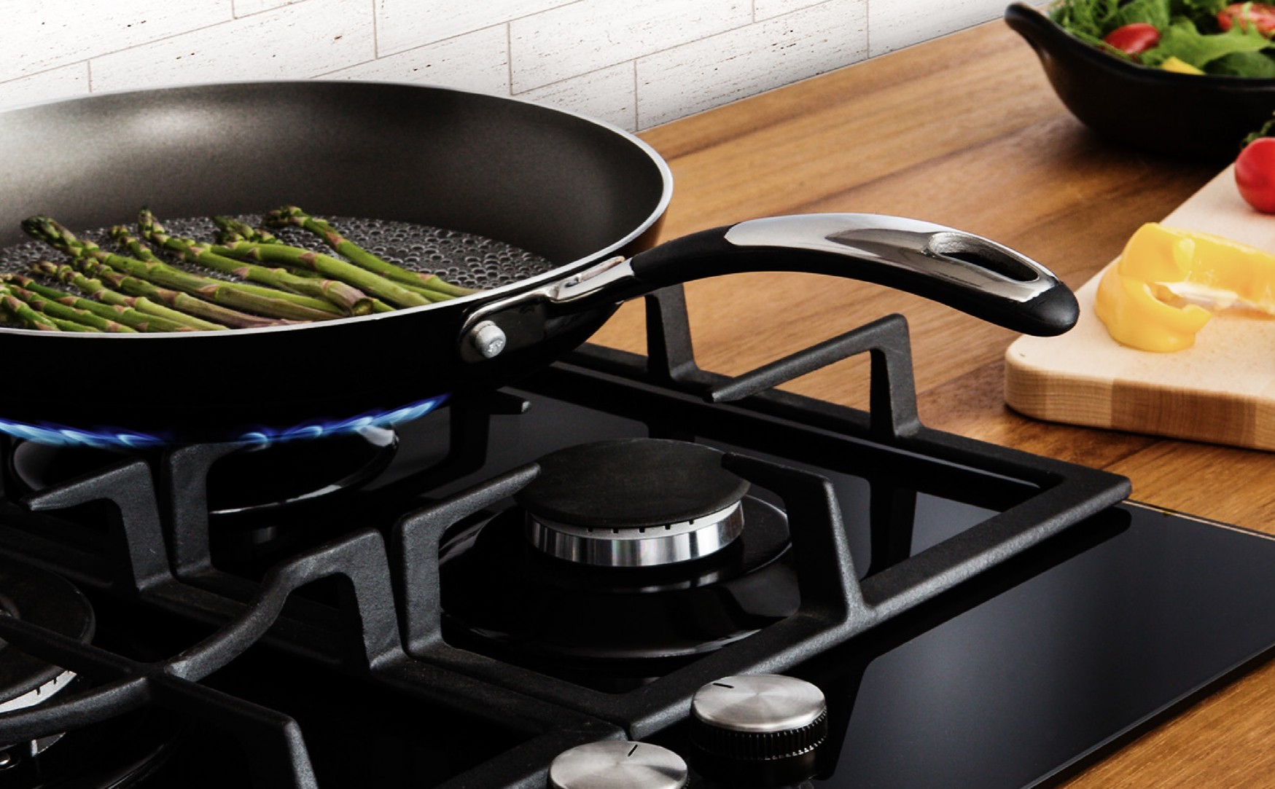
THE PERFECT BALANCE OF FUNCTION AND STYLE
Installation and Operating Instructions

LAUNDRY - DISHWASHING - COOKING - COOLING

Freestanding 20 litre Microwave
MMW21W/MMW22WS
Enamel Interior/Stainless Interior

Please read these instructions carefully before attempting to install or use this appliance. We recommend that you keep these instructions in a safe place for future reference.

Welcome

Thank you for choosing this Montpellier Freestanding Microwave.

Our Microwaves have been designed to provide you with the best combination of style, reliability and performance to give you years of trouble-free use.

You may be familiar with a similar product, but please take time to read these instructions carefully before installing or using your Microwave to ensure you get the most from your purchase.

We recommend that you keep this manual in a safe place for future reference.

Your Microwave is covered by a comprehensive two year Parts & Labour Guarantee. In the unlikely event that you experience a problem with your Microwave, you can rest assured that you are fully protected against the cost of repairs for the first 24 months . Please note that any claim must be accompanied by the model reference number, serial number and proof of purchase.

YEAR
GUARANTEE
PARTS & LABOUR

ACROSS ALL OUR MODELS

www.montpellier-appliances.com

To activate your guarantee, you will need your product serial number. This can be found on the rear of the machine.

There are two ways to register your Guarantee:

- Online: Visit the Support page on our website and complete the online Product Registration form. www.montpellier-appliances.com
- By Post: Simply detach and fill in the form provided, attach a stamp and send it in the post. Don’t forget to include your e-mail address so that we can send confirmation through to you.

Note: We are unable to take registrations over the phone.

PRECAUTIONS TO AVOID POSSIBLE EXPOSURE TO EXCESSIVE MICROWAVE ENERGY
- Do not attempt to operate this oven with the door open, since this can result in harmful exposure to microwave energy. It is important not to break or tamper with the safety interlocks.
- Do not place any object between the oven front face and the door or allow soil or cleaner residue to accumulate on sealing surfaces.
- WARNING: If the door or door seals are damaged, the oven must not be operated until it has been repaired by a qualified engineer.

ADDENDUM
If the apparatus is not maintained in a good state of cleanliness, its surface could be degraded and affect the lifespan of the apparatus and lead to a dangerous situation.

Specifications

Montpellier Model: | MMW21W / MMW22WS
Rated Voltage: | 240V~/50Hz
Rated Input Power(Microwave): | 1200W
Rated Output Power(Microwave): | 700W
Oven Capacity: | 20L
Turntable Diameter: | 255mm
External Dimensions: | 450x324x265mm
The appliances are not intended to be operated by means of an external timer or separate remote-control system.
This appliance is intended to be used in household and similar applications such as:
- staff kitchen areas in shops, offices and other working environments;
- farmhouses;
- by clients in hotels, motels and other residential type environments;
- bed and breakfast type environments.

IMPORTANT SAFETY INSTRUCTIONS

WARNING
To reduce the risk of fire, electric shock, injury to persons or exposure to excessive microwave oven energy when using your appliance, follow basic precautions, including the following:
- Warning: Liquids and other foods must not be heated in sealed containers since they are liable to explode.
- Warning: It is hazardous for anyone other than a qualified engineer to carry out any service or repair operation that involves the removal of a cover which gives protection against exposure to microwave energy.
- Warning: Only allow children to use the oven without supervision when adequate instructions have been given so that the child is able to use the oven in a safe way and understand the hazards of improper use.
- Warning: When the appliance is operated in the combination mode, children should only be permitted to use the oven under adult supervision, due to the temperatures generated. (only for grill series)
- Only use utensils suitable for use in microwave ovens.
- The oven should be cleaned regularly and any food deposits should be removed.
- Read and follow the specific:"PRECAUTIONS TO AVOID POSSIBLE EXPOSURE TO EXCESSIVE MICROWAVE ENERGY".
- When heating food in plastic or paper containers, keep an eye on the oven due to the possibility of ignition.
- If smoke is observed, switch off or unplug the appliance and keep the door closed in order to stifle any flames.
- Do not overcook food.
- Do not use the oven cavity for storage purposes. Do not store items, such as bread, cookies, etc. inside the oven.
- Remove wire twist-ties and metal handles from paper or plastic containers/bags before placing them in the oven.
- Install or locate this oven only in accordance with the installation instructions provided.

- Eggs in the shell or whole hard-boiled eggs should not be heated in microwave ovens since they may explode, even after microwave heating has ended.

- Use this appliance only for its intended uses as described in manual. Do not use corrosive chemicals or vapours in this appliance. This oven is specifically designed to heat.
It is not designed for industrial or laboratory use.
- If the supply cable is damaged, it must be replaced by the manufacturer, its service agent or similarly qualified persons in order to avoid a hazard.
- Do not store or use this appliance outdoors.
- Do not use this oven near water, in a wet basement or near a swimming pool.
- The temperature of accessible surfaces may be high when the appliance is operating. Keep cable away from heated surface, and do not cover any vents on the oven.
- Do not let the cable hang over the edge of a table or counter.
- Failure to maintain the oven in a clean condition could lead to deterioration of the surface that could adversely affect the life of the appliance and possibly result in hazardous situation.
- The contents of feeding bottles and baby food jars must be stirred or shaken and the temperature checked before consumption, in order to avoid burns.
- Microwave heating of beverages can result in delayed eruptive boiling, therefore take care when handling the container.
- The appliance is not intended for use by persons (including children) with reduced physical , sensory or mental capabilities, or lack of experience and knowledge, unless they have been given supervision or instruction concerning use of the appliance by a person responsible for their safety.
- Children should be supervised to ensure that they do not play with the appliance.
Cleaning and user maintenance must not be undertaken by children without supervision.
- The microwave oven shall not be placed in a cabinet.
- The microwave oven is intended for heating food and beverages. Drying of food or clothing and heating of warming pads, slippers, sponges, damp cloths and similar may lead to risk
of injury, ignition or fire. The microwave oven is intended to be used freestanding.The appliance must be placed against the wall. Do not immerse the appliance in water or other liquid when cleaning. The appliance must not be cleaned with a steam cleaner.

To Reduce the Risk of Injury to Persons Earthing Installation

DANGER
Electric Shock Hazard - Touching some of the internal components can cause serious injury or death. Do NOT disassemble this appliance.

WARNING
Electric Shock Hazard - Improper use of the earthing can result in electric shock. Do not plug into an outlet until the appliance is properly installed and earthed.

CLEANING
Disconnect the oven from the power supply.
- Clean the inside of the oven after using with a slightly damp cloth.
- Clean the accessories in the usual way in soapy water.
- The door frame and seal and neighbouring parts must be cleaned carefully with a damp cloth.

This appliance must be earthed. In the event of an electrical short circuit, earthing reduces the risk of electric shock by providing an escape wire for the electric current. This appliance is equipped with a cable with an earth wire with an earthed plug.
The plug must be plugged into an outlet that is properly installed and
earthed. Consult a qualified electrician or service agent if the earthing BS
instructions are not completely understood or if doubt exists as to whether the appliance is properly earthed. If it is necessary to use an extension cable, use only a 3-pin plug extension cable.
- A short power-supply cable is provided to reduce the risks resulting from becoming entangled in or tripping over a longer cable.
- If a longer extension cable is used:
  - The marked electrical rating of the cable or extension cable should be at least
as per the electrical rating of the appliance.
  - The extension cable must be an earthed cable with a 3-pin plug.
  - A long cable should be arranged so that it will not drape over the counter top or tabletop where it can be pulled by children or tripped over unintentionally.

UTENSILS CAUTION
Personal Injury Hazard
It is hazardous for anyone other than a qualified engineer to carry out any service or repair operation that involves the removal of a cover which gives protection against exposure to microwave energy.
See the instructions on "Materials you can use in microwave oven or to be avoided in microwave oven". There may be certain non-metallic utensils that are not safe to use for microwaving.
If in doubt, you can test the utensil in question following the procedure below Utensil Test:
- Fill a microwave-safe container with 1 cup of cold water (250ml) along with the utensil in question.
- Cook on maximum power for 1 minute.
- Carefully feel the utensil. If the empty utensil is warm, do not use it for microwave cooking.
Materials you can use in the microwave oven.
Utensils Remarks
Aluminum foil Shielding only. Small smooth pieces can be used to cover thin parts of

MMW22WS Only

Browning dish

Dinnerware Glass jars Glassware
Oven cooking bags
Paper plates and cups Paper towels

Parchment paper
Plastic

Plastic wrap
meat or poultry to prevent overcooking. Arcing can occur if foil is too close to oven walls. The foil should be at least 1 inch (2.5cm) away from oven walls.
Follow manufacturer’s instructions. The bottom of browning dish must be at least 3/16 inch (5mm) above the turntable. Incorrect usage may cause the turntable to break.
Microwave-safe only. Follow manufacturer's instructions. Do not use cracked or chipped dishes.
Always remove lid. Use only to heat food until just warm. Most glass jars are not heat resistant and may break.
Heat-resistant oven glassware only. Make sure there is no metallic trim. Do not use cracked or chipped dishes.
Follow manufacturer’s instructions. Do not close with metal tie. Make slits to allow steam to escape.
Use for short–term cooking/warming only. Do not leave oven unattended while cooking.
Use to cover food for reheating and absorbing fat. Use with supervision for a short-term cooking only.
Use as a cover to prevent splattering or a wrap for steaming.

Microwave-safe only. Follow the manufacturer’s instructions. Should be labeled "Microwave Safe". Some plastic containers soften, as the food inside gets hot. "Boiling bags" and tightly closed plastic bags should be slit, pierced or vented as directed by package.
Microwave-safe only. Use to cover food during cooking to retain moisture. Do not allow plastic wrap to touch food.

Thermometers Microwave-safe only (meat and candy thermometers). Wax paper Use as a cover to prevent splattering and retain moisture.

Materials to be avoided in microwave oven
Utensils Remarks

Aluminum tray Food carton with metal handle Metal or metal- trimmed utensils
Metal twist ties Paper bags Plastic foam

Wood
May cause arcing. Transfer food into microwave-safe dish. May cause arcing. Transfer food into microwave-safe dish.

Metal shields the food from microwave energy. Metal trim may cause arcing.
May cause arcing and could cause a fire in the oven. May cause a fire in the oven.
Plastic foam may melt or contaminate the liquid inside when exposed to high temperature.
Wood will dry out when used in the microwave oven and may split or crack.

SETTING UP YOUR OVEN
Names of Oven Parts and Accessories
Remove the oven and all materials from the carton and oven cavity. Your oven comes with the following accessories:
-Glass tray 1 A
-Turntable Ring Assembly 1
-Instruction Manual 1
F

E D C B

G A) Control Panel
  - Turntable Shaft
  - Turntable Ring Assembly
  - Glass Tray
  - Observation Window
  - Door Assembly
  - Safety Interlock System

Shut off oven power if the door is opened during operation.

Turntable Installation
Hub (underside)

Glass Tray

Turntable Shaft

- Never place the glass tray upside down. The glass tray should never be restricted.
- Both glass tray and turntable ring assembly must always be used during cooking.
- All food and containers of food are always placed on the glass tray for cooking.
- If glass tray or turntable ring assembly cracks or breaks, contact your nearest authorised service department.

Turntable Ring Assembly

Countertop Installation
Remove all packing material and accessories. Examine the oven for any damage such as dents or broken door. Do not install if oven is damaged.

Cabinet: Remove any protective film found on the microwave oven cabinet surface. Do not remove the light brown Mica cover that is attached to the oven cavity to protect the magnetron.

Installation
- Select a level surface that provides enough open space for the air intake and/or outlet vents.
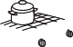
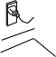
12 inch(30cm)
3.0 inch(7.5cm)
OPEN
3.0 inch(7.5cm)

A minimum clearance of 3 inches
(7.5cm) is required between the oven and any adjacent walls. One side must be open.
  - Leave a minimum clearance of 12 inches (30cm) above the oven.
  - Do not remove the legs from the bottom of the oven.

  - Blocking the intake and/or outlet openings can damage the oven.
  - Place the oven as far away from radios and TV as possible. Operation of a microwave oven may cause interference to your radio or TV reception.
- Plug your oven into a standard household outlet. Be sure the voltage and the frequency is the same as the voltage and the frequency on the rating label.

WARNING: Do not install oven over a range cooktop or other heat-producing appliance. If installed near or over a heat source, the oven could be damaged and the warranty would be void.

The accessible surface may be hot during operation.

OPERATION

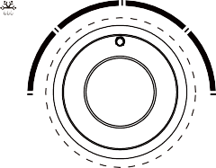
Control Panel and Features Operation Instructions
POWER
Med
M.Low
M.High

1.Set cooking power by turning the
power knob to the desired level.
Power | Low |  |  |  |  | High | 2.Set the time of cooking by turning the
 |  |  |  |  |  |  | timer knob to the desired time, as per
 |  |  |  |  |  |  | your food cooking guide.
 | 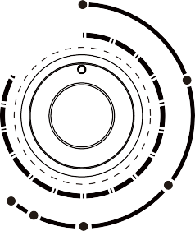  Defrost (kg) |  |  |  |  |  | 3.The microwave oven will automatically
 | TIMER (min) | 0 | 1 |  |  |  | start cooking after the power level and
 |  |  |  | 2 |  |  | time are set.
 | 35 |  |  |  | 3 | 0.2 | 4.After the cooking time is up, the alarm
 | 30 |  |  |  |  | 4 | will signal that it has stopped.
Timer | 25 |  |  |  |  | 5 | 5.If the oven is not in use, always set
 | 20 |  |  |  | 6 |  | time to "0".
15 7 0.4
1.0 10 9 8
0.8
0.6

Function/Power | Output | Application
Low | 17% micro. | Soften ice cream
Med. Low (Defrost) | 33% micro. | Soup, stews, soften butter or defrost
Med. | 55% micro. | Stew, fish
Med. High | 77% micro. | Rice, fish, chicken, mincemeat
High | 100% micro. | Reheating, boil water/milk, vegetables, drinks

Notice: When removing food from the oven, please ensure that the oven power is switched off by turning the timer switch to 0 (zero). Failure
to do so, or operating the microwave oven without food in it, can result in overheating and damage to the magnetron.

Troubleshooting

 | 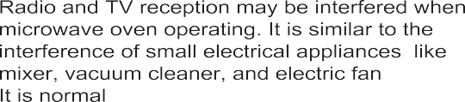
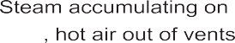 | 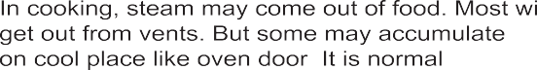
 | It is forbidden to run the unit without any food inside. It is very dangerous.

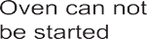 | 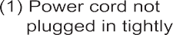 | 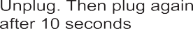
 | 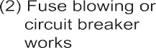 | 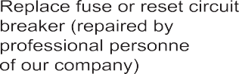
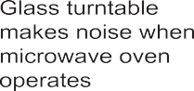 | 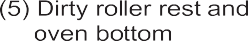 | 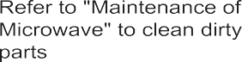

According to Waste of Electrical and Electronic Equipment
(WEEE) directive, WEEE should be separately collected and treated. If at any time in future you need to dispose of this product please do NOT dispose of this product with household waste. Please send this product to WEEE collecting points where available.

Here For You
Here For You

After-sales assistance
If you continue to experience problems with your microwave, please call the Montpellier customer service helpline on: 03333 234 473.

Please have all your product details available, including the model number, serial number, date of purchase, and your retailer’s details before registering a fault.

The service call cannot progress without this information.

Your 2 year Manufacturer’s guarantee
THIS DOES NOT AFFECT YOUR STATUTORY RIGHTS.
Your new Montpellier appliance carries a free guarantee which protects you against the cost of repairs during the first 24 months from date of purchase provided that:
Any claim is accompanied by evidence of the model reference, model serial number and proof of purchase, such as a Sales Receipt, showing that the appliance was purchased within the 24 months prior to the date
of claim.

What is not covered under the Guarantee
- Any appliance not correctly installed and operated in accordance with the manufacturer’s instructions.
- Any appliance that is used for anything other than domestic purposes.
- Any defect caused by accident, misuse, unauthorised modification or inexpert repair.
- Cost of Call-out where a fault cannot be found with the appliance.
- Cost of Call-out for work covering routine maintenance, such as, but not exclusively, cleaning of filters or defrosting.
- Cost of Call-out for work required to correct the alignment of doors following door reversal procedures carried out by you.
- Use of the appliance by anyone other than the Householder.
- Use in any commercial environment.
- Consumable items, such as, but not exclusively, fuses in plugs, bulbs and breakable items which require routine replacement.
- Repair costs incurred that have not been authorised by Repairtech and/or carried out by a non-approved Repairtech engineer.

YOUR GUARANTEE IS VALID ONLY IN THE UK & ROI.

To register your appliance simply complete the card in your appliance pack and return it with a stamp affixed or alternatively you can register online at www.montpellier-appliances.com/support

SERVICE HELP-LINE
Should your appliance develop a fault, please call the Montpellier customer service helpline on: 03333 234 473. Please remember to have all your product details available, including the model number, serial number, date of purchase and your retailer’s details before registering a fault.
Your service call cannot progress without this information.

Montpellier Domestic Appliances Ltd.
Unit 1, Tewkesbury Retail Park, Northway Lane, Tewkesbury, Gloucestershire GL20 8JU

www.montpellier-appliances.com

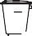
The symbol on the product or on its packaging indicates that this product may not be treated as household waste. Instead it shall be handed over to the applicable collection point for the recycling of electrical and electronic equipment. By ensuring this product is disposed of correctly, you will help prevent potential negative consequences for the environment and human health, which could otherwise be caused by inappropriate waste handling of this product. For more detailed information about recycling of this product, please contact your local city office, your household waste disposal service or the shop where you purchased the product.

