CMAFS20LWH
Microwave User Manual

Microwave Oven
INSTRUCTION MANUAL
Model:CMAFS20LWH

Read these instructions carefully before using your microwave oven, and keep it carefully.
If you follow the instructions, your oven will provide you with many years of good service.

SAVE THESE INSTRUCTIONS CAREFULLY

PRECAUTIONS TO AVOID POSSIBLE EXPOSURE TO EXCESSIVE MICROWAVE ENERGY
- Do not attempt to operate this oven with the door open since this can result in harmful exposure to microwave energy. It is important not to break or tamper with the safety interlocks.
- Do not place any object between the oven front face and the door or allow soil or cleaner residue to accumulate on sealing surfaces.
- WARNING: If the door or door seals are damaged, the oven must not be operated until it has been repaired by
a competent person.

ADDENDUM
If the apparatus is not maintained in a good state of cleanliness, its surface could be degraded and affect the lifespan of the apparatus and lead to a dangerous situation.

Specifications

Model: | CMAFS20LWH
Rated Voltage: | 230V-240V~ 50Hz
Rated Input Power(Microwave): | 1200W-1270W
Rated Output Power(Microwave): | 750W-800 W
Oven Capacity: | 20 L
Turntable Diameter: | 255 mm
External Dimensions: | 440x355x259mm
Net Weight: | Approx. 10.8 kg

IMPORTANT SAFETY INSTRUCTIONS WARNING
To reduce the risk of fire, electric shock, injury to persons or exposure to excessive microwave oven energy when using your appliance, follow basic
precautions, including the following:
- Read and follow the specific:"PRECAUTIONS TO AVOID POSSIBLE EXPOSURE TO EXCESSIVE
MICROWAVE ENERGY".
- This appliance can be used by children aged from 8 years and above and persons with reduced physical, sensory or mental capabilities or lack of experience
and knowledge if they have been given supervision or
instruction concerning use of the appliance in a safe way and understand the hazards involved. Children shall not play with the appliance. Cleaning and user maintenance
shall not be made by children unless they are older than 8 and supervised. Children less than 8 years of age shall be kept away unless continuously supervised.
- Keep the appliance and its cord out of reach of children less than 8 years.
- If the supply cord is damaged, it must be replaced by the manufacturer, its service agent or similarly qualified persons in order to avoid a hazard.( For appliance with type Y attachment)

- WARNING: Ensure that the appliance is switched off before replacing the lamp to avoid the possibility of
electric shock.
- WARNING: It is hazardous for anyone other than a competent person to carry out any service or repair
operation that involves the removal of a cover which
gives protection against exposure to microwave energy.
- WARNING: Liquids and other foods must not be heated in sealed containers since they are liable to explode.
- When heating food in plastic or paper containers,
keep an eye on the oven due to the possibility of ignition.
- Only use utensils that are suitable for use in microwave ovens.
- If smoke is emitted, switch off or unplug the appliance and keep the door closed in order to stifle any flames.
- Microwave heating of beverages can result in
delayed eruptive boiling, therefore care must be taken when handling the container.
- The contents of feeding bottles and baby food jars
shall be stirred or shaken and the temperature checked before consumption, in order to avoid burns.
- Eggs in their shell and whole hard-boiled eggs should not be heated in microwave ovens since they may
explode, even after microwave heating has ended.
- The oven should be cleaned regularly and any food deposits removed.
- Failure to maintain the oven in a clean condition could lead to deterioration of the surface that could

adversely affect the life of the appliance and possibly result in a hazardous situation.
- The appliance must not be installed behind a
decorative door in order to avoid overheating. (This is not applicable for appliances with decorative door.)
- Only use the temperature probe recommended for this oven.(for ovens provided with a facility to use a
temperature-sensing probe.)
- The microwave oven shall not be placed in a cabinet unless it has been tested in a cabinet.
- The microwave oven must be operated with the
decorative door open. (for ovens with a decorative door.) 20.This appliance is intended to be used in household
and similar applications such as:
-staff kitchen areas in shops, offices and other working environments;
-by clients in hotels, motels and other residential type environments;
-farm houses;
-bed and breakfast type environments.
- The microwave oven is intended for heating food and beverages. Drying of food or clothing and heating of
warming pads, slippers, sponges, damp cloth and similar may lead to risk of injury, ignition or fire.
- Metallic containers for food and beverages are not allowed during microwave cooking.
- The appliance shall not be cleaned with a steam cleaner.
- The appliance is intended to be used freestanding.

- The rear surface of appliances shall be placed against a wall.

READ CAREFULLY AND KEEP FOR FUTURE REFERENCE

To Reduce the Risk of Injury to Persons Grounding Installation

DANGER
Electric Shock Hazard Touching some of the
internal components can cause serious personal
injury or death. Do not disassemble this
appliance.

WARNING
Electric Shock Hazard
Improper use of the grounding can result in electric shock.
Do not plug into an outlet until appliance is properly installed and grounded.
This appliance must be grounded. In the event of an electrical short circuit, grounding reduces the risk of electric shock by providing an escape wire for the electric current.
This appliance is equipped with a cord having a grounding wire with
a grounding plug. The plug must be plugged into an outlet that is properly installed and grounded.
Consult a qualified electrician or serviceman
if the grounding instructions are not completely understood or if doubt exists as to whether the appliance is properly grounded.
If it is necessary to use an extension cord, use only a 3-wire extension cord.

- A short power-supply cord is provided to reduce the risks resulting from becoming entangled in or tripping over a longer cord.
- If a long cord set or extension cord is used:
  - The marked electrical rating
of the cord set or extension cord should be at least as great as the electrical rating of the appliance.
  - The extension cord must be a grounding-type 3-wire cord.
  - The long cord should be arranged so that it will not drape over the counter top or tabletop where it can be pulled on
by children or tripped over unintentionally.

CLEANING
Be sure to unplug the appliance from the power supply.
- Clean the cavity of the oven after using with a slightly damp cloth.
- Clean the accessories in the usual way in soapy water.
- The door frame and seal and neighbouring parts must be cleaned carefully with a damp cloth when they are dirty.
- Do not use harsh abrasive cleaners or sharp metal scrapers to clean the oven door glass since they can scratch the surface, which may result in shattering of the glass.
- Cleaning Tip---For easier cleaning of the cavity walls that the food cooked can touch: Place half a lemon in a bowl, add 300ml (1/2 pint) water and heat on 100% microwave power for 10 minutes. Wipe the oven clean using a soft, dry cloth.

UTENSILS

CAUTION
Personal Injury Hazard See the instructions on "Materials you can use in

It is hazardous for anyone other than a competent person to
carry out any service
or repair operation that involves the removal of a cover which gives protection against exposure to microwave energy.
microwave oven or to be avoided in microwave oven." There may be certain non-metallic utensils that are not safe to use for microwaving. If in doubt, you can test the utensil in question following the procedure below.
Utensil Test:
- Fill a microwave-safe container with 1 cup of cold water (250ml) along with the utensil in question.
- Cook on maximum power for 1 minute.
- Carefully feel the utensil. If the empty utensil is warm, do not use it for microwave cooking.
- Do not exceed 1 minute cooking time.

Materials you can use in microwave oven
Utensils Remarks

Browning dish

Dinnerware Glass jars Glassware
Oven cooking bags
Paper plates and cups
Paper towels

Parchment paper
Plastic

Plastic wrap
Follow manufacturer’s instructions. The bottom of browning dish must be at least 3/16 inch (5mm) above the turntable. Incorrect usage may cause the turntable to break.
Microwave-safe only. Follow manufacturer's instructions. Do not use cracked or chipped dishes.
Always remove lid. Use only to heat food until just warm. Most glass jars are not heat resistant and may break.
Heat-resistant oven glassware only. Make sure there is no metallic trim. Do not use cracked or chipped dishes.
Follow manufacturer’s instructions. Do not close with metal tie. Make slits to allow steam to escape.
Use for short–term cooking/warming only. Do not leave oven unattended while cooking.
Use to cover food for reheating and absorbing fat. Use with supervision for a short-term cooking only.
Use as a cover to prevent splattering or a wrap for steaming.

Microwave-safe only. Follow the manufacturer’s instructions. Should be labeled "Microwave Safe". Some plastic containers soften, as the food inside gets hot. "Boiling bags" and tightly closed plastic bags should be slit, pierced or vented as directed by package.
Microwave-safe only. Use to cover food during cooking to retain moisture. Do not allow plastic wrap to touch food.

Thermometers Microwave-safe only (meat and candy thermometers). Wax paper Use as a cover to prevent splattering and retain moisture.

Materials to be avoided in microwave oven
Utensils Remarks

Aluminum tray Food carton with metal handle Metal or metal- trimmed utensils
Metal twist ties Paper bags Plastic foam

Wood
May cause arcing. Transfer food into microwave-safe dish. May cause arcing. Transfer food into microwave-safe dish.

Metal shields the food from microwave energy. Metal trim may cause arcing.
May cause arcing and could cause a fire in the oven. May cause a fire in the oven.
Plastic foam may melt or contaminate the liquid inside when exposed to high temperature.
Wood will dry out when used in the microwave oven and may split or crack.

SETTING UP YOUR OVEN
Names of Oven Parts and Accessories
Remove the oven and all materials from the carton and oven cavity. Your oven comes with the following accessories:
Glass tray 1 A
Turntable ring assembly 1 Instruction Manual 1
F

E D C B

G A) Control panel
  - Turntable shaft
  - Turntable ring assembly
  - Glass tray
  - Observation window
  - Door assembly
  - Safety interlock system

Turntable Installation
Hub (underside)

Glass tray

Turntable shaft

- Never place the glass tray upside down. The glass tray should never be restricted.
- Both glass tray and turntable ring assembly must always be used during cooking.
- All food and containers of food are always placed on the glass tray for cooking.
- If glass tray or turntable ring assembly cracks or breaks, contact your nearest authorized service center.

Turntable ring assembly

Countertop Installation
Remove all packing material and accessories. Examine the oven for any damage such as dents or broken door. Do not install if oven is damaged.

Installation
  - Select a level surface that provide enough open space for the intake and/or outlet vents.
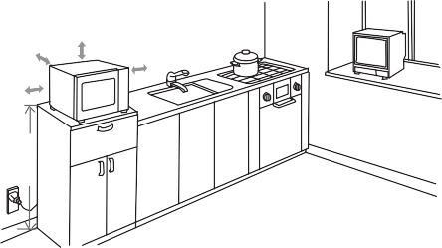
30cm
0cm
20cm
20cm
min85cm
- The minimum installation height is 85cm.
- The rear surface of appliance shall be placed against a wall.
Leave a minimum clearance of 30cm above the oven, a minimum clearance of 20cm is required between the oven and any adjacent walls.
- Do not remove the legs from the bottom of the oven.
- Blocking the intake and/ or outlet openings can damage the oven.

Cabinet: Remove any protective film found on the microwave oven cabinet surface.
Do not remove the light brown Mica cover that is attached to the oven cavity to protect the magnetron.

- Place the oven as far away from radios and TV as possible. Operation of microwave oven may cause interference to your radio or TV reception.
  - Plug your oven into a standard household outlet. Be sure the voltage and the frequency is the same as the voltage and the frequency on the rating label.
WARNING: Do not install oven over a range cooktop or other heat-producing appliance. If installed near or over a heat source, the oven could be damaged and the warranty would be void.
The accessible surface may be
hot during operation.

OPERATION
Control Panel and Features Operation Instructions

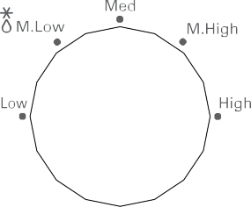
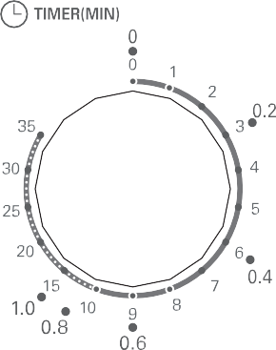
Power

Timer

- To set cooking power by turning the power knob to desired level.
- To set the time of cooking by turning the timer knob to desired time per your food cooking guide.
- The microwave oven will automatically start cooking after power level and time are set.
- After the cooking time is up, the unit will "Dong" to stop.
- If the unit is not in use, always set time to "0".

Function/Power | Output | Application
Low | 17% micro. | Soften ice cream
Med. Low (Defrost) | 33% micro. | Soup stew, soften butter or defrost
Med. | 55% micro. | Stew, fish
Med. High | 77% micro. | Rice, fish, chicken, ground meat
High | 100% micro. | Reheat, milk, boil water, vegetables, beverage
Notice: When removing food from the oven, please ensure that the oven power is switched off by turning the timer switch to 0 (zero).
Failure to do so, and operating the microwave oven without food in it, can result in overheating and damage to the magnetron.

Trouble shooting

 | 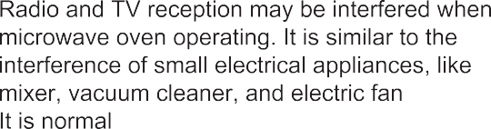
 | 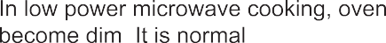
 | 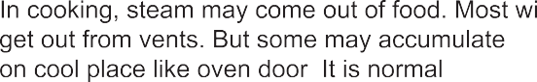
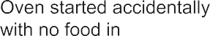 | It is forbidden to run the unit without any food inside. It is very dangerous.

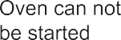 | 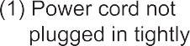 | 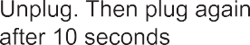
 | 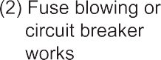 | 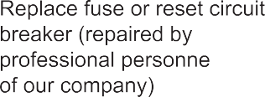
 |  | 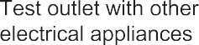
According to Waste of Electrical and Electronic Equipment (WEEE) directive, WEEE should be separately collected and treated. If at any time in future you need to dispose of this product please do NOT dispose of this product with household waste. Please send this product to WEEE collecting points where available.

PN:16170000A73475

