Congratulations on your choice of a •eKa quality Appliance which has been designed to give you service for many years.

WARNING! IMPORTANT!

DO NOT connect your appliance to the electricity supply until all packing and transit protectors have been removed.
- Leave to stand for at least 4 hours before switching on to allow compressor oil
to settle if transported horizontally.
- If you are discarding an old refrigerator with a lock or latch fitted to the door, disable the lock/latch, ensure that it is left in a safe condition to prevent the entrapment of young children.
- This appliance must only be used for its intended purpose i.e the storing and freezing of edible foodstuff.
- Do not oispose of the appliance on a fire. Your aJ?pliance contains non CFC substances in the insulation which are potentially flammable if exposed to fire.
- We suggest you contact your local authority for disposal information and facilities available.
- We do not recommend use of this appliance in an unheated, cold room. (E.g.: garage, conservatory, annex, shed, out-house etc.)
- To obtain the best possible performance and trouble free operation from your appliance it is very important to carefully read these instructions.
- On delivery, check to make sure that the product is not damaged and that all the parts and accessories are in r:>erfect condition.
- We do not recommend the use of extension leads and multi-way adapters.
- Failure to observe these instructions may invalidate your right to free service during the guarantee period.
WARNING- Do not use electrical appliances inside the food storage compartments
of the appliance, unless they are of the type recommended by the manufacturer.
- We suggest you keep these instructions in a safe place for easy reference.

•eK•
Tall Larder Fridge
TLS 480, TLG 980
PERFORMANCE
Energy efficiency class | B
Energy consumption - Kwh/year | 226
Net storage - vol fresh food ltrs (cu.ft.) | 248 It. (8.8)
Net storage - vol frozen food ltrs {cu.ft.)
Total net vol - ltrs (cu.ft.) | 248 It. (8.8)
Frozen food compartment rating
Conservation time from failure
Freezing capacity fresh food - kg
Climate class | SN
Operating noise level dB(A) | 40

CONTENTS PAGE

ELECTRICAL REQUIREMENTS
Before you insert the plug into the wall socket make sure that the voltage and the frequency shown in the rating plate inside the appliance corresponds to your electricity supply.

SAFETY FIRST/ ELECTRICAL REQUIREMENTS TRANSPORTATION INSTRUCTIONS INSTALLATION INSTRUCTIONS REPOSITIONING THE DOOR
SUGGESTED ARRANGEMENT OF FOOD IN THE REFRIGERATOR TEMPERATURE CONTROL AND ADJUSTMENT
STARTING DEFROSTING CLEANING AND CARE
REPLACING THE INTERIOR LIGHT BULB

DO'S AND DON'TS

PROBLEM SOLVING

GUARANTEE DETAILS HOW TO OBTAIN SERVICE
3

4

5

6

7-8

8

9

9

10

11

12

12

13

13
We recommend that this appliance is connected to the mains supply via a suitable switched and fused socket in a readily accessible position. Should the mains lead of the appliance become damaged or should it need replacing at anx time, it must be replaced by a special purpose made mains lead which can only be obtained from a BEKO Authorised Service Agent.

WARNING! THIS APPLIANCE MUST BE EARTHED
If the fitted moulded plug is not suitable for your socket, then the plug should be cut off and an appropriate plug fitted. Destroy the old plug whicli is cut off as a plug with bared cord could cause a shock hazard if inserted into a socket elsewhere in the house.
The moulded plug on this appliance incorporates a 13 A fuse. Should the fuse
need to be ref?laced an ASTA approved BS 1362 fuse of the same rating must be used. Do not torget to refit the fuse cover. In the event of losing the fuse cover the plug must not be used until a replacement fuse cover has been fitted. Colour of the replacement fuse cover must be the same colour as that visible on the pin face of the plug. Fuse covers are available from any good electrical store.

IMPORTANT! FITTING A DIFFERENT PLUG
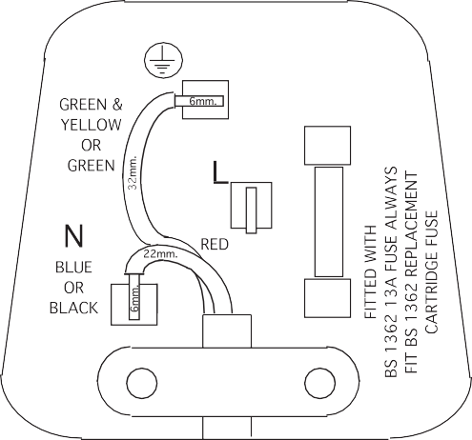
As the colours of the wires in the mains lead of this appliance may not correspond with the coloured markings identifying the terminals in your plug proceed as follows:
BROWN
LU
(./)
oa
=>
LL
CORD GRIP
(See diagram).

- Connect the green-yellow or green (Earth) wire to the terminal in the plug marked 'E' or with

the symbol or coloured green and yellow or green.
- Connect the blue (Neutral) wire to the terminal in the plug marked 'N' or coloured black.

- Connect the brownf Live) wire to the terminal in the pug marked 'L' or coloured red.
With alternative plugs a 13 A fuse must be fitted either in the plug or adaptor or in the main fuse box.
If in doubt contact a qualified electrician.

TRANSPORTATION INSTRUCTIONS
- The appliance should be transported only in a vertical upright position. The packing as supplied must be intact during transportation.
- If during the course of transport the appliance has been transported
horizontally, it must not be operated for at least 4 hours to allow the system to settle.
- Failure to comply with the above instructions could result in damage occuring

IMPORTANT
INSTALLATION INSTRUCTIONS
- If possible avoid placing the appliance near cookers, radiators or in direct sunlight as this will cause the compressor to run for long periods. If installed next to a source of heat or refrigerator, maintain the following minimum side clearances:

to the appliance. The manufacturer will not be held responsible if these instructions are disregarded.
- The appliance must be protected against rain, moisture and other
atmospheric influences.
From Cookers From Radiators
From Refrigerators or Freezers
2" (50 mm)
12" (300 mm)
1" (25 mm)

- When positioning your appliance take care not to damage your flooring, pipes, wall coverings etc. Do not move the appliance by pulling by the door or handle.
- Empty any water in the drain tray before moving. See section 'Defrosting' and
'Care & cleaning' for further information.

IMPORTANT : Care must be taken while cleaning / carrying the appliance to avoid touching the bottom of the condenser metal wires at the back of the appliance as you might injure your fingers and hands.

IMPORTANT : This appliance is not designed for stacking with any other appliance.
Do not attempt to sit or stand on top of your appliance as it is not designed for such use. You could injure yourself or damage the appliance.

"IMPORTANT: Make sure that mains cable is not caught under the appliance during and after carrying / moving the appliance, to avoid the mains cable becoming cut or damaged."

Do not allow children to play with the appliance or tamper with the controls. Beko (UK) Ltd. declines to accept any liability should the instructions not be followed.
- Make sure that sufficient room is provided around the appliance to ensure free air circulation.
- Fit the two plastic wall spacer supplied with the appliance rotating 1 / 4 turn to the condenser at the back of the refrigerator (see diagram).
- The appliance should be located on a smooth surface. The two front feet can be adjusted as required. To ensure that,
your appliance is standing upright adjust - - - - - - - -
the two front feet by turning clockwise or anti-clockwise, until the product is in firm contact with the floor. Correct adjustment of feet avoids excessive vibration and noise.
- Refer to "Cleaning and Care" section to prepare your appliance for use.
- This appliance has been designed to operate in ambient temperatures beetween +10 and +32 degrees C (50 and 90 degrees F).Therefore if the appliance is installed in an unheated / cold room (E.g.: Conservatory/
annex/ shed/ garage etc.) then the appliance may not operate and as a result the storage time of food may be reduced.
A special receptacle is supplied to store the mains plug during transit.
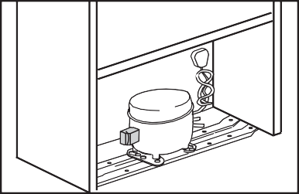
The receptacle is fixed at the back of the cabinet, on the right hand side of the compressor. (See diagram) Gently remove the plug from the receptacle. Never pull the mains cord, you may damage the appliance. In the case of transportation,
ensure you locate the plug in the receptacle provided to avoid transit damage.

REPOSITIONING THE DOOR
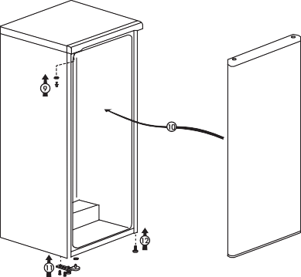
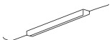
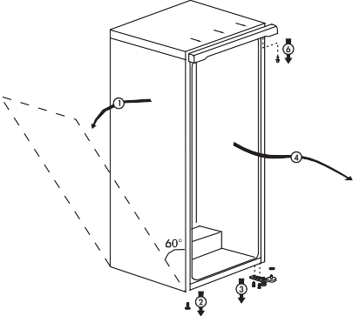
Follow the step by step instructions and the diagram below. Numbers in brackets refer to diagrams.

�� )�
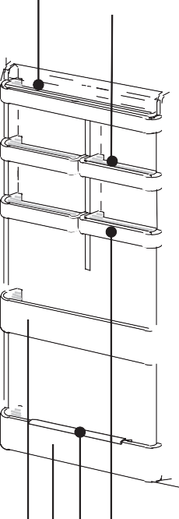
  - Switch off at the socket outlet and pull out the mains P,lug.
4
5
•

SUGGESTED ARRANGEMENT OF FOOD IN THE LARDER FRIDGE

  - Remove all food, loose items and ittings from inside the appliance and door shelves.
  - Carefully lay the appliance on its left hand side. (1) (You may need somebody to help you.) Take care not to damage the appliance by laying on
some protective material (e.g. its original packaging). Make sure that you lay the appliance on its left hand side, otherwise compressor oil may block the pipes and you may damage the apP,liance.
  - Unscrew and remove the lHS front feet (2).
  - Unscrew the bolts and remove the bottom hinge while holding the door (3).
  - Remove the door carefully from the top hinge by sliding towards the right hand side (4).
  - Reposition top hinge bushing and blanking plug on the opP,osite side and
stand the door safely (5). You may find it easier to remove the bushing and the

lug with the tip of a small screwdriver. Take care not to mark the door.
  - Remove door liinge bushing / stopper from the bottom of door (6).
You should keep door hinge bushing / stopper removed, in a safe place as it is for right hand side opening only. If you want to change the door openins direction once again you will need it.
  - Reposition door hinge bushing and plug on the opposite side (7).
  - Fit door hinge bushing / stopper for left hand side door opening (8) on the left hand side which are supP,lied with the larder.
  - Reposition the toP, hinge pin on the opposite side (9).
  - To refit the door, locate the top hinge in the door, attach to the cabinet and hold the door (10).
  - Fit the bottom hinge (11). If necessary adjust and then tighten the bolts. Ensure,
that the door opens and closes easily and that there are no gaps allowing air into the cabinet. If there are gaps between the door seal and tlie cabinet, adjust the door seal by gently pulling away from the door using fingers.
  - Fit the other front feet (12).
  - Carefully stand rour appliance. (You may need somebody to help you.) Adjust the front feet (See Installation Instructions)
  - Put back all, loose items and fittings.
  - Wait for at least 4 hours to allow the system to settle before switching on. Spare plastic arts supplied with the appliance are for your future use during door repositioning.

2 3 8 7 9 6
TLS 480, TLG 980
Arrangement Examples (See diagram).
- Baked, chilled cooked food, dairy products.
- Meat, sausages, cold cuts, cans.
- Fruit, vegetables, salads.
- Butter, cheese.
- Egg tray.
- Small cans, tubes.
- Beverages, large bottles.
- Cans, tubes, small bottles.

The following guidelines and recommendations are suggested to obtain the best results and storage hygiene.
- Appliance is for the short term storage of fresh food and drinks.
- Dairy products should be stored in the special compartment provided in the door liner.

- Cooked dishes must be stored in airtight covered containers and are best ()laced on either of the removable shelves.
- Fresh wrapP,ed produce can be placed on the shelf. Fresh fruit and vegetables should be cleaned and stored in the crisper bins.
- Bottles can be placed in the door section.
- To store raw meat, wrap in polythene bags and place on the lowest shelf. Do not allow to come into contact with cooked food to avoid contamination. For safety, only store raw meat for two to three days.
- For maximum efficiency, the removable shelves should not be covered with ()aper or other materials thus allowin9 free circulation of cool air.
- Shelves incorporate rear stops and tilting for storing bottles. Lift shelf to clear grooves when adjusting.
- To tilt a shelf place the back of the shelf one level below the front of the shelf. To remove a tilted shelf, first release the back off the grooves and then pull it.
l 0. Do not place vegetable oil on door shelves. Keep the food packed, wrapped or covered. Allow hot food and beverages to cool before placing them in the
fridge. Do not store explosive substances in the refrigerator. High proof alconol must be stored upright in sealed containers. left over canned food should not be stored in the can.
- Some fruit and vegetables suffer damage if kept at temperatures near 0 degrees centigrade. Therefore wrap pineapples, melon, cucumbers, tomatoes and-similar produce in polythene bags.
- Shelves, racks, crisper bins, dairy compartments, drawers, baskets trays, flaps, bottle grippers are all removable.
- Do not leave frozen food at room temperature to thaw; the best way to defrost food is to put it in the fridge to thaw sfowly. Make sure you avoid defrosting food or food juices drip onto other food.

TEMPERATURE CONTROL AND ADJUSTMENT
Operating temperatures are controlled by the thermostat (see diagram). Settings may be made from 1 to 5, the coldest position.
When the appliance is switched on for the first time, the thermostat should be adjusted so that after 24 hours, the average fridge temperature is no higher than +5°( (+41°F ).
5

4

3

2

0-
We recommend you set the thermostat half way between the 1 and 5 setting and monitor to obtain the desired temperature i. e. towards 5 you will obtain a colder fridge temperature and vice versa. Some sections of the fridge may be cooler or warmer ( such as the salad crisper and the top part of tlie cabinet ) which is quite normal.
Over ambient temP,eratures of 25°( (77°F) especially in summer turn the thermostat knob towards 5. Under ambient temperatures of 25°( (77°F) turn the thermostat knob to a half way position.
Frequent door opening cause higher internal temperatures, so close the door as soon as possible after use.
In case of a temporary ice build up in the fridge compartment, reduce the thermostat setting to 1, monitoring at the same time that the fridge temperature is maximum +5 degrees C [41 degrees F]. Once the ice build up disaf pears and the appliance starts auto defrosting again as norma , then you may increase the thermostat setting, if required.

STARTING

Final Check

Before you start using the refrigerator check that:

- The feet have been adjusted for perfect levelling.
- The interior is dry and air can circulate freely.
- Clean the interior as recommended under "CLEANING AND CARE."
- Insert the plug into the wall socket and switch on the electricity supply. When the door is open the interior light will come on.
- You will hear a noise as the compressor starts up. The liquid and gases sealed within the refrigeration system may also give rise to noise, whether the compressor is running or not which is quite normal.
- Slight undulation of the top of the cabinet is quite normal due to the manufacturing process used, so do not worry, it is not a defect.
- We recommend that you set the thermostat knob at 3 (three) and monitor the temperature to ensure the appliance maintains desired storage temperatures (See section Temperature Control and Adjustment).

Do not load the appliance immediately it is switched on. Wait until the correct storage temperature has been reached. We recommend that you check the temperature with an accurate thermometer (see; Temperature Control and Adjustment).

Important Note:
Ice formation at the back is normal, do not worry. (See Defrosting)

DEFROSTING

The larder refri_gerator defrosts automatically. The defrosting water runs to the drain tube via a collection channel
r
2
j
t
and is evaporated in a special container (l)
at the bacli: of the appliance (see diagram).

During defrosting water droplets may form at the back of the larder refrigerator where concealed evaporator is located. Some droplets may remain on the liner and refreeze when defrosting is completed. Do not use pointed or sharp edged objects
such as knives, forks to remove the droplets which have refreezed.

If at any time the defrost water does not drain from the collection channel, check to ensure that no food P,articles have blocked the drain tube. The drain tube can be cleared by pushing the special plastic plunger provided down the drain tube (2).

CLEANING AND CARE

** We recommend that you switch off the larder refrigerator at the socket outlet and pull out the mains plug before cleaning.
** Never use any sharp instruments or abrasive substances, soap, household cleaner, detergent and wax polish for cleaning.
** Use lukewarm water to clean the cabinet of the refrigerator and wipe it dry.
** Use a damp cloth wrung out in a solution of one teaspoon of bicarbonate of soda to one pint of water to clean the interior and wipe it dry.
** Make sure that no water enters the temperature control box.
** If the larder refrigerator is not going to be used for a long period of time switch it off, remove all food, dean it and leave the door a1ar.
** We recommend that you polish the metal parts of the product (i.e. door exterior, cabinet sides) with a silicone wax (car polish) to protect the high quality paint finish.
** Any dust that gathers on the condenser, which is located at the back of the appliance, should be removed once a year with a vacuum cleaner.

** Check door seals regularly to ensure they are clean and free from food particles.

**Never:
- Clean the worktop with unsuitable material;
- Subject it to hot temperatures in any way,
- Scour, rub etc., with abrasive material.

** Removal of dairy cover and door tray:
- To remove the dairy cover, first lift the cover up by about an inch and pull it off from the side where there is an opening on the cover.
- To remove a door tray, remove all the contents and then simply push the door tray upwards from the base.

** Make sure that the special r,lastic container (drain tray) at the back of the appliance which collects defrost water is clean at all times. If you want to remove the tray to clean it follow the instructions below:

- Switch off at the socket outlet and pull out the mains plug
- Gentlx flatten the stud on the compressor using a pair ot pliers so that the stud aligns with the slot on the plastic container.
- Simply lift the drain tray up
- Clean the drain tray and wipe it dry
- Reassemble reversing the sequence and operations

REPLACING THE INTERIOR LIGHT BULB (See diagram)

Should the light fail to work switch off at the socket outlet and pull out the mains plug.

Then ensure the bulb is screwed in until it is secure in the bulb holder (See below). Replace the plug and switch on.

If the light still fails to work obtain a replacement El 4 screw cap type 15 Watt (Max) bulb from your local electrical store and then fit it as follows:

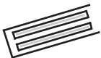
1. Switch off at the socket outlet and pull out the mains plug. You may tind it useful to remove shelves for easy access.

Don't remove the screw on the RHS.

- Remove the light diffuser cover screw. Use cross-headed screw­ driver.

- Pull off the light diffuser cover and remove the light bulb.

- Replace the burnt-out light bulb.

- Reassemble reversing the sequence and operations.

- Carefully dispose of the burnt-out light bulb immediately.
"Replacement light bulb can easily be obtained from a good local electrical or DIY store."

DO'S AND DON'TS
GUARANTEE DETAILS
  - This product is guaranteed for twelve months from the date of original

Do­
Do­
Do-

Do­
Do­
Do-

Do­

Do­
Do-

Do­
Do­ Don't­
Don't-

Don't­

Don't­

Don't-

Don't­

Don't­

Don't-
Clean your larder refrigerator regularly.
Keep raw meat and poultry below cooked food and dairy products. Keep food for as short a time as possible and adhere to 'Best Before' and "Use BY.." dates.
Take ott any unusable leaves on vegetables and wipe off any soil. Leave lettuce, cabbage, parsley and cauliflower on the stem.
Wrap cheese firstly in greaseproof paper and then in a polythene bag excluding as much air as possible. For best results take out of the refrigerator compartment an hour before eating.
Wrap raw meat and poultry loosely in polythene or aluminium foil. This prevents drying.
Wrap fish and offal in polythene bags.
Wrap food which have a strong odour or can dry out in polythene bags aluminium foil or place in airtight container.
Wrap bread well to keep it fresh.
Chill white wines, beer, lager and mineral water before serving. Store bananas in your fridge.
Store melon in your fridg_e. It can be chilled for short periods as long as it is wrapped to avoid it tlavouring other food.
Leave the door open for long periods as this will make the larder refrigerator more costly to run.
Cover the shelves with any protective materials which may obstruct air circulation through them.
Store poisonous or any dangerous substances in the larder refrigerator. Your larder refrigerator has been designed for the storage of edible foodstuffs only.
Consume food which has been stored for an excessive time in the larder refrigerator.
Store cooked and fresh food together in the same container. They should be packaged and stored separately.
Let defrosting food or food juices drip onto food in your larder
refrigerator.
purchase. Any defect that arises due to faulty materials or workmanship will be repaired free of charge during this period.
  - The guarantee is subject to the following provisions.
  - The guarantee does not cover accidental or transit damage, misuse, cabinet parts, glass shelves, knobs or consumable items such as light bulbs.
  - The guarantee does not cover the loss of food in the event of a breakdown. Food loss insurance is often included in your household contents insurance policy or may be available separately from your retailer.
  - The product must be correctly installed located and used in accordance with the instructions contained in this booklet.
  - The product is designed for domestic use only. The installation of this product on business premises for commercial use may invalidate the guarantee.
  - The guarantee is only valid within the boundaries of the United Kingdom and the Republic of Ireland.
  - The guarantee will be rendered invalid if the product is resold or has been affected by inexpert repair.
  - Beko (UK) Ltd. disclaims any liability for incidental or consequential damages.
  - The guarantee is in addition to and does not diminish your statutory or legal rights.

HOW TO OBTAIN SERVICE
Please keep your purchase receipt in a safe place as you will need to produce it should the product require attention whilst under guarantee.
Please also complete the details below, you will need it when requesting service. Model and Serial Numbers can be found on the rating label which is on the left hand side of the fridge inner liner.

MODEL NUMBER:
SERIAL NUMBER:
DATE OF PURCHASE:
PURCHASED FROM:
  - In the event of breakdown, please refer to the Operating Instructions and

PROBLEM SOLVING
If the appliance does not operate when switched on, check;
- The plug is inserted properly in the socket and that the power supply is on. (To check the power supply to the socket, plug in another appliance)
- The fuse has blown/circuit breaker has tripped/main distribution switch has been turned off.
- The temperature control has been set correctly.
- New plug is wired correctly if you have changed the fitted moulded plug.

If the appliance is still not operating after the above checks, please refer to the section on "How To Obtain Service".

Please ensure that above checks have been made as a charge will be made if no fault is found.
check all plugs, fuses and electricity supply.
  - Before requesting service please also check the trouble-shooting guide in the Operating Instructions as a charge may be levied where there is no fault found even though the appliance may still be under guarantee.

LOCATION | CONTACT
UK | 0870 241 0638
Northern Ireland | Refer to service instructions from retailer.  {If none supplied - call 0870 241 0638)
Republic of Ireland | 018623411
  - Service out of manufacturer's guarantee : If you have purchased an extended guarantee from the retailer, please contact your insurance company or retailer. Otherwise please call the above numbers where service can be obtained at a charge.

