Skills for Learning

**Guide to Poster Design**

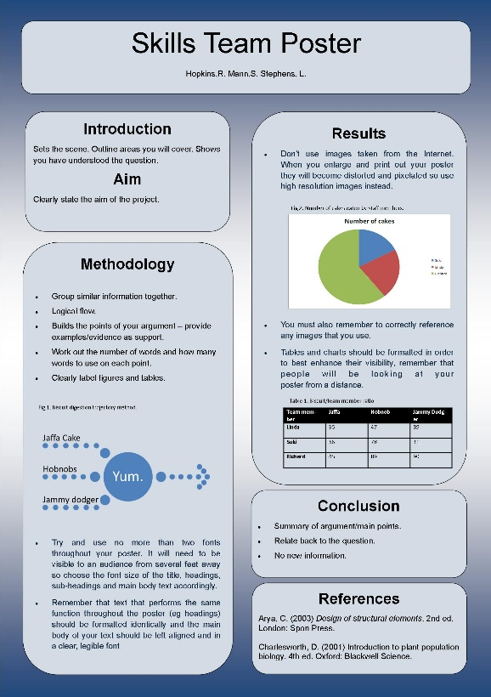What is a Poster?

An academic poster is a visual presentation of your research information and is often used at conferences. Rather than simply reproducing your entire assignment, you are creating a condensed version of the highlights in a visual medium that should both attract *and* inform potential viewers.

Think about your potential audience. Will they be your peers and understand subject specific information and terminology or are they a more general audience and should you use less complicated language and terms? Make sure that you are aware of the allocated word count as this will impact on the layout and design of your poster.

Planning

As with any piece of academic work, planning is vital. Begin by summarising your work into key points, create a rough draft and sketch out a plan of your poster. Think about the images, charts or tables that you will need to include and remember that your poster needs to be eye catching in order to capture an audience’s attention.

Formatting

Try to use no more than two fonts throughout your poster. It will need to be visible to an audience from several feet away so choose the font size of the title, headings, sub-headings and main body text accordingly. Remember that text that performs the same function throughout the poster (e.g. headings) should be formatted identically and the main body of your text should be left aligned in a clear, legible font.

Images

Don’t use images taken from the Internet. When you enlarge and print out your poster they will become distorted and pixelated so use high resolution images instead. You must also remember to correctly reference any images that you use. Tables and charts should be labelled appropriately and formatted in order to best enhance their visibility, remember that people will be looking at your poster from a distance.

Layout

Whilst the poster is a visual tool it still needs to maintain a logical structure in order that a viewer can easily follow and understand your argument from start to finish. Consider including a title, introduction, methodology, results, discussion, conclusion and references. Group related text together and think about using a design grid or columns to improve the layout. When deciding on colour schemes for your poster use a colour wheel to pick two or three complementary colours and try to avoid patterns that would distract from the text.

Review

Make sure you give yourself enough time to review your poster before printing and handing in. Check for content and referencing but also print an A4 copy off and place it on a wall in order that you can see what it will look like from a distance. Ask a friend or family member for feedback; can they follow the flow of information, read the text clearly and understand the graphics and charts you’ve used?

Printing Your Poster

The University's Digital Print Services (DPS) provides efficient and cost-effective printing. Find them at: <https://www.wlv.ac.uk/staff/services/digital-print-services/>

Further Reading

Books offering advice on poster design are available in the Study Skills collections in our libraries and as part of our e-book collection including:

Bethell, E. and Milsom, C. (2014) *Posters & presentations*. Basingstoke: Palgrave Macmillan:

<https://librarysearch.wlv.ac.uk/permalink/44UOWO_INST/8bamsd/alma991001559479704901>

Day, T. (2023) *Success in academic writing*. (section 4.2 is on posters) 3rd edn. London: Bloomsbury Academic:

<https://librarysearch.wlv.ac.uk/permalink/44UOWO_INST/13ndfb5/alma991003108022504901>

Rowe, N. (2017) *Academic and scientific poster presentation: A modern comprehensive guide*. Cham: Springer International Publishing AG: <https://librarysearch.wlv.ac.uk/permalink/44UOWO_INST/1575ou6/cdi_askewsholts_vlebooks_9783319612805>

**Cite this work:**

Skills for Learning (2024) *Guide to Poster Design*. Available at: http://www.wlv.ac.uk/skills (Accessed: give date accessed)

To request this document in an alternative format please contact [skills@wlv.libanswers.com](mailto:skills@wlv.libanswers.com)