# **Mobility Print Set-Up for Students – September 2024**

|  |  |
| --- | --- |
|  |  |
| [Click Here to get started](https://mp.cloud.papercut.com/?token=eyJhbGciOiJSUzI1NiIsIm9yZyI6Im9yZy1BTjVTMkc5VCIsInNydiI6InNydi1NMkNNN0ZaMSIsInR5cCI6IkpXVCJ9.eyJpYXQiOjE3MDI2MzE2NDQsImlzcyI6InNydi1NMkNNN0ZaMSIsImp0aSI6IlE5OTc2Njk4IiwibG5rIjoiUTk5NzY2OTgiLCJvcmciOiJvcmctQU41UzJHOVQiLCJzcnYiOiJzcnYtTTJDTTdGWjEiLCJzdWIiOiJ0b2tlbkNyZWF0aW9uIn0.lGMKxMF7UFkEfRUm-nOZurse_rYZjxjo9wPkNfykEW3imnMZkTSPvbH5e5zwozl9lOO-9aC_P9ZiLrwvM8Nu1Y0BaHaEMeI5ht1qZQpRRT2niwDUANvW5CGMOChXXiI-znD7jo5iJxLWhA7LiemDzeFhshttp9GyNaDkShK2pBK5fihjCoqeot1oRm0kIs2jpZQBBqBYjXw8hOQHutaj3RoqOvbvnhbvcYZVctmF5BXwQmni2i-ffeFFo2okYA8hA-qB2yHt_rmWcOU3U_2VivSrmME8pw7odM0jrfG03wb6cSS3f9EHGLqd82wM_g76q2MAm2pFSjIhjnkNcKkNQS6pxH-T2cvIHQUtMof6iHsbc0VysFKpyHX14VpKFOBJwtf8E-Jh0GaMApPuLtfMPRPrrt95VbXq8KPZuQoGHcsqeyNTpOIdZcekVPHaO9ql8WaJQ8Dz_KjnNwOgobvt8s97b91u6DjE4WVQOXYnkSus4g4MJ3eBCpb3v3ivKb4dKWQ9T2ru3Ua29UpthtfNqXBZ_qHz72XmpDOZOMtfagnpzVwKic1X9GexleBtcb6Ruao3-g7xhnOnz-oTpGNBEDk_tcA36T_TNrw8nHZrmjZvny_Xz5nkZRxX5LY6GhvWayU2lOzMDmwqmtqOQOlK3F-Mynf_dqCr-abn_z5ugLU) |  |

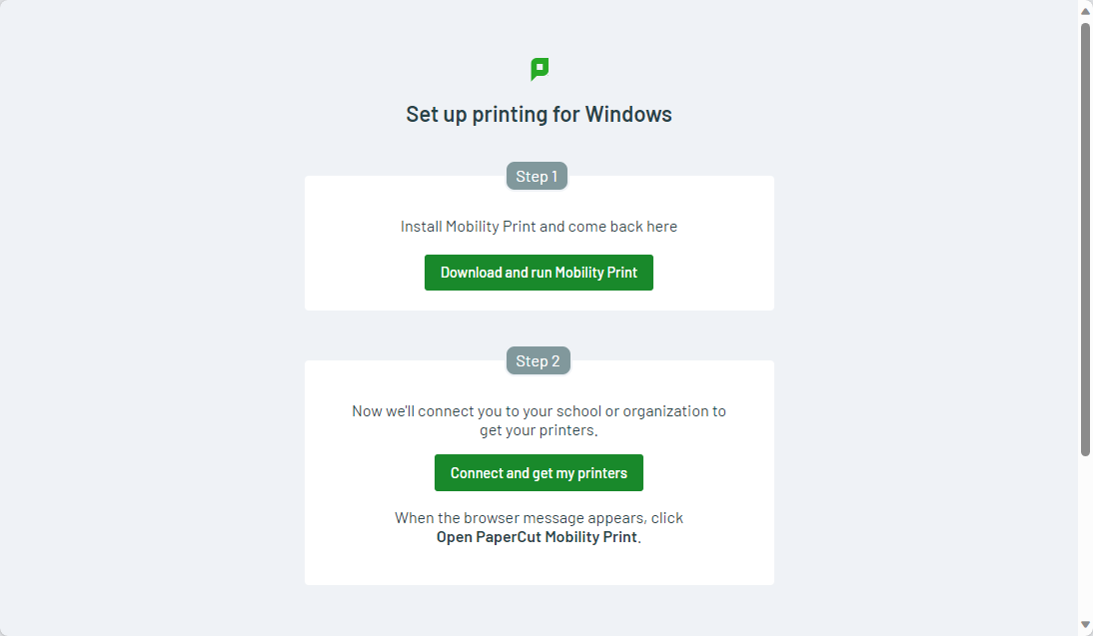

Click Download & Run Mobility Print (You must be a machine administrator to complete this)

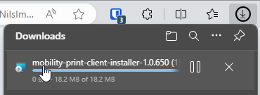

Click Next

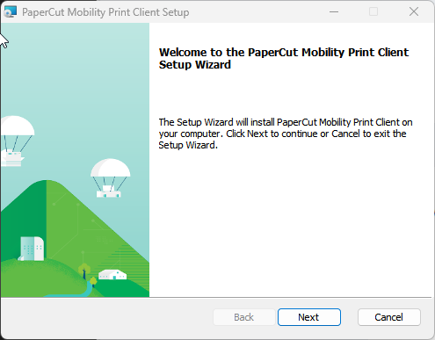

You will be prompted for User Account Control Process and Click Finish.

Once installed, click on Step 2 – Connect and Get My Printers

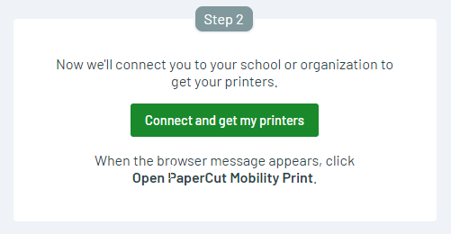

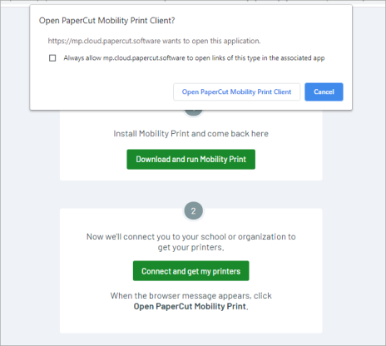

Click Open Papercut Mobility Print Client, once the setup complete, you will see the following message saying Fetching your printers.

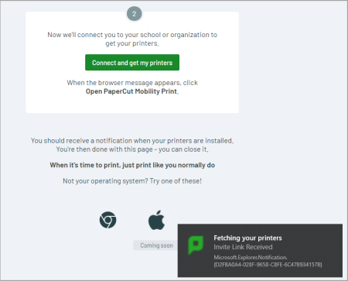

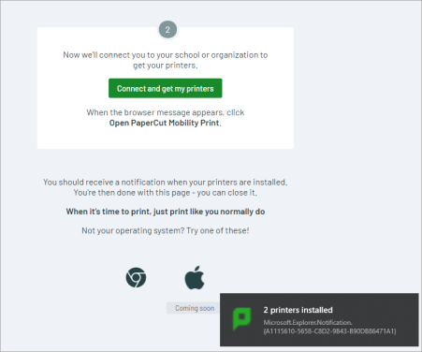

Now you are ready to print. Find your document you wish to print and print to:

Follow-You-Student [PaperCut Virtual Print Queue](Mobility)

You will be prompted to enter your Student Number and Password.

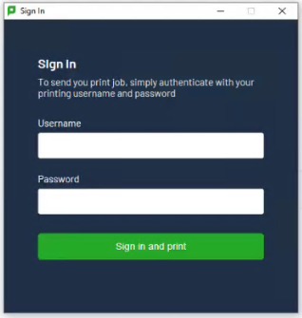

Once you have entered your student number and password click Sign in and Print. Your print job will be processed and will be available for release on any of the Ricoh MFDs on the Campuses.