University of Wolverhampton

Access and participation plan

2020-21 to 2024-25

Assessment of performance
Context
The University of Wolverhampton (UoW) is an anchor institution for (and of) the Black Country and wider West Midlands. We are proud to be the University of Opportunity, with priorities driven and influenced by our location. We make significant contributions to improving educational, social and economic outcomes in a region that has suffered disproportionately from industrial restructuring by prioritising education, skills, business engagement and employment.
We operate from three main campuses in Wolverhampton, Walsall and Telford (Priorslee), with additional centres in Stafford, Burton and Telford (Southwater) which create a strong regional footprint. Our faculties operate across the region with students taught within schools or institutes.
Relative to other universities, more of our students are recruited from the region, particularly our sub-region, the Black Country, and remain here upon graduation. Consequently it is a strategic imperative for us to lead the transformation of our region. The Black Country is currently one of the most challenged regions in the country. It has the lowest proportion of total jobs relative to the working age population (with a density of 0.71, versus a national average of 0.86) and the highest proportion of the population who are unemployed (6.2%, versus a national average of 4.2%). Another challenge for the Black Country is the population’s low qualification base, which is below regional and national averages (15.6% versus 7.7% nationally with no qualifications).
78.3% of our graduates remain within the West Midlands, predominantly in the Black Country. Significantly, the Black Country has fewer graduate level jobs (24% less highly skilled employment opportunities - 34.6% compared to 45.5% nationally) and average salaries are lower (20% less at £29,427 compared to £36,773 nationally) than the West Midlands and national averages. The outcomes for Wolverhampton graduates must be considered within this context. Due to their complex lives our graduates often do not have the choice to move to more prosperous regions.
A significant proportion (68%) of our students are the first within their family to enter higher education (HE), which is far higher than the sector norm (48%). Their transition into HE can be more challenging than for those from a family with a background in HE, and their expectations are often characterised by the absence of reference points. From surveys we know that our students’ primary motivation for study is to improve their career prospects on graduation. The employment success of our students, within an extremely challenging employment environment, is a result of the strength of our Enterprise and Employability Strategy (discussed in our strategic measures section).

In the analysis of performance, the University has analysed and reviewed data from the OfS Access and Participation dataset, internal data was used to provide analysis of additional student characteristic not recorded within the OfS dataset and relevant impact on students’ outcomes. Heidi+ and TEF pilot datasets were used to monitor and review performance of students against sector and benchmarks at subject level, as well as modelling of internal data to produce value added metrics, available to us as part of collaboration with Kingston University. HESA UKPIs and OfS KPMs were factored into review of performance across each stage, with UCAS data analysed to inform analysis of access performance. NOMIS and ONS data was used in the compilation of data about the local region and local population.

1.1 Higher education participation, household income, or socioeconomic status

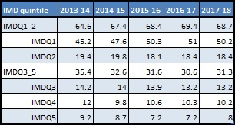
Access
The population of UoW is reflective of the diversity that can be found within the West Midlands, and the Black Country in particular has high levels of economic disadvantage. The UoW is consistently above KPIs and the sector average in the intake of students from low socio-economic (IMD12) backgrounds, and for students from low participation neighbourhoods, with more than 60% of our student population over the past five years coming from IMD quintiles 1 and 2. We have consistently performed above our LPN (Polar) target in previous access agreements. The figures for part-time students are similar to the full-time students, with the largest proportion of students coming from IMD1 backgrounds, and over 50% of new entrants coming from under-represented neighbourhoods.

Success

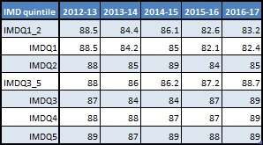
Non-continuation
Over the past four years, the gap in non-continuation amongst POLAR quintile groups has remained consistent, with small fluctuations on a yearly basis. Year 5 in the chart below represents the most recent year’s data.
University initiatives have ensured we have been in line with our targets for non-continuation in previous access agreements, but these were based on absolute, rather than relative, performance. Improvements in continuation rates have not been even, resulting in a gap in continuation for students from the most under-represented backgrounds. The gap in the most recent year stands at 6.6% between students from IMD quintiles 1 and 5, although this is below the sector average of 7.9% gap in performance for the same demographic. Analysis of continuation data shows that students with an entry tariff of below 200 UCAS points are on average 6% more likely to leave after their first year of study than students with higher entry tariffs. There is a higher proportion of IMD12 students entering the University with entry tariffs below 200 UCAS points; adjusting for this difference in population leaves an unexplained gap of 1.1%.

The University has a smaller part-time population, where the pattern of performance is very similar, with students from lower socio-economic backgrounds performing worse than those from higher socio-economic backgrounds. Whilst the gap is larger (11% gap in continuation between IMD1 and IMD5 in 2017/18), the variance in year on year performance can be considerably larger due to smaller cohort sizes. Analysis of internal data also shows a large proportion of students studying whilst working as Continuous Professional Development, particularly within the nursing and healthcare fields.

The University is committed to supporting the local region, and recognises that the economic climate of the region creates barriers for students continuing in higher education; reducing the gap in continuation levels between socio-economic groups is a key part of that commitment, and as such is a key target for the Institution.

Attainment
We have seen an increase in overall attainment rates over the past five years, which is reflective of an increase in recruitment of students with higher tariff entry scores. There were incremental gaps in performance across the POLAR quintiles until the most recent year, in which the gap was closed. However, as with continuation, the gap is wider when viewed from a socio-economic perspective. The attainment gap between IMD quintiles 1 and 5 has seen fluctuation over the five year period, but has remained significant, with UoW performance standing at a 15% gap between IMD 1 and 5, slightly lower than the sector average gap of 18%.

Attainment Progression
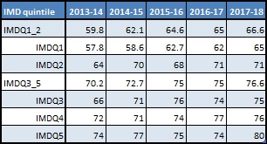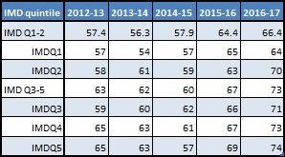

The pattern of attainment for full-time students is replicated within the part-time population, with a gap between IMD1 and IMD5 of 28% in the most recent year. Whilst this gap is significant, internal analysis shows that a large number of part-time students are healthcare staff engaging in Continuous Professional Development, who are subject to funding restrictions from employers which often means the students do not complete the full honours degree.

Reducing the attainment gap between socio-economic groups at the University forms a foundation for the University ambition to progress social mobility within the local community, and is therefore a key target for the Institution.

Progression to employment or further study
The rate at which students’ progress into highly skilled employment or further study has seen dramatic improvements over the past five years across all POLAR quintiles. Whilst the gap between POLAR quintiles has fluctuated on a yearly basis, performance of students from quintiles 1 and 2 has, on average, remained within 2% of POLAR 3-5 students.
Year 5 in the chart below represents the most recent year’s data.

As with success measures, the gap in progression is more evident when viewed through IMD data, with students from the most deprived backgrounds performing consistently worse than those from the least deprived backgrounds. Review of our DLHE data highlights that a large proportion of the IMD1 first degree students within the UoW are local students (86% of IMD1 graduates live within 25 miles, compared to 61% of IMD5 graduates). The data for part-time students follows a similar pattern, with a gap between IMD1 students and other IMD profiles of 6%, mirroring sector levels, although the most recent year’s data show performance above sector across all IMD profiles.

Improving the progression outcomes for students from lower socio-economic backgrounds, and reducing the gap between groups, is the culmination of the University ambition to improve social mobility for the Black Country, and is a key target for the University.

1.2 Black, Asian and minority ethnic students

Access
Reflective of the demographics of the Black Country, the UoW has a strong track record of recruitment of BAME students, outperforming the sector and our KPIs, to consistently have a near even split of white to BAME students. Whilst proportional recruitment of Asian students has declined slightly (19.8%, down 2.7% over census period), there has been an increase in proportional recruitment of Black (22.9%, up 5.2% over census period) and Mixed-ethnicity students (6.4% up 1.7% over census period). However, this is not the case with our higher and degree apprenticeship intakes, and we will monitor these as our intake grows. There is a significant difference in recruitment for part-time students, with White students making up over 70% of new entrants in each of the past five years. These levels are similar to the sector, and internal data shows a significant proportion of the University’s part-time population is students training towards becoming teachers, as well as funded students studying at higher education as part of Continuous Professional Development, particularly within the healthcare sector.

Access Continuation
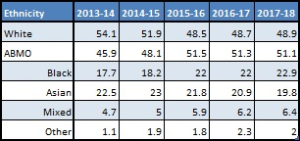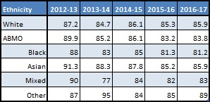

Success

Non-continuation
Continuation rates at the UoW have seen a decline of 3.7% over the past five years. There was a notable drop in performance in 2015/16 and this coincides with the introduction of Foundation Years in support of our commitment to Widening Participation. In 2013/14, foundation year entrants accounted for 5% of the full-time undergraduate student intake; this had increased to 9% by 2015/16 and currently stands at 11.6%. These students are more likely to identify within multiple areas of deprivation, and are more prone to withdrawal. In response, the UoW has sought to improve information and guidance, pre-entry and induction and transition support for these students which has improved continuation rates on the foundation year, and we will continue to address this area.

Whilst continuation rates have now stabilised, there is still a gap in performance between BAME and White students (2.1%), mostly as a consequence of the gap between White and Black students (4.7%). Analysis of continuation data shows that students with an entry tariff of below 200 UCAS points are on average 6% more likely to leave after their first year of study than students with higher entry tariffs. There is a higher proportion of Black students entering the UoW with entry tariffs below 200 UCAS points; adjusting for this difference in population leaves an unexplained gap of 3% between Black and White students. Gap analysis for part-time students evidences similar patterns to those of full-time students, with the gap standing at 16% in the most recent year. Analysis of internal data shows that part-time BAME students are more likely to enter the Institution with low entry tariffs than white students. Additionally a greater proportion of BAME part-time students were studying on foundation year courses.

The University recognises the additional barriers faced by Black students, and this will become a key target for the University to improve parity of participation in Higher Education, and removing the gap in continuation will form a pillar of the University strategy.

Attainment
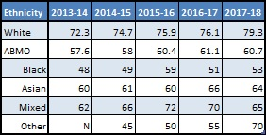
Over the past five years, the University has seen overall growth in the proportion of good honours degrees awarded. We were therefore on track to meet our milestones from previous access agreements, which were based on absolute performance of BAME students. However, the increase in attainment for White students has exceeded that for BAME students, so while BAME attainment has increased the attainment gap has widened to 18.6%. The gap is widest between White and Black students, standing at 26.3% in the most recent year, 20% of which is unexplained by other student characteristics. Whilst the gap has reduced within some subject areas, analysis of data highlights that there are some key subject areas which require improvement. Attainment rates for Asian students fell slightly in the most recent year, increasing the attainment gap to 15.3%, 12% of which is unexplained by other student characteristics. The gap in attainment between ethnicities is slightly larger amongst part-time students than full-time, standing at 33% for Black students and 34% for Asian students in the most recent year. However the smaller population size of each cohort means that there can be significant shift on a year by year basis.

Closing the attainment gap for BAME students is a University priority, and a cornerstone of our Access and Participation Strategy moving forward. Reflecting the greater gap and barriers impacting Black students, a separate target will be created to reduce the attainment gap for Black students.

Progression to employment or further study
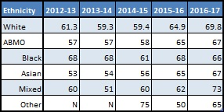
The University is located within an area of deprivation, and this has an impact on the employment of our graduates who tend to stay within the local community. As a result the UoW has undertaken extensive work to support graduates to further their careers, resulting in a marked increase in our progression rates over the past five years. This increase resulted in a 10% improvement in BAME progression, such that the gap is reduced to 2.8%. However, when considering the data in more detail, Black students are 3.8%less likely to progress to highly skilled employment or further study than White students.

The progression gap for part-time students is slightly higher than full-time students, standing at 6% for BAME students, and 7% for both Black and Asian students. However the actual progression rate is 13% higher for part-time BAME students and the University has a higher progression rate for part-time students than the sector standard. Analysis of internal data also shows that a larger proportion of White students were studying as Continuous Professional Development; adjusting for this shift in population reduces the gap to similar levels as full-time students.
The region within which the University is located is very diverse, and a key component in improving social mobility and social equality for our graduates and our region is reducing gaps in graduate employment between ethnicities, and this is therefore a target for the University.

1.3 Mature students

Access
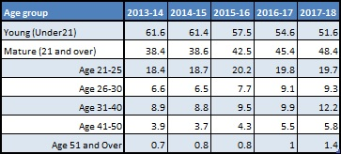
Over the past five years, we have seen an 8% increase in the number of mature students enrolling to study, meaning they account for 48.4% of our total student population. Whilst the sector has seen a 13% increase in numbers of mature students entering HE over that period, the overall proportion of mature students has only increased 3% to a level of 27.8% in the most recent year, so we are substantially ahead of sector performance. There is a significant shift in recruitment for part-time courses, mirroring the sector, with significantly higher levels of mature students, with the average being 10% of part-time students are under 21, and 59% of new entrants in the most recent year being over 26.

Success

Non-continuation
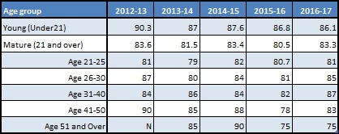
Our previous Access and Participation Plan targets related to overall continuation of mature students, rather than gaps, and we were ahead of our intended milestones on these measures. Although the gap in continuation rates has closed over the census period, the continuation rates for mature students, excepting yearly fluctuations, have remained relatively stable at 83%., The continuation rates of young students has seen a 4% reduction since Year 1 (90% to 86%). There are age groups where non-continuation is lower than the mature student average, for students aged 51 or over (75%), and for students between 21 and 25 years of age (81%). The gap in continuation for mature students is higher amongst part-time students, standing at 10% in the most recent year. However, analysis of internal data shows a significant proportion of part-time students are studying as part of Continuous Professional Development whilst in employment, and continuation is dependent on release from work, and in many cases funding from their employer. In addition the smaller population size for part-time students means that there can be wide fluctuation between cohorts, with the gap being reversed in two of the previous five years.

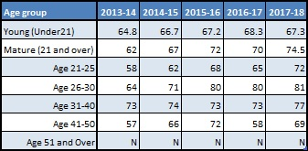
Attainment
Attainment rates have increased for all age groups over the census window, however some age groups have outperformed others, and gaps in attainment have opened, particularly with students aged 21-25 and with students aged 26-30, who are more likely to achieve a good honours degree than young students (< 21 years) by 4.7% and 14.2% respectively. In the most recent year, data shows that mature students are 7.2% more likely to achieve a good honours degree. Gaps in attainment for part-time students follow the same pattern as with full-time students, with mature students more likely to achieve a good honours degree, although the gap is larger, standing at 17% in the most recent year.

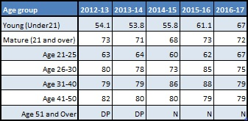
Progression to employment or further study
The gaps in progression between different age groups have reduced significantly over the course of the census window, from an initial position of mature students being 19% more likely to go on to further study or highly skilled employment to a current gap of 5%. This is reflective of a significant increase in the performance of young students, where there was a 13% improvement in progression over the census period, demonstrating the effectiveness of the UoW’s Enterprise and Employability strategy in preparing students for their future careers. Gaps in progression for part-time students follow similar patterns to the performance of the full-time students, with mature students more likely to progress to highly skilled employment or higher study, the gap in the most recent year stands at 4%.

1.4 Disabled students

Access
Our recruitment of students with disabilities is the only Access area in which we underperform against benchmark (DSA) and sector (students with a disability). It is also notable that the nature of disability has changed over the years, with a decrease in students with cognitive difficulties countered by an increase in the recruitment of students reporting mental health conditions. Although we are on track to meet our previous access agreement targets in this area we will continue our efforts to increase access and exceed the sector average. As the University of Opportunity it is strategically important to us that we maximise opportunities for all under-represented groups, exceeding our benchmark or sector average in all areas of access is therefore a key performance indicator. It is notable that we have the highest number of full-time undergraduate Deaf students in the sector, though we have seen a small decline in numbers in recent years which we intend to reverse during the duration of the Plan. Whilst recruitment of disabled students to part-time courses has increased over the census period, the proportions are smaller than with full-time students, and 8% of new entrant part-time students in the most recent year had a disclosed disability.

Access Continuation
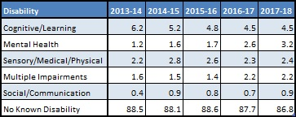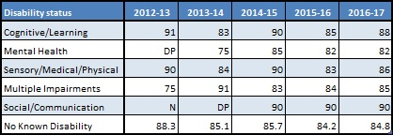

Success

Non-continuation
In each year of the census period there are no gaps in continuation rates between students with no disability and students with a reported disability, although there are cohort based fluctuations in absolute performance. There is, however, some variance in performance between students with particular disabilities, with those with mental health concerns 3% more likely to discontinue studies than other students. This gap has been reduced over the past three years, a time in which the population of students reporting mental health conditions had doubled. Continuation rates for part-time disabled students shows a slight dip to full-time students, with part-time disabled students 3% less likely to continue in the most recent years data. The cohort size for part-time disabled students is small, which limits confidence in making any statistical judgement, although analysis of internal data suggests that students with mental health conditions are the least likely to continue, as is the case with full-time students.

Attainment

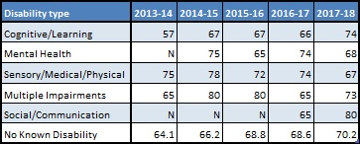
Attainment rates have risen steadily over the past five years, with good honours performance of students with a reported disability now on par with students with no reported disability. This growth in performance is particularly evident for students with cognitive and learning disabilities, with a growth of over 10 percentage points. There are fluctuations in performance, however the University is mindful that the relatively small population can lead to fluctuations in data on a yearly basis. Setting aside these fluctuations, the trajectories over the five year period indicate broad parity in achievement irrespective of disability. There is a statistically significant population of students with Cognitive and Learning difficulties (140 students), where performance has mirrored students with no known disability in three of the past four years, in the most recent year students with Cognitive and Learning difficulties (74%) have achieved a higher attainment rate than students with no known disability (70%). Part-time disabled students are more likely to obtain a good honours degree, with the gap in the most recent year being that disabled students were 15pp more likely to obtain a good honours degree. Although the cohort size is small, analysis of internal data shows that part-time students with multiple impairments are less likely to obtain a good honours degree, in contrast to the pattern of performance for full-time disabled students.

Progression to employment or further study

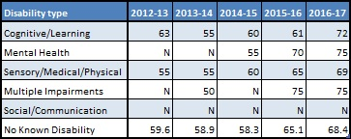
This trajectory of improvement in achievement of good honours degrees carries forward to the progression to further study or highly skilled employment, where students continue to perform equally irrespective of disability. Whilst there are yearly fluctuations, students with a disability are more likely to progress than students without a disability. Over the census period there is broad parity in the likelihood to enter highly skilled employment or higher study between students with a known disability and those without. Whilst the populations are very small, internal analysis of data indicates that this near parity is evident across most types of disability although, as with attainment rates, there is a slight dip in the progression rates for students with multiple impairment.

1.5 Care leavers

Access
Although the University has worked hard to increase the visibility of services available to care leavers, and has subsequently seen growth in the declaration of care leavers, there remains an ongoing strategy to help care leavers feel confident and assured in disclosing this information, and to work with these students to better understand and resolve the barriers that they may face across the student life cycle, and beyond into employment. Research suggests that these barriers include poor support from the local authority, difficulties in navigating changes, financial problems and social/emotional issues and that a ‘managed transition process’ can help to ensure successful participation for care leavers (HERACLES project 2017). Our previous access agreements had a care-leaver target relating to participation in a specific access programme, designed to manage this transition; the programme is meeting its targets, with expected progression to HE from the first cohort not expected until 2021 entry. Internal data highlights a significant growth in known care leaver numbers over the census window, increasing to 166 known care leavers in the most recent year. However, the optional nature of the disclosure means that we cannot identify if this is an increase in actual numbers of care leavers or an increase in the disclosure rate.

Success

Non-continuation
Due to the small population (fewer than 30 in any census year) it is difficult to analyse the performance of care leavers, although internal data indicates a continuation rate of 90% for known care leavers compared to 87% for our average student body. This compares positively to published data which suggests that care leavers are ‘around 38% more likely to withdraw from their course’ (HERACLES project, 2017). Adding to the complexity is that care leavers tend to intersect with at least one other identifier of disadvantage, which with the small population makes it difficult to determine the source of any variance in performance.

Attainment
The known care leaver population for attainment rates is too small to make any statistical assessment or comparison (fewer than ten students in any year). This is an area that the University will monitor as larger cohorts come through (which we expect given the large increase in disclosure referenced above). However, the research suggests that once demographic factors and entry qualifications are accounted for, there is no significant difference in care leavers’ likelihood of achieving a high degree classification; therefore our other objectives in this plan will also support care leavers as they intersect with at least one other identifier of disadvantage.

Progression to employment or further study
As with attainment, the population of known care leavers’ progression from HE is too small to provide confidence in any inferences or comparisons we can make.

Key Commitments

We are committed to increasing known care leave numbers by 5% per annum, through the continuation of our existing access programme for care leavers, delivered in partnership with our local virtual schools, and through increasing awareness of the benefits of disclosure among enrolling students. We are increasing awareness of the benefits of disclosure by the following methods: we contact applicants who have disclosed care-leaver status to outline the support available; as part of the enrolment process, everyone is asked whether they are a care leaver; there is information on our web pages and in our prospectus about the support available and the importance of declaring care-leaver status; our outreach teams include a statement in all presentations to schools and colleges and it is included in financial presentations at University open days. We are intending to evaluate the impact of Aspire to Uni (our access programme for care leavers) over 2019-20. We will continue to offer access bursaries for care leavers, as well as guaranteed, year round accommodation with discounted summer rates.

1.6 Intersections of disadvantage
Access

Analysis of the data shows that while the University recruits near even proportions of White to BAME, and equally from socio-economic groups, there is a notable variance in recruitment intersectionally. Data shows near even recruitment of White students from IMD12 and IMD345, however 80% of BAME students come from IMD12 backgrounds (which means that 43.4% of new students in the most recent year were BAME and from IMD12). The higher proportion of IMD12 students is mirrored within gender groups, with higher proportions of both male and female students coming from disadvantaged neighbourhoods. These demographics are largely representative of the surrounding area, from which a large proportion of the UoW population hails. Enrolment of part-time students shows significant differences to the full- time population, with an increase proportion of White students, although the proportion of students from low socio-economic backgrounds remains comparable to full-time population. The split between male and female students remain similar to full-time, with 69% of students in the most recent intake being female, although the split of female students from higher socio-economic backgrounds increased, with 31% of female students coming from IMD345 backgrounds.

Access Continuation
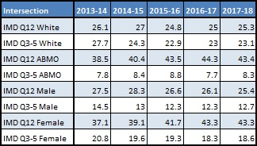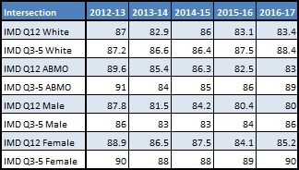

Success

Non-continuation

Review of intersectional data indicates a strong correlation between a student’s socio-economic background, ethnicity and likelihood of remaining in studies. Continuation rates between White and BAME students, when controlling for IMD profile are within 1% of each other. Students from IMD quintiles 12 are 5% less likely to continue than students from IMD quintiles 345. This gap in performance has widened over the past three years, with continuation rates for IMD345 students seeing improvements, compared to a small dip in performance for students from IMD12. Given that a far higher percentage of BAME students are from IMD12, gaps in non-continuation for IMD12 students magnify gaps for BAME students. Continuation rates for part-time students diverge from that of full-time students, with White students more likely to continue irrespective of socio-economic background. The gap between BAME students from IMD12 backgrounds and White students from IMD2 backgrounds stands at 15% in the most recent year’s data, with this gap having widened over the census period. The gap between students from IMD345 backgrounds is smaller, although BAME students remain less likely to continue.

Performance between genders follows a similar pattern, with IMD12 students 5% less likely to continue in studies than IMD345 students. There is also a gap in performance between male and female students across IMD quintiles, with IMD12 males less likely to continue than IMD12 females, and significantly (10%) less likely to continue than the IMD345 female students. Gaps in continuation between genders shows fluctuations in performance between genders, but highlights that both male and female students from under-represented (IMD12) backgrounds are less to continue than students from IMD345 backgrounds.

Attainment

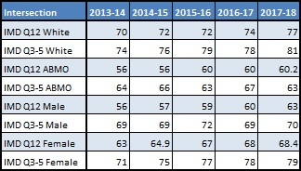
There is a gap of 17% between ethnicities of the same level of disadvantage. This is most acutely felt between the IMD12 BAME students and IMD345 White students where the attainment gap is 20.8%. Similar to full-time students the gap in attainment for part-time students shows that BAME students are less likely to achieve a good honours degree than White students of the same level of disadvantage. In the most recent year there is a 29% gap in attainment between BAME and White students from IMD12 backgrounds.

Attainment between genders follows a similar pattern to continuation, with female students more likely to achieve a good honours degree. The gap in performance between male and female students is highest when looking at the difference between IMD12 and IMD345 students with IMD12 male students 16% less like to attain a good honours degree than IMD345 female students. This contrasts against an attainment gap of 1.6% between IMD12 female students (68.4%) and IMD345 male students (70%). The gaps for part-time students show a small divergence to the full-time population, whilst students from under-represented backgrounds are less likely to achieve a good honours degree., For part-time students there is a greater likelihood of male students achieving a good honours than female students, in contrast to the full-time population, with the gap in the most recent year being 14% irrespective of socio-economic background.

The two areas with the lowest attainment outcomes are students from IMD1 and Black students. There are strong intersections between these groups, with around 70% of Black students entering the University each year coming from IMD1 neighbourhoods. Analysis shows a strong correlation in the attainment data of an intersection of disadvantage faced by these students; whilst there are gaps in the attainment across the IMD spectrum including White students, these gaps are amplified within Black students. The UoW has identified both groups as a strategic priority, with further research and analysis required to understand precisely the nature of the barriers faced by these students in order to formulate an appropriate action plan (see Strategic Measures section).

Progression to employment or further study

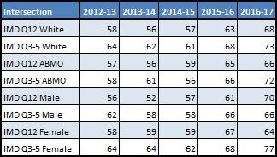
Progression follows a similar pattern, with increased performance across all groups, but with the gap between IMD12 and IMD345 students remaining consistent over the census window, with IMD12 students 5% less likely to progress to highly skilled employment than IMD345 students. White students are more likely to progress, although the gap in performance by ethnicity is significantly less than the gap between IMD quintiles. Over the course of the census part-time students have followed a similar pattern to the full-time students, with BAME students less likely to progress, and students from disadvantaged backgrounds less likely to progress across ethnicities. However in the most recent year’s data the gap in performance between socio-economic backgrounds has largely been removed, although the gap in performance between BAME and White students remains, although reduced, standing at 6% in the most recent year.

Between genders there is a notable divergence with the previous characteristics of the groups in the most recent year, with the IMD12 male students outperforming the IMD345 male students by 4%. Due to a downturn in performance in the final year of the census, the gap between the IMD12 and IMD345 female students is wider in terms of progression than in other areas, with IMD12 female students 13% less likely to progress than the IMD345 female students. IMD12 female students are also 6% less likely to progress than the IMD12 male students in the most recent year’s data. Part-time students show a high degree of fluctuation over the census period, although students from IMD345 backgrounds remain more likely to progress than students from IMD12 backgrounds. Performance between genders fluctuates year on year, and in the most recent year female students, irrespective of IMD quintile were more likely to progress than male students.

1.7 Other groups who experience barriers in higher education
We work closely with Standalone providing support for estranged students and we are one of only two universities in the West Midlands to have signed the Standalone Pledge. Since the start of the 2018-19 academic year we have asked estranged students to identify themselves at enrolment so that we can provide additional support, including a bursary. This year 72 students claimed the estrangement bursary but we believe that there are significantly more estranged students who did not make a claim, and we are working to improve disclosure rates. As these students progress through their courses we will monitor their continuation, attainment and progression rates; at this stage it is too early to say whether they experience differential success and progression rates.

Strategic aims and objectives
Our strategic plan sets a radical agenda for the University in seeking to be at the heart of economic and societal development in our region, which has significant skills gaps, low levels of graduate employment and school attainment. We aim to provide an HE opportunity and success for all those who are able to benefit, and to support students at every stage of the lifecycle, from pre-enrolment and transition through to post-qualification employment and further study.

Our principal aims are:

- To maintain our successful access performance and to be above benchmark in all areas.
- To eliminate gaps in success (attainment and continuation) as outlined in our targets, and in doing so to raise skills levels and meet local needs.
- To ensure students in the target groups progress successfully into graduate employment or further study.
- To embed a) an inclusive learning and teaching approach across the University, which supports all stages of the student lifecycle, with particular focus on the target groups and b) a culture of impact evaluation and reflective practice which supports continuous improvement and better outcomes for students.

2.1 Target groups
Our performance to date demonstrates that we have a strong track record of achieving targets relating to access for under-represented groups. Whilst we intend to continue the work we have been doing to support access in line with our mission and objectives, in line with our self-assessment the majority of our new targets will relate to student success and progression. However, we do intend to introduce an access targets focusing on ensuring we meet and exceed our benchmark for disabled student access. This target also includes a commitment to increasing our Deaf and hard of hearing new entrant numbers celebrating our close links with the Deaf communities in the West Midlands and beyond, and our thriving Deaf Studies department. Our intake of Deaf students has declined slightly in recent years, so we intend to return our intake numbers to previous levels.

We will work towards the eradication of gaps in continuation and attainment between students from different socio-economic backgrounds, and between ethnicities, beginning by working towards closing unexplained gaps in performance between these groups. The reporting timeframes for the data present a challenge to meet these objectives within a five year period, given that the first cohort it is possible to have a significant impact on through new activities relating to continuation will be reported in 2021, and for attainment in 2022. The UoW aims to significantly reduce these gaps, covering at least the unexplained gaps, within the reporting window.
We have also included a target relating progression to graduate employment or further study for our BAME and IMD 1&2 students, recognising that there are smaller, but still significant, gaps in performance.
For all relevant targets, we focus on IMD rather than Polar, as our analysis above shows that the gaps in continuation, attainment and progression are larger when measured by IMD, and our high proportion of mature students is better measured by IMD.

2.2 Aims and objectives
We are focusing on measures that address the largest of the gaps evidenced above, and on those targets that address evidenced gaps and align with our institutional mission. These are detailed in the table below. However we recognise that there are some smaller but still significant gaps in performance for other groups which are not covered by these targets. We will therefore establish a set of ‘close monitoring’ areas, which whilst not formal targets (and so not referenced explicitly in the strategic measures below), will be incorporated into our governance for the APP (see section 3.4). For Access, these will be: mature entrant headcount; Deaf and hard of hearing headcount. For Success these will be: gaps in attainment rates between Young and mature students; gaps in continuation for students with a declared mental health condition; the trajectory of care leavers and estranged students (as data based on significant cohorts becomes available). For Progression, we will monitor the gaps in progression between Young and mature students. Our analysis has also shown that many of the same gaps exist within our part-time student body and we will therefore ensure that all activities are also targeted at these students. We have set a formal target for the gap between BAME and White degree attainment within our part-time student body and will also include other metrics for this population within our close monitoring areas. Given our focus on success and progression, the national Key Performance Measures these relate to are with reference to reducing the gap in continuation for the most and least represented and in degree outcomes between Black and White students (OfS Regulatory Notice 1, 83b and 83c). We have not included the KPMs related to access for Q1 or disabled student degree outcomes as our analysis indicates that we do not have gaps in these areas.
Lifecycle stage | Description | Baseline year | Baseline data | Yearly milestones |  |  |  |  | Year by which gap will be eradicated
 |  |  |  | 2020-21 | 2021-22 | 2022 23 | 2023-24 | 2024-25
Access | Increase proportional enrolment of full-time students who have a recognised disability | 2017-18 | 13.2% | 13.7 | 14.2 | 14.7 | 15.2 | 15.7 | n/a
Success | Gap in degree attainment (1st and 2:1) between full-time white and black students. | 2017-18 | 26pp | 23 | 19 | 15 | 11 | 6 | 2029/30
Success | Gap in degree attainment (1st and 2:1) between full-time white and BAME students. | 2017-18 | 18.7pp | 16 | 13 | 10 | 7 | 4 | 2029/30
Success | Gap in degree attainment (1st and 2:1) between full-time IMD quintile 5 and quintile 1 students | 2017-18 | 15pp | 13 | 11 | 9 | 7 | 4 | 2029/30
Success | Gap in non-continuation rates between full-time IMD quintile 3,4,5 and quintile 1,2 students | 2016-17 | 5.5pp | 5.3 | 5 | 3.8 | 2.6 | 1.4 | 2026/27
Success | Gap in non-continuation rates between black and white full-time students | 2016-17 | 4.6pp | 4.5 | 4 | 3.1 | 2.2 | 1.2 | 2026/27
Success | Gap in degree attainment (1st and 2:1) between part-time white and BAME students. | 2017-18 | 32pp | 29 | 26 | 22 | 17 | 12 | 2029/30
Progression | Gap in progression (highly skilled employment or further study) between full-time IMD quintile 5 and quintile 1 students | 2016-17 | 10pp | 10 | 9 | 8 | 7.5 | 5 | 2029/30
Progression | Gap in progression (highly skilled employment or further study) between full-time BAME and white First Degree students | 2016-17 | 6pp | 6 | 5.5 | 5 | 3.5 | 1 | 2029/30

Strategic measures

3.1 Whole provider strategic approach
As set out in the context section of this document, we have an overarching mission of maximising opportunity for all, and a deep seated value of equality of opportunity. This is based on an understanding that not all students are the same, and therefore we have to differentiate in order to ensure all students have parity of experience. The first two KPIs of our strategic plan make specific reference to equality of opportunity and outcomes for all students, respectively. The first commits us to recruiting a diverse student body and the second commits us to enabling all students to progress and achieve at, or above, expected levels, with all demographic groups performing at a similar level. In the next draft of our institutional KPIs, we will refer to our specific APP targets. Our Annual Planning process ensures that strategic priorities for all departments and directorates across the University align with these KPIs.
The University has developed its theory of change based on the evidence that it has collected, the assumptions that are reasonable to make, the activities that we wish to deliver, the outcomes that we will achieve and how we will enable individuals and teams to deliver the plan. Our evidence demonstrates that we need to focus on the success of our students and maintain our access commitment. We have therefore developed seven strategic measures, namely:
A1.1 Providing employer-supported entry routes to higher education
A1.2 Supporting mature students into higher education
S1 Changing our approach to assessment in specific courses and modules
S2 Increasing our students’ sense of belonging
S3 Supporting students’ continuation
P1 Increase students’ confidence and understanding of possible career pathways
P2 Support all courses to embed work experience in the curriculum

We have then developed logic chains for each of the measures covering the following aspects and clearly showing the evidence and assumptions that feed into these aspects:
- Activities
- Outputs
- Outcomes
- Impact
As a means of ensuring that we make progress on this change and ensure colleagues are fully engaged, we have made this concept and the APP the focus of the University wide Learning and Teaching Conference in September 2019 and the associated September faculty conferences.
We are proud of our institutional commitment to providing opportunities to all students. We are an institution that is strongly embedded in our region, and therefore there is a strong understanding of the diverse lives and needs of our student body. Nevertheless, we recognise that we need to continue to do more to ensure that this understanding is evidence-led, is truly embedded, and is inclusive of all of our students. All policies and proposals brought for approval via any academic or corporate committee include an equality impact assessment, wherever there is any potential impact identified.
We have engaged a large number of staff across the institution in the development of this plan, through formal committees and working groups, and more informal opportunities to provide comments and feedback. Inclusive teaching and support is a core element of our institutional KPIs, and feeds through our appraisal system to all academic staff objectives. Implementation of the specific objectives and measures identified in this plan will form part of the core business of our University Academic Enhancement Committee, with regular reports up to the Academic Board, and in the light of detailed impact evaluation carried out by its Impact Evaluation Sub-Committee. UAEC includes members from across all faculties of the University, relevant central departments and the Students’ Union.
Logic models for each strategic objective are provided below and timeframes are provided for any commitments made. More broadly, our institutional mission focuses on providing opportunities for our students, largely from the local region, to succeed in their goals. ‘Students First’ is one of the key pillars of our strategic plan, and we have a strategic goal of successful outcomes for all. The goal of the majority of our students (and therefore of us as an institution), is to attain graduate level employment. Therefore our overarching theory of change is focused on ensuring that we support our students, whatever their demographic characteristics, to progress through education into graduate level employment. We know that the chances of a student achieving graduate level employment is based on a complex array of factors, but that a ‘successful’ student will generally engage with their course, complete it in a timely manner, and attain a ‘good’ degree, all of which relate to our strategic objectives. Furthermore, there is evidence that students need to have an awareness of a range of options, and the opportunity to test them, understand the possible next steps open to them, have a realistic sense of how to get there, and have the practical support to remove barriers to doing so. Each of our logic models, which are based on the models developed by HEFCE and Brightside, has been developed in the context of our knowledge of our particularly diverse student body, and the overarching aims described above.
Outcome 5: Student knows about wide range of potential opportunities

Alignment with other strategies
Our existing strategies – Wolverhampton Offer; Learning and Teaching; Enterprise and Employability – cover the period up to 2019/20 and will be superseded by the new Students First strategy from 2020/21. Establishment of three separate strategies led to three distinct implementation plans; evaluation has highlighted the need to establish a whole University approach and this will be at the heart of the new Students First strategy. The Students First strategy and the APP are now being aligned. APP targets will be key drivers for the Students First strategy and the existing strategies have fed into the development of this APP thus:
- The commissioning of a Student Journey mapping project is an outcome of the Wolverhampton Offer strategy.
- Strategic Measure S1 and S3 is an outcome of the Learning and Teaching strategy.
- Strategic Measure S2 is an outcome of the Wolverhampton Offer strategy.
- Strategic Measure P1 and P2 is an outcome of the Enterprise and Employability strategy.
Our Policy Statement on Equality and Diversity states that “The University celebrates and values the diversity of its student population and workforce”. The aims, objectives and strategic measures identified are aimed at ensuring that all students within this diverse body are able to reach their own full potential, regardless of their personal circumstances and characteristics. This is also reflected in our key performance indicators, such as KPI 2: our students’ achievement, which states that “all our students progress and achieve at, or above, the expected levels with all student demographic groups performing at a similar level”. These KPIs clearly align with our targets relating to gaps in performance for certain ethnic and socio-demographic groups, and more broadly to our overall aim in this plan, to ensure that students’ demographic characteristics are not a factor in their achievements. We have considered the impact of the contents of this plan on students with protected characteristics, and considered many intersections between characteristics when analysing our data. We use equality impact assessments for decision making and for any new policies to identify and mitigate any negative impacts these may have on specific groups of staff or students.

Strategic measures
Access
We are in line with or above sector average on all access measures, and have maintained our strong performance over a number of years. Nevertheless, we remain ambitious in our plans. Providing opportunities for higher level study across our region is a core element of our institutional strategy, and we are committed to ensuring that our intake is diverse, and representative of the communities we serve. We also have a significant role in leadership across the sector in the areas of access and lifelong learning; we intend to strengthen this through undertaking robust evaluation of the activities that have impacted most on our success to date.
Strategic Measure A1.1: Providing employer-supported entry routes to Higher Education
Our ambitious target recognises that apprenticeships and part-time course provision are a key mechanism for encouraging mature students into HE and ensuring that their progress is strongly linked to employment outcomes and mobility in the area. In particular, we will work closely with large employers such as NHS trusts, to develop our outreach activity and curriculum offer in tandem with their workforce plans, ensuring that the UoW is able to provide the highly skilled, local, diverse, workforce of the future. In particular, growing apprenticeship provision, and encouraging local employers to use apprenticeships to develop their workforces, is key to our strategy.
We will review our course design to ensure that we maximise the relevance of our curriculum to employers which takes the local industrial strategy into account. By September 2020, we will review timetabling for courses which attract reasonable numbers of mature part-time students, to ensure that teaching is consolidated into as few days as possible, and to allow us to advertise teaching times in advance of students applying for a place. The logic chain for this measure is:
Outputs

- More employer partnerships
- More apprenticeship programmes offered
- More part-time and flexible provision offered which meet the needs of students in employment
- Academic Framework which supports taking the local industrial strategy into account
Impact

- Increase in mature students enrolling on courses
- Increase in employer-supported students enrolling
Outcomes

- Increased number of part-time students studying on degrees
Increased number of students studying higher and degree apprenticeships
- Academic programmes clearly linked to local industrial strategy
Activities

- Establish framework for strategic partnerships with employers
- Review of part-time provision to ensure appropriate levels of flexibility

Evidence
Outputs from UUK report on part-time students, West Midlands Industrial Strategy, internal evidence on existing strong growth in apprenticeship provision, current collaboration and dialogue with employers

Assumptions
Employers will be willing to support employee learning, even where this is not funded through the apprenticeship levy. Employers are, or can be, engaged with the content of the industrial strategy. Part-time study will be attractive to students even if they are not in employment, want to change career or accelerate in their career without explicit employer support.

Strategic Measure A1.2: Supporting mature students into higher education.
Strategic Measure A1.2: Supporting mature students into higher education.
Whilst not a specific target, in order to attract more mature learners into HE we will take a multi-part approach, recognising that there is evidence of several different barriers affecting participation including for example complex caring responsibilities. From 2019/20 onwards, we will offer taster sessions at times and locations convenient to the students, making use of our existing Regional Learning Centres, which are well embedded in their local communities. We will also continue to work closely with colleges, local authorities and local enterprise partnerships, in developing our Regional Learning Centres in Telford and Stafford. These provide easily accessible drop in advice and guidance in town centres, and taster lectures, short courses, and some degree-level programmes, largely for mature learners. Our experience suggests that engaging adults with HE in an accessible way, and providing some HE services on their doorstep, encourages them to make a commitment to study for a qualification.
We will work specifically to support mature applicants to ensure that they are appropriately prepared for study. This support will take the form of a dedicated named contact for each applicant through our Gateway service, from September 2019 onwards, which will proactively make contact at key points and provide support to mitigate any barriers to the student enrolling, and succeeding on the course. From experience so far, we know that indicators that a student may not enrol include not having applied for funding, not having a clear plan for fitting university study into their lives, and not having transport or childcare arrangements in place. This support will transfer to Academic Coaches at enrolment, ensuring that students have a smooth transition to studying.
Our commitment to continuing to increase mature student entrants aligns with the goals of the West Midlands Industrial Strategy to increase the number of adults in the local community who are qualified to level 4 or above, and with our institutional mission. The Black Country population has 24.5% of residents qualified to level 4 or above, compared to 39.2% nationally. To achieve national average for the region, a further 107,100 people need to achieve level 4. Although not a target, we are committed to continuing to increase the numbers of mature students entering the University, as it is the number of individuals impacted, rather than the proportion relative to young students, that matters in achieving this goal. In part this commitment will be delivered collaboratively, with employers and colleges, recognising that many students wish to study via an apprenticeship, or part-time whilst in employment. We are aiming to increase the following number of mature entrants entering the University from within a 25 mile postcode radius as follows:

Baseline year | Baseline data | Yearly milestones
 |  | 2020-21 | 2021-22 | 2022-23 | 2023-24 | 2024-25
2017-18 | 2613 | 2700 | 2800 | 2900 | 2950 | 3000

The logic chain for this measure is:
Impact
- Increase in mature students enrolling
- Increase in part-time students enrolling
- Reduction in students enrolling without having financial support arrangements in place
Outcomes
- Students know in advance when their modules will be taught.
- Students have set up their finance arrangements in advance of enrolling
- Students know what steps are required to enrol on course.

Activities
- Taster sessions aimed at mature applicants through Outreach Hub and Regional Learning Centres
- Named contact and communication plan for each mature applicant
- Timetabling project to provide students with personalised timetables
Outputs
- Review of timetables for courses with significant numbers of p/t students
- Increasing numbers of students engaging with taster sessions
- Strong links with colleges providing level 3 qualifications to mature students
- At least two points of engagement with each mature applicant

Evidence
Evidence

MillionPlus and OfS research reports, institutional evidence from successful recruitment of mature students so far, feedback from mature students on barriers to enrolment in HE. We are currently undertaking a project to better understand the applicant and student journey which will provide further evidence for the specific activities to be undertaken.

Assumptions
These actions will start with students enrolling for Semester 1 starts on a university campus, and will be rolled out to other start dates and types of provision if successful. The underpinning assumption is that it will be possible for student finance to be processed before the start of the semester. ELQ students who are not eligible for public funding will not be supported through this process.

We will continue to work collaboratively with other institutions across our region, and beyond, in pursuit of our targets. We are the lead institution for the Aspire to HE NCOP, working closely with a number of FE college partners to deliver sustained outreach across Telford and the Black Country. The new Outreach Hubs provide us with an opportunity to develop the success of our NCOP into a more holistic support service for HE advice and guidance across our region, for adults as well as young people. In particular, we will work collaboratively with teachers in schools and colleges to develop programmes targeting the learners most in need of additional support, building on our recent collaborative development of a progressive and sustained HE access curriculum through NCOP.
In addition, we will continue our excellent track record of long term and evidence-based access work with schools and colleges. We have a substantial Children’s University programme, working with schools across the region to support year 5 and 6 pupils and their parents to take part in co-curricular activity and engage with the language of university. We have a sustained intervention programme, ‘Aspire to Uni’, which works with virtual schools to support Looked After Children through mentoring and outreach activities. We also sponsor a Multi-Academy Trust of ten Primary schools and two Secondary schools, in addition to sponsoring two UTCs. Key to all of our sponsorship is raising attainment and building progression pathways to further and higher education. More broadly, academics across the institution engage in a wide range of outreach and public engagement activity, both as part of the activity referenced above, and in smaller initiatives.
In addition to the specific initiatives noted above we will continue our outstanding holistic approach to access offering a range of activity that ensures our work continues to be embedded across the region. Our offer spans the age ranges and communities, reflects a diversity of approach and is aimed at ensuring that all under-represented groups are encouraged to engage in education.
The broader types of activity we offer widely that are not already covered above include:
- Primary School activity aimed at raising aspirations including sessions such as: Build a University in Lego; Science Assemblies; How the Heart Works; Fossil /Volcano workshops. Sessions trying to address sector gaps in participation such as those engaging girls with STEM subjects at an early age are also offered.
- Secondary School Activity throughout Year 7-13 including: a comprehensive range of Subject Masterclasses and Activity Days from Physical Theatre to A Day in the Life of a Small Business Owner or Judgement Day; Study Skills in the Library activities such as Planning & Structuring an academic essay, Finding & Evaluating information on the web; Introduction to HE sessions including on finance, the application process, Employability and Student Life.
- Adult access is driven through our Learning City initiative and in 2019 we were the UK nominee to UNESCO for such designation. This initiative is based on close partnership with councils and colleges through City Strategy Boards and LEPs to ensure a more integrated approach and includes out town centre learning centres. This also include the ground breaking Science in Pubs programme.
We also lead or play a major role in a number of festivals that are open to the region and offer activities across the age ranges engage people from all backgrounds in learning activities. These include Sci Fest; Arts Fest and Lit Fest that between them engaged more than 10,000 people in 2017/18. We also run Deaf Fest, the only festival aimed specifically at Deaf Students and support other activities aimed at encouraging inclusivity within our locality such as supporting Pride events. Finally we have recently established the UK’s first Centre for Sikh & Panjabi Studies focusing on raising skills and knowledge levels within those communities.
We estimate that these activities currently cost the University approximately £1.5m per year to deliver.
Success
The strategic measures being undertaken in order to address our gaps in non-continuation and attainment are part of a wider strategy to embed ‘inclusive teaching and learning’ across the University. Our measures have been developed based on evidence gathered in part through a number of national projects we have participated in that have investigated reasons for the gap in award attainment between groups of students with different characteristics.
We are choosing to present strategic measures which relate to continuation and attainment together, as many of the intended actions should impact on both. Likewise, we have combined actions focusing on BAME students, and on students from IMD12, as many actions should help both groups (and as described above, there is a very substantial overlap between the two groups).
Strategic Measure S1: Changing our approach to assessment in specific courses and modules
Over the past four years, approximately 30% of the University’s Black students have studied Business Management, Creative Arts and Design, Computing or Education. The differential attainment within these subject areas over the past four years is over 30%, which is disproportionately impacting overall University levels. If these subject areas were to achieve parity in attainment rates, then the differential attainment rate at the University would improve by 5%. These areas are likely to be our initial priorities for targeted activities. However, we are also using a value-added score to identify the explained differences in attainment (e.g. subject of study and entry qualifications) and compare this information to our absolute data on attainment. This analysis has provided us with information as to which areas to prioritise and, during the next academic year, targeted activity will take place beginning with subjects with relatively large unexplained gaps in attainment rates.
Based on the analysis undertaken, the subject areas above will be the focus of activity targeted at reducing the attainment gap in 2019/20 with those subjects with the greatest unexplained difference in 2020/21 and then the rest of the University in 2021/22.
Research suggests that the context of assessments can impact the attainment of BAME students (i.e. using examples which are culturally relevant to BAME students or ones that will be relevant to their employment aspirations can support engagement and motivation), the format will impact if students face assessment regimes unfamiliar to them (the majority of BAME students coming from a BTEC educational background unlike their White counterparts) and that understanding of the expectations of assessors and the rules of plagiarism (assessment literacy and improved support in cases of unintended plagiarism) will impact the outcomes for BAME students and contribute to the reduction of the attainment gap.
The targeted actions will involve CoLT undertaking expert evaluation of assessment at subject level to identify unintended bias and to ensure tasks are fully inclusive and therefore inform the training and support that they will provide targeted staff groups. Concentrated staff development of academic staff and academic coaches to support them in delivering assessment literacy to students will take place. Assessment literacy will support students in developing a better understanding of the expectations and requirements of assessments. Staff will also receive intensive training in practices which our ‘What Works?’ research has evidenced has positive impacts on student attainment, e.g. assessment unpacking. Once trained, staff will be required to employ these techniques. As part of the review process, modules will go through minor modification to allow alternative assessments to be employed so that students can select assessment formats which better suit their personal learning style and educational background (our analysis showing that BAME students are predominantly coming from BTEC qualifications and therefore impact their assessment preferences). Finally, staff will be encouraged to develop assessments which allow students to select their own context or vocational focus. Research suggesting that students being able to focus assessment on context familiar to themselves, rather than White Eurocentric contexts, and permitting these to be vocationally focused increases BAME student engagement and it is inferred this will also impact performance. Experience gained from 2019/20 will inform the development of practice and roll-out of training in 2020/21 and 2021/22. Staff development activities, whilst open to all staff, will focus directly on the targeted subject areas in the timeframes identified above: those with the biggest gap during 2019/20; those with the biggest unexplained gap during 2020/21; and all other areas during 2021/22.
We will continue our work using student ‘curriculum consultants’ to provide a student’s perspective on assessment design and documentation to course and module teams. As a short term activity (i.e. to be completed by November 2019), we will review the assessment strategies of modules and courses and will implement changes in line with our normal quality procedures. Other activities that do not require curriculum modifications will be enacted immediately. We will conduct this review, and implement a similar timeline, on an annual basis. On a medium-long term basis (by September 2020), in order to support annual reviews in the future, we will investigate the feasibility of determining value-added scores for student performance in individual modules. We will be implementing a new ‘Wolverhampton Framework for Course Design’ in 2019/20, which outlines a number of principles for the development of undergraduate and postgraduate awards. The development of courses within the framework will be based on a model of co-creation, which is co-designed by students and evidenced from their experiences. One of the key outputs from this process will be the development of courses that are inclusive and which will support transition, progression and student wellbeing.
Our own data demonstrates that Black students are disproportionately represented in cases of academic misconduct. Promotion of, and support for, the development of academic integrity skills will therefore provide positive action towards supporting our Black students and their attainment in assignment submissions. As an output of our Electronic Management of Assessment project, from September 2019 to September 2020 we have a phased programme to introduce text-matching software into all relevant assignment submissions (both formatively and summatively) at all academic levels. An empirical enquiry approach will be conducted, using a longitudinal analysis of academic misconduct cases, focusing on cases that involve our target students.
We are further developing our approach to academic integrity aligned with the introduction of EMA. This will focus, as part of developing students’ academic literacy, on increasing understanding of plagiarism, providing students with tools to self-identify unintended plagiarism and adopting a supportive and developmental approach to students in the early stages of their studies in respect of academic integrity. As BAME students are disproportionately represented in academic integrity cases, which negatively impacts their progression and attainment, we expect that following a short term increase in the number of academic misconduct cases detected, we will achieve a medium to long term reduction and consequently the BAME attainment gap should be reduced.
The logic chain for this strategic measure is as follows:
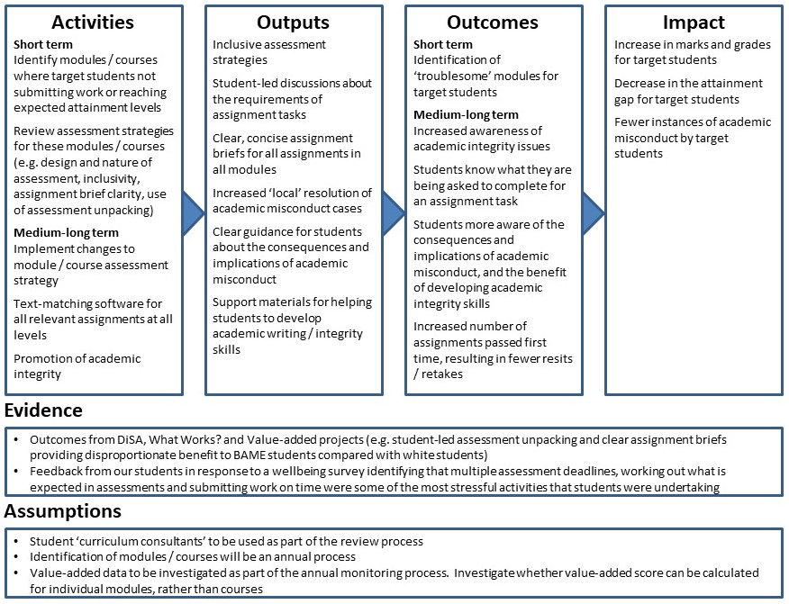
Strategic Measure S2: Increasing our students’ sense of belonging
There is substantial sector research to suggest that feeling a sense of belonging to the University makes a student far more likely to engage, and to succeed in their studies. We have some evidence that students from our target groups are less likely to engage with the university (whether through attending teaching, or participating in extra-curricular activities). Therefore increasing engagement, and belonging, for students from our target groups, is a strategic measure.
We will be working in collaboration with our Students’ Union to update our research on students’ sense of belonging in the short term (i.e. semester 1, 2019/20), and then implement measures to address the practical needs of students in the medium-long term (e.g. addressing existing student feedback to provide more opportunities for engagement with student societies). This work will be aimed specifically at courses that demonstrate different levels of attainment and submission rates for assessment activities for our target students. This comparison of the sense of belonging across courses with differential attainment for our target students will allow research into the relationship between sense of belonging and achievement in assessment activities and will therefore provide an alignment with strategic measure S1. We will continue to run the survey over the next five years, in order to determine the impact of our activities. In addition, we have recently revised our assessment regulations around level progression to facilitate a greater proportion of our students remaining in their original peer groups for the majority of their modules, given the strong evidence pointing to the positive impact of peer engagement on retention.
We will implement the Higher Education Achievement Report (HEAR) to reward engagement in, and provide recognition for, co- and extra-curricular activities. Working with the Students’ Union, we will work to increase students’ engagement with student societies, and ensure there is an academic society for every student within two years. Our activities will also focus on ways to enhance the sense of belonging of our students who are not always able to access campus-based support or communities of practice (e.g. commuter students, carers), through developing a better understanding of their needs, and exploring digital solutions through our Canvas VLE to enable collaborative peer-to-peer interaction. We will review the points at which students interact with support services physically and digitally, streamlining their experience of engagement, especially focusing on students who commute to the University.
The logic chain for this strategic measure is as follows:
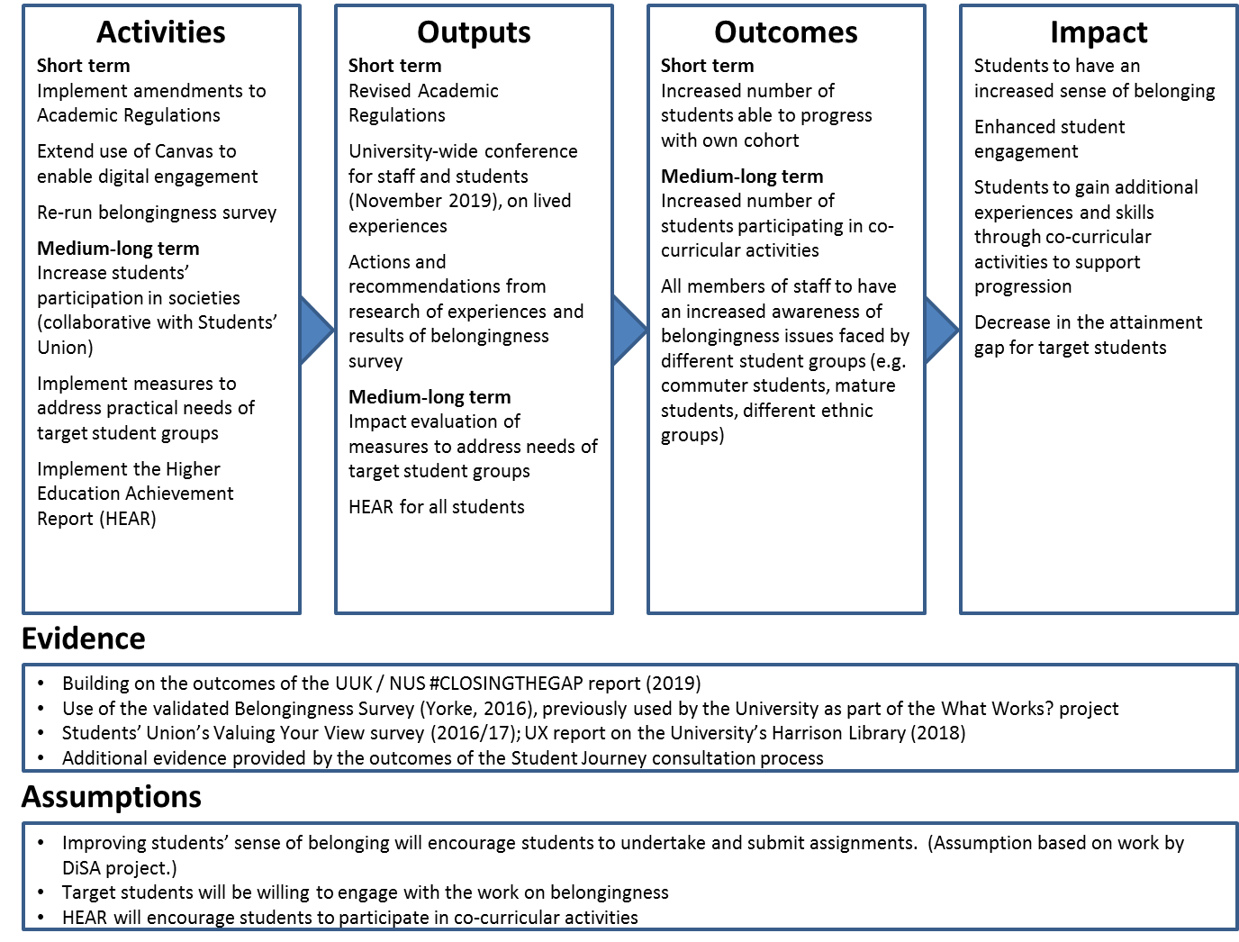
Strategic Measure S3: Supporting students’ continuation
Our Graduate Teaching Assistant (GTA) Scheme was implemented to enhance learning relationships between students and members of staff, and support students to succeed in classroom settings. In building upon the success of this scheme we introduced Academic Coaches in September 2018, starting with a pilot in two faculties. Recognising the importance of availability in developing learning relationships, the Academic Coaches do not undertake any teaching responsibilities and instead provide academic and pastoral support for the most vulnerable students outside of a formal classroom setting. The Academic Coaches initiative will be expanded to all academic faculties for 2019/20. Recruitment of future GTAs will align with the subject areas identified as having high rates of non-submission and gaps in attainment for our target students (see S1). We will also seek to ensure that our GTAs and Academic Coaches reflect the demographics of the student groups that they work with, and specifically our target students.
In the medium term (2020/21), we will implement a whole-University approach to induction, seeing it as an ongoing process rather than a one-off event. This will include regular touchpoints supported by our online platform, and the expansion of existing mentoring and buddying schemes. We will work with our local Further Education College partners to develop a holistic approach to transition to university, beginning before students enrol.
We are developing approaches to monitoring student engagement during their study, identifying students who are not engaging and providing interventions to support those students to engage, continue and achieve. Building on this work, we will be implementing an attendance monitoring system in the medium term, building to a learner analytics approach in the longer term (2022/23).
The logic chain for this strategic measure is as follows:
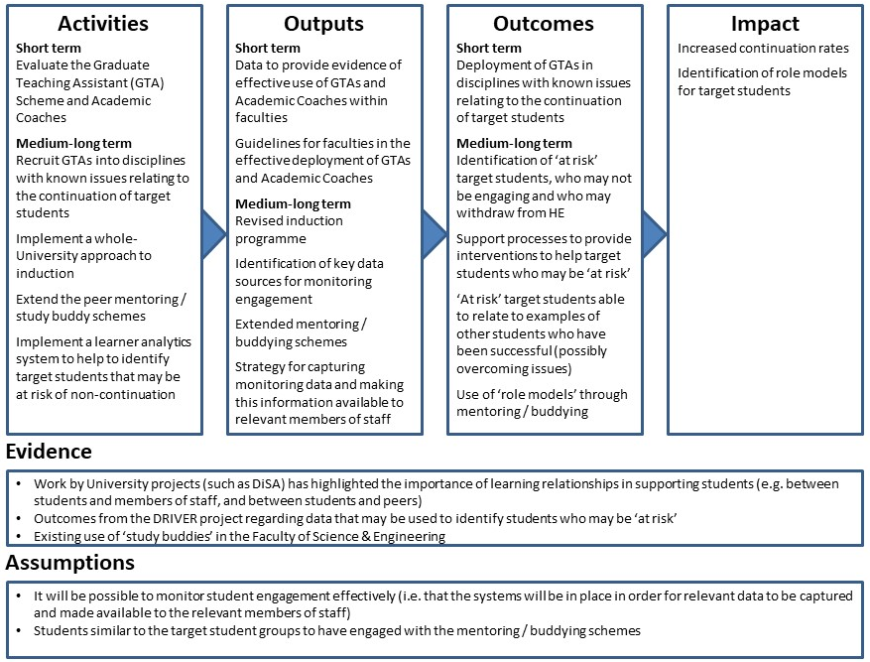
Progression
We recognise that the nature of employment is ever-changing and that it is no longer characterised by graduates proceeding along predictable and linear career progression pathways. Through the wide ranging services that we offer, our aim is that our graduates are able to develop, identify and utilise their cultural, social, psychological and human capital. Greater opportunities to secure meaningful and rewarding employment are increasingly one of the most important factors for students when choosing which university and degree course to study. Despite the challenging regional employment environment, 96% of our undergraduate students were in employment/further study and over 70% were in graduate-level employment 6 months after completing their studies. However we realise that this progress has not been shared equally amongst the diverse student groups that we serve.
Strategic Measure P1: Increase students’ confidence and understanding of possible career pathways
This strategic measure recognises that our students arrive with varied levels of confidence and understanding of potential career paths. We will implement a tool known as Assessment for Career Readiness (ACR) as part of the annual enrolment process, alongside a series of informed interventions, to ensure that students are consistently coached to engage in career planning during their studies.
Employability will be embedded as part of the offer delivered through the Academic Coaches to level 3 and 4 students, in order to embed conversations about career aspirations and progression paths at an early stage in students’ courses. These Coaches will have access to results of ACR giving a prior understanding of individual student confidence levels, and to identify students in the target groups to ensure they receive tailored support. Through ACR, and our Wolverhampton Enterprise and Employability Award (WEEA), we will measure improvements in skills, work-readiness and personal development made by students during their time studying at the University of Wolverhampton to help formulate evidence-based career plans addressing the specific needs of individual students. In response to a suggestion from students who were consulted as part of the development of this plan, we will scale up an alumni mentoring programme to match current students with alumni from diverse backgrounds who can provide career support and encouragement.
Whilst ACR will be implemented in 2019/20 across all degree disciplines, support from academic coaches and systematic increase in the uptake of WEEA (supported by course tutors) will initially be targeted at courses with:
- A 30% population of BAME and/or IMD Q1/2 students;
- A professional-level employment gap of over 3% from their peers.
Impact will be measured annually as the University-wide embedding process will continue.
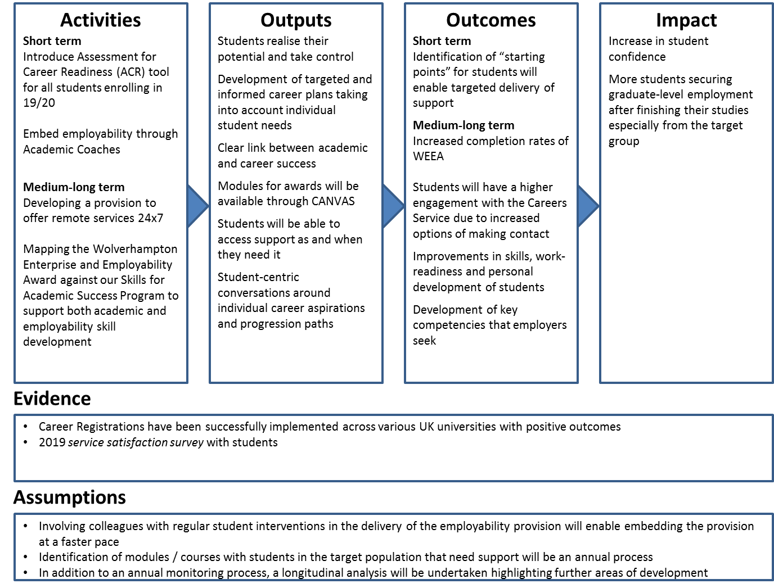
The logic chain for this strategic measure is as follows:

Strategic Measure P2: Support all courses to embed work experience in the curriculum
There is considerable evidence, observed both at the University and nationally, that a placement year significantly enhances the chances of a student attaining a graduate-level role on leaving their studies. 90.3% of our 2016/17 graduates who completed a sandwich-year placement secured graduate-level employment, and students on courses with placements, such as nursing and teaching, tend to have higher employment levels. Though continuous efforts have been exerted in this regard, we have had limited success in engaging students to undertake a year-long placement especially from IMD Q1/Q2 and BAME students.
Given that students are reluctant to undertake a full year work placement, we will develop other routes for them to engage in similar activities which are embedded in their course. A core element of the new Wolverhampton Curriculum Framework is that all courses will offer alternative routes to gain work experience. This will include a mixture of summer work, embedded work based assessments, live projects, and shorter work placements, including increased international opportunities. In addition, we will create a fund to enable target students experiencing financial hardship to undertake work experience, or to engage in valuable extra-curricular activities.
Increased promotion of existing services through course tutors and academic coaches and the financial support fund targeted at the specific groups will take place from 2019/20, ensuring that any barriers (perceived or otherwise) to the uptake of work experience are eliminated systematically. There will be a University-wide launch of these campaigns, however the provisions of the fund will only enable targeted support to the identified groups of students (BAME and IMDQ1/2).
An annual impact review will be conducted through GOS results and alumni employment data collected at and after graduations.
The logic chain for this strategic measure is as follows:
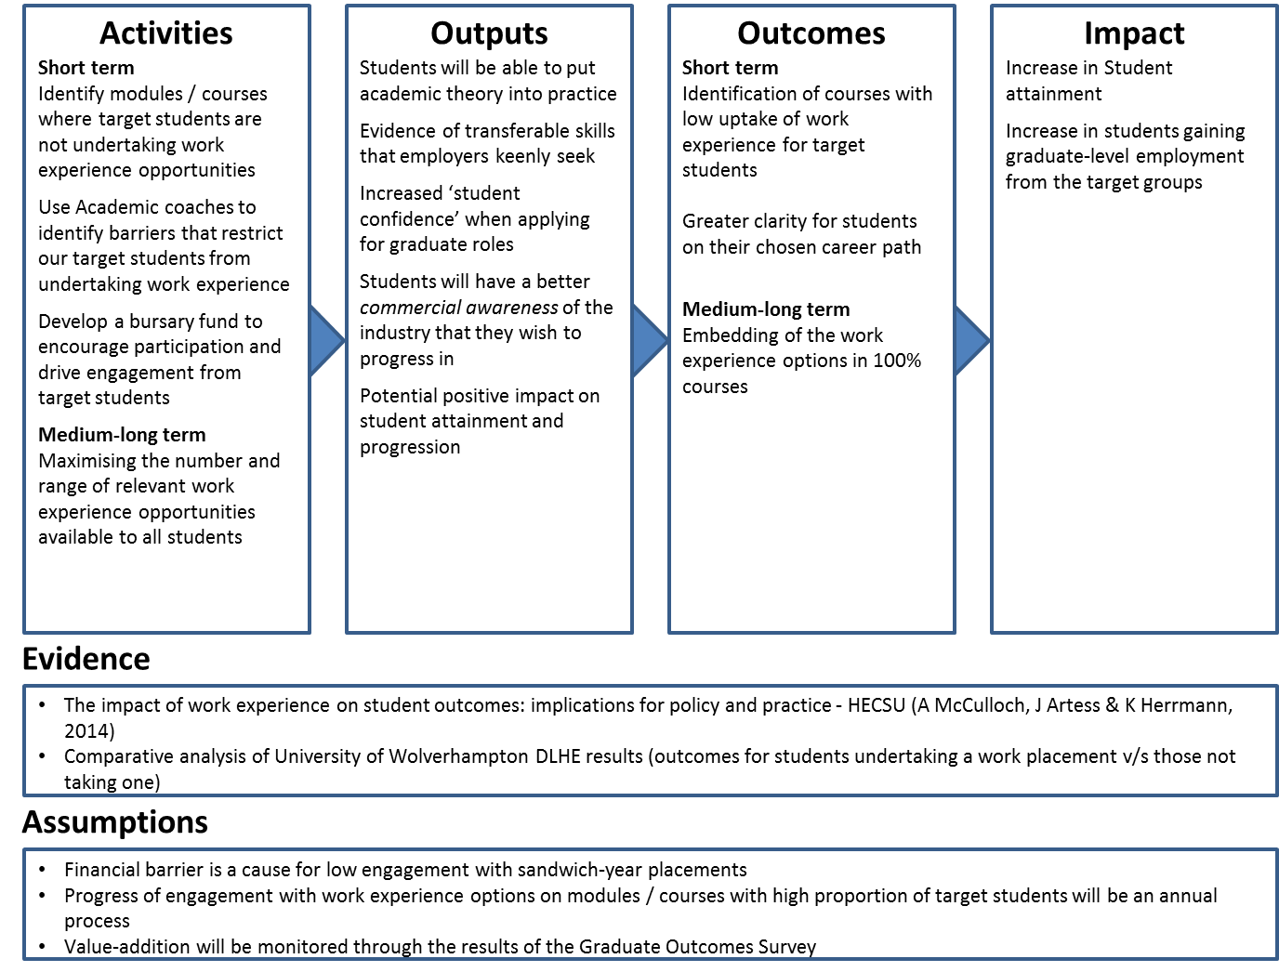

Collaborative Implementation
Strategic measures S1, S2 and P2 will be implemented jointly with our collaborative delivery partners, either wholly or in part. In changing our approach to assessment on specific courses and modules, the assessment of target subject areas will include all collaborative partner provision, and changes will be targeted accordingly. In addition, the positive actions to improve academic integrity and formative and summative use of text matching software will apply across all collaborative partner provision. With regard to increasing students’ sense of belonging, whilst some of the planned activities will necessarily apply mainly to on campus students, the regulatory changes and the introduction of the HEAR will impact across collaborative partner provision also. Finally, the support and direction for all courses to embed alternative routes to gain work experience will apply also to our collaborative provision.

3.2 Student consultation

Approaches to student voice at the University of Wolverhampton
In order to develop strong student engagement, we have worked collaboratively with the Students’ Union to develop a student representative scheme. Course representatives are elected annually by their peers, and trained by the Students’ Union via an extensive training package. This is a key input to inform course planning, monitoring and evaluation at the University. The Students’ Union representatives are members of all management and academic governance committees, including the Board of Governors. An evaluation by SUMS Consulting at the University, during 2018/19, commented positively on the University’s commitment to effective student representation.

We have recognised that course committee representation alone does not provide a holistic approach to student voice for all aspects of the student journey. To address the need to ensure that a diversity of voices can be heard, we work collaboratively with the Students’ Union to support specific interest groups, such as the student Deaf and Hard of Hearing Society, student carers, and mature students. There are local feedback mechanisms for specific service areas, such as the University Library’s ‘feedback wall’, and these are being developed through online platforms, such as the Students’ Union’s ‘create change’ platform, which allows students to start petitions to influence University services.

A formal Student Ambassador scheme has been implemented at the University in the last few months, although we have been employing students to deliver outreach activities for many years. As well as providing flexible paid employment to our students, the scheme provides opportunities for students to formally and informally influence our outreach activities. Student Ambassadors are a core element of our engagement with students before they enrol, and will increasingly be used to deliver transition support to applicants from the hardest to reach groups.

Student input to the self-evaluation process and identification of targets and actions
The self-evaluation group considered feedback from students via existing student voice mechanisms (e.g. course committee, Student Councils) as well as feedback from student surveys including the NSS and a questionnaire conducted with BAME students – which fed into Race Equality Charter as well as self-evaluation for the Access and Participation Plan. The Students’ Union Diversity Officer was a member of the preparation and self-evaluation group, and the Students’ Union provided challenge and comment throughout. For example, a focus group of students was held by the SU in order to critique the self-evaluation process.

The Students’ Union has provided the following comment:
The Students’ Union has welcomed inclusion in the design of the Access and Participation Plan through membership on the preparation and self-evaluation group and in engaging students in the content of the plan. The SU canvassed the views of students from a range of backgrounds including; mature, commuter, disabled and BAME students. In the student focus group many confirmed that they had low aspirations particularly when from poor and/or BAME backgrounds. The concept of belonging was discussed at length; students recommended that alumni role models would be beneficial in both recruiting and retaining students from non-traditional backgrounds and that more research into belonging would be helpful in exploring the BAME Attainment Gap. Students also confirmed that the forthcoming change to the Academic Regulations to allow more students to remain within their cohort was beneficial. Praise was given to the University’s travel fund bursary and free travel between campuses. The University included these recommendations within the plan. The Students’ Union feels that they have been given ample scope to contribute to the plan. We have worked closely with the University on a number of initiatives in relation to attainment, success and retention in previous years and look forward to maintaining this close working relationship during the implementation of the plan.

A student panel, including representatives from target groups (BAME, mature, care leavers, commuter students) and chaired by the Deputy Vice Chancellor (Regional Engagement), was held to review and validate targets and proposed actions. They considered the self-assessment document and commented on a first draft of the Plan. The group confirmed that the targets which had been identified via the self-assessment process were appropriate, and they helped to identify relevant actions to meet these targets. Output from this process was used to refine actions in respect of targets, and fed into a second draft of the plan. Particular feedback from students included the identification of group work as especially challenging as an assessment method, and mixed feedback on the benefits and challenges of extenuating circumstances and assessment extensions for students with protected characteristics. We intend to address these issues through our assessment review in strategic measure S1. Students will be involved in ongoing monitoring of this plan through their representation on the formal committees which consider updates on the plan (see section 3.4 below), and through regular updates and opportunities for feedback at student panel meetings. These student panels are an element of our Student Engagement Strategy, and meet at least three times per year.

3.3 Evaluation strategy
Strategic context
We have assessed our overall performance in evaluation as ‘emerging’ using the self-assessment toolkit. Through the work of the College of Learning & Teaching and the NCOP programme, there has been an increased awareness of the importance of impact evaluation. Whilst we have strong evaluation in some specific areas, we have not had a full evaluation strategy in the past, and the embedded nature of many of our activities has tended to make establishing causality challenging. We are aware, therefore, that we have more to do to develop robust evaluation of all of our activities. The toolkit has highlighted several areas where we can focus further work, particularly in relation to robust data collection and strategic overview of evaluation.
Our initial strategy is to invest in specific evaluation expertise to provide a rapid increase in our evaluation, whilst also creating appropriate governance. There will be a specific appointment of a Senior Evaluation Lead in 2019/20 who will design and co-ordinate the evaluation strategy. Our priorities for evaluation will be: upskilling staff across the University to make more use of data and best practice in evaluation, specific analysis of our areas of largest expenditure such at the Graduate Teaching Assistant scheme, ensuring the student voice is fully represented in planning and decision-making, and disseminating findings and best practice across and beyond the University. The evaluation investment will primarily focus on the areas of biggest challenge and gap. It is important to ensure that there is a comprehensive evaluation for the biggest risks. The initial investigation will focus on the investment in early interventions in student success, namely closing the BAME attainment gap. Early priorities will include a review of the effectiveness of Academic Coaches, the Graduate Teaching Assistant scheme, targeted module/assessment interventions and the Students Representatives system. We will keep evaluation spend under review and increase if necessary.
Programme design
Teams within our Strategic Planning Office, Directorate of Student & Academic Services, and NCOP team evaluate findings from institutional and national data sources and surveys in order to inform our activities and target under-represented groups. Theories of change and logic chains have been developed for the strategic measures identified to address the aims and objectives in this plan. Evidence used to inform these strategic measures has either been derived from our own data and observations or from findings in the sector. Some of our strategic measures are new activities that have been proposed on the basis of local and national data, and these will require on-going empirical evaluation in order to test the logic provided for the effectiveness of the proposed measures. An example of where past evaluation has influenced programme design is WhatWorks Phase II (WW: 2013-17). This focused on the subject areas where it was necessary to enhance retention and success. The programme introduced an inclusive assessment brief template and a flipped assessment brief unpacking approach. The evaluation of this approach indicated decreases in non-submissions and an increase in students’ assessment scores.
Using the structures outlined below, our strategic measures will be developed further to ensure that there is a robust mechanism for data collection and a strategic overview of this evaluation activity.
Evaluation design
The impact evaluation approaches proposed for our strategic measures fall within the narrative and empirical enquiry methodologies. We are not proposing to undertake any causality evaluations of the identified strategic measures at this stage, although we intend that the data and evidence collected for these measures may lead to the development of causality evaluations in the future. We will be reviewing the empirical enquiry approaches for our strategic measures, particularly for new activities, in order to determine whether appropriate counterfactual groups can be identified in order to establish the level of impact of the strategic measure.
Many of our evaluation activities undertaken to date use a mixed-method approach in order to provide qualitative context for the quantitative data obtained with students. We propose to continue with this approach, which is especially important given the diversity of students in our institution; we want to ensure that we hear a range of student voices when assessing the impact of activities.
In addition to using the logic chain approach as outlined in the ‘Report to HEFCE by CFE Research’ (July 2015), our evaluation design will draw on the Value and Impact Evaluation Toolkit provided by AMOSSHE which closely aligns with the logic models. The Toolkit provides a set of questions that, when applied, will create a tailored evaluation of impact for each strategic measure.
Our greatest investment will relate to initiatives that respond to the BAME attainment gap. In addition to the process outlined above, we will develop cases studies utilising student questionnaires, semi structured interviews and focus groups. We will also identify Value Indicators through considering the economy, efficiency and effectiveness of initiatives.
Implementing evaluation
We adopt a project management methodology to our major University projects, and this includes the identification of objectives, targets and risks. This process also allows for appropriate governance through project and programme boards chaired by senior staff.
We are proposing to establish a new sub-committee of our University’s Academic Enhancement Committee (UAEC). The Impact Evaluation sub-committee (IESC) will replace the existing Student Transition, Induction and Retention (STIR) working group and will be responsible for review and evaluation of our Access and Participation Plan activities.
We will be allocating resources for specialist impact evaluation and data analysis, in order to provide appropriate skills in the evaluation of data and for evaluating the reliability of the proposed data collection mechanisms.
Preliminary results of pilot activities pertaining to S1: Changing our approach to assessment in specific course and modules are likely to be available in early January 2020. These results will inform the further roll-out of interventions toward this strategic measure.
Learning from evaluation
The new IESC will have strategic oversight of the evaluation strategies for the individual projects, and will ensure that lessons learnt are applied to current projects and to shape future initiatives. They will ensure that appropriate ethical approval has been obtained for the projects, and will be responsible for the dissemination of outcomes and impact to Academic Faculties and Directorates in order to inform and enhance evaluative practice.
Lessons learned through research and practice have fed back into programme design and interventions in two ways. Firstly this occurs through using the findings of institutional research as an evidence base for the design of strategic interventions. For example,
The DiSA programme comprised of a number of stages; the first of which was a research stage. What we learned from the research that this programme produced, was used to create a number of interventions that were further evaluated via action research cycles.
The findings from DiSA that pertained to assessment anxiety and students’ difficulties in understanding assignment briefs were fed forward into the WW programme. The results of this work have informed the design of inclusive assessment practices, which are now used in the programmes where the pilots took place.
What we have already learned is also fed back into programme design and interventions at a programme level. In addition to this, the University of Wolverhampton Students’ Union hold an annual Attainment and Equality Summit. The Summit engages both staff and students in utilising the findings of institutional research and identified best practice to rectify educational inequalities. Furthermore, each Faculty develops an Annual Attainment Plan that utilises the Faculty’s attainment and retention data to identify areas of concern. The action plan templates encourage Faculties to implement successful initiatives from institutional research and identified best practice. The above methods have proved to be useful dissemination mechanisms and will continue. However, changes to the Governance structure via the creation of a new sub-committee of UAEC entitled The Impact Evaluation sub-committee (IESC), will encourage a wider and deeper engagement with learning from current and future initiatives.
The sharing of our best practice extends beyond the University. Over the past nine years, we developed lasting working relationships with a number of HEIs across the country, with whom we collaboratively work towards reducing the BAME attainment gap. These have included Coventry, Derby, Greenwich, Kingston, Hertfordshire and DeMontfort Universities.
Evaluation of financial support
Our total investment in financial support in 2020-21 will be £1,640,000.
Our financial support package for students includes the Student Travel Fund, which is £300 offered to all eligible students to support their travel to university. This is a direct consequence of the knowledge that the majority of our students commute to campus, and research we have undertaken to suggest that the cost of travel is a significant barrier to our students, and that the travel fund is a very welcome support. We also have specific bursaries for care leavers, Deaf students, and estranged students, who we know face specific financial barriers to participation. We invest substantially in hardship support which is awarded based on immediate student need. In addition, based on student feedback, we are discontinuing our Progression Scholarship, and reallocating some funds to evaluation, and the majority to an engagement fund to support students to undertake placements or to participate in student societies. This will be specifically aimed at students in our target groups. Our financial support packages are:
Fund | Eligibility criteria | Comments
Dennis Turner Opportunity Fund | In proven genuine financial hardship  Have taken up and are in receipt of all statutory support available. | Maximum award £1000.  Available in each year of study.
Access Bursary | Deaf or have hearing loss or  Are care leavers | £2000 (£1000 - year one, £1000 - year two)
Care Leavers | Care leavers in receipt of money from Access Bursary | £650 – year one, year two and subsequent (non-final) years  £1000 in final year plus £250 graduation costs
Estranged Students | Students who are estranged from, and have no contact with, their families | £650 – year one, year two and subsequent (non-final) years  £1000 in final year plus £250 graduation costs
Travel Fund | Full-time, undergraduate entrants. | £300 – year one

During the course of 2019/20, we intend to undertake a thorough quantitative evaluation of the impact of our Student Travel Fund and our specific bursaries, as our evaluations to date have focused on qualitative analysis.
We aim to use our financial support packages to ensure that groups that are under-represented in HE can access, succeed in and progress from University. We have identified a number of target groups where we believe financial support will have a positive impact on both access and success. We are planning to appoint an independent consultant to review our financial support packages and make recommendations.
We evaluated our financial support through qualitative surveys of our students, and through consultation with schools and colleges which send large numbers of non-traditional students to us. As a consequence, in 2018 we discontinued Distinction scholarships. As a consequence of further feedback, we are discontinuing our progression scholarship for certain students who progress to us from further education colleges, and using the majority of the funds for new support for students once they are on course to help them to access extra-curricular activities, placements and work experience which support their progression into employment. This change is a result both of sector-wide evidence and feedback through various student surveys and focus groups, which demonstrates that our students find finance to be a specific barrier to participation in career-enhancing activities. Some of the funding which was previously allocated to financial support has been moved to evaluation, in part so that we can more consistently evaluate the impact of our financial support. We intend to use both the quantitative and qualitative elements of the OfS financial support toolkit to evaluate our support for students. We will undertake an analysis in the 2019/20 academic year, though as we are making some changes to the support we offer we anticipate needing to re-run the analysis in the following two cycles as well. We intend that undertaking this work will be one of the first pieces of work undertaken by our new evaluation post holder, in conjunction with our strategic planning team, and as part of our approach we will consider the use of independent evaluation, where appropriate. We have been moving away from financial support and this has included discontinuation of Distinction Scholarships, which accounts for the lower expenditure in this area, and are gradually refocussing expenditure from financial support into success, progression and evaluation.

3.4 Monitoring progress against delivery of the plan
Progress against the delivery of this plan will be overseen by a Deputy Vice-Chancellor, with regular reports to the Academic and Student Affairs Committee (a sub-committee of Board of Governors) and Board of Governors. Progress will also be reported regularly to University Academic Enhancement Committee (UAEC) and then on to Academic Board, and the Corporate Management Team (CMT), and to the termly Student Panel meeting, ensuring that an understanding of the plan, and progress, are embedded across the institution, including with students. The governance is as follows:

A detailed action plan arising from the initiatives described above will be created, detailing actions, milestones and timescales, roles and responsibilities. We will also maintain a risk register ensuring early monitoring of any potential barriers to achieving our targets. If progress is not as expected, or appears to be worsening, a recovery plan will be put in place with actions depending on the circumstances, but likely to include an investigation of the reasons for a lack of progress, consideration of potential alternative actions to achieve similar outcomes, revised timescales for delivery will be developed by UAEC, and further monitoring of progress with frequent updates to the Deputy Vice-Chancellor.

Students are involved in monitoring the delivery and achievement of the plan in two ways:

Student representation through the Students’ Union on key committees that focus on the actions and review of progress, namely:
- Board of Governors
- Academic and Student Affairs Committee (Governor Committee)
- Equality and Diversity Committee
- Academic Board
- Corporate Management Team
- University Quality Enhancement Committee
- Fees and Bursaries Working Group
- Faculty Boards

Secondly there are further specific focused activities for wider involvement. We are formulating a revised approach to the Student Voice, to include the successful Student Panel referred to earlier. This will include building on student conferences focusing on the BAME attainment gap and involving focus groups and review activities at University, Faculty and School level.

The Board of Governors takes an active role in monitoring performance. There are two aspects to this monitoring.
Firstly, there is the ongoing and regular monitoring of progress through KPIs associated with the University’s Strategic Plan that contribute to the APP, as follows:

- Continuation
- Achievement
- Employability
- Satisfaction

All of which had detailed contextual information focusing on the BAME Attainment Gap in detail. KPI performance is reviewed annually and also at strategic Board of Governors away days.

Secondly, there will be thorough detailed examination of progress with the APP, which will a key ongoing focus of both the Equality and Diversity Committee and the Academic and Student Affairs Committee; the APP will be a particular focus for the Chair of Academic and Student Affairs Committee. Both committees report to the Board of Governors and issues will be specifically reported. The Board will also consider the APP progress report annually.

Provision of information to students
We provide information about student fees and any additional course costs on our website, in our prospectus and other relevant marketing collateral; we also provide information during outreach and recruitment events, and at open days. Our terms and conditions set out the conditions under which fees may be raised (for instance, by inflation each year) and our tuition fee liability policy makes clear the circumstances in which students will be liable for fees when they experience any change in circumstance (such as taking leave of absence). We are introducing a new offer pack which will be sent out with all applicant offer letters and will encompass all the essential contractual information required combined with materials to nurture and engage. We commit to ensuring that students are informed about the financial support they are entitled to, and its eligibility criteria, and will do so through our communication with applicants, offer holders and students, as well as through our website and printed publications.
Students who declare through the application or enrolment processes that they are a care leaver, or an estranged student, are contacted directly to make them aware of the financial support that may be available to them. We have dedicated financial information on our website, including transparency information about how students’ fees are spent.

NOMIS data
Internal data
Internal data
HESA data - https://www.hesa.ac.uk/news/17-01-2019/sb252-higher-education-student-statistics/numbers
https://assets.publishing.service.gov.uk/government/uploads/system/uploads/attachment_data/file/587221/Inclusive_Teaching_and_Learning_in_Higher_Education_as_a_route_to-excellence.pdf
This includes Disparities in Student Attainment (DiSA); What Works?; Value-added; and Using a value added metric and an inclusive curriculum framework to address the BME attainment gap.
E.g. Thomas, L. (2012) Building student engagement and belonging in Higher Education at a time of change: final report from the What Works? Student Retention & Success programme. London: Paul Hamlyn Foundation.
University of Wolverhampton Destination of Leavers from Higher Education (DLHE) results 16/17

