How to do to logon to e: Vision
- Open University of Wolverhampton website in Windows Internet Explorer by typing http://www.wlv.ac.uk in the address bar
- Click on the “For Staff” button on the right hand side

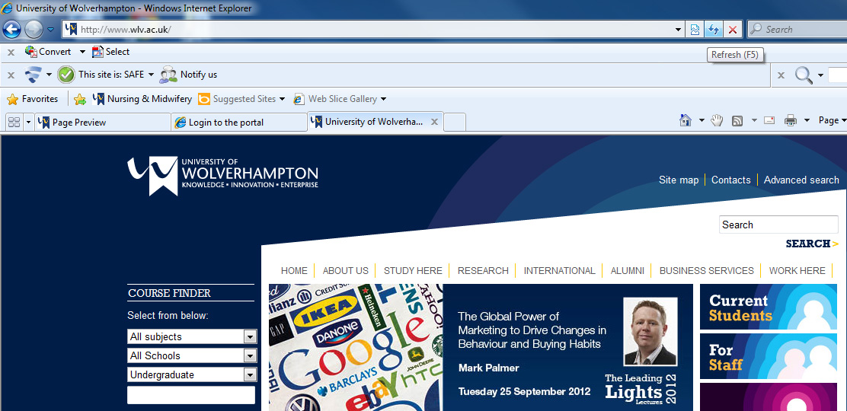

- Click on the button e:Vision as shown below:

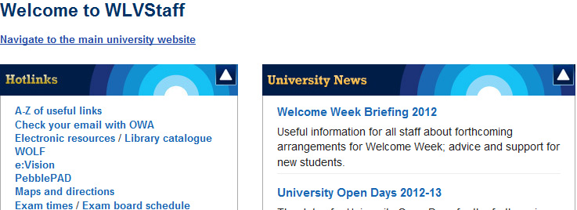

- Type your User-name and password in the boxes provided

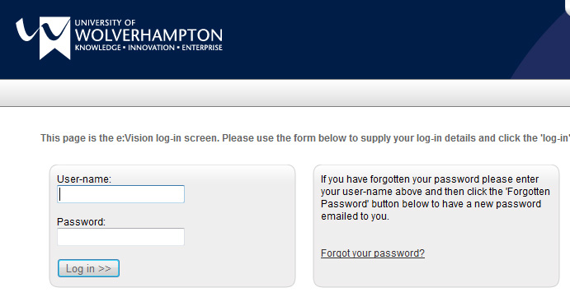
- After you logged on successfully the screen below will appear
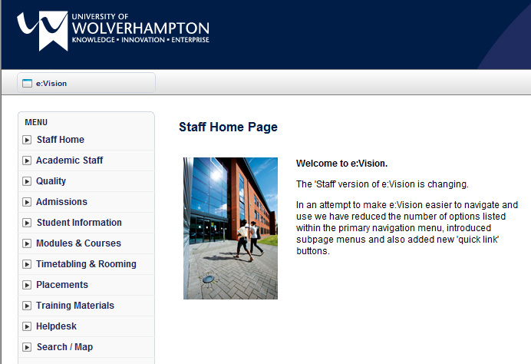

Students
Cannot log into e:Vision or have forgotten my e:Vision password
First Time Logging into e:Vision
If you are using e:Vision for the first time, you should use your seven digit student number as the Username and enter the temporary password supplied to you. Once you have successfully logged into e:Vision, you should change your password to a more memorable one.
Have used e:Vision before
If you have used e:Vision in the past and have forgotten your password, you can now use your IT Account password to log on to e:Vision. If you can't remember this either, you should visit the e:Vision page and enter your username as normal, leave the password field blank, then click the Forgotten Password button and a new password will be emailed to your registered email address, (the one you gave us when you applied to the University).
Notes:
If you do not receive your new password, please contact your School's Student Office.
If you have problems logging on, please contact the IT Service Desk on (01902) 322000 or ext. 2000.

