Vitae Researcher Development Framework (RDF)

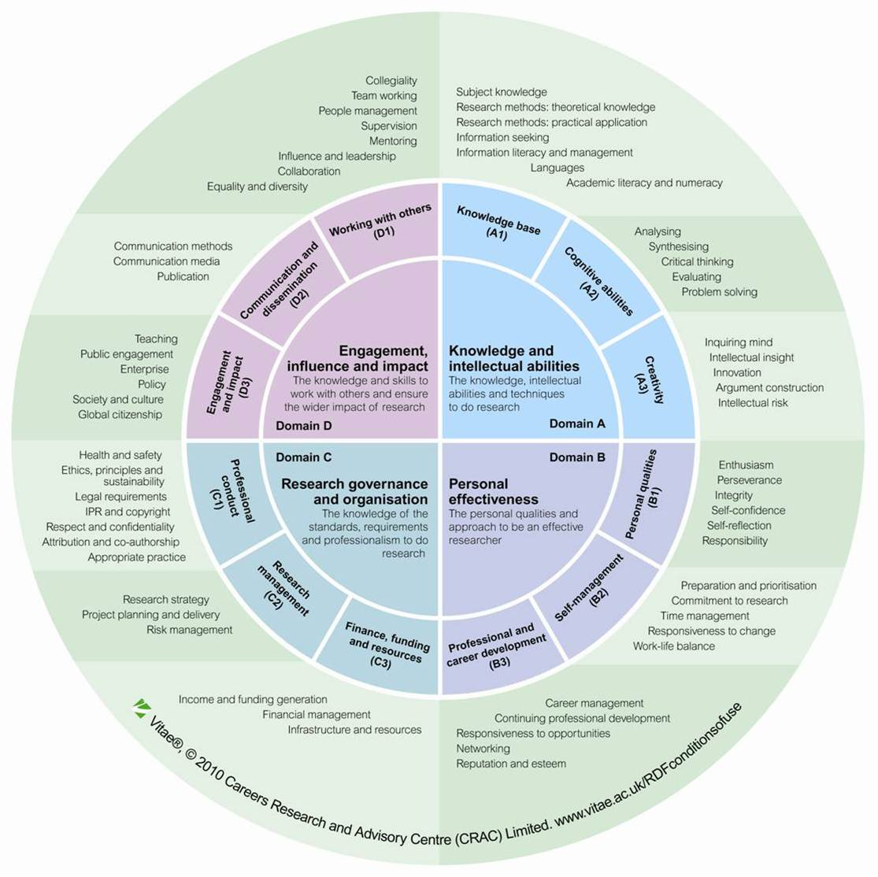
Researcher Development Statement
The UK is committed to enhancing the higher-level capabilities of the UK workforce including the development of world-class researchers. Researchers are critical to economic success, addressing major global challenges, and building a leading knowledge economy.

The Researcher Development Statement (RDS) sets out the knowledge, behaviours and attributes of effective and highly skilled researchers appropriate for a wide range of careers. The RDS is for policy makers and research organisations which provide personal, professional and career development for researchers in higher education. The Researcher Development Statement is derived from the Researcher Development Framework (RDF), a major new approach to researcher development, which aims to enhance our capacity to build the UK workforce, develop world-class researchers and build our research base.

The RDS and RDF will contribute to researcher training and development in the UK by providing a strategic statement (RDS) and operational framework (RDF) to support the implementation of the Concordat to Support the Career Development of Researchers¹, the QAA Code of practice for research degree programmes² and the ‘Roberts’³ recommendations for postgraduate researchers and research staff.

The RDS is structured in four domains encompassing the knowledge, intellectual abilities, techniques and professional standards to do research, as well as the personal qualities, knowledge and skills to work with others and ensure the wider impact of research. Within each of the domains are three sub-domains and associated descriptors, which describe different aspects of being a researcher.

For more information on the Researcher Development Framework and associated Statement go to www.vitae.ac.uk/rdf

¹ www.researchconcordat.ac.uk
² www.qaa.ac.uk
³ http://webarchive.nationalarchives.gov.uk/+/http:/www.hm-treasury.gov.uk/set_for_success.htm

