ARENA THEATRE

STATEMENT OF POLICY FOR SAFEGUARDING OF CHILDREN AND YOUNG PEOPLE

Updated February 2022

The Arena Theatre believes that it is always unacceptable for a child or young person to experience abuse of any kind, and recognises its responsibility to safeguard the welfare of all children and young people by a commitment to practice which protects them.

We aim to provide safe participatory and creative opportunities for all the children and young people who use our theatre.

In order to do this, we recognise that:

- The welfare of the child/young person is paramount.
- All children and young people – regardless of age, culture, disability, gender, language, race, religious beliefs and sexual identity – have the right to equal protection from all types of harm and abuse.
- Working in partnership with children and young people, their parents, carers and other agencies is essential in promoting their welfare.

The purpose of this policy is:

- To provide protection for children and young people who receive services from the Arena Theatre.
- To provide staff members and volunteers with guidance on procedures they should adopt in the event that they suspect a child or young person may be at risk of, or currently experiencing, harm.
- This policy applies to all staff, including: the Arena Theatre box office team, the Arena Theatre technical team, volunteers, freelancers, visiting theatre companies and anyone working on behalf of the Arena Theatre at any given point.

We will endeavour to safeguard all children and young people by:

- Valuing, listening to and respecting them.
- Adopting child safeguarding guidelines through procedures for members of staff, framed by the relevant legal framework.
- Recruiting staff and volunteers safely, ensuring all necessary checks are carried out.
- Sharing information about child safeguarding best practice with fellow community groups, theatre companies, relevant organisations we work with and parents.
- Sharing concerns with relevant agencies who need to know, ensuring the involvement of parents and children when appropriate.

The Arena Theatre is committed to reviewing its policies annually.

This policy was approved by:

Name:
Position:
Date:

Signature:

CONTENTS

Safeguarding Procedures

  - Definition of Children and Young People
  - Statement of Values and Principles
  - Designated Persons
  - Code of Conduct
  - Photographic Procedures
  - Whistleblowing and Complaints Procedures

Response Procedures

2.1 Responding to a child disclosing abuse
2.2 Responding to signs or suspicions of abuse
2.3 Responding to allegations of abuse against a member of staff, volunteer, visiting theatre company of freelancer
2.4 Recording and Information Sharing
2.5 Confidentiality, Retention and Storage of Documentation

Appendices

Appendix 1 - Consent Form for Photographs and Videos
Appendix 2 - Definitions of Abuse
Appendix 3 - Legal Framework

SAFEGUARDING PROCEDURES

1.1 Definition of Children and Young People

Children and young people are, by definition, anyone up to the age of 18 years old, and those between 19 years old and 25 years old with special educational needs (SEN).

1.2 Statement of Values and Principles

The Arena Theatre believes that:

- The organisation – and any visiting theatre companies – have a duty of care to children and young people who use its services and takes part in its activities.
- Everybody has a responsibility to support the care and protection of children.
- All children should be encouraged to fulfil their potential, and any inequalities should be challenged.

1.3 Designated Persons

Designated persons are members of both the Arena Theatre staff team and the wider University of Wolverhampton, who have specific responsibility for ensuring effective safeguarding and protection procedures. These include:

Artistic Director for the Arena Theatre

Neil Reading: Neil.Reading@wlv.ac.uk / 01902 322 373

Designated Safeguarding Lead for the University of Wolverhampton

Samantha Waters: safeguarding@wlv.ac.uk

The role of the designated person is to:

- Receive and record information from staff, volunteers, freelancers (or visiting company members), children or parents/carers who have child protection concerns.
- Assess the information carefully and correctly, clarifying and obtaining more information as appropriate and consulting with fellow senior colleagues if necessary.
- Consult initially with a statutory child protection agency to express any concerns or doubts as soon as possible.
- If necessary, to make a formal referral to a statutory child protection agency without delay.

1.4 Code of Conduct

When working with or for children and young people, you are acting in a position of trust. You are likely to be seen as a role model and must act appropriately.
All Arena Theatre staff, volunteers, visiting companies and freelancers should:
- Treat children and young people fairly and without prejudice or discrimination.
- Understand that children and young people are individuals with individual needs.
- Respect differences in gender, sexual orientation, culture, race, ethnicity, disability and religious belief systems between yourself and others, and appreciate that all participants bring something valuable and different to the group/organisation
- Challenge discrimination and prejudice.
- Encourage young people and adults to speak out about attitudes or behaviour that makes them uncomfortable.
Relationships
You should:
- Promote relationships that are based on openness, honesty, trust and respect.
- Avoid favouritism.
- Be patient with others.
- Use special caution when you are discussing sensitive issues with children or young people.
- Ensure your contact with children and young people is appropriate and relevant to the work of the project you are involved in.
- Ensure that whenever possible, there is more than one adult present during activities with children and young people. If this isn’t possible, ensure that you are within sight or hearing of other adults. If a child specifically asks for or needs some private time with you, ensure other staff or volunteers know where you and the child are.
- Only provide personal care in an emergency and make sure there is more than one adult present if possible. (This is unless you are working under specific circumstances where it has been agreed that the provision of personal care is part of your role and you have been trained to do this safely.)
Respect
You should:
- Listen to, and respect, children at all times.
- Value and take children’s contributions seriously, actively involving them in planning activities wherever possible.
- Respect a young person’s right to personal privacy as far as possible (in some cases it may be necessary to break confidentiality to follow child protection procedures; if this is the case it is important to explain this to the child or young person at the earliest opportunity).
Unacceptable behaviour
When working with children and young people, you must not:
- Allow concerns or allegations to go unreported.
- Take unnecessary risks.
- Smoke, consume alcohol or use illegal substances.
- Develop inappropriate relationships with children and young people.
- Make inappropriate promises to children and young people.
- Engage in behaviour that is in any way abusive this includes having any form of sexual contact with a child or young person.
- Let children and young people have your personal contact details (mobile number, email or address) or have contact with them via a personal social media account.
- Act in a way that can be perceived as threatening or intrusive.
- Patronise or belittle children and young people
- Make sarcastic, insensitive, derogatory or sexually suggestive comments or gestures to or in front of children and young people.
Upholding this code of behaviour
You should always follow this code of behaviour and never rely on your reputation or that of our organisation to protect you.
If you have behaved inappropriately you will be subject to our disciplinary procedures. Depending on the seriousness of the situation, you may be asked to leave Arena Theatre. We may also make a referral to statutory agencies such as the police and/or the local authority children’s social care department.
If you become aware of any breaches of this code, you must report them to safeguarding@wlv.ac.uk. To do this you should follow the whistle-blowing procedure or, If necessary, the child protection/safeguarding procedures.

1.5 Photographic Procedures

- Avoid using the name of the child or young person in the photographic caption. If the photograph is used, avoid naming the child.
- Always use a parental permission form to obtain content for a child to be either photographed or videoed (see Appendix 1)
- Only use images for the specific purpose agreed with the parent/carer of the child or young person. Additional use without permission is not acceptable.
- All images of children must be stored safely and securely.

1.6 Whistleblowing and Complaints Procedure

Arena Theatre promotes a culture where staff can express any concern they may have about a colleague’s behaviour in relation to child protection.

In order to achieve this, staff are encouraged to raise and share concerns with a designated person without delay. Concerns will be treated seriously and in the strictest confidence.

RESPONSE PROCEDURES

Please see Appendix 2 for Definitions of Abuse.

2.1 Responding to a child disclosing abuse

- Stay calm.
- Listen carefully to what is said.
- Identify an early – but appropriate – opportunity to explain that it is likely the information disclosed will need to be shared with others.
- Allow the child to explain at their own pace.
- Reassure the child or young person that they are doing the correct thing in telling you.
- Ask questions to receive clarification, do not ask questions with undertones of suggestion for a particular answer.
- Tell them what your next steps are, and who you will be sharing the information with.
- Record in writing what is said using the child’s own words – note the date, time, any names mentioned and who received the information.
- Contact a designated person.

2.2 Responding to signs of suspicion or abuse

Please follow the below if you have concerns about the welfare of a child or young person.

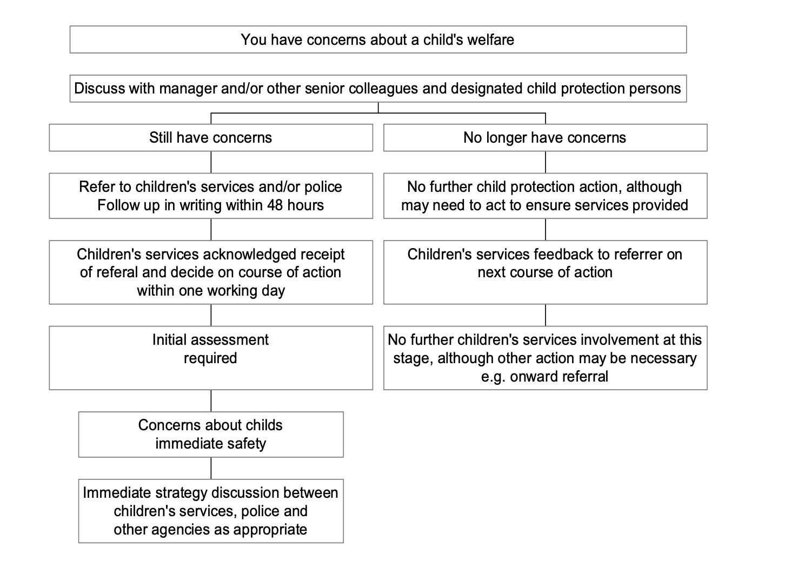
2.3 Responding to allegations of abuse against a member of staff, volunteer, visiting theatre company of freelancer

Please see below if you have concerns about a member of staff, volunteer, visiting company or freelancer in relation to child protection.

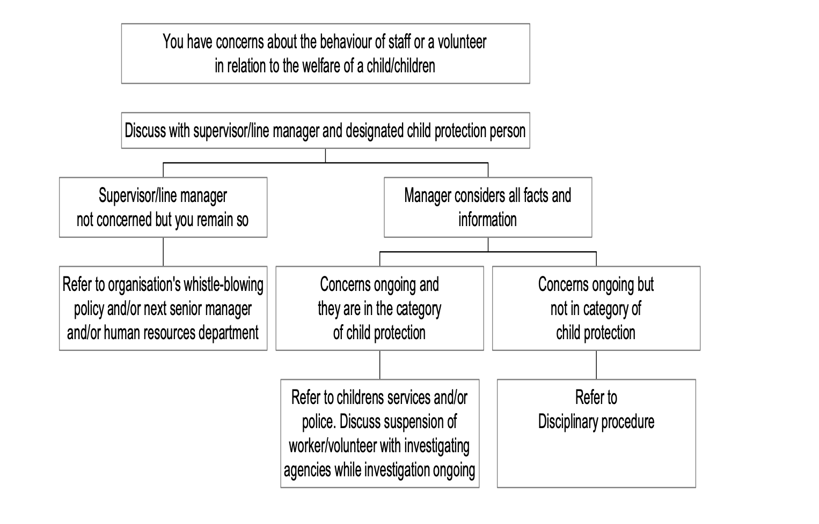
2.4 Recording and Information Sharing

It is vitally important to record the details of an allegation or reported incident in all situations – regardless of whether or not the concerns are shared with a statutory child protection agency.

An accurate note should be made of:

- Date and time of the incident.
- Parties who were involved.
- What was said and done, and by whom.
- Any action taken by the Arena Theatre to investigate the matter.
- Any further action taken (this might be in the event of the suspension of a worker)
- In the case that a referral was not made to a statutory agency, why was this?
- Name of person filing the report, and to which designated person this was referred to.

Please ensure the record is clear and factual as child protection agencies may need it when investigating the incident. In some instances, the record may also be used as evidence in court. Keeping such a record may also help protect the Arena Theatre and University of Wolverhampton.

2.5 Confidentiality, Retention and Storage of Documentation

In line with General Data Protection Regulations (GDPR) all personal information that is acquired and held on children and young people should be treated as confidential and stored securely. All members of the Arena Theatre Box Office and Technical Teams have access to the GDPR coded safe based in the Box Office where personal information is held and stored safely. A passcode is required to access this information.

In line with the Arena Theatre’s Privacy Policy, all personal documentation and details held by the venue is reviewed every four years and disposed of appropriately if no longer required.

Appendix 1 – Consent Form for Photograph and Videos

Arena Theatre recognises the need to ensure the welfare and safety of all children.

In accordance with our Child Safeguarding Policy we will not permit photographs, video or other images of children and young people to be taken without the consent of the parents/carers and children.

Arena Theatre will follow the guidance for the use of photographs a copy of which is available from the Education and Outreach Officer.

We will inform as to where photographs will be used. Arena Theatre will take all steps to ensure these images are used solely for the purposes they are intended, and are stored safely and securely.

If you become aware that these images are being used inappropriately, you should inform the Arena Theatre immediately. You have the right to ask for the removal of photographs involving you or your child at any time.

I hereby consent to the use and publication of photographs, video recordings and other media featuring (CHILD NAME HERE), taken during my participation in (EVENT NAME HERE) for use in promotional, archival and other capacities.

Parent/Carer Name: ………………………………………………….....

Signed: ……………………………………..................

Date: ……… / …...... / ...................

Appendix 2 – Definitions of Abuse

Physical Abuse:
Physical abuse may involve hitting, shaking, throwing, poisoning, burning or
scalding, drowning, suffocating, or otherwise causing physical harm to a child.
Physical harm may also be caused when a parent or carer fabricates the symptoms of, or deliberately induces, illness in a child.
Emotional Abuse:
Emotional abuse is the persistent emotional maltreatment of a child such as to cause severe and persistent adverse effects on the child’s emotional development. It may involve conveying to children that they are worthless and unloved, inadequate, or valued only insofar as they meet the needs of another person. It may include not giving the child opportunities to express their views, deliberately silencing them, ‘making fun’ of what they say or how they communicate. It may feature age or developmentally inappropriate expectations being imposed on children. These may include interactions that are beyond the child’s developmental capability, as well as overprotection and limitation of exploration and learning, or preventing the child participating in normal social interaction. It may involve seeing or hearing the ill-treatment of another. It may involve serious bullying (including cyber bullying), causing children frequently to feel frightened or in danger, or the exploitation or corruption of children. Some level of emotional abuse is involved in all types of maltreatment of a child, though it may occur alone.
Sexual Abuse:
Sexual abuse involves forcing or enticing a child or children to take part in sexual activities, not necessarily involving a high level of violence. Whether or not the child is aware of what is happening. The activities may involve physical contact, including assault by penetration (for example rape or oral sex) or non-penetrative acts, such as masturbation, kissing, rubbing and touching outside of clothing. They may also include non-contact activities, such as involving children in looking at, or in the production of pornographic material or watching sexual activities, or encouraging children to behave in sexually inappropriate ways, or grooming a child in preparation for abuse (including via the internet). Sexual abuse is not solely perpetrated by adult males. Women can also commit acts of sexual abuse, as can other children.
Neglect:
Neglect is the persistent failure to meet a child's basic physical and/or psychological needs, likely to result in the serious impairment of the child's health or development. Neglect may occur during pregnancy as a result of material substance abuse. Once a child is born it may involve a parent or carer failing to provide adequate food, clothing, and shelter, including exclusion from home or abandonment; failure to protect a child from physical harm or danger; failure to ensure adequate supervision, including the use of adequate care takers; or the failure to ensure access to appropriate medical care or treatment. It may also include neglect of, or unresponsiveness to, a child's basic emotional needs.
There are also emerging types and methods of child abuse, including:
- Sexual exploitation
- Female genital mutilation CFGM)
- Trafficking of children in order to exploit them sexually, financially, via domestic servitude, or via the involvement in activity such as the production and sale of illegal drugs.
- Abuse linked to beliefs such as spirit possession or witchcraft.
- Radicalisation and the encouragement or coercion to become involved in terrorist activities
- Abuse via online methods e.g. from adults seeking to develop sexual relationships with children or to use sexual or abusive images of them
- Domestic violence (either witnessing violence between adults, family members, or, in the case of older young people, being subjected to coercion or violence in an intimate relationship in the same way as an older person)

Appendix 3 - Legal Framework

This policy has been drawn up on the basis of law and guidance that seeks to protect children. Namely:

- Children Act 1989
(An Act to reform the law relating to children; to provide for local authority services for children in need and others; to amend the law with respect to children’s homes, community homes, voluntary homes and voluntary organisations; to make provision with respect to fostering, child minding and day care for young children and adoption; and for connected purposes.)

- United Convention of the Rights of the Child 1991
(The United Nations Convention on the Rights of the Child (UNCRC) is a legally-binding international agreement setting out the civil, political, economic, social and cultural rights of every child, regardless of their race, religion or abilities. The UNCRC consists of 54 articles that set out children’s rights and how governments should work together to make them available to all children.)
- Data Protection Act 1998
(An Act to make new provision for the regulation of the processing of information relating to individuals, including the obtaining, holding, use or disclosure of such information.)
- Human Rights Act 1998
(An Act to give further effect to rights and freedoms guaranteed under the European Convention on Human Rights; to make provision with respect to holders of certain judicial offices who become judges of the European Court of Human Rights; and for connected purposes.)
- Sexual Offences Act 2003
(An Act to make new provision about sexual offences, their prevention and the protection of children from harm from other sexual acts, and for connected purposes)
- Children Act 2004
(An Act to make provision for the establishment of a Children's Commissioner; to make provision about services provided to and for children and young people by local authorities and other persons; to make provision in relation to Wales about advisory and support services relating to family proceedings; to make provision about private fostering, child minding and day care, adoption review panels, the defence of reasonable punishment, the making of grants as respects children and families, child safety orders, the Children's Commissioner for Wales, the publication of material relating to children involved in certain legal proceedings and the disclosure by the Inland Revenue of information relating to children.)
- Safeguarding Vulnerable Groups Act 2006
(An Act of the Parliament of the United Kingdom to make provision in connection with the protection of children and vulnerable adults. It was created following the UK Government accepting recommendation 19 of the inquiry headed by Sir Michael Bichard, which was set up in the wake of the Soham Murders.)
- Protection of Freedoms Act 2012
(An Act to provide for the destruction, retention, use and other regulation of certain evidential material; to impose consent and other requirements in relation to certain processing of biometric information relating to children; to provide for a code of practice about surveillance camera systems and for the appointment and role of the Surveillance Camera Commissioner; to provide for judicial approval in relation to certain authorisations and notices under the Regulation of Investigatory Powers Act 2000; to provide for the repeal or rewriting of powers of entry and associated powers and for codes of practice and other safeguards in relation to such powers; to make provision about vehicles left on land; to amend the maximum detention period for terrorist suspects; to replace certain stop and search powers and to provide for a related code of practice; to make provision about the safeguarding of vulnerable groups and about criminal records including provision for the establishment of the Disclosure and Barring Service and the dissolution of the Independent Safeguarding Authority; to disregard convictions and cautions for certain abolished offences; to make provision about the release and publication of datasets held by public authorities and to make other provision about freedom of information and the Information Commissioner; to make provision about the trafficking of people for exploitation and about stalking; to repeal certain enactments; and for connected purposes)
- Children and Families Act 2014
(The Bill seeks to reform legislation relating to; adoption and children in care, aspects of the family justice system, children and young people with special educational needs, the Office of the Children’s Commissioner for England, statutory rights to leave and pay for parents and adopters, time off work for ante-natal care, the right to request flexible working.)
- Special educational needs and disability (SEND) code of practice 0 to 25 years
(Statutory guidance for organisations which work with and support children and young people who have special educational needs or disabilities; HM Government 2014)
- Information sharing
(Advice for practitioners providing safeguarding services to children, young people, parents and carers; HM Government 2015)
Working together to safeguard children
(A guide to inter-agency working to safeguard and promote the welfare of children; HM Government 2015)

