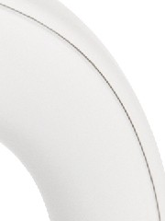
max
J
I
..
!:ZQk
.
1..50
.
1.25

1..00
.
)
0.75
min

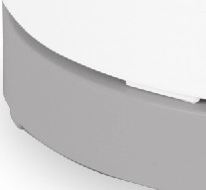
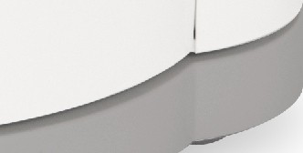
sabichi.

Instruction Manual
Product Code: 189080

COMPONENTS

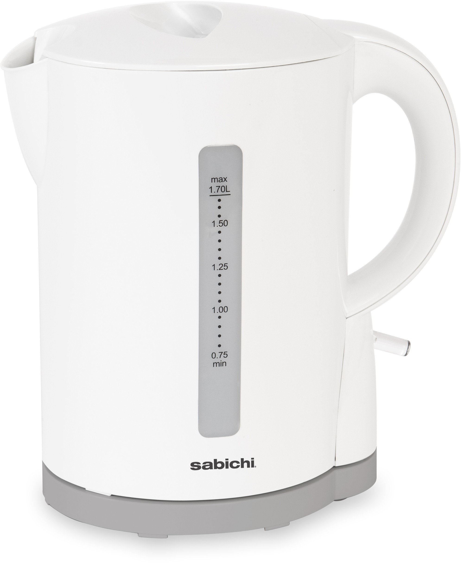
■
■
■
■

- - Lid 5 - ON/OFF Switch
- - Handle 6 - Base
- - Body
- - Water level indicator

Congratulations on your Sabichi purchase! We really hope you enjoy using your new kettle. Please read and retain this instruction manual carefully to reduce the risk of fire, electric shock and/ or injury when using your appliance.

IMPORTANT INSTRUCTIONS
- Please read these instructions carefully before using your kettle for the first time.
- This appliance should not be used by children Cleaning and user maintenance should not be carried out by children. Keep the appliance and its cord out of reach of children.
- Children shall not play with the appliance.
-Appliances can be used by persons with reduced physical, sensory or mental capabilities or lack of experience and knowledge if they have been given supervision or instruction concerning use of the appliance in a safe way and understand the hazards involved.
- If the supply cord is damaged, it must be replaced by the manufacturer, its service agent or similarly qualified persons in order to avoid a hazard.
- If the kettle is overfilled, boiling water may spill out of the top.
- This kettle is only to be used with the base provided.
- This appliance is intended for domestic use only.
- Do not operate the kettle if it malfunctions or has been damaged in any manner due to misuse. If there is a manufactoring fault, please contact the Homemakers for review.
- Before you connect the kettle to the mains supply, make sure that the voltage indicated on the rating label, located on the bottom of the water kettle matches the mains voltage in your home. If it does not, do not use the kettle.
- The kettle will switch off automatically when the water has boiled. If you want to stop
the heating process before the kettle automatically switches off, lift the ON/OFF switch up.
- After the kettle has switched off automatically (or has been switched off manually) it
may need some time to cool down. After 15-20 seconds, the kettle can be switched on again.
- Always fill the kettle with water before switching it on.

- The kettle is designed to disconnect the live electrical supply from the element in abnormal operating conditions. If the kettle is accidentally switched on without water, the boil dry protector will operate.
- If the kettle ever boils dry, the power indicator will go out Allow 15 minutes to cool before refilling with cold water. The safety cutout will automatically reset during this time.
- Always place the kettle on a stable flat surface.
- Do not use the kettle outdoors.
- Ensure that the kettle is switched off before removing it from its base.
- Do not remove the kettle from its base during operation
- Never immerse the kettle or cord in water or any other liquid. Do no allow liquid to penetrate the electrical parts of this kettle.
- Prevent children from pulling on the mains cord or knocking the kettle over.
- Ensure that the mains lead does not overhang any worktop surface.
- The outside surface of the kettle may get hot during use, please take care when using the kettle.
- Never fill the kettle more than the maximum water level
- Never use the kettle with the lid open
- Do not open the lid when steam is coming out of the spout
- Before cleaning the kettle, disconnect from the power supply and wait until it has cooled down.

BEFORE USING YOUR KETTLE
Before first use, it is recommended to operate the kettle 3 times following the instructions below, this will remove any dust or residue remaining from the manufacturing process.
- Remove the kettle from the base before filling
- To fill the kettle, open by pulling the lid handle inwards. then fill to the desired level (min 0.75L- max 1.7L), close the lid by pressing it down until it clicks into place.
- Plug the power supply cord into the main, press the ON/OFF switch, the power indicator lights up.
- When the water has boiled the kettle will automatically switch itself off, you can stop
the boiling process at any time by lifting the On/Off switch The power indicator will go out.
- Perform this 3 times.

CLEANING
- First read the instructions in the section titled "IMPORTANT INSTRUCTIONS".
- Avoid using abrasive cleaning agents.
- Empty the kettle and allow to cool, open the lid lift out the filter, rinse the filter under warm water and brush off any impurities.

DESCALING
- Half fill the kettle with tap water and add the juice of 1 lemon to the water.
- Boil this mixture and allow it to stand for 15 minutes. Re-boil the mixture and allow it to stand a further 15 minutes. Re boil this mixture a third time then rinse the kettle well.

TECHNICAL DETAILS
AC: 220-240V- 50/60Hz
Power: 1850-2200W

WASTE DISPOSAL
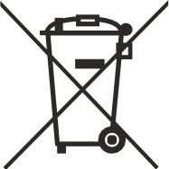
According to Waste of Electrical and Electronic Equipment (WEEE) directive, WEEE should be separately collected and treated.
If at any time in the future you need to dispose of this product please do NOT do so with household waste.
Please send this product to WEEE collection points where available.

sabichi homewares ltd
UB6 7JD
www.sabichihomewares.com thehomemakers@sabichi.co.uk

