TL55144W

Please read through all of this guide carefully before you st
appliance, as we have endeavoured to answer as many qu and provide you with as much support as we can.

If, however, you should find something missing, or not cov the Lee Customer Care team who will be only too happy to

Our policy is one of constant development and improvemen cannot guarantee the strict accuracy of all of our illustration changes may have been made subsequent to publishing.
0844 815 3737

The refrigeration system contains insulating gases and refrigerant which will require specialist disposal. Most components can be recycled. Always contact your local counciI or authority for information regarding the correct disposal/removal of old appliances, do not dispose of with household waste.
Warning: When disposing of an old appliance make sure
that the pipe work does not become damaged.

Packaging
All of the packaging supplied with your appliance can be recycled, or disposed of without any harm to the environment.
Cardboard may be crushed, or cut into smaller pieces if required for recycling or disposal. The polythene and polystyrene included contain no CFC's, and are environmentally friendly.
For further information on recycling, contact your local counciI or authority.

Before installing and using your new appliance
- Read through the instructions supplied with your appliance - failure to instalI or use this appliance in accordance with the instruction book may invalidate any warranty.
- The manufacturer does not accept any liability for damage caused through improper use, or incorrect installation.
- Do not install this appliance if it has been damaged during transportation. This includes the plug and power supply cord.
- Always install this appliance in line with these instructions.
- Always read these instructions fully before using the appliance for the first time.

For Your Safety 2

  - Warning: Do not allow the refrigerant circuit to become damaged while using or installing. Should it become damaged, do not use the appliance until you are instructed to do so by a service engineer. Refrigerant can ignite or cause damage to the eye when leaking.
  - Warning: Always remember to unplug the appliance before cleaning.When disconn­ ecting from the electricity supply, pull the plug, not the powe rcord.
  - Warning: Do not use any electrical appliance inside the food storage area - unless t­ hey are recommended by the manufacturer.
  - Warning: All electrical repairs must be carried out by a qualified electrician. Inade­ quate repairs may result in in a major source of danger for the user and invalidate any warranty.
  - Warning: Never store anything dangerous inside the appliance, such as combustibles, explosives, strong acid and alkali etc. Alcoholic beverages must be stored upright in an air tight container in the refrigerator. Never store alcohol in a freezer.
  - Warning:When defrosting the appliance, never use sharp or pointed metal impleme­ nts.Always use a plastic scraper. (see Defrosting for moreinformation).
  - Warning: Always keep any ventilation openings clear of obstruction. Should they be­ come blocked, clear them straight away.
  - Warning: Do not allow children to play, sit or hang onto any part of the appliance.
  - Warning: This appliance is intended for domestic use only, for food refrigeration, fo­ od freezing and frozen food storage.
  - Warning: Make sure that the plug is in an accessible place wheninstallation is compl­ ete remove all packaging.Only use this appliance for domestic purposes in accordance with these instructions.
  - Warning:Refrigerating appliances might not operate consistently when sited for an extended period of time below the cold end of the the range of temperatures of the ap­ pliappliance.
  - Warning:This appliance is not intended for use by persons (including children) with reduced physical, sensory or mental capabilities, or lack of experience and knowledge, unless they have been given supervision or instruction concerning use of the appliance by a person responsible for their safety. Children should be supervised to ensure that they do not play with the appliance.
  - Warning:Keep ventilation openings, in the appliance enclosure or in the built-in str­ ucture, clear of obstruction.
  - Warning: Do not use mechanical devices or other means to accelerate the defrosting process, otherthan those recommended by the manufacturer.
  - Warning:Do not damage the refrigerant circuit.
  - Warning: Do not store explosive substances such as aerosol cans with a flammable propellant in this appliance.
  - Warning: When positioning the appliance ensure the supply cord is not trapped or damaged.
  - Warning:Do not locate extension sockets or charging transformers/power supplies adjacent to the compressor as they could overheat

TL55144W
II

6

4

lass she g door s
7, Door shelves
4,Crisper 5,Feet
3,G
6,Bi
2, Light bulb
LTop cover

TL55144W
235L
A+
This appliance operates at a voltage of:
ST
220 - 240V ~ SOHz
40dBA
R600a(27g)
1420
550
550

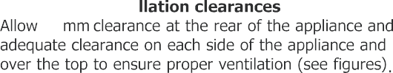
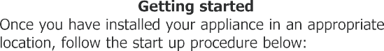
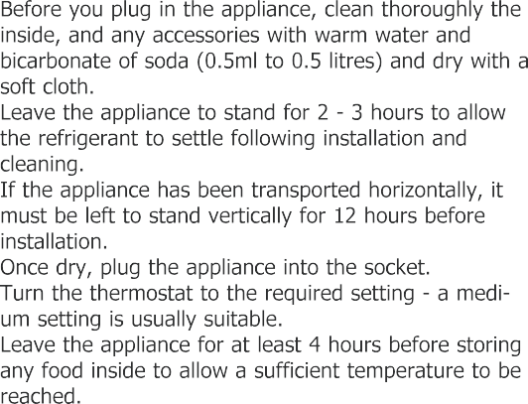
TL55144W
This appliance is intended to be used in households but is not intended to be used in applications such as;
- Staff kitchen areas in shops, offices and other working environments;
- Farm houses and by clients in hotels, motels and other residential type environments;
- Bed and breakfast type environments;
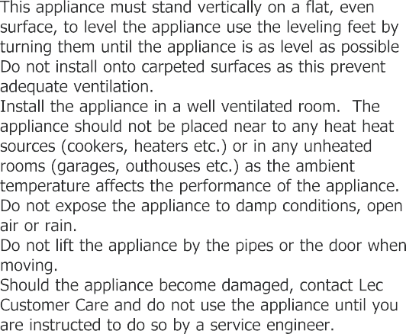
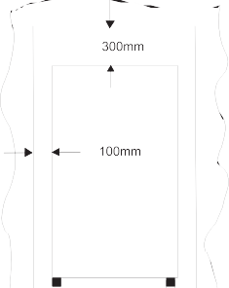
- Catering and similar non-retail applications

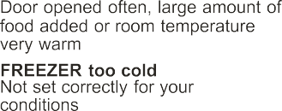
- The temperature selector knob is located on the right hand sidewall of the refrigerator interior Setting“Min”：Less Cool Temperature Setting“Med”：Normal Operation(adequate for most situations) Setting“Max”：Coolest Temperature
- During high ambient temperatures e.g. on hot summer days. It may
be necessary to set the thermostat to the Coolest setting(position“Max”). This may cause the compressor running continuously in order to maintain a low temperature in the cabinet.
- For the first time you install your refrigerator, set the thermostat knob
at “Med”.Give your refrigerator time to cool down completely before adding food. It is the best to wait 24 hours before adding food. The thermostat knob controls the temperature.

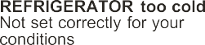
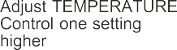
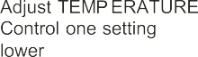

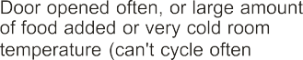

from the freezer - this can cause ice burns to the tongue and hands.
  - Never touch the ns de of the appliance, or any frozen
items with wet hands. This can cause injury to your hands if they stick to cold surfaces.
  - Wrap or cover foods well before storing. Always make sure that any packaging is air tight and suitable for use inside a fridge or freezer.
  - Cooked meats and raw meats should be stored on separate shelves, and raw meat should not be allowed to drip onto other foods. Food which is to be frozen should not be in direct contact with already frozen food.
  - You may hear gurgling noises or a humming sound
while the appliance is in use and this is perfectly nor­ mal when the compressor is running and the coolant is moving through the system.
  - A clicking sound may be heard, this is the thermostat and is normal.
  - This appliance is designed to operate in an ambient temperature between 16 and 38 °c.
  - Effervescent (fizzy) drinks should not be stored in the freezer or low temperature compartments.
  - Do not exceed the storage times recommended by the food manufacturer andd always check expiry dates.
  - Smaller portions of fresh food freeze quicker than large portions. Divide large portions into smaller ones.
This helps to preserve the nutrients and quality of the food.
  - Always allow warm food to cool down before freezing it, preferably to room temperature.
  - Before you store large amounts of food in the freezer, adjust the thermostat to the maximum (coldest) set­ ting while the appliance freezes the food. After 24 hours, re-set the thermostat to the previous setting.
  - Only thaw the amount of food you need, once food has been thawed cook it immediately.
  - Do not wash shelf retention in hot water.

  - Avoid getting water into the electric components of the
appliance (i.e. the thermostat), or spilling water on the fridge.
  - When cleaning the door seals, use only warm soapy water. Please use a mild soap and avoid damaging the door seal as this will affect the performance of your appliance.
  - Clean the outside of the appliance with warm, soapy water and dry with a soft cloth. Any accumulation of dirt and dust should be removed from the back and bottom of the appliance to maintain adequate ventilation.
  - If the appliance is not in use for a long period of time, you should clean the appliance as detailed.
Make sure that it is dry, then unplug and leave the door open to prevent unpleasant smells inside.
  - Clean the drainage channel regularly to prevent any build up of impurities. Use a damp clean cloth and wipe the channel clean, then use a pipe cleaner or simi­ lar flexible object to clean the drainage hole to prevent blockages.
  - Unhook and clean the drip tray occaisionally.

Please note: Regular turning off may shorten the life of this appliance.

    - Turn the thermostat up higher
    - Check there has not been a power cut by c lights.

Unusual noises

The temperature inside the fridge / freezer is not cold
  - Check that the appliance is on a flat, level
  - Check that nothing is coming into contact

  - Check that there is not too much stored in
  - Check the frequency of door openings. If

enough. cause the compressor to run for some time
    - Check that the thermostat is set to a suitab
    - Check that the appliance is not in direct su source.
    - Check that the ventilation grille has not be
    - Check the ambient temperature is within th appliance (16°C - 38°C)

The temperature inside the • Change the temperature setting to a more appliance is too cold

The outer surfaces of the fridge • Caused by condensation - dry the outer of
/ freezer are wet

The inner surfaces of the fridge/ • The door is opened frequently, or kept ope
freezer are wet • Caused by condensation - dry the inside of

Excess frost and ice has built up

- Check that the door has not been left open

inside the appliance.
  - Check that the door gasket is clean and un

Please note: Any damage caused by not following the instructions within this handbook may lead to a charge for a service engineer visit and any repairs carried out.

TL55144W
Tools Required:Phillips style screwdriver / Flat blated screwdriver / Hexagonal spanner
- Remove the right top hingercover .
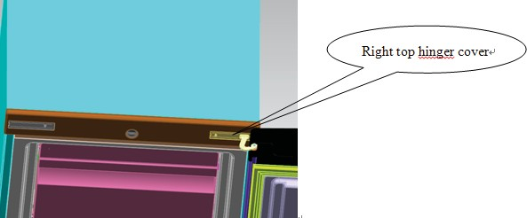
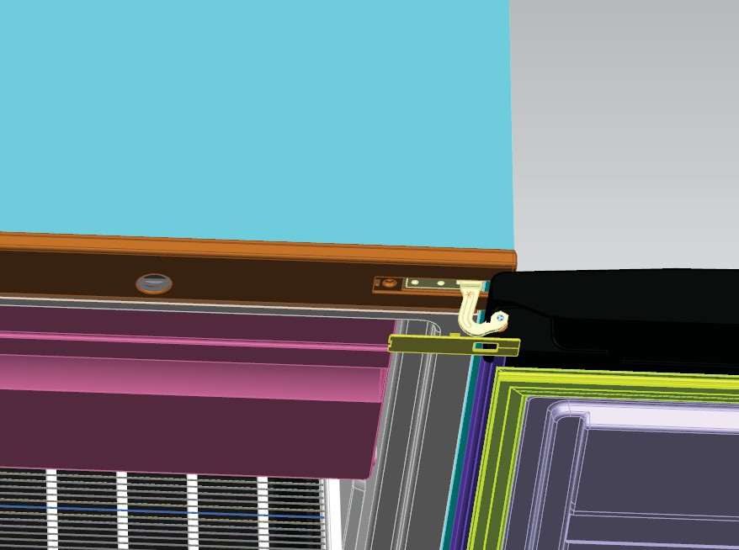
Right top hinger cover

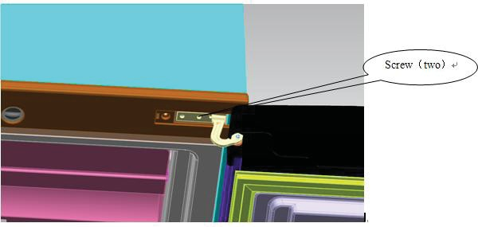
- Remove the screws ﬁxed the top-hinge with cross-slot screwdriver.
Screw (two)
- Replace the top-hinge and the top-door limit block and the door bearing bush to the other side.
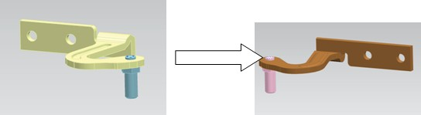
  - Remove the nut with sleeve.Take oﬀ the washer then remove the axes to the other side and ﬁxed.
  - Remove the door limit block
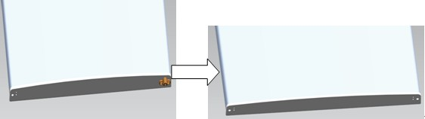

  - Please taking out another door limit block, with screw mounting to the door

- Disassemble the screws ﬁxed the bottom-hinge with cross-slot screwdriver .
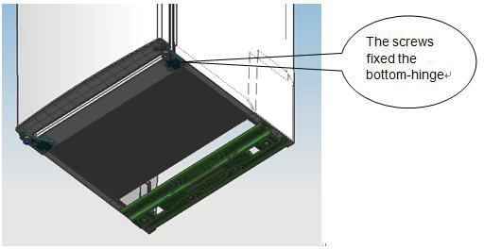

The screws ﬁxed the bottom-hinge
Note：the refrigerator-freezer incline angle less 45°

- Replace the bottom hinge to the other side then ﬁx it with screws.
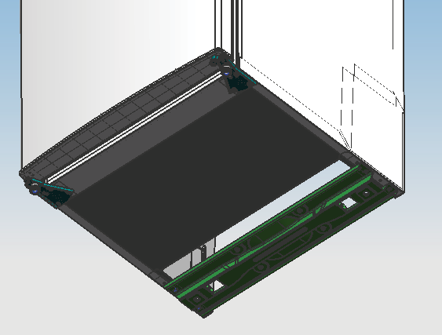

- Set the door right position,ﬁx the mid-hinge.
- Replace the top-hinge.
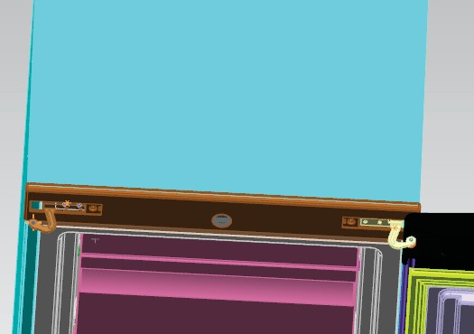

- Set the top door right position,ﬁx the top-hinge and the cover.

- Replace the leveler to the other side and adjust it to make sure the cabinet level.

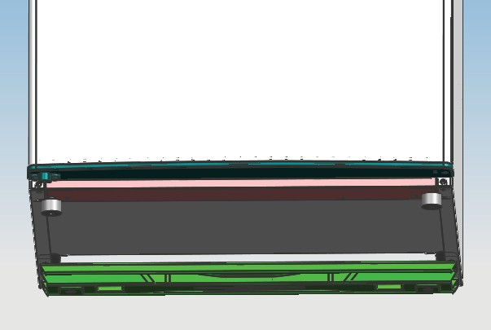

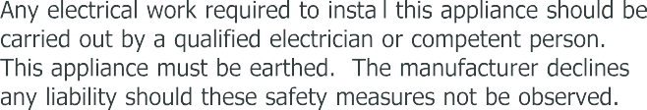
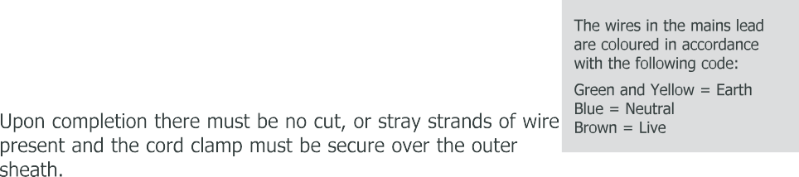
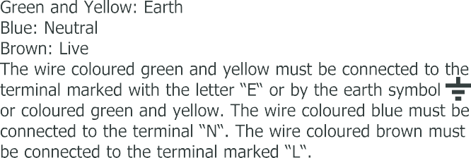
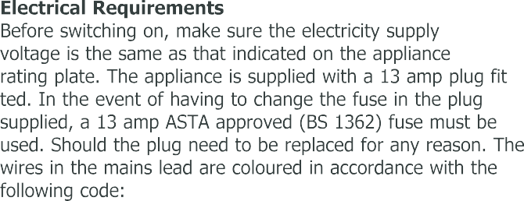
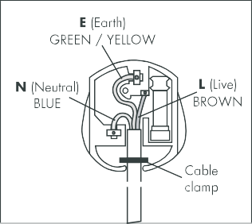
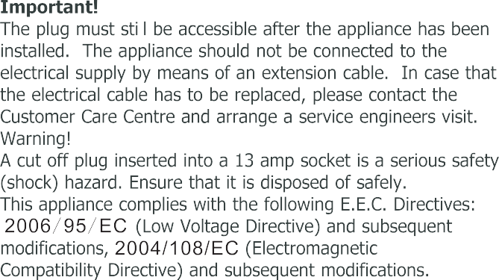

Note: Figures in the user manual are only for reference.
The actual product may differ slightly.

Serial Number

Date of purchase Installers stamp/ Printed name

Place of purchase:

E
Date | Part(s |  |  | ) replaced

Lee Refrigeration
Stoney Lane, Prescot, Merseyside, L35 2XW Customer Care Centre:
www.lec.co.uk
Lee Refrigera08ti4o4n8,15a3d73iv7ision of Glen Dimplex Home Appliance

