Downloaded from www.Manualslib.com manuals search engine

P/N 216768600 (0009)

Product Registration
The information contained in this Owner's Guide will instruct you on how to properly operate and care for your product. Please read through the information contained in your literature pack to learn more about your new appliance.

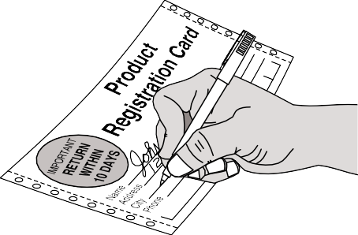
Record Your Model and Serial Numbers
Record the Model No. and Serial No. of this freezer in the space provided below.

Model No.

Serial No.

Register Your Product
The self-addressed PRODUCT REGISTRATION CARD (shown left) should be filled in completely, signed and returned to Electrolux Home Products. In Canada, return to Frigidaire Canada.

Contents

2 Product Registration
2 Versión en español
This Owner’s Guide provides operating instructions for your model. Use your freezer only as instructed in this Owner’s Guide.
- Energy Saving Ideas
- Important Safety Instructions
- First Steps
- Setting the Temperature Control
5-6 Freezer Optional Features
Versión en español
Si desea obtener una copia en español de este Manual del Usuario, sírvase escribir a la dirección que se incluye a continuación. Solicite la P/N 216768700.

Spanish Owner's Guides Electrolux Home Products
P.O. Box 212378
Augusta, GA 30917
- Care and Cleaning
- Power Failure/Freezer Failure
9-10 Avoid Service Checklist
- U.S. Warranty
- Canada Service Information
- Canada Warranty

Energy Saving Ideas • The freezer should be located in the coolest area of the room, away from heat
producing appliances or heating ducts, and out of direct sunlight.
  - Let hot foods cool to room temperature before placing in the freezer. Overloading the freezer forces the compressor to run longer. Foods that freeze too slowly may lose quality or spoil.
  - Be sure to wrap foods properly and wipe containers dry before placing them in the freezer. This cuts down on frost build-up inside the freezer.
  - Freezer shelves and baskets should not be lined with aluminum foil, wax paper, or paper toweling. Liners interfere with cold air circulation, making the freezer less efficient.
  - Organize and label food to reduce door openings and extended searches. Remove as many items as needed at one time, and close door as soon as possible.

© 2000 White Consolidated Industries, Inc. All rights reserved.

Important Safety Instructions

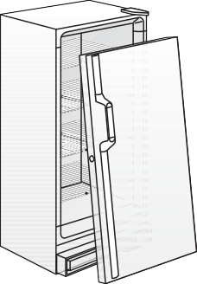

Read all instructions before using this freezer.
For Your Safety
Do not store or use gasoline or other flammable vapors and liquids in the vicinity of this or any other appliance. Read product labels for flammability and other warnings.
Proper Disposal of Your Refrigerator/Freezer

Risk of child entrap-ment. Child entrapment and suffocation are not problems of the past. Junked or abandoned refrigerators or freezer are still dangerous — even if they will sit for “just a few days.” If you are getting rid of your old refrigerator or freezer, please follow the instructions below to help prevent accidents.
BEFORE YOU THROW AWAY YOUR OLD REFRIGERATOR/FREEZER:

- Remove doors.

- Leave shelves in place so children may not easily climb inside.

Child Safety
- Destroy carton, plastic bags, and any exterior wrapping material immediately after the freezer is unpacked. Children should never use these items for play. Cartons covered with rugs, bedspreads, plastic sheets or stretch wrap may become airtight chambers and can quickly cause suffocation.
- A child might suffocate if he crawls into a freezer to hide or play. Remove
the door of a freezer when not in use, even if you plan to discard the freezer. Many communities have laws requiring you to take this safety precaution.
- Remove and discard any spacers used to secure the shelves during shipping.
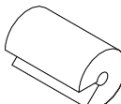
Small objects are a choke hazard to children.

Electrical Information
These guidelines must be followed to ensure that safety mechanisms in the design of this freezer will operate properly.
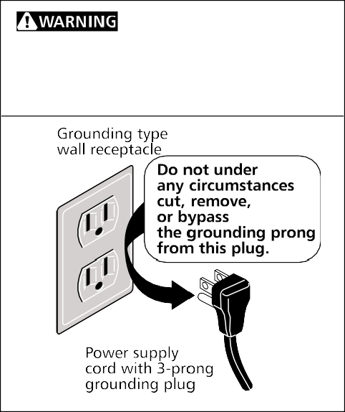
- Refer to the serial plate for correct electrical rating. The power cord of the appliance is equipped with a three-prong grounding plug for protection against shock hazards. It must be plugged directly into its own properly grounded three- prong receptacle, protected with a 15 amp time delay fuse or circuit breaker. The receptacle must be installed in accordance with the local codes and ordinances. Consult a qualified electrician. Receptacles protected by Ground Fault Circuit Interrupters (GFCI) are NOT RECOMMENDED. DO NOT use an extension cord or adapter plug.
Avoid fire hazard or electric shock. Do not use an extension cord or an adapter plug. Do not remove any prong from power cord.
- If voltage varies by 10 percent or more, freezer performance may be affected. Operating the freezer with insufficient power can damage the motor. Such damage is not covered under the warranty. If you suspect your household voltage is high or low, consult your power company for testing.
- To prevent the freezer from being turned off accidentally, do not plug unit into an outlet controlled by a wall switch or pull cord.
- Do not pinch, knot, or bend power cord in any manner.

Other Precautions
- Never unplug the freezer by pulling on the power cord. Always grip the plug firmly and pull straight out from the receptacle.
- Turning the control to OFF turns off the compressor, but does not disconnect power to other electrical components.

First Steps Before starting the freezer, follow these important first steps:

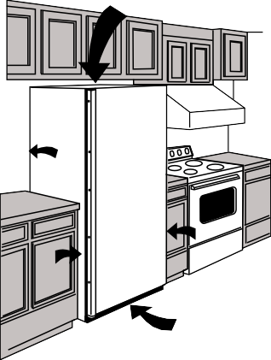
Installation

3" AIR SPACE

3"

3"
3"

1"
Installation
  - Choose a place that is near a grounded electrical outlet.
  - For the most efficient operation, the freezer should be located where surrounding temperatures will not exceed 110°F (43°C). Temperatures of 32°F (0°C) and below will NOT affect freezer operation. Additional compressor heaters are not recom- mended.
  - Allow space around the unit for good air circulation. Leave a 3 inch (75 mm) space on all sides of the freezer for adequate circulation.

Leveling
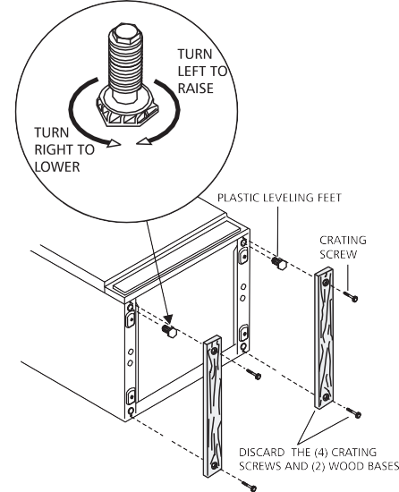
The freezer must have all bottom corners resting firmly on a solid floor. The floor must be strong enough to support a fully loaded freezer. NOTE: It is VERY IMPORTANT for your freezer to be level in order to function properly. If the freezer is not leveled during installatioin, the door may be misaligned and not close or seal properly, causing cooling, frost, or moisture problems.

Unpacking and Leveling - Upright Freezers
To Level Upright Unit:
After discarding crating screws and wood base, use a carpenter's level to level the freezer from front-to-back. Adjust the plastic leveling feet in front, ½ bubble higher, so that the door closes easily when left halfway open.
To Level Chest Unit:
If needed, add metal or wood shims between feet pads and floor.

Cleaning
  - Wash any removable parts, the freezer interior, and exterior with mild detergent and warm water. Wipe dry. DO NOT USE HARSH CLEANERS ON THESE SURFACES.
  - Do not use razor blades or other sharp instruments, which can scratch the appliance surface when removing adhesive labels. Any glue left from the tape can be removed with a mixture of warm water and mild detergent, or touch the residue with the sticky side of tape already removed. DO NOT REMOVE THE SERIAL PLATE.

Upright Freezer Door Removal
If door must be removed:
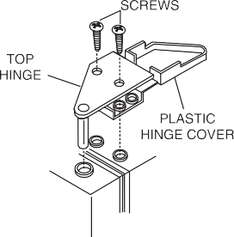
- Lift up plastic hinge cover and fold back.

Upright Freezer Door Removal
- Use a Phillips® screwdriver to loosen and retighten the screws on the top hinge to ensure that a secure assembly and prevent hinge slippage.
- Remove the top hinge from cabinet and lift door off the lower hinge pin.
- After door is removed, remove the two screws from the bottom hinge.
- To replace door, reverse above order.

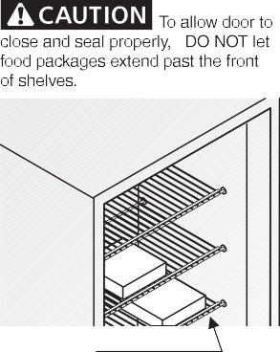

Setting the Temperature Control

Cool Down Period
- For safe food storage, allow 4 hours for freezer to cool down completely. The freezer will run continuously for the first several hours. Foods that are already frozen may be placed in freezer after the first few hours of operation. Unfrozen foods should NOT be loaded into freezer until freezer has operated for 4 hours.

- When loading freezer, freeze only 3 pounds of fresh food per cubic foot of freezer space at one time. Distribute packages to be frozen evenly throughout the freezer. It is not necessary to turn control knob to a colder setting while freezing food.

Temperature Control
The temperature control is located inside the freezer on upright models, and on the left outside wall on chest models. The temperature is factory preset to provide satisfactory food storage temperatures. However, the temperature control is adjustable to provide a range of temperatures for your personal satisfaction. If a colder temperature is desired, turn the temperature control knob toward COLD- EST and allow several hours for temperatures to stabilize between adjustments.

Freezer Optional Features
NOTE: Your freezer may have some, or all of the features listed below. Become familiar with these features, and their use and care.

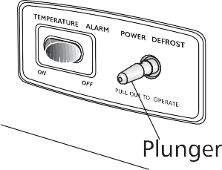
Power On Light

Temp Alarm and Power Defrost -
Upright Freezers
The Power On Light indicates that the freezer is properly connected to electrical power. The light glows even when the temperature control is turned to OFF. If the light goes out, refer to "Freezer does not run" in the Avoid Service Checklist.

Temp Alarm (audible only or audible with warning light)
This feature is designed to provide a warning of possible malfunction. If the temperature of the food rises to a level unsafe for long-term storage, the buzzer will sound. The red light will also glow on models so equipped. The Temp Alarm feature operates on household electricity. If power fails, the alarm will not perform. An ON/ OFF switch allows you to deactivate the Temp Alarm when not wanted. The freezer is shipped with Temp Alarm in the OFF position. After freezer has run approximately 4 hours, the red light, if equipped, will go off. Then you may activate the Temp Alarm without the alarm sounding.

Temp Alarm

Temp Alarm Switch Location -
Some Chest Freezers

Press the ON switch to activate the Temp Alarm. To deactivate, press the OFF switch.

If the alarm sounds, be sure freezer is properly leveled, and the door closes freely, and seals properly. If you suspect a technical malfunction, call an authorized servicer immediately.

Power Cord Clamp
The clamp prevents the power cord from being accidently unplugged. Remember when removing or replacing the electrical cord, to remove or replace the power cord clamp.

Temp Alarm - Upright Freezers

Power Freeze
Power Freeze allows you to lower your freezer temperature to the lowest possible temperature by pushing the switch to ON. For maximum benefit, Power Freeze should be selected 24 hours before placing a large quantity of unfrozen food into freezer. Food should then be spread throughout freezer compartment to speed up the freezing process. To turn off Power Freeze, manually push the switch to OFF. (This will return compressor to the normal operating mode.)

Freezer Optional Features (continued)

Power Defrost
The Power Defrost feature will defrost freezer in a fraction of the time usually required. To defrost, remove all food, and follow these steps.
- Pull out Power Defrost Plunger. Leave door open while defrosting. (Closing freezer door will push in plunger and power defrost will be turned off.)

Power Defrost Plunger - Chest Freezers
- Push Power Defrost Plunger in to restart freezer after defrosting is completed.
NOTE: When defrosting units with the Temp Alarm Feature, turn off the alarm when defrosting. When the freezer reaches the freezing temperature, turn the Temp Alarm back on.

Slide-Out Basket (upright models)
The Slide-Out Basket, located at the bottom of the freezer provides separate storage space for items that are difficult to store on freezer shelves. To remove the basket, pull out, and lift up.
Juice Can Rack (upright models)
The Juice Can Rack on the freezer door is specially ridged to store juice cans and prevent them from rolling out of the shelf.

Security Lock with Pop-Out Key
This security lock fastens the door snugly, ensuring that stored food is secure. To lock or unlock the freezer, push the key into the lock and turn. The key pops out of the lock after it has been turned.

Interior Light
The light comes on automatically when the door is opened. To replace the light bulb, turn the temperature control to OFF and unplug the electrical cord. Replace the old bulb with a bulb of the same wattage.
Adjustable Shelf (upright models)
This shelf can be moved to one of two positions. Lift the shelf up and out to move to the desired position.

Defrost Drain
The defrost drain provides a method of draining the water during defrosting and cleaning. See "Defrosting" in Care and Cleaning Section.
Slide-Aside Basket (chest models)
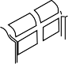
This basket helps organize odd-shaped items. To reach other packages in the freezer, slide the basket aside or lift out.

Slide-Aside Basket
Divider/Drain Pan (chest models)
The Divider/Drain Pan doubles as a convenient storage area and serves as a shallow drain pan when defrosting. To remove, lift pan straight up out of the supports, and out of the chest.
Fast Freezing Shelves (upright models)
These shelves contain cooling coils to freeze foods quickly and allow cold air to constantly circulate throughout the freezer. Do not use sharp metal objects such as ice picks or scrapers to clean the shelves. This could damage the shelves and reduce their cooling ability. These shelves are not adjustable.

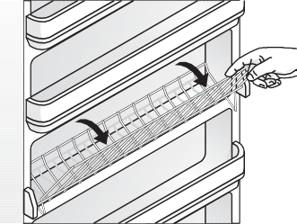
Tilt-Out Shelf

Tilt-Out Shelf
This shelf is located inside on the freezer door and provides additional storage space. To access an item, tilt top of "basket" shelf down.
Drop Front Shelf (upright models)
The Drop Front Shelf, located at the bottom of the freezer, provides a separate compartment for small irregular shaped items or large, bulky items. Lift the shelf front up and out to remove.

Care and Cleaning
Some upright freezers are frost-free and defrost automatically, but should be cleaned occasionally.

Between Defrostings
Damp objects stick to cold metal surfaces. Do not touch interior metal surfaces with wet or damp hands.
To avoid frequent defrosting, occasionally use a plastic scraper to remove frost. Scrape with a pulling motion. Never use a metal instrument to remove frost.

Defrosting

Figure 1
It is important to defrost and clean freezer when ¼ to ½ inch of frost has accumulated. Frost may tend to accumulate faster on upper part of the freezer due to warm, moist air entering the freezer when the door is opened. Remove food and leave the door open when defrosting the freezer.
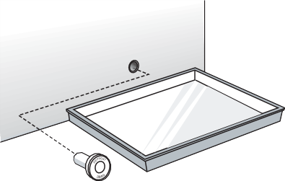
- On upright models with a defrost drain (Figure 1), remove drain plug on the inside floor of the freezer by pulling straight out. To access external drain tube on models with a base panel, first remove the two screws from the base panel. Locate the drain tube near the left center under the freezer. Place a shallow pan under the drain tube. Defrost water will drain out. Check pan occasionally so water does not overflow. A ½ inch garden hose adapter can be used to drain the freezer directly into a floor drain. If your model is not equipped with an adapter, one can be purchased at most hardware stores. Replace the drain plug when defrosting and cleaning are completed. If the drain is left open, warm air may enter freezer.
PAN
DEFROST DRAIN PLUG
Figure 2
- On chest models with a defrost drain, place a shallow pan or the Divider/Drain Pan (some models) beneath the drain outlet (Figure 2). A ½ inch garden hose adapter can be used to drain the freezer directly into a floor drain (Figure 3). If your model is not equipped with an adapter, one can be purchased at most hardware stores. Pull out the drain plug inside the freezer, and pull off the outside defrost drain plug (Figure 4). Defrost water will drain out. Check pan occasionally so water does not overflow. Replace the drain plugs when defrosting is completed.
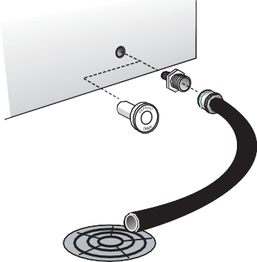
- On modelswithout a defrost drain, place towelsor newspaperson the freezer bottom to catch the frost. The frost will loosen and fall. Remove towels and/or newspapers.

HOSE ADAPTOR

DEFROST DRAIN PLUG

Figure 3
- If the frost is soft, remove it by using a plastic scraper. If the frost is glazed and hard, fill deep pans with hot water and place them on the freezer bottom. Close the freezer door. Frost should soften in about 15 minutes. Repeat this procedure if necessary.

Cleaning the Inside
After defrosting, wash inside surfaces of the freezer with a solution of two tablespoons of baking soda in one quart (1.136 litres) warm water. Rinse and dry. Wring excess water out of the sponge or cloth when cleaning in the area of the controls, or any electrical parts.
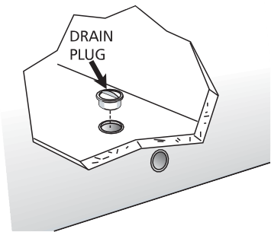
Wash the removable parts and door basket with the baking soda solution mentioned above, or mild detergent and warm water. Rinse and dry. Never use metallic scouring pads, brushes, abrasive cleaners, or alkaline solutions on any surface. Do not wash removable parts in a dishwasher.

Figure 4

Cleaning the Outside
Wash the cabinet with warm water and mild liquid detergent. Rinse well and wipe dry with a clean soft cloth. Replace parts and food.

Vacation and Moving Tips
Short Vacations: Leave the freezer operating during vacations of less than three weeks. Long Vacations: If the freezer will not be used for several months, remove all food and unplug the power cord. Clean and dry the interior thoroughly. To prevent odor and mold growth, leave the freezer door open slightly, blocking it open if necessary. Moving: Disconnect the power cord plug from the wall outlet. Remove foods, then defrost, and clean the freezer. Secure all loose items such as base panel, baskets, and shelves by taping them securely in place to prevent damage. In the moving
If leaving freezer door open while on vacation, make certain that children cannot get into the freezer and become entrapped.
WARNING
vehicle, secure freezer in an upright position, and secure to prevent movement. Also protect outside of freezer with a blanket, or similar item.

Power Failure/ Freezer Failure
If a power failure occurs, frozen foods will stay frozen for at least 24 hours if the freezer is kept closed. If the power failure continues, pack seven or eight pounds of dry ice into the freezer every 24 hours. Look in the Yellow Pages under "Dry Ice," "Dairies," or "Ice Cream Manufacturers" for local dry ice suppliers. Always wear gloves and use caution when handling dry ice.

If the freezer has stopped operating, see "Freezer does not run" in the Avoid Service Checklist Section of this manual. If you cannot solve the problem, call an authorized servicer immediately.
Do not open freezer door unnecessarily if freezer is off for several hours.

If the freezer remains off for several hours, follow the directions above for the use of dry ice during a power failure. If necessary, take the food to a local locker plant until the freezer is ready to operate. Look in the Yellow Pages under "Frozen Food Locker Plants."

Avoid Service Checklist Before calling for service, review this list. It may save you both time and
expense. This list includes common occurrences that are not the result of
defective workmanship or materials in this appliance.

OCCURRENCE SOLUTION
FREEZER DOES NOT RUN
Check to ensure that freezer is not plugged into a circuit that has ground fault interrupt. If you are unsure about the outlet, have it checked by a certified technician.

Temperature control is in the OFF position. See Setting the Temperature Control Section.

Freezer may not be plugged in, or plug may be loose. Be sure plug is tightly pushed into electrical outlet.

House fuse has blown, or circuit breaker has tripped. Check/reset circuit breaker, or replace fuse with 15 amp. time delay fuse.

Freezer runs too much or too long.

Temperatures inside the freezer are too cold.

Temperatures inside the freezer are too warm.

Temperature of external freezer surface is warm.
SOUND AND NOISE
Louder sound levels whenever freezer is on.

Louder sound levels when compressor comes on.

Popping or cracking sound when compressor comes on.
Power outage. Check house lights. Call local electric company.

Room or outside weather is hot. It is normal for the freezer to work harder under these conditions.

Freezer had recently been disconnected for a period of time. Freezer requires 4 hours to cool down completely.

Large amounts of warm or hot food have been stored recently. Warm food will cause the freezer to run more until the desired temperature is reached.

Door is kept open too long or too frequently. Warm air enters the freezer every time the door is opened. Open the door less often.

Freezer door may be slightly open. See Occurrence “Door Problems.”

Temperature control is set too cold. Turn the control knob to a warmer setting. Allow several hours for the temperature to stabilize.

Freezer gasket is dirty, worn, cracked, or poorly fitted. Clean or change gasket. Leaks in the door seal will cause freezer to run longer in order to maintain desired temperature.

Temperature control is set too cold. Turn the control to a warmer setting. Allow several hours for the temperature to stabilize.

Temperature control is set too warm. Turn the control to a colder setting. Allow several hours for the temperature to stabilize.

Door is kept open too long or is opened too frequently. Warm air enters the freezer every time the door is opened. Open the door less often.

Door may be open slightly. See Occurrence section “Door Problems.”

Large amounts of warm or hot food might have been stored recently. Wait until the freezer has had a chance to reach its selected temperature.

Freezer has recently been disconnected for a period of time. Freezer requires 4 hours to cool down completely.

The exterior freezer walls can be as much as 30°F warmer than room temperature. This is normal while the compressor works to transfer heat from inside the freezer cabinet.

Modern freezers have increased storage capacity and more even temperatures. They require a high efficiency compressor. When the surrounding noise level is low, you might hear the compressor running while it cools the interior.

Freezer operates at higher pressures during the start of the ON cycle. This is normal. Sound will level off or disappear as freezer continues to run.

Metal parts undergo expansion and contraction, as in hot water pipes. This is normal. Sound will level off or disappear as freezer continues to run.

OCCURRENCE SOLUTION
SOUND AND NOISE (cont'd)

Bubbling or gurgling sound, like water boiling.

Vibrating or rattling noise.
Refrigerant (used to cool freezer) is circulating throughout the system. This is normal.

Freezer is not level. It rocks on the floor when it is moved slightly. Level the unit. Refer to "Leveling" in the First Steps Section.

WATER/MOISTURE/FROST INSIDE FREEZER
Moisture forms on inside freezer walls.

WATER/MOISTURE/FROST OUTSIDE FREEZER
Moisture forms on outside of freezer.

ODOR IN FREEZER

DOOR PROBLEMS
Door will not close.

LIGHT BULB IS NOT ON
Floor is uneven or weak. Freezer rocks on the floor when it is moved slightly. Be sure floor can adequately support freezer. Level the freezer by putting wood or metal shims under part of the freezer.

Freezer is touching the wall. Relevel the freezer or move freezer slightly. Refer to "Leveling" in the First Steps Section.

Weather is hot and humid, which increases internal rate of frost build-up. This is normal. Door is slightly open. See Occurrence “Door Problems.”
Door is kept open too long, or is opened too frequently. Open the door less often.

Door is slightly open, causing the cold air from inside the freezer to meet warm moist air from outside. See “Door Problems” in the Occurrence Section.

Interior needs to be cleaned. Clean interior with sponge, warm water, and baking soda. Foods with strong odors are in the freezer. Cover the food tightly.
Freezer is not level. It rocks on the floor when it is moved slightly. This condition can force the cabinet out of square and misalign the door. Refer to "Leveling" in the First Steps Section.

Floor is uneven or weak. Freezer rocks on the floor when it is moved slightly. Level the floor by using metal or wood shims under the freezer or brace floor supporting the freezer.

Light bulb is burned out. Follow directions under "Interior Light" in the Freezer Features Section.

No electric current is reaching the freezer. See Occurrence "Freezer Does Not Run."

FRIGIDAIRE FREEZER WARRANTY (USA Only)
Your Frigidaire product is protected by this warranty

 | WARRANTY PERIOD | FRIGIDAIRE, THROUGH ITS AUTHORIZED SERVICERS, WILL: | THE CONSUMER WILL BE RESPONSIBLE FOR:
FULL ONE-YEAR WARRANTY | One year from original purchase date. | Pay all costs for repairing or replacing any parts of this appliance which prove to be defective in materials or workmanship. | Costs of service calls that are listed under NORMAL RESPONSIBILITIES OF THE CONSUMER.*
LIMITED 2ND - 5TH YEAR WARRANTY  (Sealed System) | Second through fifth years from original purchase date. | Repair or replace any parts in the Sealed Refrigeration System(compressor, condenser, evaporator, drierand tubing) which prove to be defective in materials or workmanship, and provide the labor to install such part. | Diagnostic costs and any removal, transportation and reinstallation costs which are required because of service. Costs for labor, parts and transportation other than with respect to the Sealed Refrigeration System.
LIMITED 6TH - 10TH YEAR WARRANTY  (Compressor only) | Sixth through tenth years from original purchase date. | Provide a replacement for any compressor which proves to be defective in materials or workmanship. | Diagnostic costs and any removal, transportation and reinstallation costs which are required because of service. Costs for labor, parts and transportation other than the cost of the replacement compressor itself.
LIMITED WARRANTY  (Applicable to the State of Alaska) | Time periods listed above. | All of the provisions of the full and limited warranties above and the exclusions listed below apply. | Costs of the technician's travel to the home and any costs for pick up and delivery of the appliance required because of service.
THREE-YEAR LIMITED FOOD SPOILAGE PLAN | During the first three years from original purchase date. | If food loss results because of defects in materials or workmanship during the time periods listed above, and applies to the limitations stated in the normal responsibilities of the consumer listed below, Frigidaire will reimburse the consumer for the actual food spoilage loss in excess of $5.00 per occurrence, but not to exceed the maximum payment in the schedule at right, provided the food losses:  - Are reported and the food shown to any Frigidaire authorized servicer within 24 hours of the discovery of the loss.  - Are not occasioned by either the manual disconnection of the electrical power within the premises of the owner or a general power failure. | C) Occur even though the owner exercised reasonable care and diligence to save food per suggestions furnished with the appliance.  MAXIMUMPAYMENTSCHEDULE
 |  |  | Size - Cubic Foot Cumulative Maximum
.5-9.9 $100
10.0-16.5 $150
16.6-21.5 $200
21.6+ $250
Your appliance is warranted by White Consolidated Industries, Inc. We authorize no person to change or add to any of our obligations under this warranty. Our obligations for service and parts under this warranty must be performed by Frigidaire or an authorized Frigidaire servicer.

*NORMAL RESPONSIBILITIES OF THE CONSUMER

EXCLUSIONS

IF YOU NEED SERVICE
This warranty applies only to products in ordinary household use, and the consumer is responsible for the items listed below:
- Proper use of the appliance in accordance with instructions provided with the product.
- Proper installation by an authorized servicer in accordance with instructions provided with the appliance and in accordance with all local plumbing, electrical and/or gas codes.
- Proper connection to a grounded power supply of sufficient voltage, replacement of blown fuses, repair of loose connections or defects in house wiring.
- Expenses for making the appliance accessible for servicing, such as removal of trim, cupboards, shelves, etc., which are not a part of the appliance when it was shipped from the factory.
- Damages to finish after installation.
- Replacement of light bulbs and/or fluorescent tubes (on models with these features).

This warranty does not cover the following:
- CONSEQUENTIAL OR INCIDENTAL DAMAGES SUCH AS PROPERTY DAMAGE AND INCIDENTAL EXPENSES RESULTING FROM ANY BREACH OF THIS WRITTEN OR ANY IMPLIED WARRANTY.
Note: Some states do not allow the exclusion or limitation of incidental or consequential damages, so this limitation or exclusion may not apply to you.
- Service calls which do not involve malfunction or defects in workmanship or material, or for appliances not in ordinary household use. The consumer shall pay for such service calls.
- Damages caused by services performed by servicers other than Frigidaire or its authorized servicers; use of parts other than genuine Electrolux Home Products parts; obtained from persons other than such servicers; or external causes such as abuse, misuse, inadequate power supply or acts of God.
- Products with original serial numbers that have been removed or altered and cannot be readily determined.

Keep your bill of sale, delivery slip, or some other appropriate payment record. The date on the bill establishes the warranty period should service be required. If service is performed, it is in your best interest to obtain and keep all receipts. This written warranty gives you specific legal rights. You may also have other rights that vary from state to state. Service under this warranty must be obtained by contacting Electrolux Home Products:

800•944•9044
Electrolux Home Products
P.O. Box 212378
Augusta, GA 30917

Product features or specifications as described or illustrated are subject to change without notice. All warranties are made by White Consolidated Industries, Inc. This warranty applies only in the 50 states of the U.S.A. and Puerto Rico.

Service Information in Canada Only
To avoid unnecessary cost and inconvenience, make a few simple checks before calling for service. Common occurrences and their solutions can be found in the Avoid Service Checklist. Be sure you have followed the instructions in this manual.

If you are unable to locate the cause of a problem, call for service. Insist on factory service by an authorized FRIGIDAIRE PARTS AND SERVICE depot.

FRIGIDAIRE PARTS AND SERVICE
All Frigidaire appliances are backed by FRIGIDAIRE PARTS AND SERVICE, one of Canada's largest parts and service networks.

The Frigidaire reputation means you can enjoy complete professional service from one of our hundreds of trained technicians across the country.

FRIGIDAIRE PARTS AND SERVICE
7075 Ordan Drive Mississauga, Ontario L5T 1K6

Place the name, address and telephone number of your service depot in the spaces below.

Product and feature specifications as described or illustrated are subject to change without notice.

FREEZER
WARRANTY in Canada

WARRANTOR:
Frigidaire Home Products of Canada 7075 Ordan Drive
Mississauga, Ontario L5T 1K6

WARRANTY PERIOD:

For the first year after purchase by the original consumer/owner:

For the second, third, fourth and fifth year after purchase by the original consumer/owner:

For the sixth, seventh, eighth, ninth and tenth year after purchase by the original consumer/owner.

For service under this warranty, contact your local dealer/retailer, authorized FRIGIDAIRE PARTS AND SERVICE depot, or:

FRIGIDAIRE PARTS AND SERVICE
7075 Ordan Drive Mississauga, Ontario L5T 1K6
Tel: (905) 565-9200
Fax: (905) 565-0937

WARRANTOR WILL THROUGH ITS AUTHORIZED SERVICE DEPOT:

Pay cost to repair or replace any defective parts (including service and labour charge).

Pay cost (including service and labour charge) to repair or replace defective parts of the sealed refrigeration system consisting of the compressor, evaporator, condenser, interconnecting tubing, drier and refrigeration charge.

Pay cost (excluding service and labour charge) to replace a defective motor compressor.

FREEZER FOOD SPOILAGE PLAN
In addition, in the event of loss of food due to spoilage as a result of a mechanical failure or an inoperative component of the freezer due to faulty workmanship or materials, the following freezer food spoilage plan applies. The cumulative total responsibility, as outlined below, shall not be exceeded for any given freezer.

Type of freezer | Plan period | Frigidaire will pay | Consumer/Owner will pay
5 cu. ft/142 litres to  11.9 cu. ft./337.1 litres | 1st through 5th year after date of purchase by original consumer/owner | A cumulative total of up to $200. | First $25 of each claim
12.0 cu. ft./340 litres to  23.0 cu. ft./651.5 litres | 1st through 5th year after date of purchase by original consumer/owner | A cumulative total of up to $400. | First $25 of each claim

Claim forms may be obtained from your local dealer/retailer, authorized FRIGIDAIRE PARTS AND SERVICE depot or from the office shown above and must be submitted to the warranty department within thirty (30) days of the loss.

Where a claim is submitted under the Freezer Food Spoilage Plan, such claim constitutes a waiver by the consumer/owner of any other right to remedy to which he/she is otherwise entitled by law with respect to the loss of food due to spoilage as a result of mechanical failure or an inoperative component of the freezer due to faulty workmanship or materials.

WARRANTY APPLIES TO:
- Products purchased and installed in Canada for personal single family household use.
- Defects resulting or arising out of the manufacturing process.
- Products bearing legible manufacturer's model and serial numbers.
- Replacement parts only for the remainder of the original warranty.

WARRANTY DOES NOT APPLY TO:
- Transportation damage.
- Supply and replacement of porcelain, fuses, glass and light bulbs.
- Parts and service supplied or obtained from other than FRIGIDAIRE PARTS AND SERVICE or FRIGIDAIRE PARTS AND SERVICE authorized depots.
- Damage or failure as the result of abuse, improper or commercial use.

CONSUMER/OWNER RESPONSIBILITY:
- To provide proof of the original date of purchase by means of a bill of sale or payment record verifying purchase date.
- To pay all costs to make the appliance readily accessible for service.
- To ensure proper power supply and connection of the appliance to same.
- Proper installation, control setting and care of finish.

This warranty is in addition to any statutory warranties contained in any applicable legislation. The terms and conditions of this warranty are not intended to exclude or limit your rights under those statutes. The warrantor however reserves the right to charge transportation and travelling costs for distances in excess of 48 kilometres (30 miles) from the nearest FRIGIDAIRE PARTS AND SERVICE authorized service depot.

This warranty plus the statutory warranties mentioned are the only warranties given to the consumer/owner for this product.

Notes

14

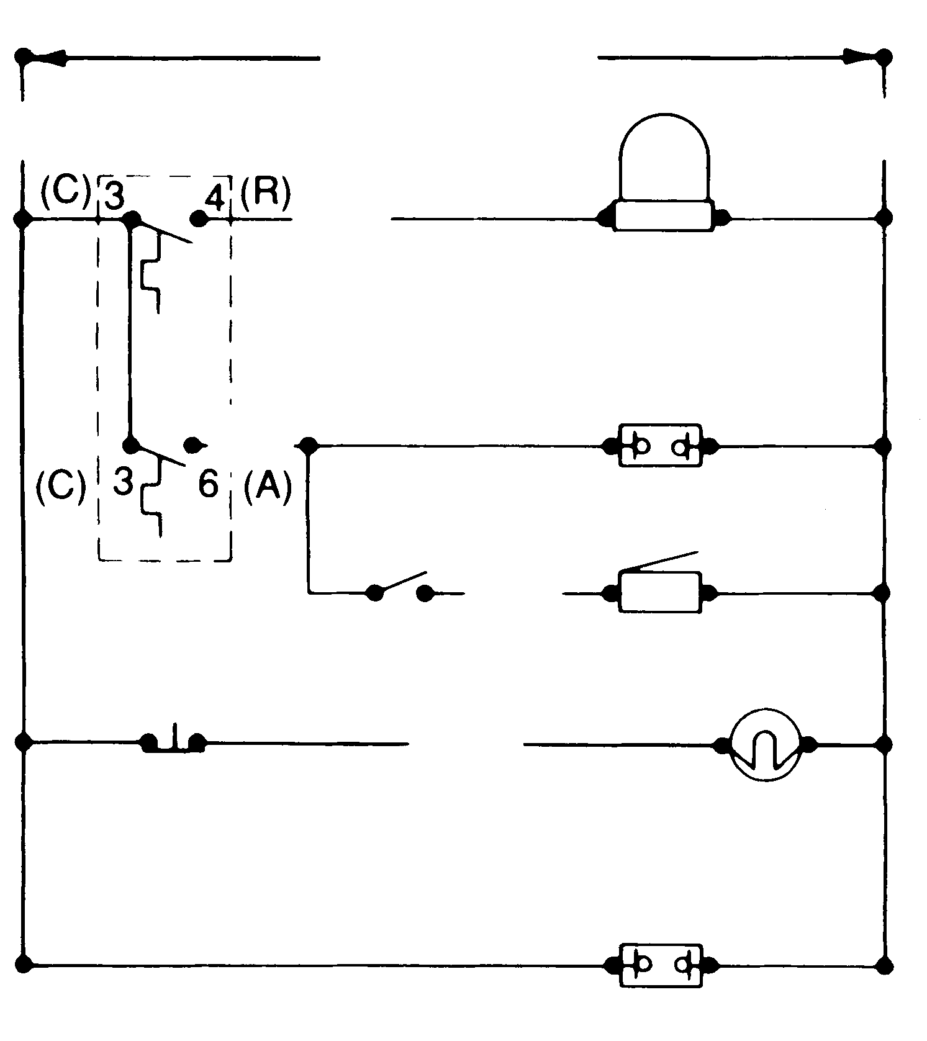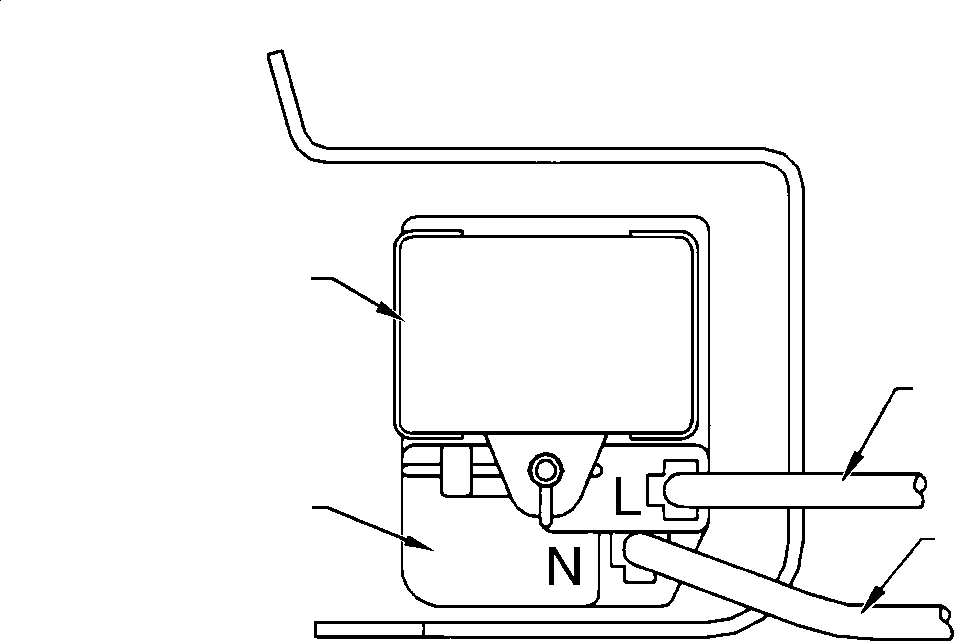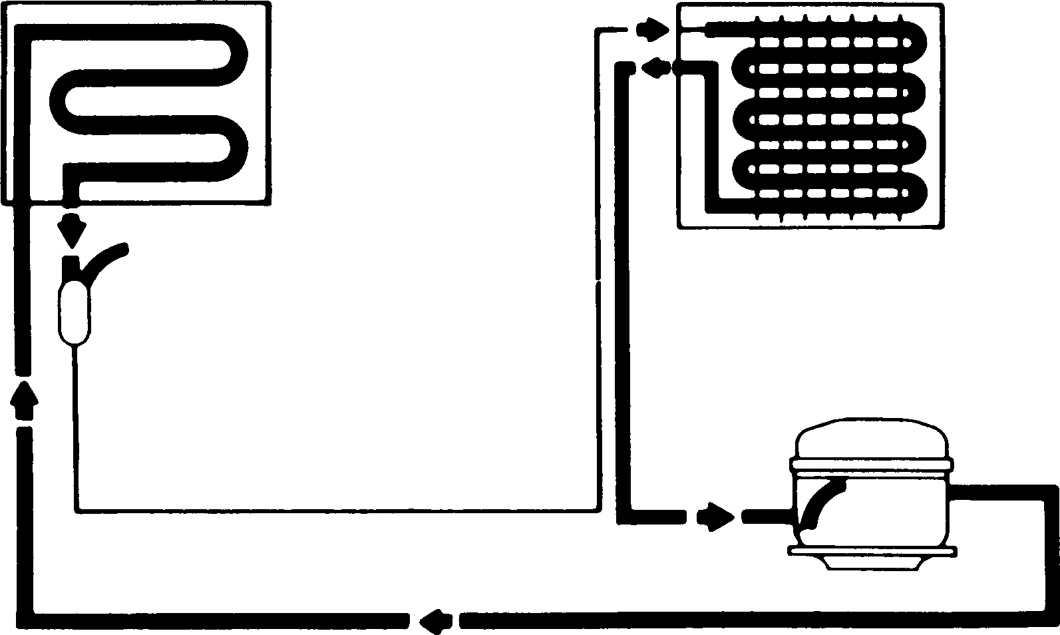
IMPORTANT SAFETY NOTICE
The information provided herein is designed to assist qualified repair personnel only. Untrained persons should not attempt to make repairs due to the possibility of electrical shock. Disconnect power cord before servicing.
216803100
SERVICE DATA SHEET MANUAL DEFROST UPRIGHT FREEZER
INSTALLATION
This product is designed for “free standing installation only” and three inches of clearance must be provided on all sides of the freezer for air circulation.
The freezer should be positioned on a solid floor, and the front of the cabinet should be raised just enough to provide easy door closure when open about half way.

REFRIGERANT CHARGE AND ELECTRICAL SPECIFICATIONS
Refer to serial plate.

TEMPERATURE CONTROL
11.1°F cut in, -4.7°F cut-out @ number 1 setting.

PERFORMANCE (Control at number 1 setting)
Room Ambient 70°F
Freezer Compartment Temperature Percent Running Time
*Wattage Range (Last 1⁄3 of cycle) Suction Pressure (Cut-in, cut-out), PSIG
High Side Pressure (Last 1⁄3 of cycle), PSIG
Specifications subject to change without notice.
5 to 10°F
40-55%
70-110
15-0
105-115
90°F
5 to 10°F
45-60%
70-110
15-0
140-160
*For complete performance data by model refer to service manual. PD643
ELECTRICAL CIRCUIT
Blk
Power
See Diagram
Wh
Blu
Compressor
IMPORTANT
If any green grounding wires are removed dur- ing servicing, they must be returned to their original position and properly secured.
Pink
Temp Warning
WIRING DIAGRAM
Cold Control
Alarm Off On
Red
Buzzer
Door Switch
Red
Run Capacitor
Interior Light
Blu
Compressor Controller
Wh
Power On
EC40
C26
SYSTEM SCHEMATIC
Condenser Evaporator
High Side Process Tube
Drier

Capillary
Compressor Suction
Tube
Low Side Process Tube
SS1
Discharge

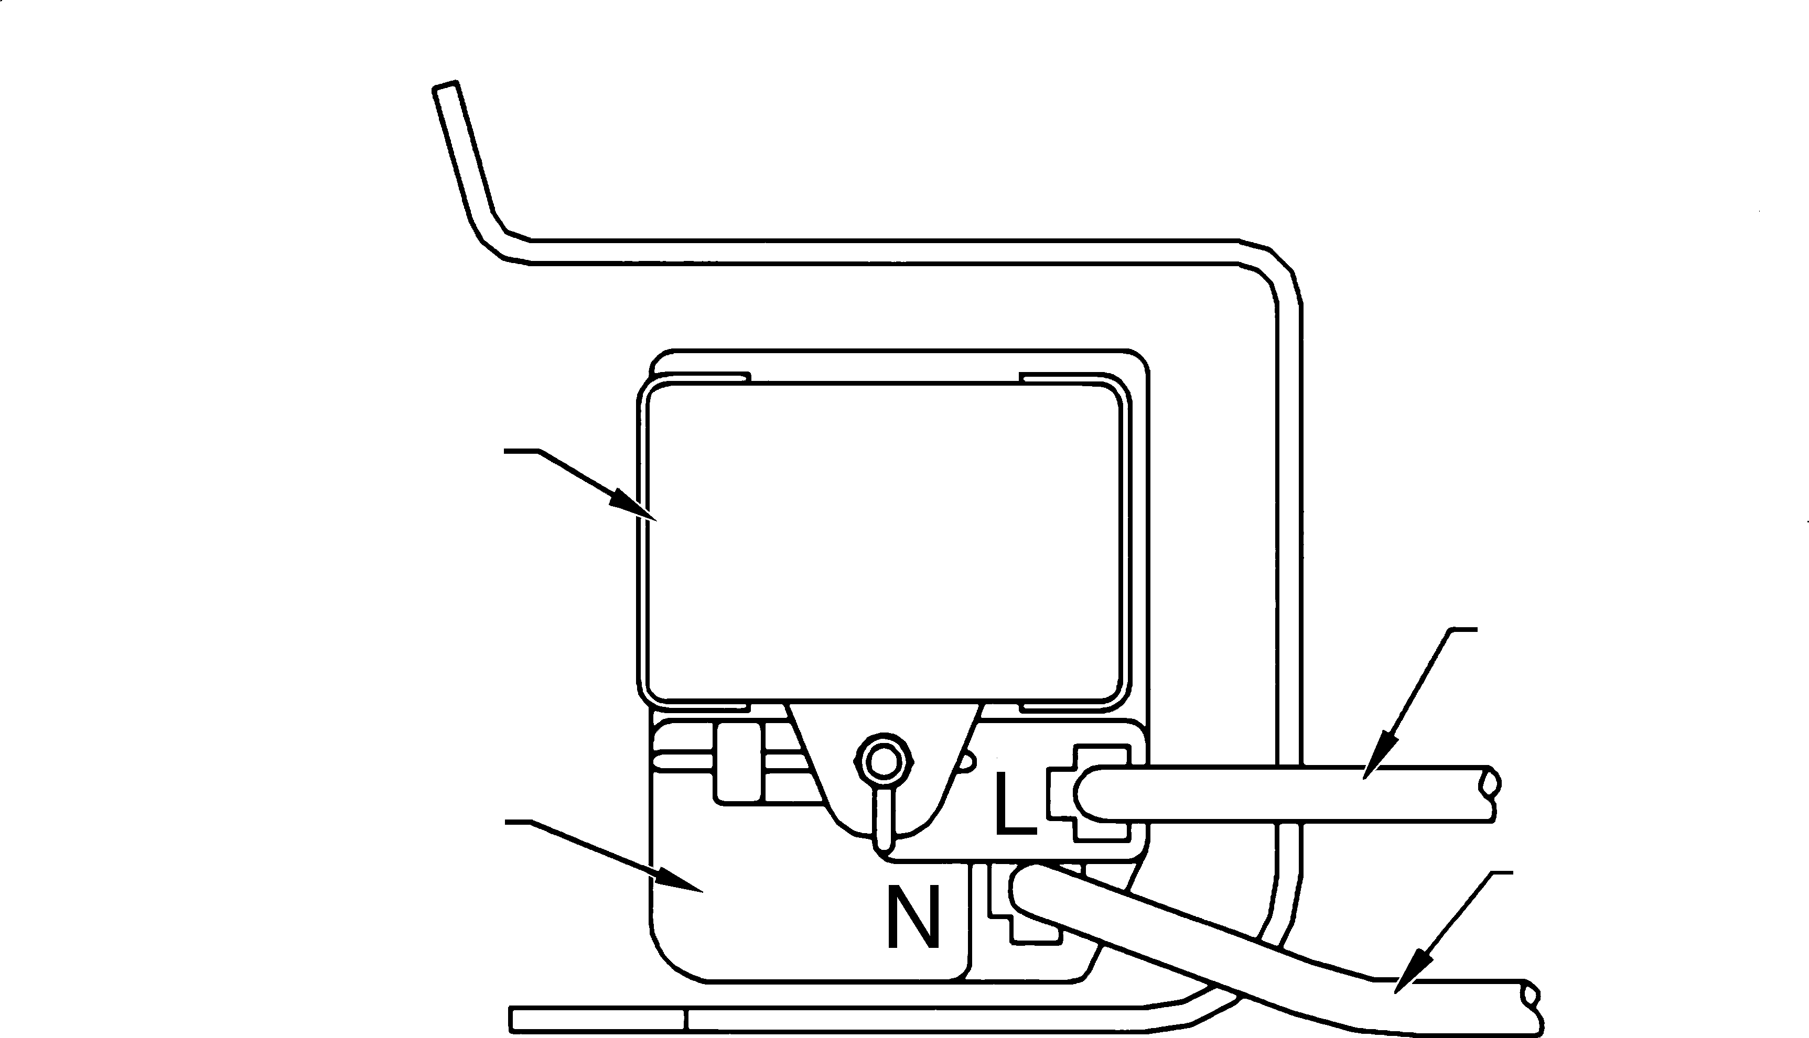
AVIS DE SÉCURITÉ IMPORTANT
CIRCUIT ÉLECTRIQUE
Noir
Courant électrique
Voir schéma
Blanc
Bleu
Compresseur
IMPORTANT
Si des fils de mise à la terre verts sont enlevés lors de l’entretien, les remettre à leur position d’origine et bien les fixer.
Rose
Avertissement temp.
SCHÉMA DE CÂBLAGE
Commande de froid
Alarme
Rouge
Arrêt Marche
Sonnerie
Interrupteur de porte
Rouge
Condensateur de marche
Lampe intérieure
Bleu
Contrôleur du compresseur
Blanc
Circuit fermé
FEC40
FC26
SCHÉMA DU SYSTÈME
Condenseur Évaporateur
Tube de traitement côté haute pression
Déshydrateur
Conduite d'aspiration
Compresseur
Capillaire
Tube de traitement côté basse pression
FSS1
Refoulement
L’information fournie n’est destinée qu’au personnel de réparation qualifié. Par suite du risque de décharge électrique, les personnes non expérimentées ne devraient pas essayer d’entreprendre des réparations. Débrancher le cordon avant tout entretien.
FICHE DE DONNÉES TECHNIQUES CONGÉLATEUR VERTICAL À DÉGIVRAGE MANUEL

INSTALLATION
Cet appareil n’est conçu que pour être installé de façon autonome. Un dégagement de trois pouces de chaque côté du congélateur doit être prévu pour assurer la circulation de l’air.
Le congélateur doit être placé sur un plancher solide et l’avant de sa caisse doit être relevé, juste assez pour permettre une fermeture facile de la porte lorsqu’elle est à moitié ouverte.

CHARGE DE RÉFRIGÉRANT ET CARACTÉRISTIQUES ÉLECTRIQUES
Se reporter à la plaque signalétique.

COMMANDE DE TEMPÉRATURE
Enclenchement 11.1°F; déclanchement -4.7°F au réglage numéro 1

PERFORMANCE (commande sur réglage numéro 1)
Température ambiante | 70°F | 90°F
Température du compartiment congélateur | 5 à 10°F | 5 à 10°F
Pourcentage de durée de fonctionnement | 40-55% | 45-60%
*Gamme du puissance (dernier 1⁄3 du cycle) | 70-110 | 70-110
Pression d’aspiration (enclenchement, déclenchement), en lb/po² au man. | 15-0 | 15-0
Pression côté haut (dernier 1⁄3 du cycle), en lb/po² au man. | 105-115 | 140-160

Caractéristiques modifiables sans préavis.
*Pour des renseignements complets: se reporter au manuel du modèle. FPD643

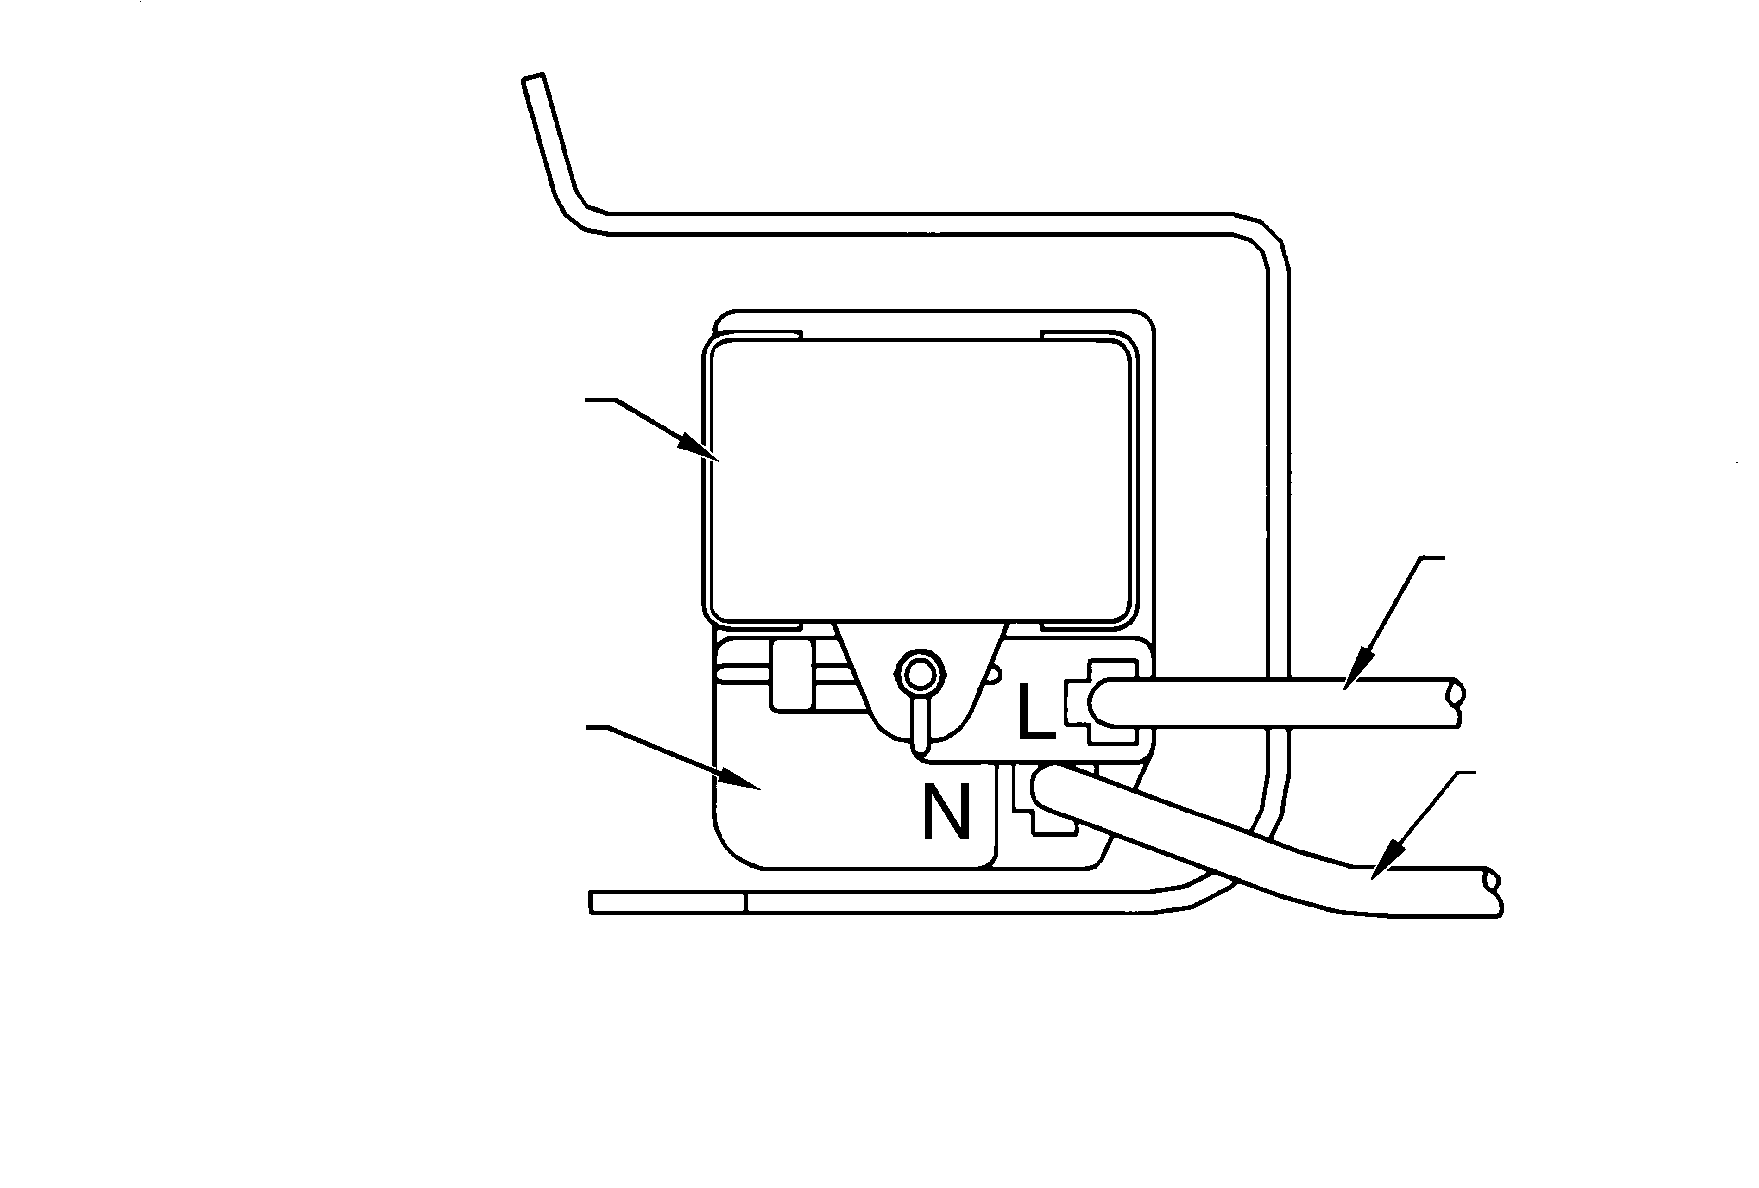
AVISO IMPORTANTE DE SEGURIDAD
CIRCUITO ELECTRICO
Negro
Corriente eléctrica
Ver diagrama
IMPORTANTE
Si los alambres de puesta a
Blanco tierra verdes son sacados
Azul
Compresor
durante el mantenimiento, ellos deben volver a colocarse en su posición original y ser asegurados debidamente.
Rosado
Advertencia de Temp.
Control del frio
Alarma
Rojo
DIAGRAMA DE CABLEADO
Activ. Apag.
Zumbador
Interruptor de la Puerta
Rojo
Condensador de marcha
Luz interior
Azul
Controlador del compresor
Blanco
Encendido
SEC40
SC26
ESQUEMA DEL SISTEMA
Condensador Evaporador
Tubo de Tratamiento Lado Alto
Secadora
Tubo de Aspiración
Compresor
Capilar
Tubo de Tratamiento Lado Bajo
SSS1
Descarga
Downloaded from www.Manualslib.com manuals search engine
La información aquí provista está destinada a ayudar al personal calificado de reparación solamente. Las personas no especializadas en esta materia no deben intentar hacer reparaciones debido a la posibilidad de choque eléctrico. Desconecte el cordón eléctrico antes del mantenimiento.

FICHA DE DATOS TECNICOS CONGELADOR VERTICAL CON DESCONGELACION MANUAL

INSTALACION
Este producto está diseñado para “instalación autónoma solamente” y se debe proveer tres pulgadas de holgura en todos los lados del congelador para circulación del aire.
El congelador debe ser instalado sobre suelo firme y la parte delantera del gabinete debe estar levantada solamente lo suficiente como para permitir el cierre fácil de la puerta cuando se abre hasta la mitad.

PARA LAS ESPECIFICACIONES ELECTRICAS Y CARGA DEL REFRIGERANTE
Ver la placa del número de serie.

CONTROL DE LA TEMPERATURA
Conexión 11.1°F; desconexión -4.7°F en el ajuste 1.

RENDIMIENTO (Control en el ajuste 1)
Temperatura Ambiente | 70°F | 90°F
Temperatura del Compartimiento Congelador | 5 a 10°F | 5 a 10°F
Porcentaje de Tiempo de Funcionamiento | 40-55% | 45-60%
*Gama de Potencia (Ultimo 1⁄3 de ciclo) | 70-110 | 70-110
Presión de Aspiración (Conexión, Desconexión), en Lbs./pulg.² | 15-0 | 15-0
Presión Lado Alto (Ultimo 1⁄3 de ciclo). Lbs./pulg.² | 105-115 | 140-160

Especificaciones sujetas a cambio sin aviso previo.
*Para información completa, consultar el manual del modelo. SPD643

