BLACK KETTLE

INSTRUCTION MANUAL

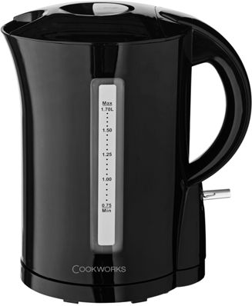

Safety Warnings
- If the supply cord is damaged, it must be replaced by the manufacturer, its service agent or similarly qualified persons in order to avoid a hazard.
- Only use the cord & powerbase supplied with this kettle. If a replacement is required, only approved components can be used.

Keep the appliance and its cord out of reach of children less than 8 years.
- This appliance is intended to be used in household and similar environments such as : staff kitchen areas in shops, offices and other working environments, farm houses : by clients in hotels, motels and other residential type environments bed and breakfast type environments.

Please read these instructions carefully before using the kettle for the first time.
- Before power connection, make sure your electricity supply is the same as the one shown on the underside of your kettle.
- The kettle will switch off automatically. You may switch the kettle off manually by using the on/off switch.
- After the kettle has switched off automatically (or has been switched off manually) allow to cool down at least 30

seconds before switched on another boiling cycle.
- If the kettle ever boils dry, allow 15 minutes to cool before refilling with cold water. The safety cutout will automatically reset during this time.
- Always place the kettle on a stable flat surface.
- Never immerse the kettle, powerbase or cord in water or any other liquid. Do no allow liquid to penetrate the electrical parts of this kettle.
- Never let the cord hang down where a child could grab it or knock the kettle over.
- The outside surface of the kettle gets hot during use, take care when using the kettle.
- Never fill in water more than the maximum acceptable water level. Always use the filter and never overfill ‐ boiling water may splash out.
- WARNING! Do not remove or open lid while the water is boiling.
- Make sure the kettle is switched off before lifting from its stand or pouring.
- Avoid contact with steam coming out of the spout area when pouring and out of the lid or spout area when refilling.

This appliance can be used by children aged from 8 years and above and persons with reduced physical, sensory or mental capabilities or lack of experience and knowledge if they have been given supervision or instruction concerning use of the appliance in a safe way and understand the hazards involved. Children shall not play with the appliance. Cleaning and user maintenance shall not be made by children without supervision.
- WARNNING! This kettle is designed for boiling, water only. NEVER USE IT FOR HEATING UP OTHER LIQUIDS SUCH AS
MILK. It will stop kettle from switching off automatically and result to overheating and product damage.
- If the kettle is overfilled, boiling water may be ejected.
- Heating element surface is subject to residual heat after use.
- Use the kettle according to this instruction, any misuse may cause electric shock or other hazards.
- Avoid spillage on the connector.

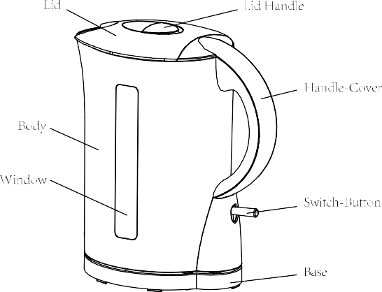
Know you appliance
Capacity: 1.7L
Power: 220‐240V 50Hz 1850‐2200W

Before using for the first time
- Fill kettle up to the MAX WATER MARK and bring to a boil. It is recommended that you fill, boil, and empty the kettle at least 3 times to clear the kettle of any tiny particles, metal or plastic taste and to give the rubber seals a chance to settle.

Using the kettle

Filling
- Take up the kettle from the base before filling.
- Fill the kettle through either the spout or the lid.
- Fill to the desired level. WARNING: The water level must be between ‘MAX’ and ‘MIN’
- Close the lid by pressing it down until it clicks into place securely.
- Be economical: do not boil more water than you need.

Switching on
- Check the lid is closed.
- Plug the power supply cord into the mains.
- To switch to ON position. The power indicator lights up.

Switching off
- When the water has boiled the kettle will automatically switch itself

off.
- You can stop the boiling process at any time by clicking the ON/OFF switch to off position manually. The power indicator will go out.
WARNING: Do not open the lid when steam is coming out of the spout. Kettle is only to be used with the stand provided.

- If you switch on with too little water, your kettle will cut out automatically by the boil‐dry protection. Switch off, remove from the powerbase and let it cool down at least 15 minutes before re‐filling. When it has cooled down, the switch will reset itself.

Care and Cleaning
- First read the instructions in the section titled “SAFETY WARNINGS”.
- Before cleaning, unplug your kettle and let it cool down.
- Wipe with a damp cloth, then dry. Avoid using abrasive cleaning agents.
- Do not immerse the kettle, base, cord or plug in water at any time.
- Kettle, filter, and base are NOT dishwasher‐safe.
- Always unplug your kettle when not in use.

Descaling
The major cause of damage to kettles is limescale and your kettle will require regular maintenance to ensure that it continues to work properly. Limescale deposits build up over time, blocking important parts of the kettle and stopping it from working properly.

Remember:
  - Descale every few months
  - Don’t wait for limescale to build up before you descale
  - You can buy descaler from us at www.argosspares.co.uk or in many high street shops
  - Clean the limescale filter if your kettle has one

Types of problems caused by limescale build‐up:
  - Colour – Limescale will discolour your kettle.
  - Performance – your kettle will take longer to boil (wasting electricity) and eventually will switch off before it has boiled.
  - Taste – limescale can give the water a chalky taste and limescale flakes will give a gritty texture.

Other care tips:
  - To clean the outside of your kettle use a soft, wet cloth.
  - The first time you use your kettle the water may taste of plastic. Always boil your kettle a couple of times before you use it to make drinks. If the taste persists add 2 teaspoons of bicarbonate of soda to the full kettle, boil and discard the water.
  - If you find drops of water under your kettle, don’t worry ‐ it is just condensation.
  - Most kettles will cut‐out if they boil dry. If this happens, consult your instruction manual.

Connection to Power
- Before connecting, check that the voltage indicated on the appliance corresponds with the main voltage in your home. If this is not the case, consult your dealer and do not use.
- This appliance may be fitted with a non‐rewirable plug. If you need to change the fuse in a non‐rewirable plug, the fuse cover must be refitted. If the fuse cover is lost or damaged, the plug must not be used until a replacement is obtained (available from the appliance manufacturer).
- If the plug has to be changed because it is not suitable for your socket, or becomes damaged, it should be cut off and appropriate plug fitted following the wiring instructions. The plug removed must be disposed of safely as insertion into a mains socket is likely to cause an electrical hazard.
- WARNING: This appliance must be earthed. This equipment must be disconnected from the mains when not in use. Do not allow this unit to be exposed to rain or moisture.

For your own safety read the following instructions carefully before attempting to connect this unit to the mains.

You should only plug the appliance into a 220V‐240V AC, 50Hz supply. Connecting it to other power sources may damage the appliance.
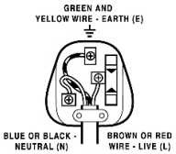
The wires in this mains lead are coloured in accordance with the following code:
BLUE = NEUTRAL BROWN = LIVE
GREEN + YELLOW = EARTH

IMPORTANT

The colours of the wires in the mains lead of this appliance may not correspond with the coloured markings identifying the terminals in your plug, proceed as follows:
Caution
To prevent electric shock disconnect from the mains before removing the cover

- The blue wire must be connected to the terminal marked with the letter N or coloured black.
- The brown wire must be connected to the terminal marked with the letter L or coloured red.
- The green and yellow wire must be connecting to the terminal marked with the letter E or the earth symbol. ().

If a 13 Amp (BS1363) fused plug is used it must be fitted with a 13A fuse conforming to BS1362 and be ASTA approved.

If in doubt contact a qualified electrician

Disposal Information
Waste electrical products should not be disposed of with household waste. Please recycle where facilities exist. Check with your local authority for recycling advice.

Guarantee
This product is guaranteed against manufacturing defects for a period of

1 year

This does not cover the product where the fault is due to misuse, abuse, use in contravention of the instructions, or where the product has been the subject of unauthorised modifications or alterations, or has been the subject of commercial use

In the event of a problem with the product within the guarantee period please return it to your nearest Argos store

If the item is shown to have had an inherent defect present at the time of sale, the store will provide you with a replacement

Your statutory rights remain unaffected

Guarantor; Argos Ltd 489 – 499 Avebury Boulevard
Central Milton Keynes MK9 2NW

