Printing Documents

Home Screen:
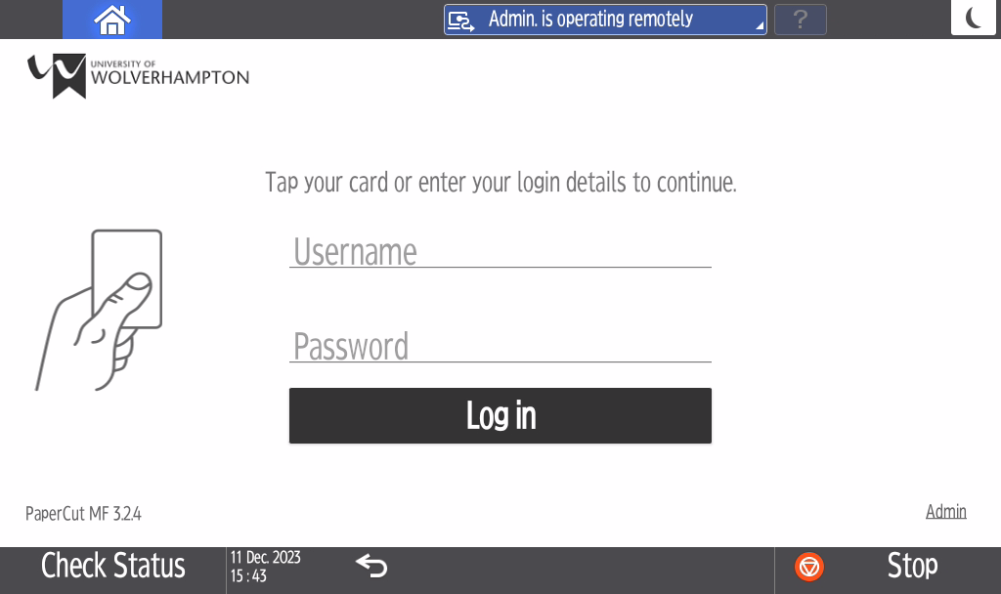

Tap your ID card or enter your university email address and password

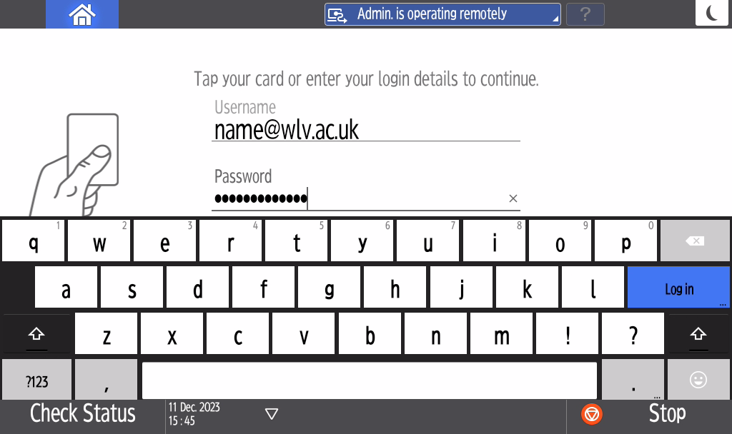
Select ‘Print release’ to print 1 or more documents selectively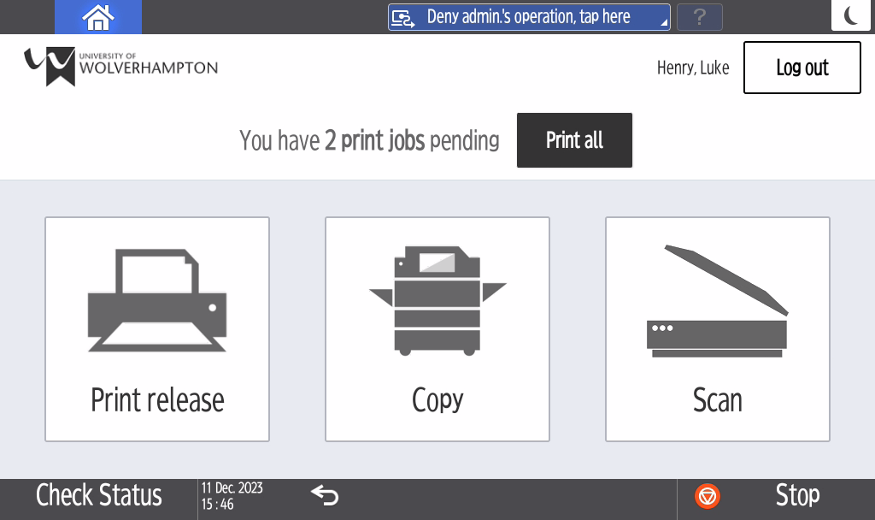

Choose the document(s) you would like to print and press ‘Print’
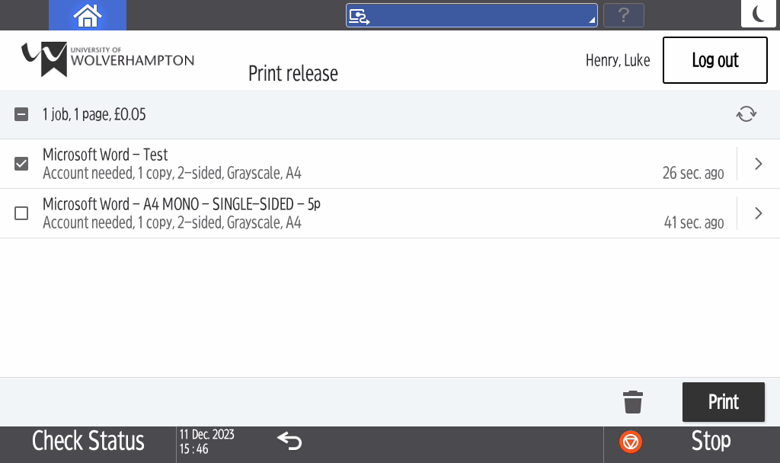

To Print all documents Select ‘Print all’ which will print all queued documents
